WEEK 5 TASK
DEEP LEARNING APPLICATION IN DATA SCIENCE
Titanic Survival Prediction Using a Neural Network
Framework: PyTorch | Task Type: Binary Classification | Random Seed: 42
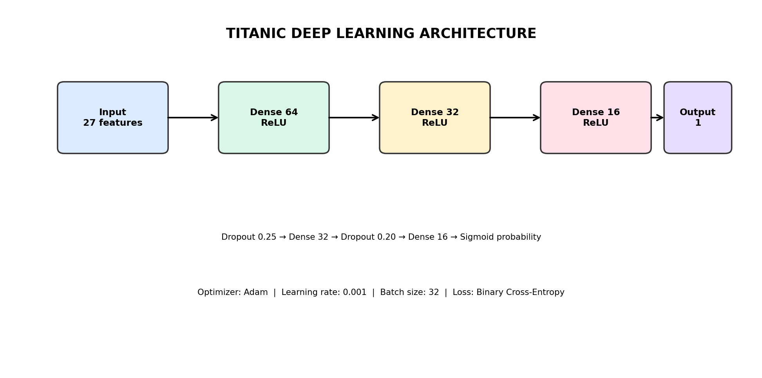
Complete Week 5 implementation, analysis, visualizations, and submission documentation

1. Executive Summary
This report presents a complete deep-learning application using the Titanic passenger dataset. The objective is to demonstrate the full practical workflow requested in Week 5: define a problem, prepare a public dataset, design a neural network, train it, evaluate it with appropriate metrics, visualize results, and critically discuss limitations and improvements.
Building on the previous weeks' Titanic EDA, clustering, and supervised-learning work, this submission moves from conventional machine learning to a multilayer perceptron implemented in PyTorch. The target is Survived, making the problem binary classification. The final model receives 27 encoded inputs and uses hidden dense layers of 64, 32, and 16 units with ReLU activations and dropout. On the held-out test set, it achieved 82.12% accuracy and 0.853 ROC-AUC.

2. Problem Statement and Objectives
Given structured information about a Titanic passenger, predict whether that passenger survived the disaster. The task is binary classification: 0 = did not survive and 1 = survived.
Objectives: apply deep-learning concepts to structured data; reuse the Titanic dataset from earlier weeks; engineer meaningful features; design a neural network; train and evaluate it; analyze overfitting and resource constraints; and document the complete process.
- Define a clear binary classification problem.
- Prepare and transform the Titanic data.
- Design and justify a neural-network architecture.
- Train with validation monitoring and regularization.
- Evaluate with accuracy, precision, recall, F1-score and ROC-AUC.
- Discuss challenges, limitations and future improvements.

3. Dataset Description
The supplied Titanic dataset contains 891 passenger records and 12 original columns. The target column is Survived, with a survival rate of 38.38%. Missing values include 177 Age values, 687 Cabin values, and 2 Embarked values.
Week 2 established exploratory understanding, Week 3 introduced clustering, and Week 4 treated survival as supervised classification. Week 5 continues the same dataset and adds a neural-network solution.
Dataset item | Value
Rows | 891
Original columns | 12
Target | Survived
Survival rate | 38.38%
Missing Age | 177
Missing Cabin | 687
Missing Embarked | 2
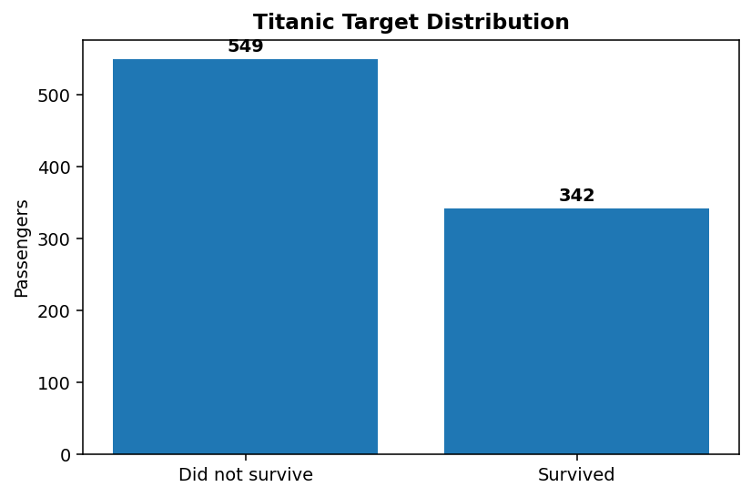

4. End-to-End Architecture and Workflow
The workflow begins with the raw CSV, performs domain-inspired feature engineering, handles missing values, encodes categorical variables, standardizes numerical variables, and sends the resulting feature matrix to the MLP. The test set remains unseen until final evaluation.
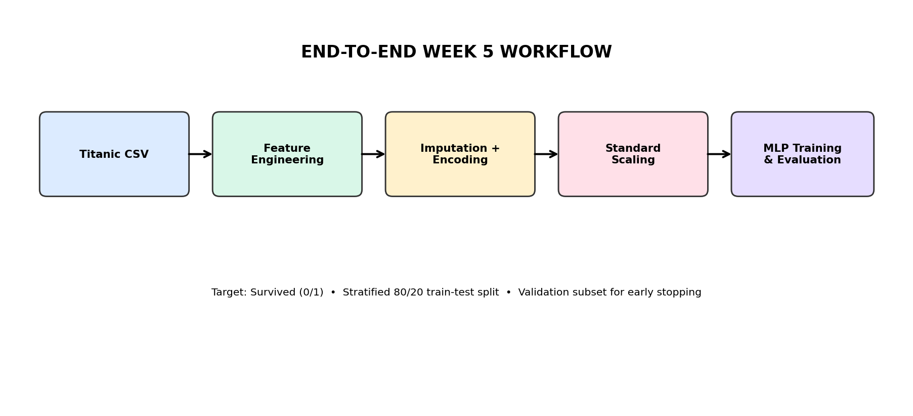

5. Data Preprocessing and Feature Engineering
Numerical missing values are filled with the median and categorical missing values with the most frequent category. Categorical variables are one-hot encoded and numerical variables are standardized. The target is kept separate throughout the pipeline to reduce leakage risk.
Engineered variables include Title, FamilySize, IsAlone, FarePerPerson, and Deck. These variables capture social title, travelling-party size, solo travel, normalized fare, and cabin-deck information.
Feature | Type | Reason
Title | Categorical | Demographic/social title
FamilySize | Numeric | Travelling-party size
IsAlone | Binary | Solo-travel indicator
FarePerPerson | Numeric | Fare normalized by family size
Deck | Categorical | Cabin-deck signal with U for missing

6. Neural Network Architecture
The model is a compact multilayer perceptron. It accepts 27 encoded inputs, then uses Dense 64 + ReLU, Dropout 0.25, Dense 32 + ReLU, Dropout 0.20, Dense 16 + ReLU, and a single output neuron for binary prediction.
ReLU provides nonlinear representation in the hidden layers. Dropout is used as regularization. Adam optimization provides adaptive parameter updates, while binary cross-entropy with logits provides a numerically stable classification loss.
Layer | Units | Activation | Purpose
Input | 27 | — | Preprocessed inputs
Dense 1 | 64 | ReLU | First nonlinear representation
Dropout | 0 | 0.25 | Regularization
Dense 2 | 32 | ReLU | Higher-level interactions
Dropout | 0 | 0.20 | Regularization
Dense 3 | 16 | ReLU | Compact representation
Output | 1 | Sigmoid | Binary prediction

7. Training Process and Hyperparameters
The network uses Adam with learning rate 0.001, batch size 32, weight decay 0.0001, a maximum of 120 epochs, and validation-loss early stopping with patience 12. The actual training stopped after 26 epochs. A stratified validation subset was taken from the training portion.
Training and validation accuracy/loss were tracked at each epoch, and the best validation-loss model state was restored.
Parameter | Value
Framework | PyTorch
Optimizer | Adam
Learning rate | 0.001
Batch size | 32
Maximum epochs | 120
Early stopping patience | 12
Loss | BCEWithLogitsLoss
Weight decay | 0.0001
Random seed | 42
Actual epochs | 26
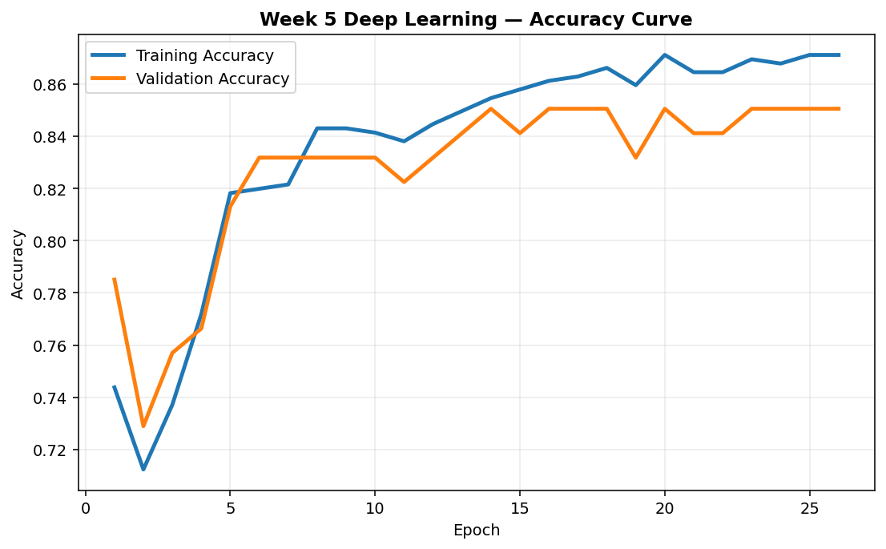
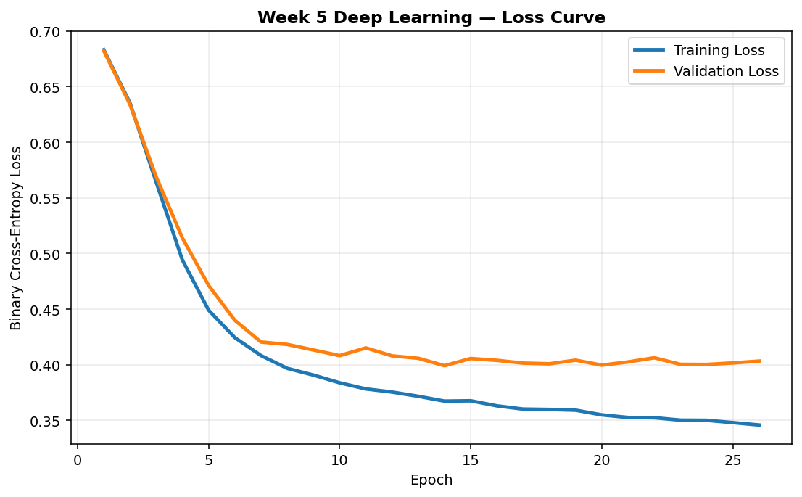

8. Model Evaluation and Results
The held-out test set contains 179 passengers. Performance was Accuracy=0.8212, Precision=0.8033, Recall=0.7101, F1=0.7538, and ROC-AUC=0.8534.
The metrics are interpreted together rather than using accuracy alone, because survival classes are not perfectly balanced and precision/recall provide additional information about classification errors.
Metric | Test score
Accuracy | 0.8212
Precision | 0.8033
Recall | 0.7101
F1 Score | 0.7538
ROC-AUC | 0.8534
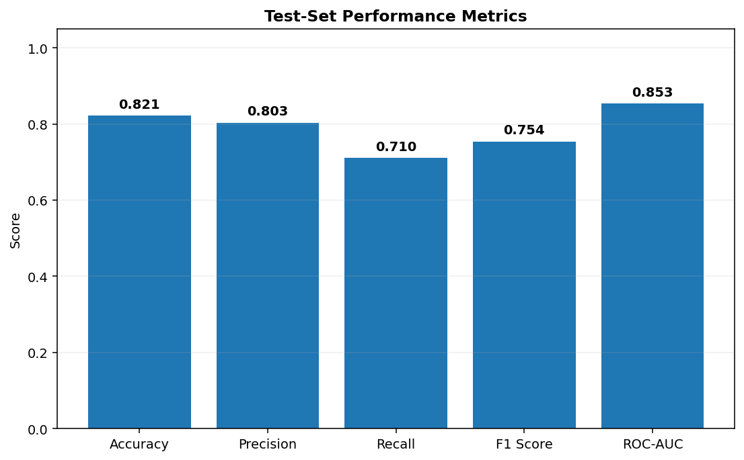

9. Confusion Matrix and ROC Analysis
The confusion matrix separates correct and incorrect predictions for the two classes. False negatives represent actual survivors predicted as non-survivors, while false positives represent non-survivors predicted as survivors.
The ROC curve shows classification behaviour across probability thresholds. The ROC-AUC of 0.853 indicates useful ranking ability above the 0.5 random baseline.
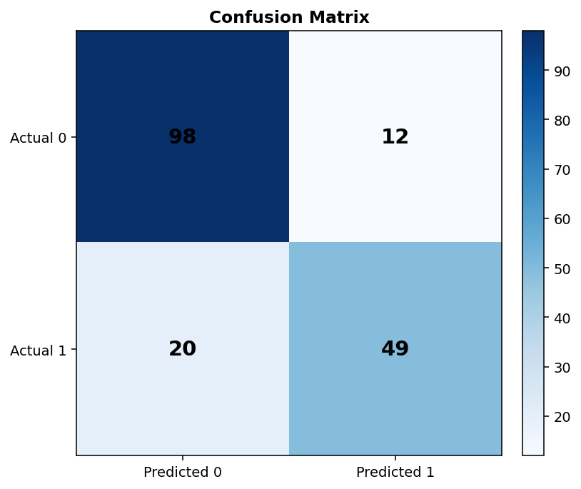
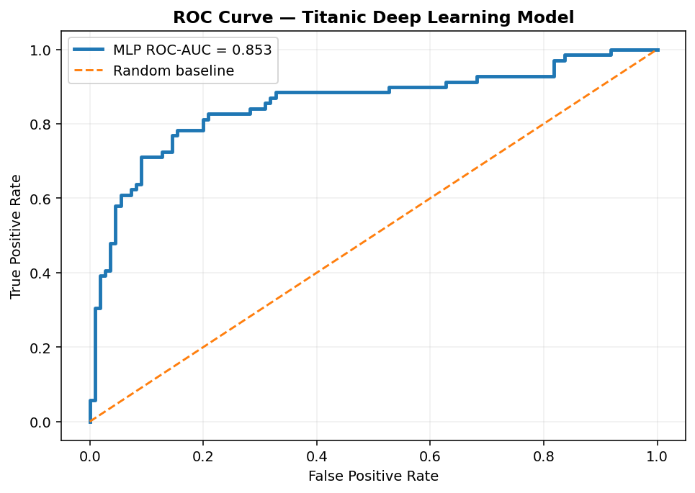

10. Challenges Encountered and Solutions
Missing data was handled with training-fitted imputation. Categorical text was converted into numerical features through one-hot encoding. Feature-scale differences were handled through standardization. The small dataset created overfitting risk, so a compact network, dropout, validation monitoring, and early stopping were used.
CPU/resource constraints were addressed by keeping the network lightweight. Stratified splitting and multiple evaluation metrics were used to reduce the risk of drawing conclusions from a misleading class distribution.
- Missing Age/Cabin/Embarked → imputation and unknown-deck handling.
- Categorical text → one-hot encoding.
- Different numerical scales → standardization.
- Small dataset → compact MLP, dropout and early stopping.
- Class imbalance → stratified split and multiple metrics.
- Resource limits → CPU-friendly architecture.

11. Critical Analysis of Results
The MLP demonstrates that a neural network can learn nonlinear relationships from engineered Titanic features, but the dataset is small for deep learning. Week 4's Logistic Regression achieved about 0.866 ROC-AUC on its held-out test set, while the Week 5 MLP achieved 0.853. This illustrates an important data-science lesson: greater model complexity does not automatically produce better results on small tabular datasets.
Good preprocessing, leakage control, regularization, validation, and critical interpretation are as important as the neural-network architecture itself.
- Strong reproducibility through a fixed seed and documented pipeline.
- Feature engineering improves the representation available to the network.
- The result should not be interpreted as evidence that deep learning is always superior for tabular data.
- Repeated cross-validation and baseline comparisons would strengthen the conclusion.

12. Implementation and Reproducibility
The GitHub package contains both a Python implementation and a Jupyter notebook. The Python script can be run after installing requirements, while the notebook presents the same process cell by cell for academic demonstration.
Reproducibility is supported by a fixed seed, documented preprocessing, a fixed train/test split, explicit hyperparameters, saved metrics, test predictions, and a saved PyTorch model.
python -m pip install -r requirements.txt
python week5_deep_learning.py
- Python script
- Jupyter notebook
- README
- Requirements file
- Dataset
- Metrics and predictions
- Charts and architecture diagrams
- Saved model

13. Conclusion and Future Scope
This Week 5 project successfully applies deep learning to Titanic binary classification. The final model achieved 82.12% test accuracy, 0.754 F1-score, and 0.853 ROC-AUC on the held-out set.
Future work can include repeated cross-validation, systematic hyperparameter tuning, batch normalization, learning-rate scheduling, class-weighted loss, SHAP/permutation-based explainability, model calibration, and a Streamlit or Flask demonstration.
- Hyperparameter optimization
- Repeated stratified validation
- Explainability dashboard
- Streamlit/Flask demo
- Model calibration
- MLP vs tree-based benchmark

14. References
Technical references consulted for standard neural-network and dropout concepts:
- TensorFlow Core — Sequential model guide: https://www.tensorflow.org/guide/keras/sequential_model
- TensorFlow Core — Image classification tutorial and dropout discussion: https://www.tensorflow.org/tutorials/images/classification
- Keras — Sequential model API: https://keras.io/api/models/sequential/
- Keras — Dropout layer API: https://keras.io/api/layers/regularization_layers/dropout/

