Ball Tracking and Virtual Replays for Innovative Tennis Broadcasts
G. Pingali, A. Opalach and Y. Jean, "Ball tracking and virtual replays for innovative tennis broadcasts," in 2000, . DOI: 10.1109/ICPR.2000.902885.
- Six Monochrome progressive scan (60 Hz Cameras)
  - Number of cameras chosen to cover entire field
  - 60 Hz needed for sufficient tracking
  - Monochrome, rather than color cameras, have been chosen so that the bandwidth of a dual PCI bus is sufficient for fullframe capture at 60 Hz from all six cameras
  - “The six cameras are placed around a stadium with four cameras on the side and two at the ends of the court. Each of the four side cameras is paired with one of the end cameras to form a set of four stereo pairs that track the ball in 3D.”
- “The search for the ball is performed in only one of the two cameras to ensure efficiency. Once the ball is detected in one camera, the search region in the other camera is based on epipolar constraints.” (Circle tracking in one camera, going ROI on second camera based on existing coords for efficiency)
- Logical AND operation of regions found in expected range for the ball in provided images (frame differencing the previous and future images)
  - “When the current velocity of the ball indicates that the ball will be out of bounds of the current camera pair by the next frame, the positions of the ball in the next camera pair are determined based on the current 3D velocity of the ball and 3D to image mapping using camera calibration parameters.”

Real-time ball-position measurement using multi-view cameras for live football broadcast
M. Takahashi, S. Yokozawa, H. Mitsumine, and T. Mishina, “Real-time ball-position measurement using multi-view cameras for live football broadcast,” Multimedia Tools and Applications, vol. 77, no. 18, pp. 23729–23750, Feb. 2018, doi: https://doi.org/10.1007/s11042-018-5694-1.
- Robust system for ball position tracking from fixed multi-view cameras installed in football stadiums which outputs ball positions with top-view coordinates on the field. (X, Y positioning, not Z but can be converted for X, Z)
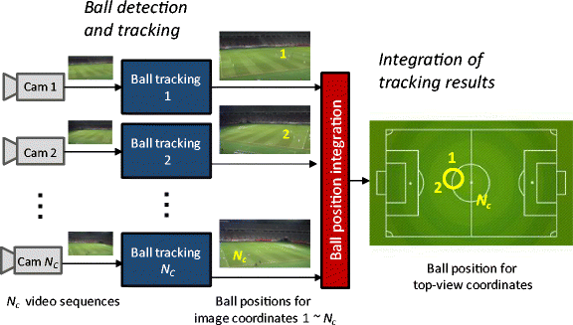
- The system uses several consumer HD cameras, the same number of ball-tracking PCs, and a ball-position-integration PC. All PCs in the system are common consumer PCs.
  - The detected ball positions are input to the integration PC via Ethernet, and a final ball position is measured.
  - Ball tracking processes for all cameras are executed in parallel.
  - The final position is presented with top-view plain coordinates, which ignore the height axis in real 3D space.
  - Used 4 Cameras.
  - The ball position is measured in real time because all ball-tracking processes, which are executed in parallel, are executed within 33 msec (30 fps).
- The module calculates frame differences by subtracting the brightness of each pixel between two temporally consequent frames. This calculation is limited to a football field area to narrow the ball-search area
- Color (white in RGB color space), size (number of pixels in blob), and shape (circular level). The thresholds of this filtering process are set with wide enough margins, taking care not to miss a true ball object.
- The RGB color space is segmented into 3 × 3 × 3 blocks, and a 27-bin color histogram is created by counting pixel colors in an image.
- Previous frames are used to create direction histogram based on trajectory.

Tracking a Golf Ball With High-Speed Stereo Vision System
S. Wang, Y. Xu, Y. Zheng, M. Zhu, H. Yao and Z. Xiao, "Tracking a Golf Ball With High-Speed Stereo Vision System," in IEEE Transactions on Instrumentation and Measurement, vol. 68, no. 8, pp. 2742-2754, Aug. 2019, doi: 10.1109/TIM.2018.2869180. keywords: {Sports equipment;Cameras;Tracking;Stereo vision;Trajectory;Image resolution;Radar tracking;Golf ball tracking;high-speed camera;motion parameter extraction;spin measurement;stereo vision},
- Presents a high-speed stereo vision system that can track the golf ball motion at the speed of up to 360 km/h under normal indoor lighting conditions. Binocular camera operated at 810 frames/s with 35-μs exposure time, requiring no additional strobe lights in order not to compromise user experiences, with overall processing time less than 300 ms.

Accurate real-time ball trajectory estimation with onboard stereo camera system for humanoid ping-pong robot
Y. Liu and L. Liu, “Accurate real-time ball trajectory estimation with onboard stereo camera system for humanoid ping-pong robot,” Robotics and Autonomous Systems, vol. 101, pp. 34–44, Mar. 2018, doi: https://doi.org/10.1016/j.robot.2017.12.004.

Motion Prejudgment Dependent Mixture System Noise in System Model for Tennis Ball 3D Position Tracking by Particle Filter
Y. Wang, X. Cheng, N. Ikoma, M. Honda and T. Ikenaga, "Motion Prejudgment Dependent Mixture System Noise in System Model for Tennis Ball 3D Position Tracking by Particle Filter," 2016 Joint 8th International Conference on Soft Computing and Intelligent Systems (SCIS) and 17th International Symposium on Advanced Intelligent Systems (ISIS), Sapporo, Japan, 2016, pp. 124-129, doi: 10.1109/SCIS-ISIS.2016.0038.

