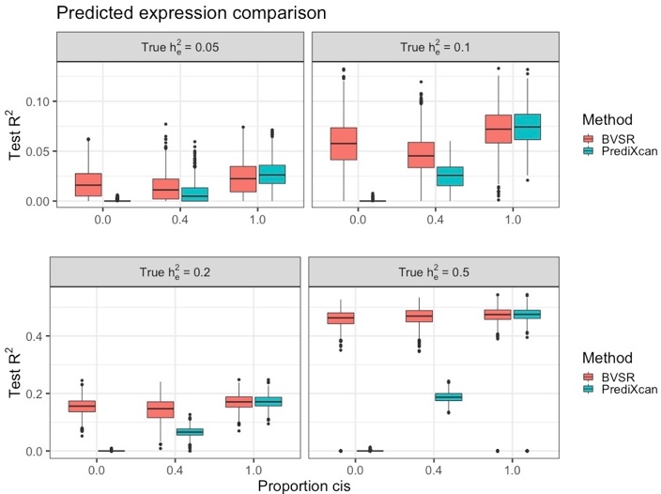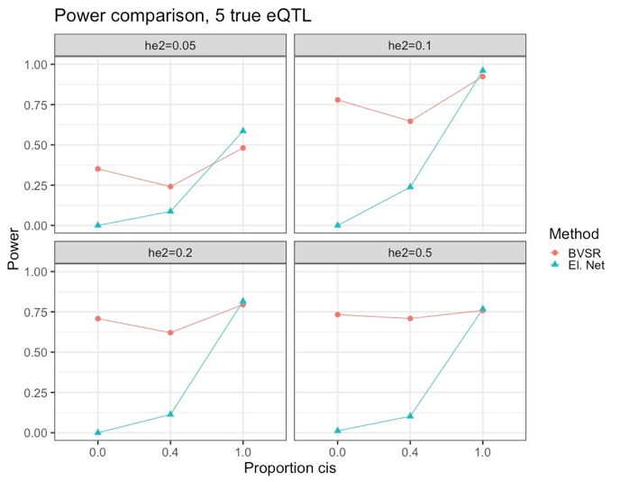

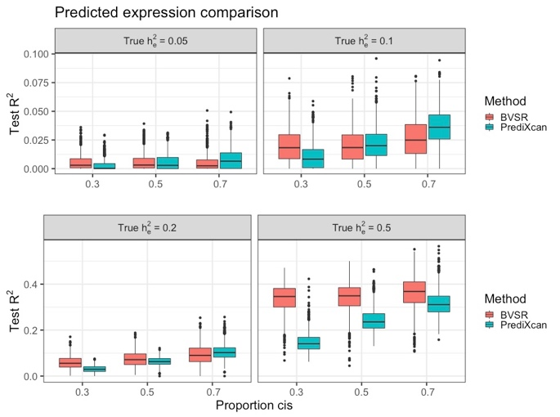 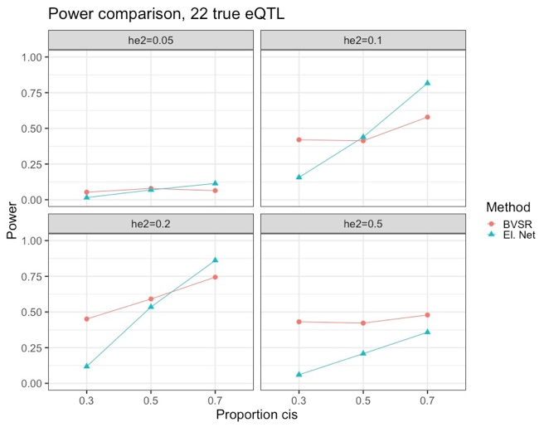

**Figure 1. Compare TWAS performance between our Bayesian approach and the PrediXcan method with various gene expression heritability $h_{e}^{2}=(0.05, 0.1, 0.2, 0.5)$ and various proportions of true causal cis-eQTL.** (A, B) Test R2 and TWAS power comparison when there are 5 true causal eQTL. Our Bayesian method was found to out-perform PrediXcan method when a certain proportion of true causal eQTL are from trans- genome regions. (C, D) Test R2 and TWAS power comparison when there are 22 true causal eQTL. Our Bayesian method was found to out-perform PrediXcan method when >50% of true causal eQTL are from trans- genome regions.

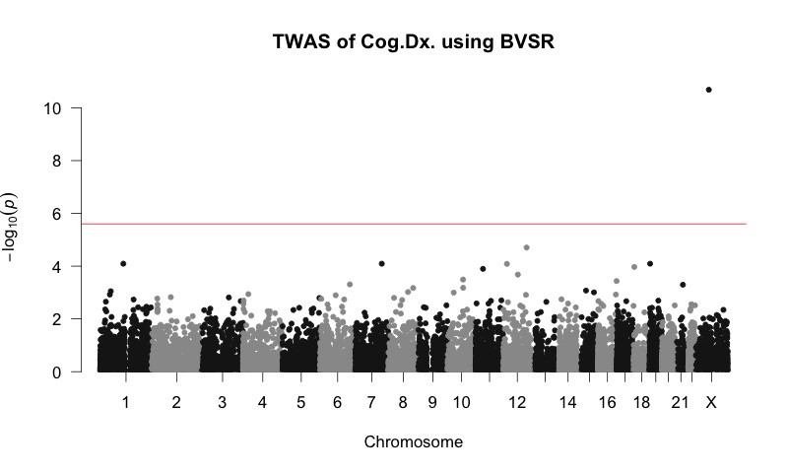

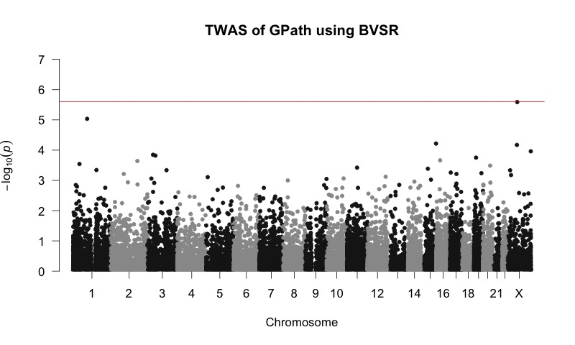

**Figure 2. Manhattan plots of TWAS of the AD clinical diagnosis (A) and quantitative global pathology (gpath) index (B) by our Bayesian approach based on BVSR model.** The red lines denote genome-wide significant threshold ($2.5×{10}^{-6}$) for gene-based association studies. Gene ZC3H12B was found to be significantly associated with both AD clinical diagnosis and gpath. Gene RPAP2 was found to be marginally associated with gpath.

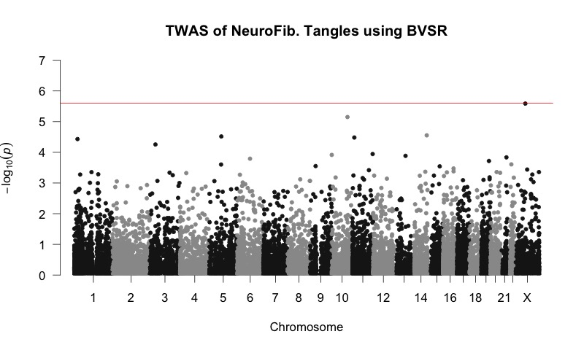

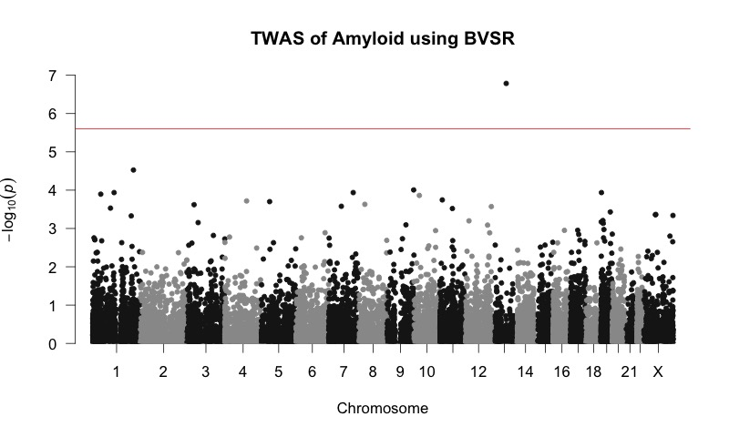

Figure 3. **Manhattan plots of TWAS of neurofibrillary tangle density (tangles, A) and β-amyloid load (amyloid, B) by our Bayesian approach based on BVSR model.** The red lines denote genome-wide significant threshold ($2.5×{10}^{-6}$) for gene-based association studies. Gene ZC3H12B was found to be significantly associated with neurofibrillary tangle density. Gene KCTD12 was found to be significantly associated with and β-amyloid load.

Table 1. Significantly associated genes identified by our Bayesian TWAS approach.

|  |  |  |  |  |  |  |
| --- | --- | --- | --- | --- | --- | --- |
| **Gene** | **Chr** | **Position** | **Train $R^{2}$** | **p-value** | **Effect size (SD)** | **Phenotype** |
| *ZC3H12B* |  |  |  |  |  |  |
| *RPAP2* |  |  |  |  |  |  |
| *KCTD12* |  |  |  |  |  |  |

Table 2. Average sums of posterior inclusion probabilities that are stratified based on train $R^{2}$ of the fitted BVSR models (using ROS/MAP data) for GReX prediction.

|  |  |  |  |  |
| --- | --- | --- | --- | --- |
| **Train $R^{2}$** | **Sum of Posterior Inclusion Probabilities** | | | **Number of Genes** |
| **Whole Genome** | **Cis- Region** | **Trans- Region** |
| (0, 0.01) | 7.84 | 0.59 | 7.25 | 695 |
| (0.01, 0.05) | 5.60 | 0.61 | 5.35 | 809 |
| (0.05, 0.1) | 1.45 | 0.13 | 1.32 | 1964 |
| (0.1, 0.25) | 2.00 | 0.17 | 1.83 | 6617 |
| (0.25, 0.5) | 2.66 | 0.22 | 2.44 | 3224 |
| (0.5, 1) | 3.04 | 0.31 | 2.73 | 474 |

Table 3. Average sums of posterior inclusion probabilities that are stratified based on train $R^{2}$ of the fitted BVSR models (simulation studies) for GReX prediction.

|  |  |  |  |  |
| --- | --- | --- | --- | --- |
| $$h_{e}^{2}$$ | **Sum of Posterior Inclusion Probabilities** | | | **Number of Causal eQTL** |
| **Whole Genome** | **Cis- Region** | **Trans- Region** |
| 0.05 |  |  |  | 5 |
|  |  |  | 22 |
| 0.1 |  |  |  | 5 |
|  |  |  | 22 |
| 0.2 |  |  |  | 5 |
|  |  |  | 22 |
| 0.5 |  |  |  | 5 |
|  |  |  | 22 |