**Supplementary Note**

**Supplementary Text**

Method Details

Technical details – about BVSR model, EM-MCMC, how the summary statistics are used in MCMC, example computation time, and C++ tool you developed.

Data Description

The Religious Orders Study (ROS)

ROS is a longitudinal clinical-pathologic cohort study of aging and Alzheimer's disease (AD) run from Rush University that enrolled individuals from religious communities for longitudinal clinical analysis and brain donation. Participants were enrolled from more than 40 groups of religious orders (nuns, priests, brothers) across the United States. Enrollment required no known signed of dementia. Medical conditions are documented starting in 1994 by clinical evaluation or self-report. Alzheimer's Disease status was determined by a computer algorithm based on cognitive test performance with a series of discrete clinical judgments made in series by a neuropsychologist and a clinician. Persons were categorized as no cognitive impairment (NCI) if diagnosed without dementia or mild cognitive impairment (MCI). Diagnoses of dementia and AD conform to standard definitions. A clinician reviewed all cases determined by this algorithm. In addition to dementia, five other diagnoses were determined by this approach including stroke, cognitive impairment due to stroke, parkinsonism, Parkinson's disease, and depression. Most other diagnoses are by self-report. In addition, a battery of 21 cognitive performance tests is administered each year to assess cognitive abilities and determine these diagnostic classifications. Upon death, a post-mortem neuropathologic evaluation is performed that includes a uniform structured assessment of AD pathology, cerebral infarcts, Lewy body disease, and other pathologies common in aging and dementia. The procedures follow those outlined by the pathologic dataset recommended by the National Alzheimer’s Disease Coordinating Center and pathologic diagnoses of AD use NIA-Reagan and modified CERAD criteria, and the staging of neurofibrillary pathology uses Braak Staging. The ROS study is described in detail in this Bennett et. al. 2012 article. [1]

The Memory and Aging Project (MAP)

MAP is a longitudinal, epidemiologic clinical-pathologic cohort study of common chronic conditions of aging with an emphasis on decline in cognitive and motor function and risk of Alzheimer’s disease that began in 1997 and is run from Rush University. This study was designed to complement the ROS study by enrolling individuals with a wider range of life experiences and socioeconomic status into a study of similar structure and design as ROS. The study enrolls older individuals without any signs of dementia, primarily recruiting from continuous care retirement communities throughout northeastern Illinois, USA. Diagnoses of dementia and AD are performed in an identical manner to the ROS study (described above). The MAP study is described in detail in this Bennett et. al 2012. [2]

[1] Bennett et. al. [Curr Alzheimer Res. 2012 Jul;9(6):628-45.](http://www.eurekaselect.com/99957/article)

[2] Bennett et. al. [Curr Alzheimer Res. 2012 Jul;9(6):646-63.](http://www.eurekaselect.com/99959/article)

### Raw Genotype Data

Two batches of genotype data are available in ROS and MAP studies. The first batch was generated in 2009 on 1709 individuals using the Affymetrix GeneChip 6.0 (Affymetrix, Inc, Santa Clara, CA, USA) at the Broad Institute’s Center for Genotyping or the Translational Genomics Research Institute. The second batch was generated in 2012 on 382 individuals using the Illumina HumanOmniExpress (Illumina, Inc, San Diego, CA, USA) at the Children’s Hospital of Philadelphia. Both batches underwent the same quality control (QC) analysis, as described in De Jager et. al [1]. Only individuals with European ancestry were genotyped to minimize population heterogeneity. Sample-level quality control assessment included exclusion of samples with genotype success rate <95%, discordance between inferred and reported gender, and excess inter/intraheterozygosity. SNP-level quality control assessment included exclusion of SNPs with Hardy-Weighberg equilibrium (p<0.001), MAF < 0.01, genotype call rate < 0.95, misshap test < 1x10-9. Population outliers were identified and removed using EIGENSTRAT with default parameters.

**Supplementary Figures**

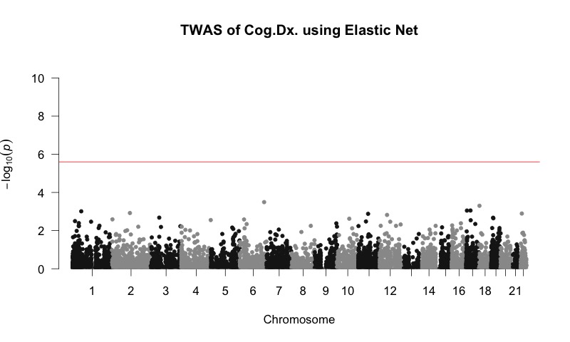

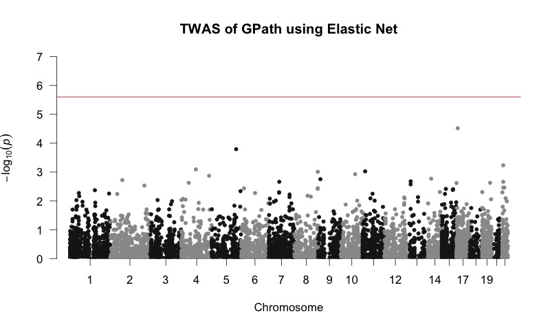

**Supplementary Figure 1.** **Manhattan plots of TWAS of the AD clinical diagnosis (panel A) and quantitative global pathology (gpath) index (panel B) by PrediXcan.** No significant genes were identified.

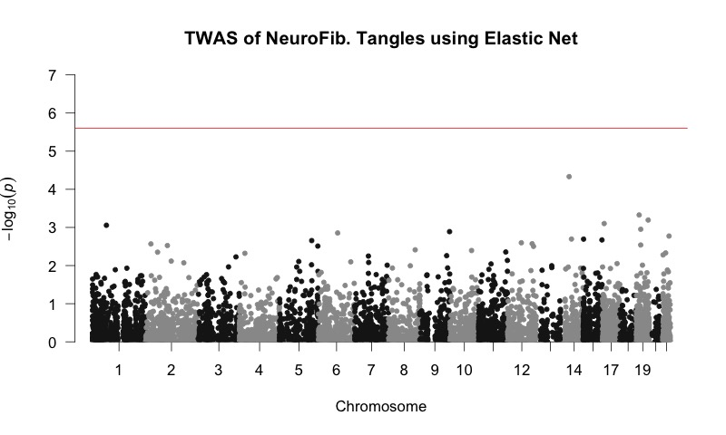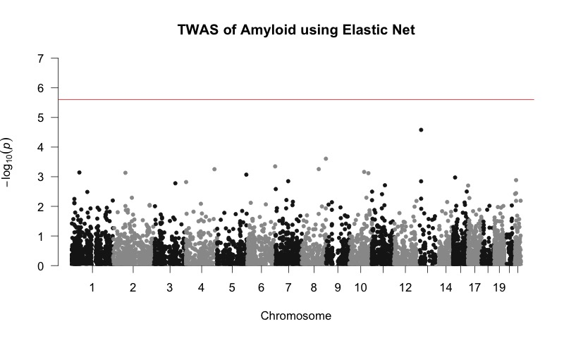

**Supplementary Figure 2. Manhattan plots of TWAS of neurofibrillary tangle density (tangles, A) and β-amyloid load (amyloid, B) by PrediXcan.** No significant genes were identified.

Put all QQ plot here in different panels of one figure

**Supplementary Figure 3. QQ plots of TWAS of AD related phenotypes by both our Bayesian (A, B, C) and PrediXcan (D, E, F) methods.**

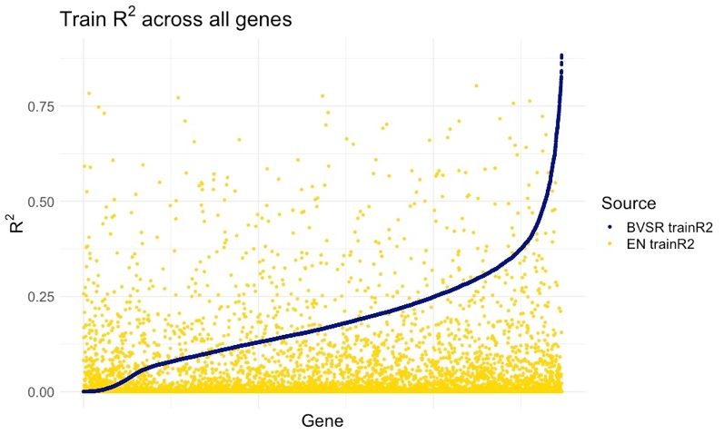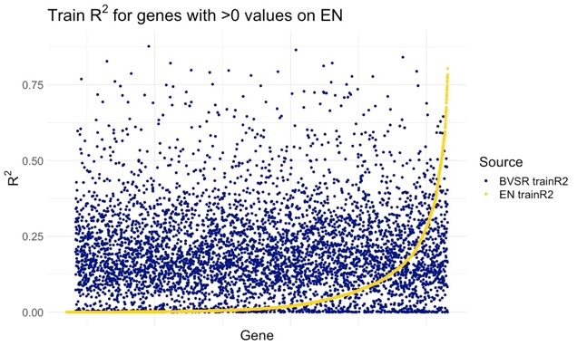

**Supplementary Figure 4. Comparing train R2 obtained by our Bayesian and PrediXcan methods.** Train R2 value per gene by our Bayesian approach (blue) and PrediXcan (yellow) are plotted, ranked in the increase order of R2 by our Bayesian approach for genome-wide genes (panel A) and ranked in the increase order of R2 by PrediXcan (panel B).