**The impact of Artificial Intelligence on brain diseases in the future**

**Jingyuan Chen**

With the development of science and technology, artificial intelligence has become an increasingly popular and important topic. Some theories compare the human brain to a computer, which has led to deeper thinking about the connection between artificial intelligence and the human brain. This paper will focus on the impact of artificial intelligence on human brain diseases in the future and propose three open, unanswered questions for readers to think about.

First, the connection between Artificial intelligence and the human brain is an important question. The A.P. Publications Ltd. gives us the connection between Artificial intelligence and the human brain [1] Artificial intelligence does not just imitate the human brain in structure but allows machines to obtain human-like intelligence. Also, With Brain-Computer Interface (BCI), future machines can better understand human thoughts and emotions. Therefore, artificial intelligence and the human brain have a similar structure, and according to BCI technology, artificial intelligence will simulate human intelligence to understand thoughts and emotions. The following will introduce the impact of artificial intelligence on human brain diseases from two technologies and one negative aspect.

**Computed tomography technology (CT)**

Artificial intelligence can allow us to better understand our brain structure so as to find the abnormal area. So, we see that Michel [2] The use of AI methodologies and techniques is highly valuable for addressing specific problems encountered in brain imaging research. Through the use of AI, we can see very clearly the images of our brain structure. Although we still face a series of difficulties, they will be overcome in the future. The image of the brain structure obtained through AI will play an important role in the study of brain diseases. According to Vasconcelos, et al. [3] Computed tomography (CT) has a low computational cost to get the image of the brain then doctors can make a diagnosis through images. In the future, with the development of computer vision and artificial intelligence, artificial intelligence can be used to help doctors quickly determine the type of stroke so that treatment can be provided faster increasing their chances of recovery. According to Vasconcelos, et al. [3] By using a larger data set, performance will be improved and thus diagnosis will be faster. Intracerebral hemorrhage (ICH) is a kind of stroke that is generally instigated by an artery in the brain such as a stroke burst and bleeding in the nearby tissues. According to Mansour et al. [4], The presented AIBDA-ICH model involves a graph cut-based segmentation model for identifying the affected regions in the CT images. This technology makes it possible to find and treat the area of Intracerebral hemorrhage in a very short time.

In addition, Artificial intelligence may stimulate brain function to achieve simulated therapy in the future. Since Artificial intelligence has a similar structure to the human brain. The idea is through the CT images we get and project them into artificial intelligence, artificial intelligence will simulate abnormal areas of the brain, such as cutting off some neural networks. Then use another machine to simulate the treatment method to repair the severed neural network. But this is just an idea, and the process of implementing the simulation will be very complicated. For example, cutting off that part of the neural network can simulate the appearance in our CT images. In addition, there are differences between the human brain and artificial intelligence. The function of the human brain is essentially a chemical electronic process. How will we transform it? But according to the BCI to stimulate the human brain described below, the idea may be possible in the future.

**Brain-Computer Interface (BCI)**

AI can use Brain-Computer Interface (BCI), future machines can better understand human thoughts and emotions. According to Gao, et al. [5] A brain-computer interface establishes a direct communication channel between a brain and an external device. 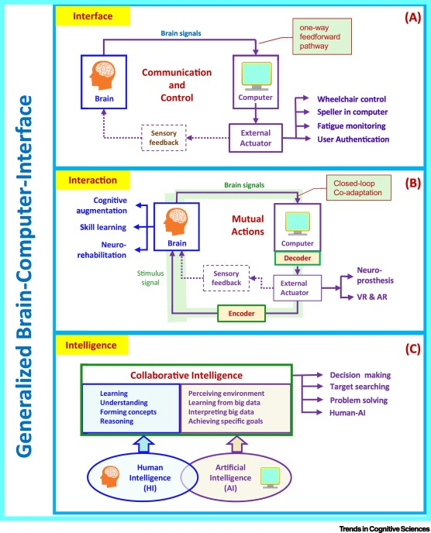

Figure 1[5]

This picture shows the three stages of the development and evolution of BCI technology. In the first stage, it is called interface, which means that the computer only gets brain signals and through an external actuator to give the sensory feedback to people's brain. That is a direct communication channel for people and computers. In the second stage, the computer gets the brain signals and decodes them. Then encoder it to give the stimulus signal which will change the brain function. Then it constructs a closed-loop that Human-computer interaction. In the third stage, the system will combine humans’ intelligence and Artificial intelligence to form an intelligence system. The BCI technology will be applied in Brain therapy in the future. As the second stage, the computer will give people’s brain the stimulus signal which will change the brain function, that will be helpful to medicinal. According to Gao, et al. [5], direct modulations of brain activities have been used to treat neurological diseases or improve the capability of healthy people. According to Nierhaus et al. [6] their results demonstrate for the first time that BCI by means of targeted neurofeedback rapidly impacts on MRI measures of brain structure and function. The spatial specificity of BCI-induced brain plasticity promises therapeutic interventions tailored to individual functional deficits, for example in patients after stroke. Furthermore, in the future, since future machines can better understand human thoughts and emotions by BCI, it may become a way to treat depression. The machine helps doctors enlighten the patient's emotions by understanding the patient's emotions and finding effective methods through the database. Many brain diseases nowadays are caused by loneliness and incomprehensibility. In the future, machines may be able to overcome this difficulty, understand human emotions and thoughts through BCI, and communicate with humans to eliminate this loneliness, thereby reducing people’s brain diseases.

**Negative aspect**

The impact of artificial intelligence on human brain thinking. Artificial intelligence may adversely affect the development of the human brain in the future. Nowadays, many of our problems are solved by computers. In the future, with the development of artificial intelligence, almost all mathematical/computational problems can be solved by artificial intelligence. In this environment, humans will inevitably lack training in mathematics/computational thinking. Lack of mathematics and computational thinking will adversely affect adolescent brain development, which may lead to brain diseases. In other words, in the future, most of the daily logic problems may be solved by artificial intelligence. As a result, the training of logical thinking will be missing, which will lead to a decline in human logical thinking ability. Even most people will be used to using artificial intelligence to solve problems instead do it by their own.

**Three open, unanswered questions.**

**What diseases will cause our brain by lacking mathematics/computational thinking?**

In the future, since future machines can understand human thoughts and emotions, with the development the intelligence robotic will be created. Many of our problems are now solved by computers. In the future, with the development of artificial intelligence, almost all mathematical problems can be solved by artificial intelligence. In this environment, humans will inevitably lack training in mathematics/computational thinking. That will create a question that what changes will they bring to our brain with lacking mathematics/computational thinking? In other word, what diseases will cause our brain by lacking mathematics/computational thinking? This question will be open because it cannot be answer by yes or no. Also, since it discusses the changes for our brain in the future, no one knows what will be happened in the future. We can consider that lack of mathematics and computational thinking makes people more prone to dementia and so on. Both mathematics and computational thinking are opened by logic, so we can say that mathematics and computational thinking are exercises for our brain’s logical thinking, and when we lack this exercise for a long time, it is difficult to have an exact answer to this question, because in today society, it is difficult for us to completely abandon mathematics and computational thinking. Therefore, it is an open, unanswered question.

**What are the potential risks of using BCI to stimulate the brain?**

This question will be open because it cannot be answer by yes or no. Also, since the BCI is in infancy, the risks are not be pointed out so that this question is unanswered. People can discuss the safety of receiving stimulation from the brain, the safety of BCI, the accuracy of BCI, etc. For example, stimulating the brain may cause damage to the brain and loss of some brain functions. The security of BCI still needs to be strengthened to avoid serious consequences. BCI needs to accurately find the location that needs stimulation. Since BCI is still an immature technology, and this technology is powerful, we have to worry about the dangers contained in this technology. The Question can enable people to explore the risks or difficulties that BCI needs to overcome in the future from a deeper level. Therefore, it is an open, unanswered question.

**What are pros and cons of artificial intelligence in the treatment of brain diseases in the future?**

The question is focus on the future so that is unanswered. Also, people can consider it by Artificial intelligence will bring many benefits to the treatment of brain diseases in the future. For example, artificial intelligence can help doctors diagnose the condition in a very short time, but in any case, the accuracy of artificial intelligence is difficult to reach 100%, which may mislead doctors to misdiagnose the condition. In addition, when the doctor’s diagnosis and the artificial intelligence judgment diverge, it will be a big trouble. People can also consider this problem through BCI. BCI can stimulate the human brain to treat some intractable diseases, but at the same time, as the previous question tells, BCI must have certain risks. The above are only two possible answers. People who think about this question from different angles will get a variety of different answers, so the question is open, unanswered.

**Conclusion**

This paper discusses the intersection between Artificial Intelligence and the brain, it introduces the Computed tomography (CT) technology, Brain-Computer Interface (BCI) technology and explains the current and future impact of these two technologies on brain diseases. Also, from a negative point of view, it points out the harm that artificial intelligence may bring to human brain thinking in the future, which will cause a series of brain diseases. In addition, the authors identify three open, unanswered questions which are:

1. **What diseases will cause our brain by lacking mathematics/computational thinking?**
2. **What are the potential risks of using BCI to stimulate the brain?**
3. **What are pros and cons of artificial intelligence in the treatment of brain diseases in the future?**

for the reader to think more deeply about the connection between artificial intelligence and brain diseases. In the future research, we will discuss the third stage of BCI technology, which is the intelligence system combined with human intelligence and artificial intelligence, and see how it helps the brain disease in the future. Also, the how Artificial intelligence simulates brain function to achieve the effect of simulated therapy in the future.

References

[1] A.P. Publications Ltd. Feb 1st, 2017. Advances in Artificial Intelligence Will Help Machines Understand Human Thoughts Using Brain Computer Interface Retrieved from <https://go.gale.com/ps/i.do?p=ITOF&u=gainstoftech&id=GALE|A488192040&v=2.1&it=r>

[2] Dojat, Michel Feb, 2004 Artificial intelligence in neuroimaging: four challenges to improve interpretation of brain images Retrieved from <https://www.sciencedirect.com/science/article/pii/S0933365703001374>

[3] Vasconcelos, Francisco F.X, et al. May 2020. Artificial Intelligence Techniques Empowered Edge-Cloud Architecture for Brain CT Image Analysis. Retrieved from <https://www.sciencedirect.com/science/article/pii/S0952197620300610>

[4] Mansour, Romany F, et al. June 21st, 2021 Artificial Intelligence with Big Data Analytics-Based Brain Intracranial Hemorrhage e-Diagnosis Using CT Images. Retrieved from <https://link.springer.com/article/10.1007/s00521-021-06240-y>

[5] Gao, Xiaorong, et al. Aug 2021 Interface, Interaction, and Intelligence in Generalized Brain–computer Interfaces. Retrieved from <https://www.sciencedirect.com/science/article/pii/S1364661321000966>

[6] Nierhaus, Till, et al. May 1st, 2021 Immediate Brain Plasticity after One Hour of Brain–computer Interface (BCI). Retrieved from <https://physoc.onlinelibrary.wiley.com/doi/full/10.1113/JP278118>