線性代數作業5 report

Q2作圖：

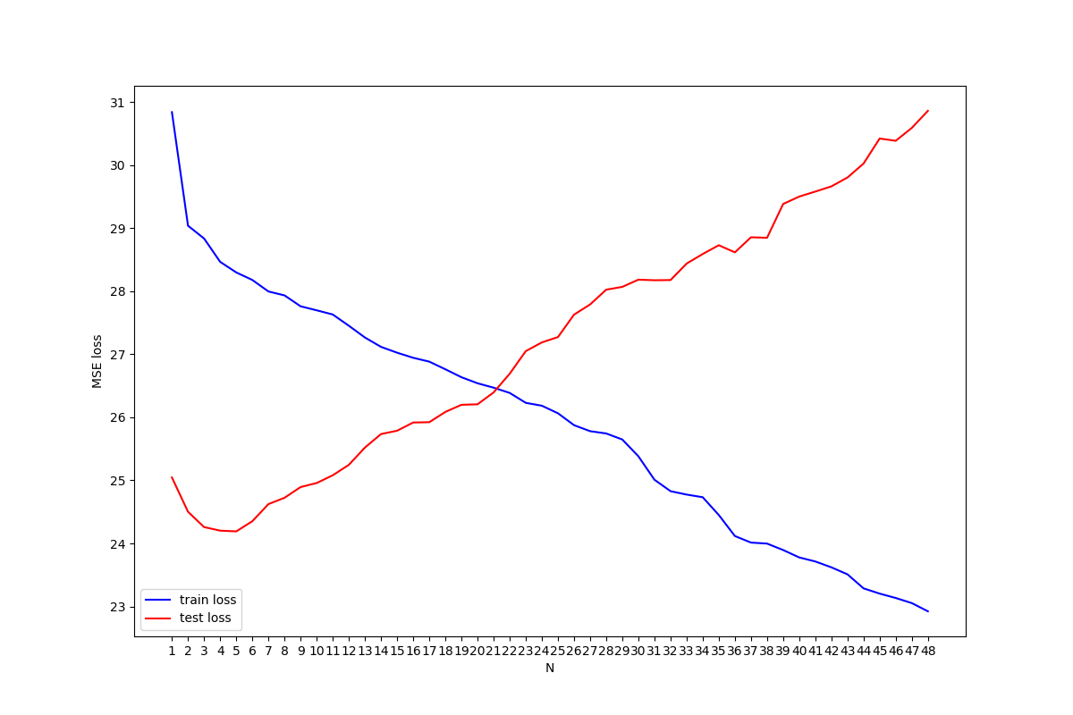

From the figure above, we can notice that less error in training set doesn’t also mean less error in testing set. As N increases, more parameters are considered in the regression. More parameters could cause overfitting in testing set since the variance is larger, which causes more loss.

Q3.

For better performance, I chose to use RNN for training(GRU cell). By considering the data of previous hours first other than processing them at the same time. Though, I started my homework to late, there is not enough time to train my model. I believe there are still many improvements that can be done in my code.

With 100 epochs:

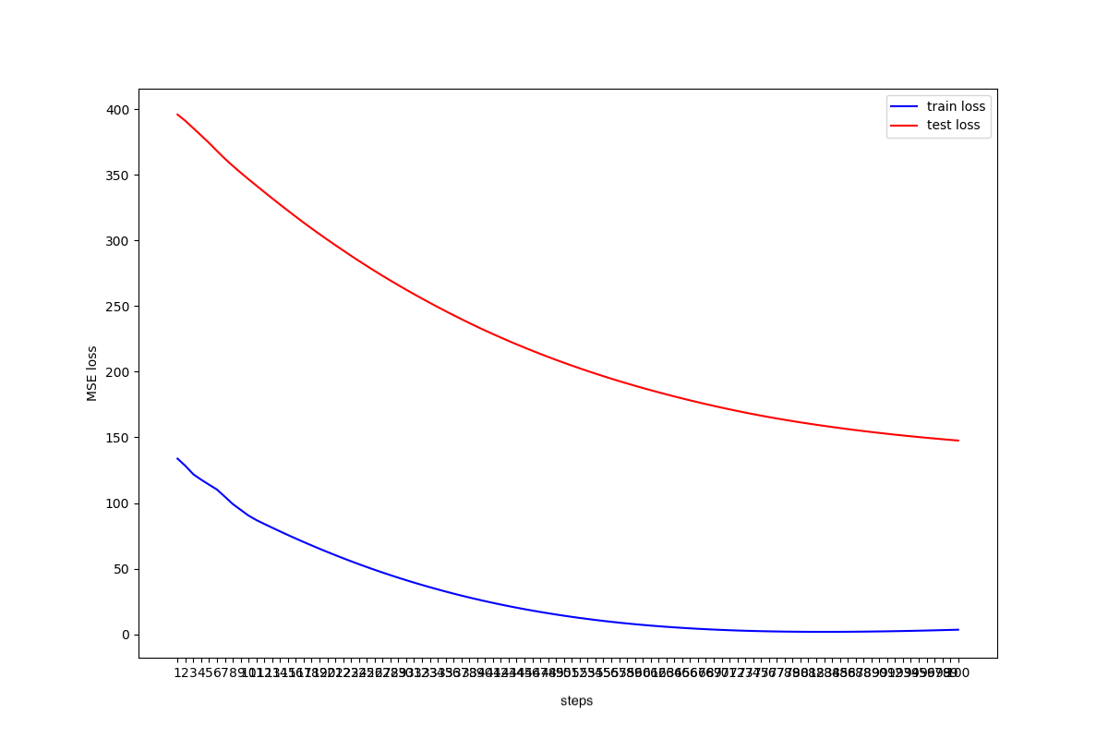

The hyperparameters are:

learnrate = 1e-5,

optimizer = Adam(betas=(0.9, 0.999), eps=1e-08)

batch_size in dataloader is actually N(N = 5 in this code),for my convenience to modify the input length, since batch_size_first of RNN is set to false.