Tutorial 2
BCIS 443/543 Database Design and Implementation
ORACLE Form Builder, Report Builder, and Triggers

Form Builder is a development tool for building applications that provide users access to information stored in a database. Form modules can run standalone, and they can also have reports or graphics embedded in them.

When you create a Form Builder application, you work with three types of modules: forms, menus, and libraries. A form module is a collection of objects and data that users interact with in order to modify database tables. They make up the main body of a Form Builder application, and they contain any of the user interface items as well as the data source definitions and behavior. A menu module is comprised of menus and menu code. Users choose menu items to execute application functions. A library module is a collection of client-side code that can be shared across modules and applications.

Objects in Form Builder Oracle supports object-oriented system design and programming. One of the important benefits of object-oriented approach is the code reusability/object reusability. In Form Builder, reusable object include forms, windows, canvas, data blocks, etc.

A form module is a container within which you can have several windows running. A window can contain canvases on which you place data blocks and other items such as buttons. A data block is a group of related form items that are associated with a single database table. In the Figure 1 below, the outer window is the form module. There are two windows running inside the form. On the Order Entry Window there are two data blocks. Each of the two windows has a canvas (invisible) on which data blocks are placed.

Objects in Form Builder are organized by Object Navigator. The Object Navigator provides a hierarchical display of all the objects in the application.

The Data Block Wizard enables you to easily create or modify data blocks for use in your application. The Data Block Wizard can be reentered after initial creation of the data block, enabling you to modify an existing data block, even if it was not originally created with the wizard. The Object Libraries provide an easy method of reusing objects and enforcing standards across the entire development organization.

The Layout Wizard enables you to quickly layout the items of a data block. The wizard displays the items in a frame on a canvas and lays them out in one of several layout styles, after which you can manually alter the layout to your own specifications. You can reenter the Layout Wizard after the initial creation of a frame, enabling you to modify an existing frame, even if it was not created with the Layout Wizard.
The Property Palette enables you to set the properties of objects you create in form and menu modules. When you select an object in an editor or in the Object Navigator, the Property Palette updates to show the properties of that object. When you need to compare the properties of two different objects, you can invoke additional Property Palettes as needed. The integrated PL/SQL Editor enables you to write PL/SQL code from within Form Builder. It provides a graphical interface for editing and debugging both client- and server-side functions and procedures.

To build a Form Builder application, you perform the following steps:
- Create modules using the Object Navigator.
- Create blocks and items manually or by using the Data Block Wizard.
- Fine-tune the layout using the Layout Wizard or the Layout Editor.
- Set properties using the Property Palette.
- Add code using the PL/SQL Editor.
- Test your application using the Forms Runtime component and the integrated source-level debugger.

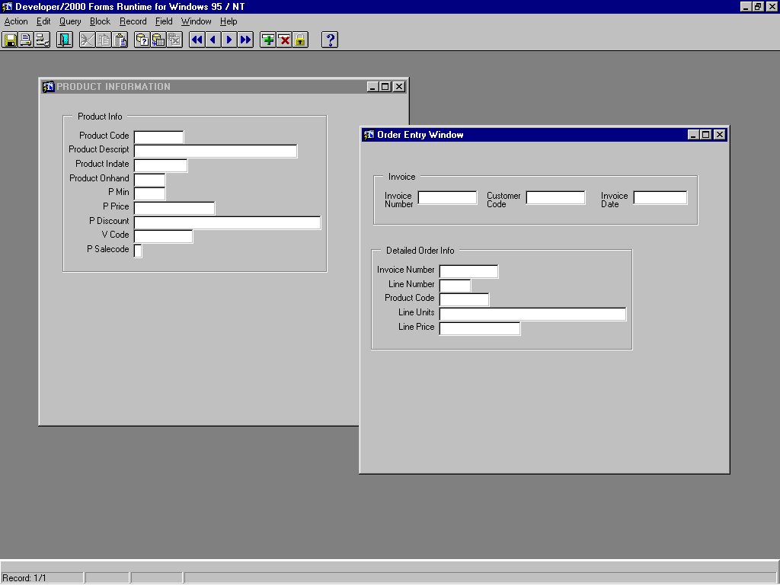
Figure 1. A Form Module Example

Report Builder enables you to develop production-quality reports in a client/server or Web environment. You can deploy reports on the Web using the Reports Server and Reports Web CGI. Reports can be run standalone, or they can be embedded in forms or Graphics Builder displays.

To quickly create new reports, you use the Report Wizard. The wizard guides you through the process of choosing a report type, defining a data model, and laying out the data. You can reenter the Report Wizard after the initial creation of a report, so you may re-invoke it on an existing report, make changes, and re-default the report, even if the report was not originally created with the Report Wizard.
When you complete the Report Wizard, your report is displayed in the Report Editor's Live Previewer. The Live Previewer is a WYSIWYG editing environment for making basic changes to your report layout. For more complex report editing, you can use the Report Editor's Data Model, Layout Model, and Parameter Form views. (All of the Report Editor's views are accessible from the View menu.)

Steps involved in creating a form and report will be demonstrated in class.

Example: Page 306-308 (Project #2 you did)

Given the five tables (Customer, Product, Vendor, Invoice, Line), develop a database system that performs the following tasks:
- Generate a report that shows a list of customer purchases, including the subtotals for each invoice line number (use the query for Prob. #19).
- View and add new vendor & product to the database.
- Allow the salesperson to record a sale transaction. If the customer is not in the database, add the customer.

- Create the report
Steps:
a. Start Report Builder
b. Use report Wizard
c. Type <A Summary of Customer Purchases> as report title; Select Tabular as the report style.
d. Click Import SQL Query (select Q19.sql if that is the file name you gave to the query)
e. Click Connect (supply requested information); Click on Next.
d. Select all fields to display in the report.
e. Select subtotal data field to compute grand total; Click on SUM / Next.
f. Modify the labels as you wish.
g. Select a predefined template. Click on Finish.
h. Click on floppy disk icon on menu bar to save the report definition file as PurchaseSummary.rdf

Note: column width in report can be easily adjusted in Live PreViewer window.

- Create a form to view and add new vendors and products to the database.
Steps:
- Start Form Builder.
- Select Use the Data Block Wizard. OK/NEXT
- Select Table or View; NEXT.
- Click on Browse; provide connection information. OK. Select Vendor table. Click Enforce data integrity; Select all data fields; Next; Finish; NEXT;
- Select canvas (new); canvas type: content (default); NEXT
- Select all items. NEXT
- Modify the labels. NEXT. Layout style: form. NEXT.
- Type Vendor Information as the frame title. NEXT. FINISH.
- Run the form module; Click on the traffic icon. Press F8 key to retrieve records. Press Pgup or PgDn key to go through the records. Exit or close the running window.
- Bring up Object Navigator window. Rename the frame as FRAME_Vendor. Rename current canvas as CANVAS_VENDOR_PRODUCT.
- Click on + next to window object in the object navigator. Rename window1 as WINDOW_VENDOR_PRODUCT.
- Rename the form module1 as VENDOR_PRODUCT
- Save the form module as VENDOR_PRODUCT.fmb
- Run the form module. As a result a compiled file will be created and named as VENDOR_PRODUCT.fmx.
- Exit the form builder and get some rest!

- Welcome back from your break. Purpose: Add another Data Block -- Product
- Start Form Builder.
- Open existing form: VENDOR_PRODUCT.fmb
- Select Data Block in the Object Navigator. Click on + button near the left edge of the screen to create a new Data Block using the Data Block Wizard. Follow the instructions.
- Use Browse to select PRODUCT table. Enforce data integrity. Select all columns to be used as database items.
- Create a master-detail relationship: Select Auto-join data blocks. Click on Create Relationship. Feel free to delete the relationship and recreate it. Make sure the join condition is PRODUCT.V_Code=VENDOR.V_Code. NEXT. FINISH. NEXT to Layout Wizard.
- Select CANVAS_VENDOR_PRODUCT as the canvas to layout the data block. Select Product (default) as the data block, all items to display. Edit Prompt. Style: form. Frame title: Product Information. FINISH.
- Run the form module: click on the traffic light icon. Press F8 to retrieve records.

Exercise: Suppose the company just received 1000 units of product xxyy88 from vendor St. Cloud Best Inc. You need to record the transaction. First, search vendor 26666 in the vendor table by conducting a query(see class demonstration). If the vendor information is not in the database, enter the vendor info in vendor table. Then enter the product information in Product table. Otherwise, update the product quantity on hand.

- Create a user interface to record sales transactions.

Steps are similar to II & III
- Create a data block, CUSTOMER. Layout style: form.
- Create a data block, INVOICE. Layout style: form.
- Create a data block, LINE. Layout style: table.
Note: make sure the join conditions are correct.

- Create an Integrated Oracle Application.

We have created a report, a form for updating vendor/product information, and a form for recording sales transactions (new order entry). Now we will integrate them into one application.

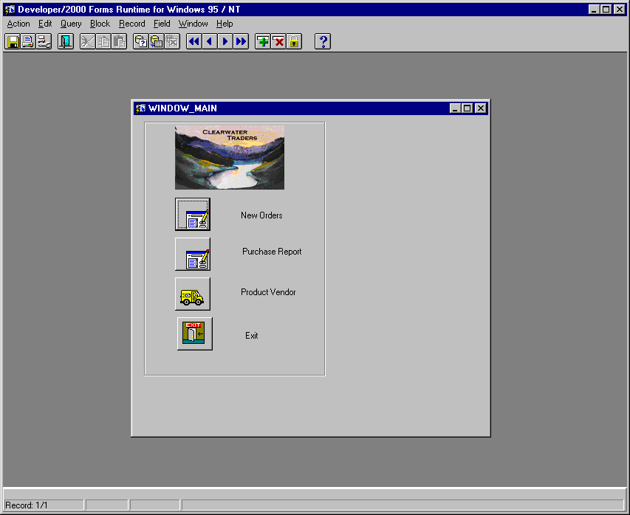
- Start Form Builder.
- Select Build a New Form Manually.
- Change the default form module name from Module1 to MAIN
- Click once on Canvas. Click on + button (near the left edge of the screen) to create a new canvas. Rename it as CANVAS_MAIN
- Click on + next to WINDOWS Object in Object Navigator. Rename Window1 to WINDOW_MAIN.
- Right Click on the WINDOW_MAIN object. Select Layout Editor.
- Create four buttons.
- Make the first button New Orders: Bring up the property window for the first button: right click on the button. Select Property Palette. Find label property, delete its default value. Set ICONIC property to Yes. Set ICON FILENAME to a:\Filename (e.g. a:\sales, although the file name is sales.ico).
- Repeat h step to set the proper properties for the other three buttons.
- Go back to the user interface form. Select the New Orders button. Right click it. Select PL/SQL Editor. Find event: WHEN BUTTON PRESSED. Double click it to open code window for the event (trigger). Type the following statement:

CALL_FORM('a:\ORDER_ENTRY.fmx', HIDE, NO_REPLACE);

Note: to call one form from another, you use the CALL_FORM procedure, which has the following general format: CALL_FORM(Form module name , Display, Switch_Menu)
Display specifies whether the calling form is hidden or not by the called form. Switch_Menu is NO_REPLACE if pull-down menus are inherited from the calling form) otherwise use Do_REPLACE (pull-down menus are specified by the programmer).

- Refer to step j to create Purchase Report button. The following Statement should be used in WHEN BUTTON PRESSED trigger:

RUN_PRODUCT(REPORTS, 'a:\PurchaseSummary.rdf',SYNCHRONOUS, RUNTIME, FILESYSTEM, '');

Note: The first parameter is the type of Developer applications: REPORTS or GRAPHICS. The second parameter is the path and name of the report file you defined earlier. The third parameter is COMMUNICATION MODE. SYNCHRONOUS means that controls returns to the form only after the report application is closed. ASYCHRONOUS means that control returns to the form while the report is still running. The 4th parameter specifies EXECUTION MODE: use RUNTIME when running Report Builder application so that control is transferred to the Reports Runtime environment. Use BATCH when running a Graphics application when a graphic is displayed directly in a form.
The fifth parameter specifies where the program is stored.
The last parameter specifies where to display a graphics. Use '' when running a report application.

- Refer to j to create Product/Vendor button.
Insert the following statement in the WHEN BUTTON PRESSED trigger:

CALL_FORM('a:\VENDOR_PRODUCT.fmx',HIDE,NO_REPLACE);

- Refer to step j to create Exit button. Use the following command:

EXIT_FORM;

Triggers: database triggers are event-driven procedures. A trigger is fired (or executed) when the triggering event occurs.
The triggering events include INSERT, DELETE, UPDATE. A trigger may be fired before or after a triggering event occurs. There are two types of triggers: Statement-level and row-level. Statement-level triggers fire once for each triggering statement. Row-level triggers fire once for each row affected by the triggering statement. A table can have many triggers attached to it.

For example: create a trigger to update quantity on hand for a product when a new order is created for the product, or a customer changes the order's quantity or cancels the order. The trigger should be attached to the LINE table.

Steps:
1. Click the following objects in Object navigator: Database Objects, <your account>, Tables, Line table, and Trigger.
2. Click on + button. Select After; Check all three statements (INSERT, UPDATE, DELETE); Select LINE_UNITS column to update.
3. Check Row-level trigger
4. Type the following code in Trigger Body:

BEGIN
IF INSERTING then
Update Product SET P_ONHAND=P_ONHAND - :NEW.LINE_UNITS
WHERE P_CODE = :NEW.P_CODE;
ELSIF UPDATING THEN
UPDATE PRODUCT SET P_ONHand=P_OnHand + :OLD.LINE_UNITS - :NEW.LINE_UNITS
WHERE P_CODE = :NEW.P_CODE;
ElsIF DELETING THEN
UPDATE PRODUCT SET P_ONHAND = P_ONHAND + :OLD.LINE_UNITS
WHERE P_CODE = :OLD.P_CODE;
END IF;
END;

5. Save and close.

Sequences

Oracle sequences are sequential lists of numbers that are generated automatically by the database. Sequences are often used as unique surrogate key values for primary key field.

For example, create a sequence for Customer ID.
Step 1: Create a sequence on the server
At SQL> prompt type the following statements:

Create sequence Cust_ID_Seq
Start with 40000
NoMaxValue
Nocache;

Step 2: Create a Form trigger for datablock Customer
Click on + box next to datablocks, click + box beside CUSTOMER, and then select Tiggers under the CUSTOMER data block. Click the Create button + to create a new trigger.

Select event WHEN-CREATE-RECORD.

Type:

SELECT CUST_ID_SEQ.nextVal
INTO :CUSTOMER.CUS_CODE
FROM DUAL;

Compile the trigger and Close.

To compile a form file, click the FILE-->Administration --> Compile.

Message Box (or Alert Message) in Oracle

You may use statement: message(‘Hi World!’); in form triggers to display a quick message on the bottom of a screen. You can also create a pop up message box 9called Alert in Oracle). Here are the steps:
(1). Bring up Object Navigator
(2). Look for Alert in the list. Click on it. Click on + create button on the left toolbar . Bring up the property palette to edit the following properties: name, title, message, Alert style, button 1 label, button 2 label, button 3 label. For this example, set name to UPDATE_ALERT. Set the other properties to anything you like.
(3). Create a command button on the form. Edit its relevant properties. Bring up quick menu , then select PL/SQL Editor. Create a new trigger called WHEN MOUSE CLICK. Type the following code:

DECLARE
Ret Number;
BEGIN
Ret := Show_ALERT('UPDATE_ALERT');
IF ret = Alert_Button1 then
commit;
message ('Database successfully updated');
Else
-- Rollback;
message('Change rolled back');
End If;
END;

(4). Click on Compile. If no error, click on Close button.

To test the Alert message code, run the form and click on the button you just programmed.

How to Run Two or More Windows with One Form

Just create two windows in one form.
Run the form.
Click on >> next block button to show both windows.

