IS 340 Management Information Systems
Project#4 SAP Global Bike Inc. Exercises
Global Bike Inc. is a world class bicycle company serving the professional and “prosumer” cyclists for touring and off-road racing. GBI’s riders demand the highest level of quality, toughness and performance from their bikes and accessories. GBI ’s headquarters is located in Dallas and GBI is registered as a US company, following US GAAP accounting standards. GBI operates a subsidiary company, GBI Europe, which is based in Heidelberg and is subject to IFRS accounting standards and German tax regulations. Material planning, finance, administration, HR and IT functions are consolidated at the Dallas headquarters. The Dallas facility manufactures products for the US and export markets and its warehouse manages product distribution for the central US and internet retailers. GBI also has warehouses for shipping and export in both San Diego and Miami. San Diego handles West Coast distribution and exports for Asia, while Miami handles East Coast distribution and Latin America exports. GBI Europe has its headquarters in Heidelberg Germany. The majority of research and development is housed in the Heidelberg offices. Heidelberg is also the main manufacturing facility for GBI in Europe. The Heidelberg warehouse handles all shipping for southern Europe. The Hamburg warehouse handles all shipping for the UK, Ireland, Middle East and Africa. GBI sells its bikes throughout the world and employs approximately 100 people, 2/3rds of the employees are in the US and the remaining 1/3 in Europe.

GBI primarily assembles semi-finished goods into finished goods at its production facilities. Finished goods are either stored in the local warehouse or shipped to other regional distribution centers to fulfill customer orders. GBI operates two production facilities, Dallas and Heidelberg. Each facility has three assembly lines and can produce around 1000 bikes per year. Total production capacity is roughly 6000 bikes per year, but can be increased by 15%-20% by using overtime hours and part-time workers.

GBI also sells accessories product line comprised of helmets, knee pads, air pump, t-shirts and other riding accessories. GBI partners with only the highest quality suppliers of accessories which will help enhance riders’ performance and comfort while riding GBI bikes.

GBI sells its bikes exclusively through well-known and respected Independent Bicycle Dealers (IBDs). These dealers employ staff members who are experts in off-road and tour racing to help consumers choose the right GBI bike and accessories for their individual needs.

During 2009, GBI integrated a shared services model for all IT functions, located in the Dallas office. Along with this move to centralize IT, GBI also implemented SAP ERP (version 6.0). Prior to this, divisions were running multiple, independent application environments. All ERP functions are centralized with the primary objectives to reduce costs and deliver best-in-class technology to all divisions globally. This centralized approach offers GBI an advanced business platform under a highly controlled environment, which enables consistency of operations and process integrity across the globe.
The following five exercises should give you some hands-on experience with SAP’s material management module.
 | Exercise 1: Display Purchase Order
Exercise Use the SAP Easy Access Menu in order to display a purchase order. Time 10 Min.
Task Display a purchase order for 60 offroad helmets and 150 road helmets from vendor Olympic Protective Gear. This purchase order was created by the purchasing group “North America“ (N00) for the purchasing organization “GBI US“ (US00).
Name (Position) Tirrell Winsten (Buyer)
To display a purchase order, follow the SAP Easy Access Menu path:  Logistics ► Materials Management ► Purchasing ► Purchase Order ► Display |  | Menu path
Following the menu path, you are taken to the transaction for displaying purchase orders. The system automatically displays the most recently processed purchase order. To find the requested purchase order, click “Other Purchase Order“ (Shift+F5) in the application toolbar.
In the popup-screen that now opens, select the radio button “Pur. Order” and use the F4 help for searching the purchase order mentioned above by clicking on the small button to the right of the text box “Pur. Order”.
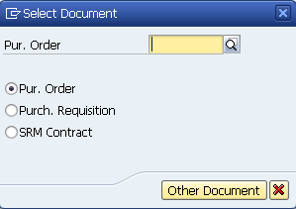
In the opening screen, choose the “Purchasing Documents per Vendor“ tab.
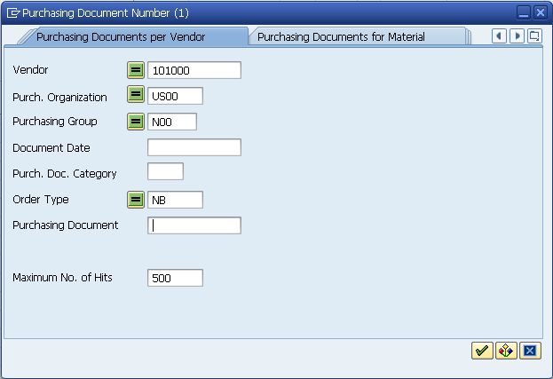
For Vendor enter 101000 (Olympic Protective Gear), for Purchase Organization enter US00, for Purchasing Group enter N00 and for Order Type enter NB (Standard Purchase Order). Click “Start search”. |  | 101000  US00  N00  NB
The system now displays the purchase order(s) that were found based on the search criteria.
Select one purchase order with a double-click. The order number will be transferred to the screen “Select Document“. Click “Other Document” to display the selected purchase order.
You will notice that 60 offroad helmets and 150 road helmets were ordered from vendor “Olympic Protective Gear“ for 25.00 USD each to be delivered to the Miami factory (MI00).
Click on the exit icon to return to the SAP Easy Access screen.

 | Exercise 2: Display Goods Receipt for Purchase Order
Exercise Display the goods receipt for the purchase order. Time 10 Min.
Task After the goods have arrived in Miami, the goods receipt at the warehouse is manually posted in the system by the receiving clerk. This process ensures that the good have arrived within the required time frame and in accordance with the necessary quality. Display the goods receipt for the purchase order displayed in the previous task (Ex 1).
Name (Position) Tatiana Karsova (Receiving Clerk)
Follow the menu path to display the goods receipt for purchase order:  Logistics ► Materials Management ► Inventory Management ► Goods Movement ► Goods Receipt ► For Purchase Order ► GR for Purchase Order (MIGO) |  | Menu path
Change the operation to “Display“ and the reference document to “Material Document“. In the field “Material Document“, enter the receipt number 5000000000 for the goods receipt. Press enter. |  | 5000000000
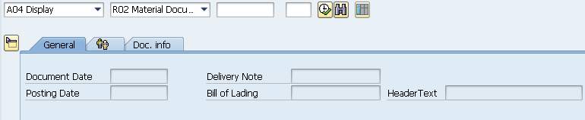
The system now displays the goods receipt document. The line items are each assigned to the movement type 101 (goods receipt for purchase order in the warehouse). Both positions have the stock type “Usable without restriction“.
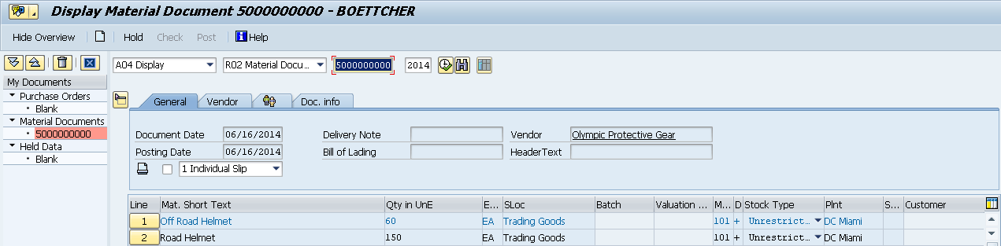
Click on the exit icon to return to the SAP Easy Access screen.

 | Exercise 3: Display Invoice Overview from the Vendor
Exercise Use the SAP Easy Access Menu in order to display an invoice. Time 10 Min.
Task The vendor “Olympic Protective Gear“ has sent an invoice with 5,250.00 USD for the goods delivered. This invoice was entered into the system manually. The posting of the invoice occurs within an existing expense account in the general ledger and generates an open item in Accounts Payable. The invoice is cleared at a later point by issuing a cheque for “Olympic Protective Gear“. Display the invoice entered in the system.
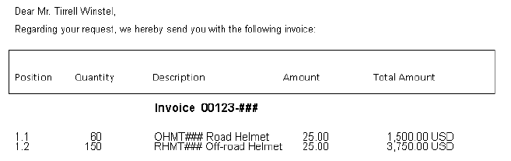
Name (Position) Silvia Cassano (Accounts Payable Specialist)
Follow the menu path to display the invoice:  Logistics ► Materials Management ► Logistics Invoice Verification ► Further Processing ►Invoice Overview  Following the menu path leads you to the search mask for invoices. Enter 2014 for Fiscal Year, 101000 for Invoicing Party (vendor), and US00 as Company Code. Furthermore, select Invoices Verified Online for “Entry Type“ in order to further limit the search and make sure that the Processor field is left blank. |  | Menu path  2014  101000  US00  Invoices Verified Online
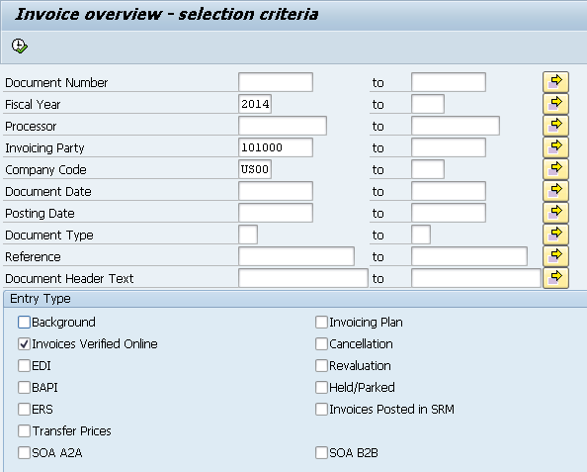
Start your search by clicking “Execute“(F8) in the application toolbar.
As a next step, select the first invoice document from the list of results through a double-click.
You now see the selected invoice document. It was previously recorded in the system by the accounts payable specialist, Silvia Cassano, after the invoice arrived by mail.
Note By relating the invoice to a predecessing document (purchase order), necessary data such as material, amounts, and prices were pre-filled by the system when the subsequent invoice was created.
As you can see, the invoice document contains the overall amount as well as the single amounts for both individual items of the invoice in USD. Take a closer look at the document.
In the “Details“ tab, you see among other things the bank G/L account number which the transaction was posted to.
Please note the invoice document number and click on the exit icon to return to the SAP Easy Access screen. |  | Invoice document number  ________________

 | Exercise 4: Post Payment to Vendor
Exercise Use the SAP Easy Access Menu to get information about the payment Time 10 Min
to the vendor. .
Task After the invoice document was recorded in the system, it can be paid by the accounts payable specialist. Through this process, the vendor account debited by the invoice receipt is cleared. Since the invoice is paid with a bank cheque in this example, the bank cheque G/L account is debited (to the same amount).
Through the payment transaction, a posting to the vendor account of Olympic Protective Gear (101000) and a posting to the bank cheque account (300000) were set up in the general ledger. This is done automatically as a one-step process when executing the payment.
Name (Position) Silvia Cassano (Accounts Payable Specialist)
Through the vendor payment process, the vendor account (which was debited with 5,250.00 USD) was credited. Please take a look at the corresponding document (as a follow-up document of the invoice). Therefore, please display the invoice document using the menu path below:  Logistics ► Materials Management ► Logistics Invoice Verification ► Further Processing ► Display Invoice Document |  | Menu path
Enter the invoice document number noted down in task Ex. 3 and enter 2014 for Fiscal Year. Click “Display Document“ (F2). |  | Invoice document number  2014
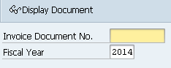
You are directed to the invoice document:
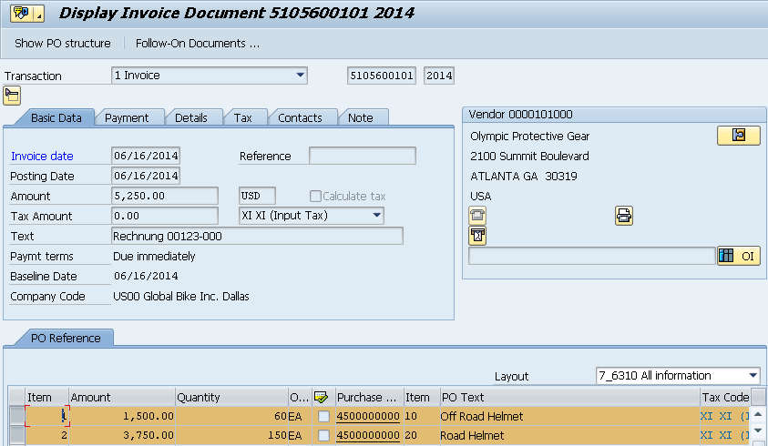
Display the posting that originated from the clearing of the vendor account through the payment to the vendor by clicking the “Follow-On Documents“ button (on the top of the screen).
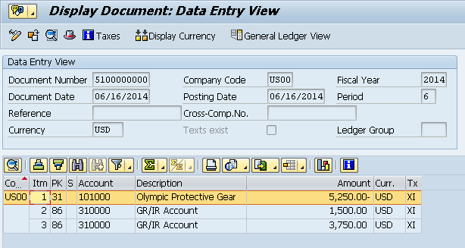
Now you can see values posted to the respective G/L accounts (on the goods receipt/invoice receipt account for the particular purchase order item/delivery item (310000) and the credit of 5,250.00 USD on the vendor account (101000).
Since the payment was made by a bank cheque, the credit of the vendor account led to a bank cheque G/L account debit (300000) of the same amount. You can display the corresponding document by double-clicking on the first row.
Click on the exit icon several times to return to the SAP Easy Access screen.

 | Exercise 5: Display Vendor Line Items
Exercise Display the line items of a vendor. Time 5 Min.
Task Display all activities and the corresponding balance of the vendor Olympic Protective Gear. You should see one debit posting and one credit posting representing the invoice receipt and the payment posting to Olympic Protective Gear for balance clearing.
Name (Position) Shuyuan Chen (Chief Accountant)
In order to display the line items of a vendor, follow the menu path:  Accounting ► Financial Accounting ► Accounts Payable ► Account ► Display/Change Line Items |  | Menu path
Use the search function (search term 000) in order to enter the vendor Olympic Protective Gear into the field Customer Account. Enter US00 as Company Code and select All Items. Click . A screen similar to the one shown below should appear: |  | 000  US00  All Items
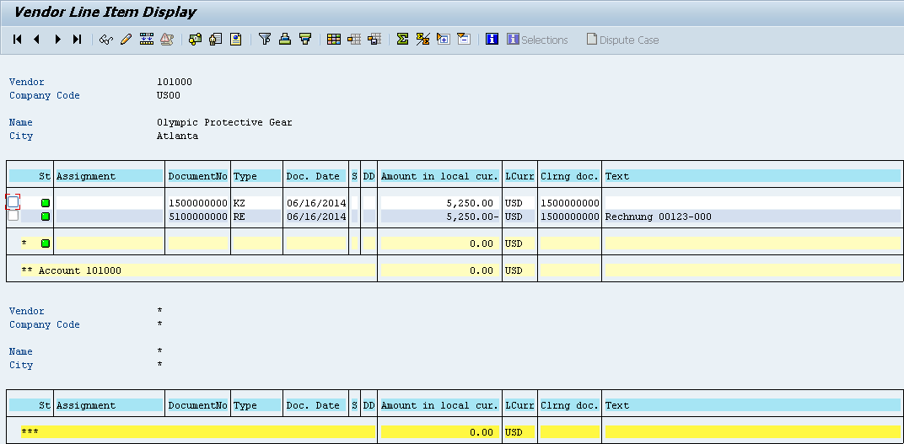
You can see that all postings for the vendor are balanced. Double-click the invoice line (RE). Select in order to display line items. |  | RE
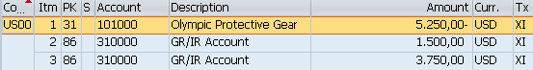
Click in order to get back to the line items. Afterwards, double-click the vendor payment line (KZ). Select in order to display the general ledger items. |  | KZ
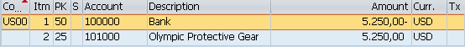
Click on the exit icon three times to return to the SAP Easy Access screen.

