User Instructions

**CorelDraw 2020 – Kerr Automation Label Tool**

Date: 2020-11-03

Version: V1

Edited By: Jameson Cheong

Contents

Introduction 3

Requirements 3

Installation 3

Guide 6

MachPro Sys Labels 6

MachPro Zone Labels 9

Input Output Point Labels 11

Export All Page PNG 13

Export All Page PNG for Proview 14

Inputs and Outputs tags 14

Setting up Development 16

# Introduction

The purpose of this document is to demo on CorelDraw 2020 Kerr Automation Label Tool. This Tool improves the workflow and reduces labour time on making labels. The exported all page to PNG tool reduced repetitive export one-by-one page.

Kerr Automation Label Tool has the following selections:

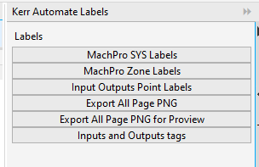

# Requirements

Must have the following installed:

* CorelDraw 2020

# Installation

1. Open the following folder:

**<install location>**\Corel\CorelDRAW Graphics Suite 2020\Programs64\Addons

1. Drag the **DockerTemplateCS1test** folder (inside **Tutorial- Kerr Auomation Labels**) in to the Addons folder

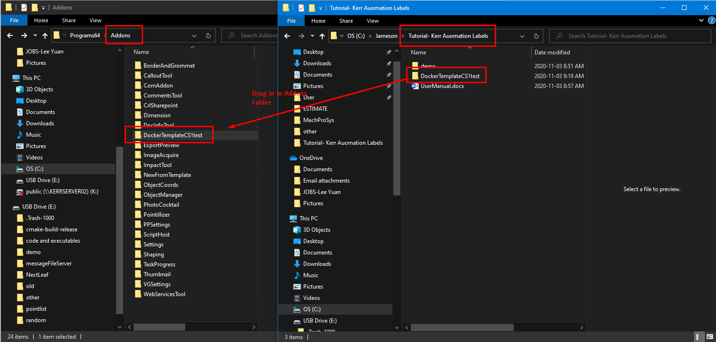

1. Open CorelDraw 2020
2. Click Window -> Dockers -> Kerr Automate Labels

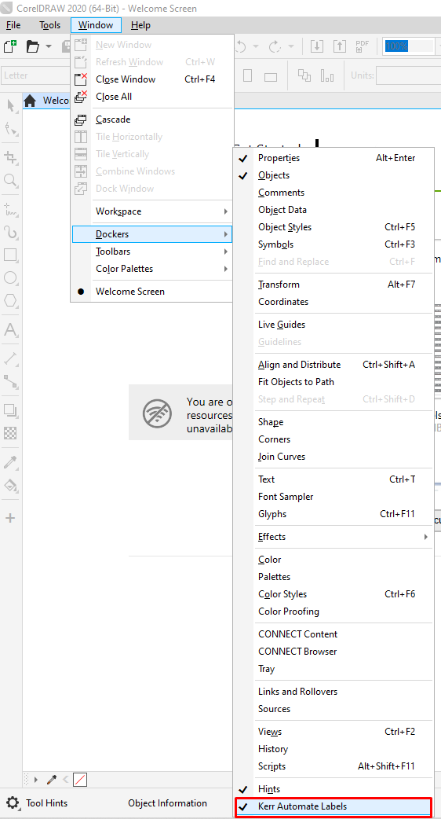

# Guide

## MachPro Sys Labels

1. Open MachPro_Sys_KerrLabels.cdr in ./demo/Labels

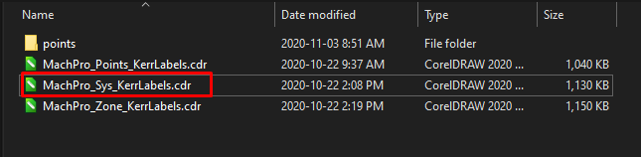

1. Click on MachPro SYS Labels

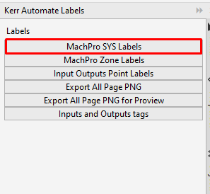

1. Open the following folder: **Tutorial- Kerr Auomation Labels\demo\Labels\points\MachProSys**

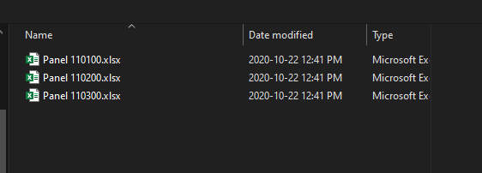

**Result:**

Produced 2 pages of the Labels for the 3 Panels in the folder selected.

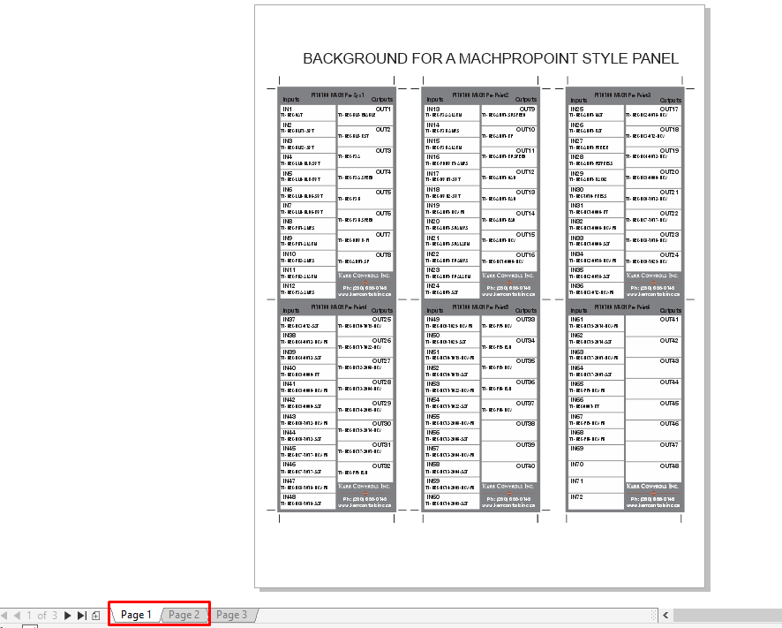

## MachPro Zone Labels

1. Open MachPro_Zone_KerrLabels.cdr in **./demo/Labels**

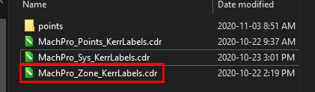

1. Click on MachPro Zone Labels

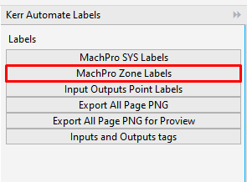

1. Open the following folder: **Tutorial- Kerr Auomation Labels\demo\Labels\points\MachProZone**

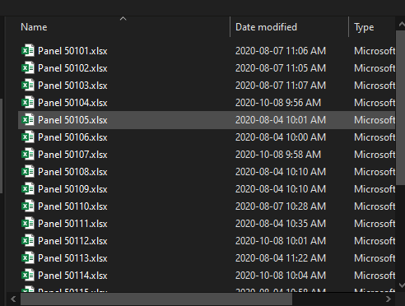

**Result:**

Produce 3 pages of MachPro Zone Labels.

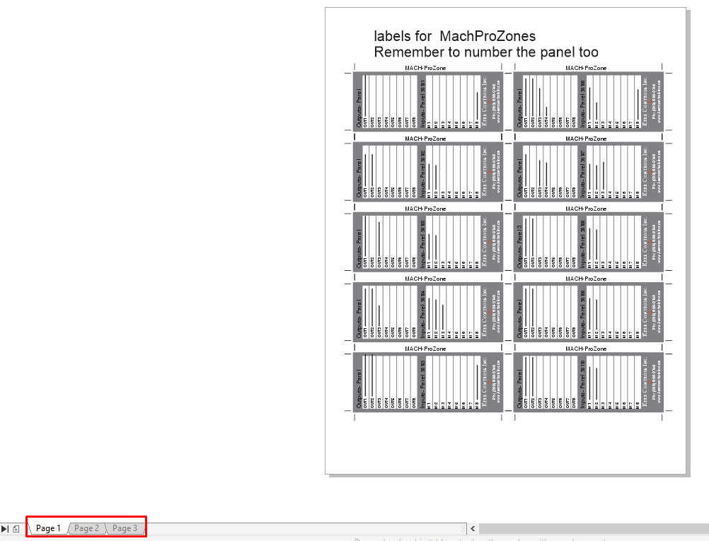

## Input Output Point Labels

1. Open MachPro_Points_KerrLabels.cdr in **./demo/Labels**

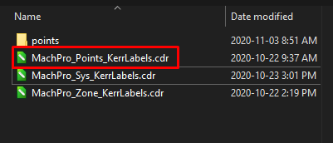

1. Click on Input Output Point Labels

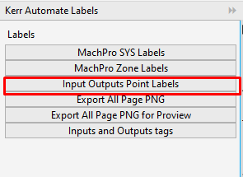

1. Open the following folder: **Tutorial- Kerr Auomation Labels\demo\Labels\points**

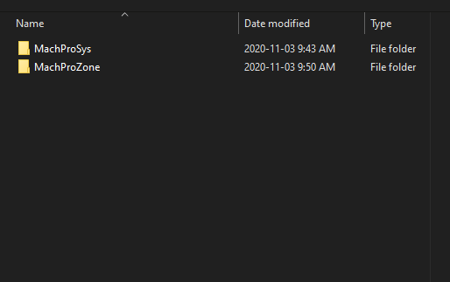

**Note**: it may take some time dude to the large data.

**Result:**

Produced 7 pages that include all the input and output points from MachPro Sys and MachPro Zone.

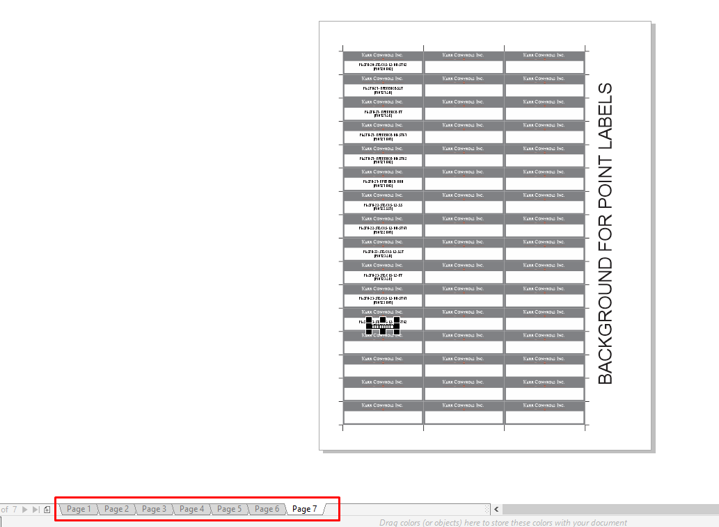

# Export All Page PNG

This export mainly used for exporting **1200x800 PNG files**

1. Open CorelDraw File that you want to export
2. Click on Export All Page PNG

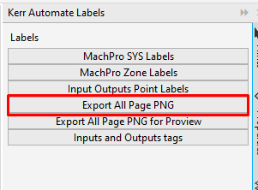

1. Select the following folder you want to save the export PNGs

**Result:**

The PNGs export are save in that folder

# Export All Page PNG for Proview

This export mainly used for exporting **480x272 PNG files**

1. Open CorelDraw File that you want to export
2. Click on Export All Page PNG

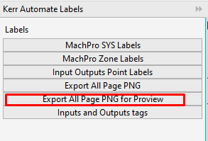

1. Select the following folder you want to save the export PNGs

**Result:**

The PNGs export are save in that folder

# Inputs and Outputs tags

1. Open TAGS TEMPLATE.cdr in **./demo/TAGS**

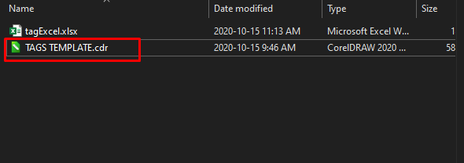

1. Click on Inputs and Outputs tags

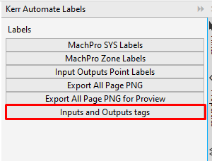

1. Select a file you want to label for this example we will use **tagExcel.xlsx**

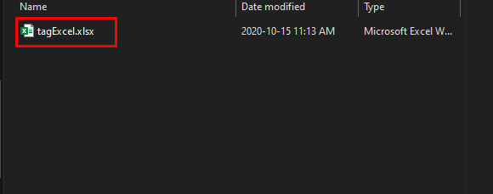

Note: the Excel format headers must match **tagExcel.xlsx**. The follow is **tagExcel.xlsx’s** headers.

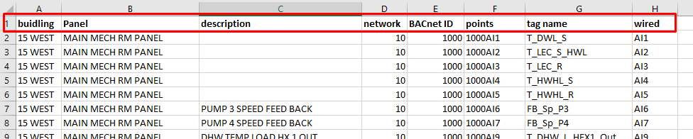

**Result:**

This produced 6 pages of tag labels based on the data from tagExcel.xlsx.

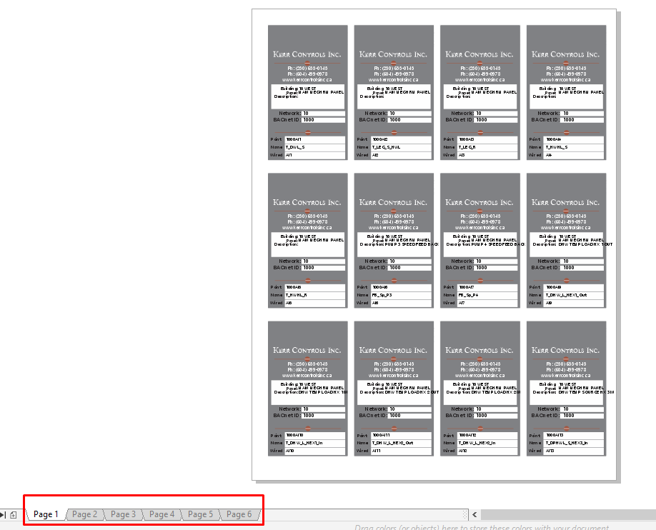

# Setting up Development

Requirement:

* Visual Studio
* CorelDraw Addons Templates

1. Open Visual Studio by right-click and run as **administration**
2. Click Extensions -> Mange extensions
3. Type coreldraw and install CorelDraw Addons Templates

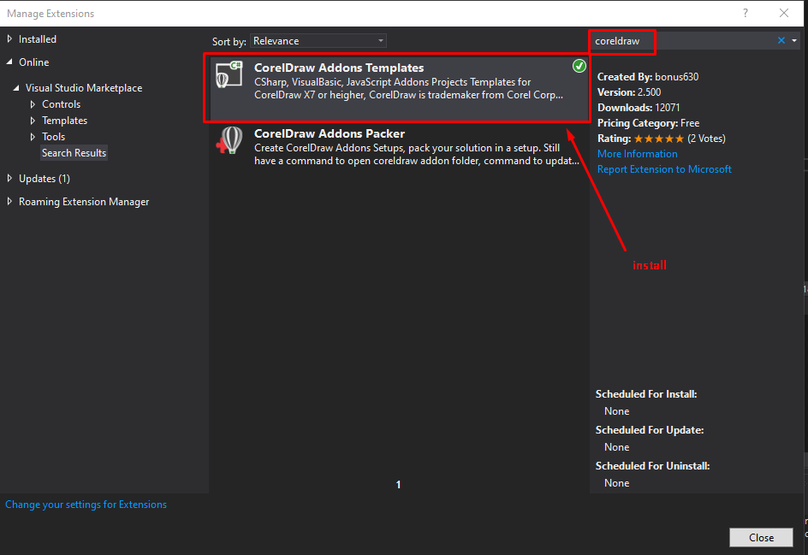

1. Open **DockerTemplateCS1test.sln**
2. Add the following references:

