Reference: Poverty in the Philippines: Its Social Roots

<https://www.google.com.ph/url?sa=t&rct=j&q=&esrc=s&source=web&cd=22&cad=rja&uact=8&ved=0ahUKEwjt75amxK3SAhWFvbwKHeOUAfU4FBAWCEMwAQ&url=http%3A%2F%2Fjournals.upd.edu.ph%2Findex.php%2Fkasarinlan%2Farticle%2Fdownload%2F1038%2F1049&usg=AFQjCNELe7dKWRppsYeaMItp4-BD8yJuhw&sig2=IQvh9wkJtguStsHTGPheGQ&bvm=bv.148073327,d.dGo>

underdeveloped country

social inequality

NEDA poverty line:

5.67 million or 59.3$ of all families in 1985

World bank estimated that 57% of the entire population in 1985

Minimum monthly income for a family of six: 2382 for entire Philippines  
In metro Manila: 3282  
lower for provincial urban and rural areas: 2912 and 2066

Lowest in Luzon – 29%  
Highest in Visayan region – 69%

Poverty: Insufficiency of life-sustaining good – food, clothing, housing, medical care

need for housing – Metro Manila – worst 58% of all households don’t own house – squatters

Education – public – free – quality is low

Abiding opium of the Filipino poor – Education  
Staunch belief that, given the chance to finish college, their children will rescue them from the mud, from the slums and the sweatshops

But is that the right thinking?

Recruitment into the top corporate positions is largely determined by two factors: links with the elite families or a diploma from the elite schools

**Why the Poor Remain Poor  
 Poverty –** Inability to provide for the basic requirements of minimum survival – like food, housing, clothing, and medical care. The question we must ask is why large numbers of a country’s population find themselves in this situation.

Because they don’t earn enough to buy these needs  
Because the government doesn’t provide adequate social services to those who could least afford to pay for these needs

Poor’s encounter with their government has been a negative one

Reference: 11 Things that are Poor in the Philippines

<http://faq.ph/11-things-that-are-poor-in-the-philippines-why-our-country-cant-progress/>

Not yet highly developed

No matter how the government tells us about our current economic achievements, poverty is still evident across our country.

many of our countrymen are already working hard, yet they’re still trapped in the limbo of poverty.

Reference: Poverty in the Philippines: The impact of Family Size

http://www.eastwestcenter.org/fileadmin/stored/pdfs/p%26p021.pdf

Demographically, households with many children are at greatest risk of being poor.

Presence of additional young children in the household reduces the probability that older siblings will be enrolled in school

Occupations plays a role. Poverty rates are highest among households headed by laborers and agricultural workers

Population of Philippines, how many family, how large, what year, number of household members, average family size

Reference: We, the Facets of Material Economic Poverty

<http://www.ceap.org.ph/upload/download/201510/2010226884_1.pdf>

Family expenditure

Family income

Population per region

Family per region

Low economics per region

Total number of poor people per year per region

Province with highest poverty

**Characteristics of Poor households**

Heads of two thirds of poor households have only elementary education and below

57 percent of households with six members and above are poor

Major source of income for the poor is derived from enterprise activities, not from wages

**Causes of Poverty**

Episodes of food inflation - 10% increase in food prices will create an additional 2.3 million poor people (Son, 2008); height of rice crisis – 50% increase in price of rice (July 2008)

Regular dose of shocks and exposure to risks - conflicts, economic crisis and natural disasters and environmental poverty

High and persistent inequality – land inequality and unequal access to quality education and health services

Rice price

What are we doing to Fight Poverty?

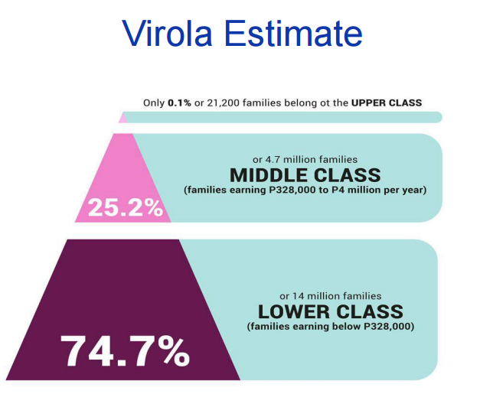

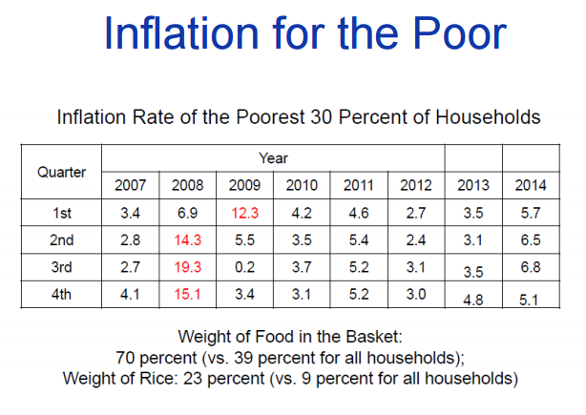

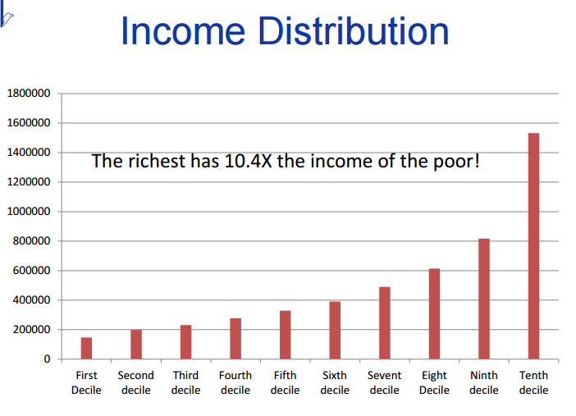

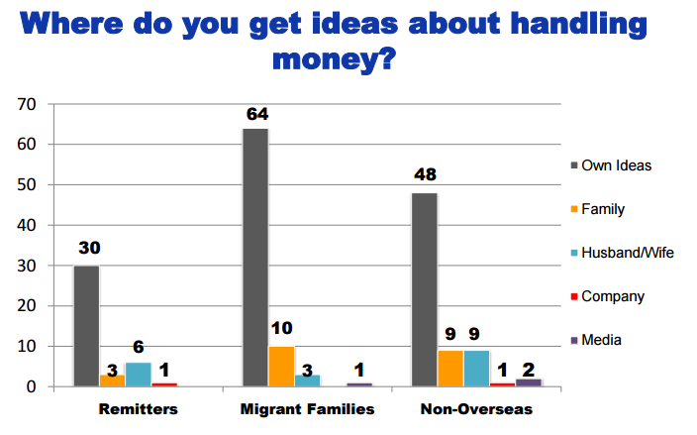

Reference:

<https://prezi.com/v4glkui2katy/cause-and-effect-of-poverty-in-the-philippines/>

Lack of Jobs  
Natural Calamities and Over-population  
Crime and Theft

Reference:

<http://joxcam.blogspot.com/2011/12/top-10-reasons-why-there-is-poor.html>

large-scale immigration of individuals with technical skills or knowledge

Lack of discipline

Corruption

Reference:

<https://www.poverties.org/blog/poverty-in-the-philippines>

Lack of infrastructure

In fact, the best way to help its own industry is for the Philippines to support its agriculture and help it find funding to modernize as well as build decent infrastructure (roads, bridges, markets). Many Filipinos also need training, technical help and useful and timely information (e.g. on weather, seeds etc). This in itself helps promote the education of children as adults realize the importance of learning new skills to improve their income.

Reference: Poverty in the Philippines: Causes, Constraints and Opportunities

<https://www.adb.org/sites/default/files/publication/27529/poverty-philippines-causes-constraints-opportunities.pdf>

“Poverty and inequality have been recurrent challenges in the Philippines”

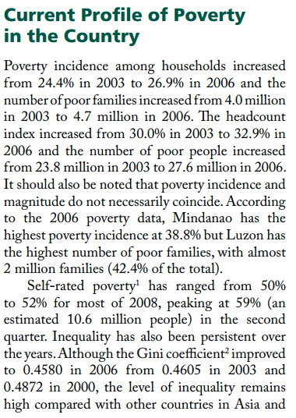

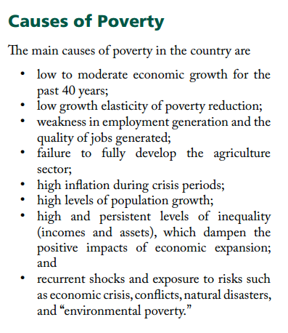

**Reference: Major Causes of Poverty in the Philippines**

<http://powerpinoys.com/cause-solution-poverty-problem-philippines/>

1. Corruption – doesn’t seem to end
2. Lack of Education
3. Fear – prevent us from growing
4. Lack of Discipline
5. Crab Mentality

**Reference:**

<http://endpoverty.org/philippines/>

**“**Many families are headed by women whose husbands have left them or return home only sporadically. In other families, the breadwinners cannot earn a stable income, leaving many poor and without hope.”

Reference:

http://notes.tyrocity.com/causes-of-poverty/

Causes of Poverty

1. **Rapid Population Growth**
2. **Gender inequality**
3. **Illiteracy**
4. **Lack of employment**
5. **Low saving**
6. **Old technology**

**Reference:**

<http://www.napc.gov.ph/articles/poverty-count>

**Poverty Incidence: 25.8% or 1 in 4 Filipinos lives in poverty (20% or 1 out of 5 Filipino families). This is 1.2% higher compared to the 2013 first semester poverty statistics. The increase in the count of poor is partly due to high food prices and the after-effects of super typhoon Yolanda. But the effect of high food prices was minimized by the increase in income of the poor.**

Poverty Incidence refers to the proportion of poor individuals/families to the population; those whose income fall below the poverty threshold or those who cannot afford to provide for their basic needs.

**Poverty Threshold: A 5-member family must earn at least  P8,778 a month to be considered non-poor. An income of P10,534 for six months (9.4% higher than the 2013 poverty threshold) is needed by an individual to be considered non-poor.**

Poverty Threshold refers to the required minimum income/expenditure to meet the basic food & non-food requirements.

**Subsistence Incidence: 10.5% or 1 in 10 Filipinos is considered food poor or living in extreme poverty (7.6% or 8 out of 100 Filipino families).**

Subsistence Incidence refers to the proportion of individuals/families living in extreme poverty, and with income/expenditure that is less than the required amount to meet the basic food requirements.

**Food Threshold: An individual income of P7,350 for six months or P6,125 monthly income for a 5-member family (2.4% higher than the 2012 food threshold) is needed to buy food.**

Food Threshold refers to the required minimum income/expenditure to meet the basic food needs that will satisfy the nutritional requirements for economically necessary and socially desirable physical activities.

**Poorest Regions/Provinces:**  
Based on the 2012 Poverty Estimates, ARMM remains the poorest among all the regions with the highest poverty incidence among families in 2006, 2009, and 2012. Provinces that have the highest poverty incidence among families from 2006 to 2012 are Eastern Samar, Lanao del Sur, Maguindanao, Masbate, Northern Samar, Saranggani and Zamboanga del Norte. New entrants in the poorest cluster of provinces in 2012 are Camiguin, Lanao del Norte, North Cotabato and Western Samar.

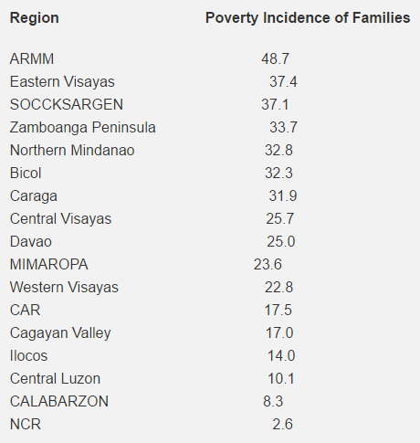

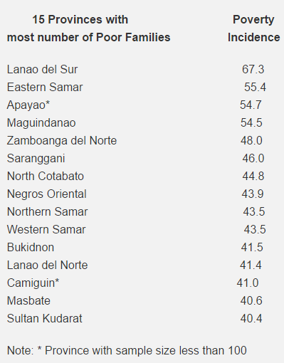

**Areas that improved from 2006 to 2012**  
Regions with the lowest poverty incidence among families from 2006 to 2012 continue to be NCR, CALABARZON, and Central Luzon. Caraga improved its poverty incidence significantly from 46.0 percent in 2009 to 31.9 percent in 2012. Areas with the lowest poverty incidence are NCR, Bataan, Benguet, Bulacan, Cavite, Laguna, Pampanga, and Rizal, with the addition of Ilocos Norte in the group in 2012.

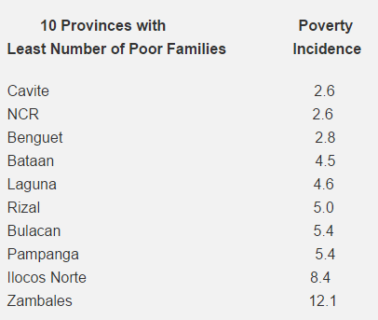

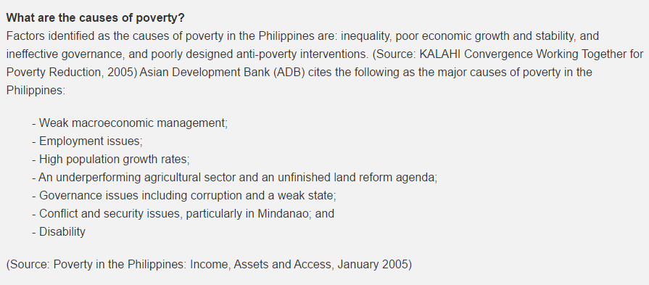

Reference:

<http://www.neda.gov.ph/2016/10/27/statement-on-full-year-2015-official-poverty-statistics-as-delivered-by-dir-reynaldo-r-cancio-of-neda/>

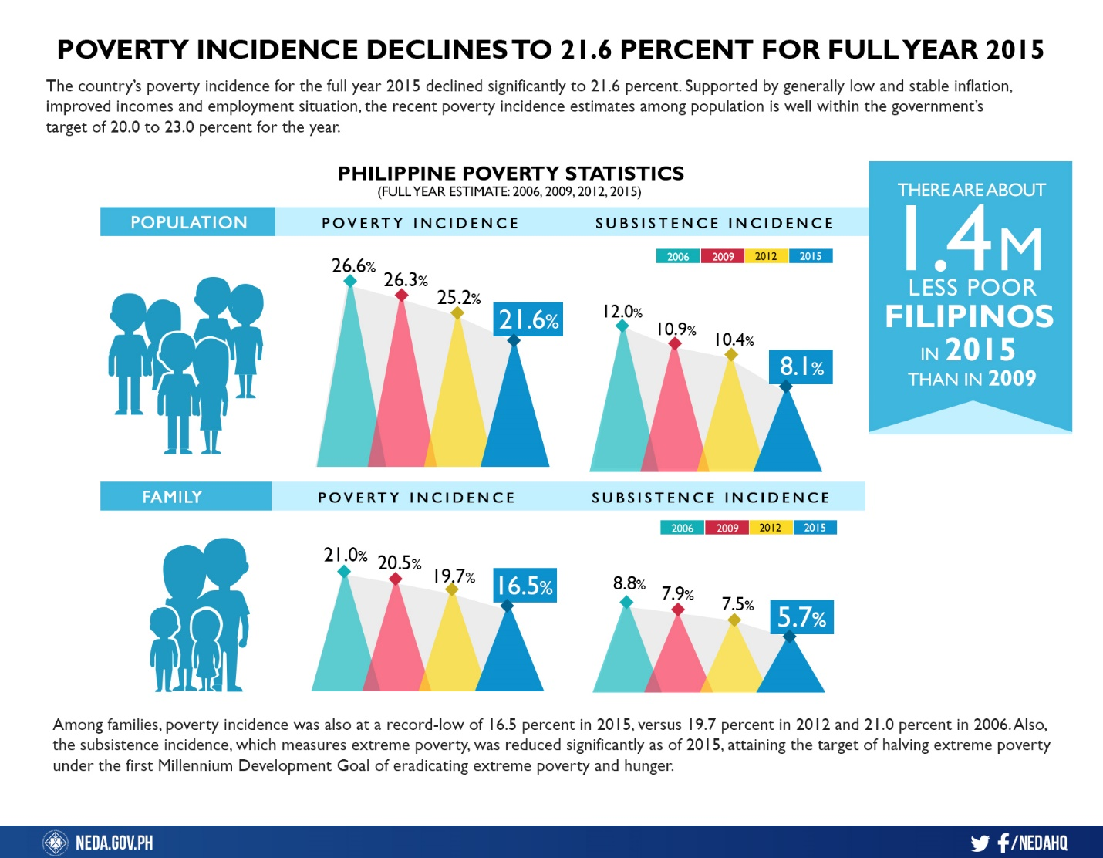

Reference:

<http://newsinfo.inquirer.net/689515/11-4m-families-remain-poor-sws-poll>

Reference:

<http://www.ph.undp.org/content/philippines/en/home/countryinfo.html>

Reference:

<http://www.manilatimes.net/reducing-the-poverty-statistics/263977/>

<http://www.tradingeconomics.com/philippines/poverty-headcount-ratio-at-national-poverty-line-percent-of-population-wb-data.html>

<http://www.philstar.com/headlines/2015/03/06/1430828/philippine-poverty-incidence-rises-first-half-2014>

<http://www.philstar.com/headlines/2016/10/28/1638032/poverty-incidence-drops-21.6>

<http://news.abs-cbn.com/focus/03/18/16/poverty-incidence-in-philippines-eased-in-2015-study-says>

<https://www.adb.org/countries/philippines/poverty>

<http://www.rappler.com/nation/134464-sws-poverty-poll-first-quarter-2016>

<http://www.indexmundi.com/philippines/population_below_poverty_line.html>

<http://data.gov.ph/catalogue/dataset/poverty--statistics>

<https://psa.gov.ph/content/incidence-families-experiencing-hunger-highest-eastern-visayas-results-2011-annual-poverty>

<https://www.ukessays.com/essays/economics/poverty-in-the-philippines-economics-essay.php>

<http://newsinfo.inquirer.net/775062/12m-filipinos-living-in-extreme-poverty>

http://psa.gov.ph/poverty-press-releases/data