Reference: 2015 Full Year Poverty Statistics

Link: <http://psa.gov.ph/poverty-press-releases/data>

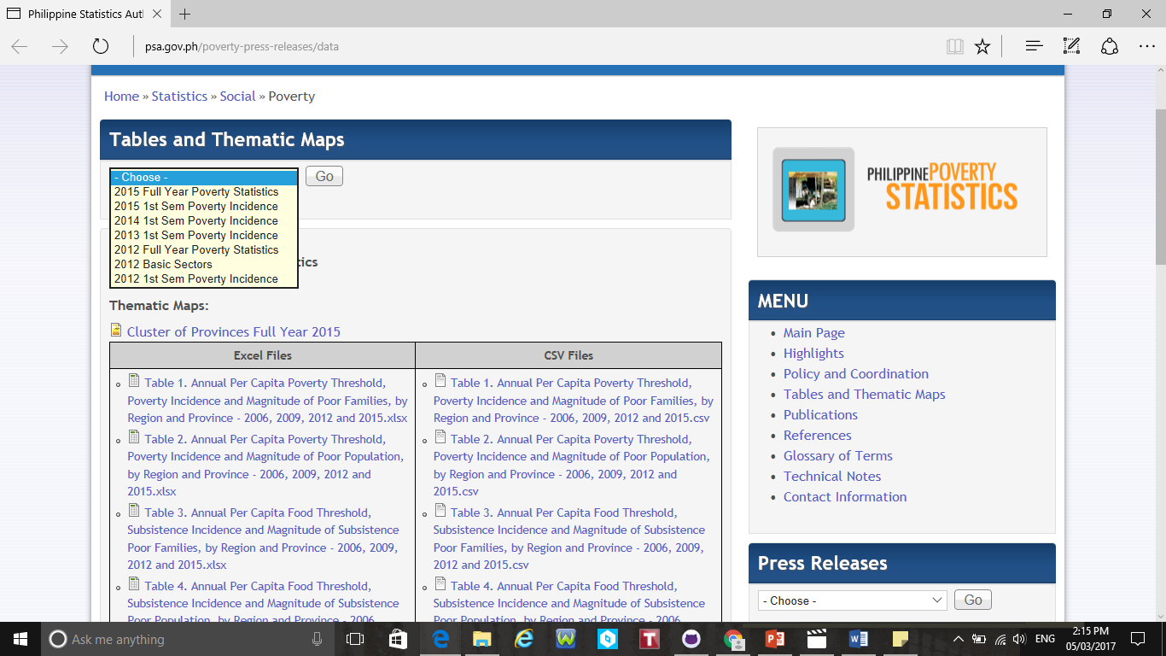

Reference: Poverty in the Philippines – Causes, Constraints, and Opportunities

Link: <https://www.adb.org/sites/default/files/publication/27529/poverty-philippines-causes-constraints-opportunities.pdf>

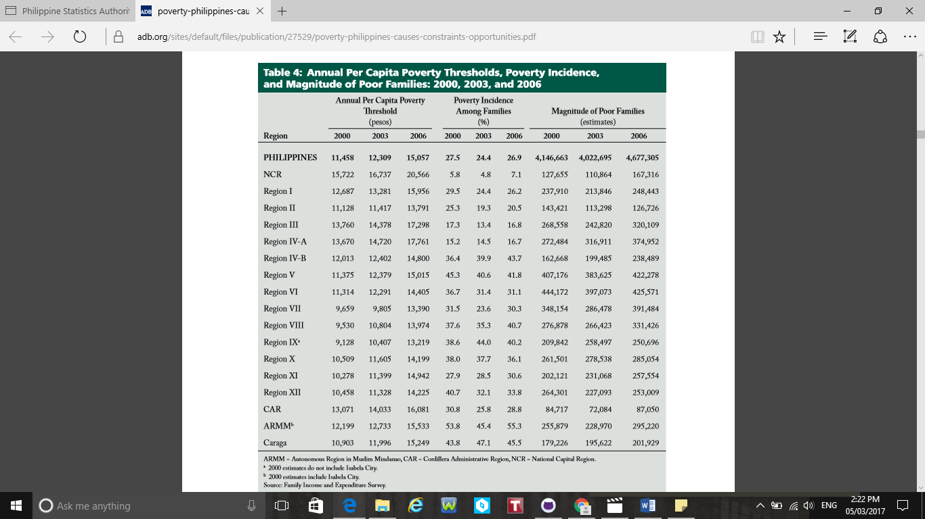

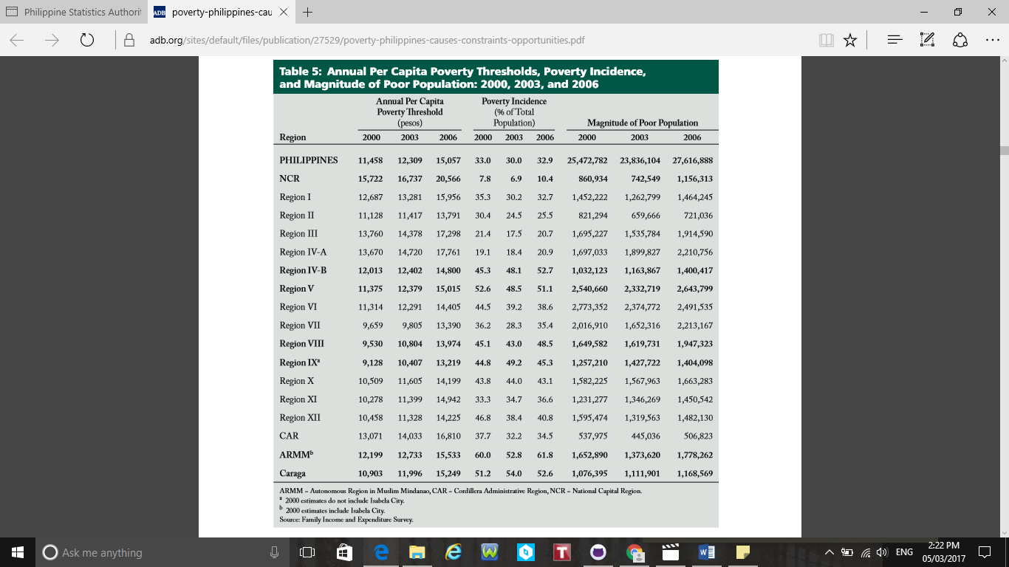

\*Maraming tables and graphs dito

Reference: Statement on Full Year 2015 Official Poverty Statistics as Delivered by Dir. Reynaldo R. Cancio of Neda

Link: <http://www.neda.gov.ph/2016/10/27/statement-on-full-year-2015-official-poverty-statistics-as-delivered-by-dir-reynaldo-r-cancio-of-neda/>

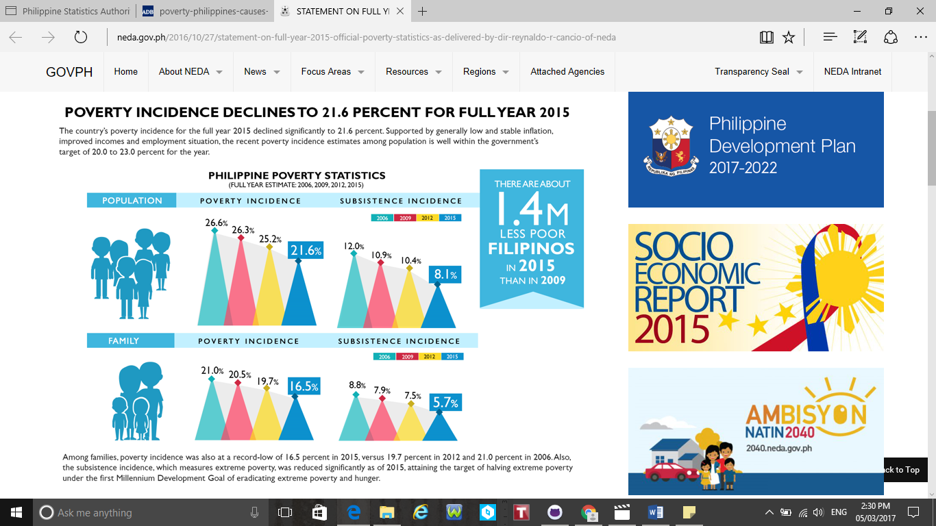

Reference: Poverty Count

Link: <http://www.napc.gov.ph/articles/poverty-count>

