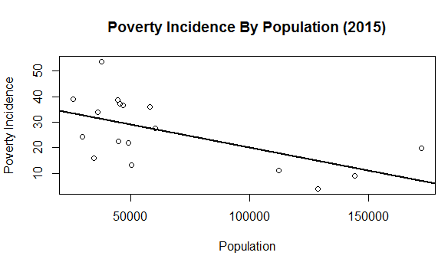

> plot(Data$Population2015, Data$PovertyIncidenceAmongPopulation2015, xlab="Population", ylab="Poverty Incidence", main="Poverty Incidence By Population (2015)")

> poverpopu2 <- lm(Data$PovertyIncidenceAmongPopulation2015~Data$Population2015)

> abline(coef(poverpopu2), lwd=2)

> plot(Data$Population2012, Data$PovertyIncidenceAmongPopulation2012, xlab="Population", ylab="Poverty Incidence", main="Poverty Incidence By Population (2012)")

> poverpopu <- lm(Data$PovertyIncidenceAmongPopulation2012~Data$Population2012)

> abline(coef(poverpopu), lwd=2)

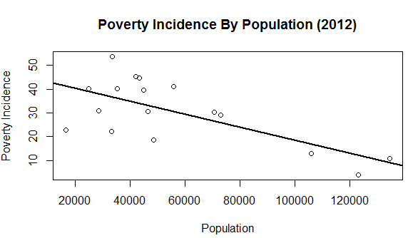

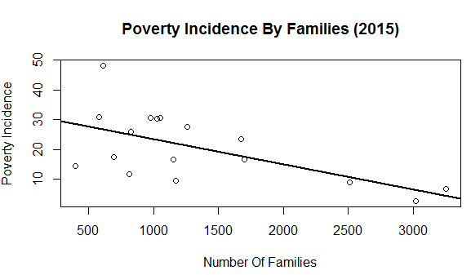

> plot(Data$NumberOfFamilies2015, Data$PovertyIncidenceAmongFamilies2015, xlab="Number Of Families", ylab="Poverty Incidence", main="Poverty Incidence By Families (2015)")

> poverfami2 <- lm(Data$PovertyIncidenceAmongFamilies2015~Data$NumberOfFamilies2015)

> abline(coef(poverfami2), lwd=2)