**UBER**

Interesting facts

* Available in 450 cities (2016) compared to 30 cities (2016) of Grab
  + Uber operates on 70 countries unlike 6 countries of Grab (2016)
* Uber founded on March 2009 (Grab - 2012)
* Uber Users: 40 million (2016) – Grab: 11 million (2016)

Features

* For Riders
  + Choose payment medium (Cash or Card)
  + Display and Share ETA
  + Fare Estimate
  + *Upcoming feature: “people are the new places”*
* For Drivers
  + Speed Display
  + Reminders to driver
  + Dashboard mount notification
  + Daily reports

**UBER GRAPHS**

**INTERNATIONAL EXPANSION BY CITY**

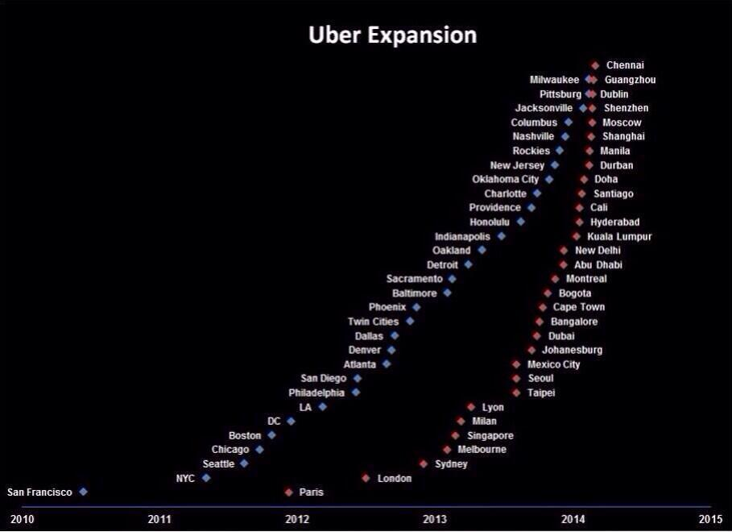

**REFERENCES:**

[**http://expandedramblings.com/index.php/uber-statistics/**](http://expandedramblings.com/index.php/uber-statistics/) **(Number of cities – Uber)**

[**https://en.wikipedia.org/wiki/Grab_(application)**](https://en.wikipedia.org/wiki/Grab_(application)) **(Number of cities, Founding date – Grab)**

[**https://en.wikipedia.org/wiki/Uber_(company)**](https://en.wikipedia.org/wiki/Uber_(company)) **(Founding date – Uber)**

[**http://expandedramblings.com/index.php/business-directory/24389/grabtaxi-stats-facts/**](http://expandedramblings.com/index.php/business-directory/24389/grabtaxi-stats-facts/) **(Number of grab users)**

[**http://fortune.com/2016/10/20/uber-app-riders/**](http://fortune.com/2016/10/20/uber-app-riders/) **(Number of uber users)**

[**https://newsroom.uber.com/safety-on-the-road-july-2016/**](https://newsroom.uber.com/safety-on-the-road-july-2016/) **(App features for Uber drivers)**

[**http://www.businessofapps.com/uber-usage-statistics-and-revenue/**](http://www.businessofapps.com/uber-usage-statistics-and-revenue/) **(International Expansion graph)**