UBER

Statistical Data of how many UBER users are there as of (March 2017)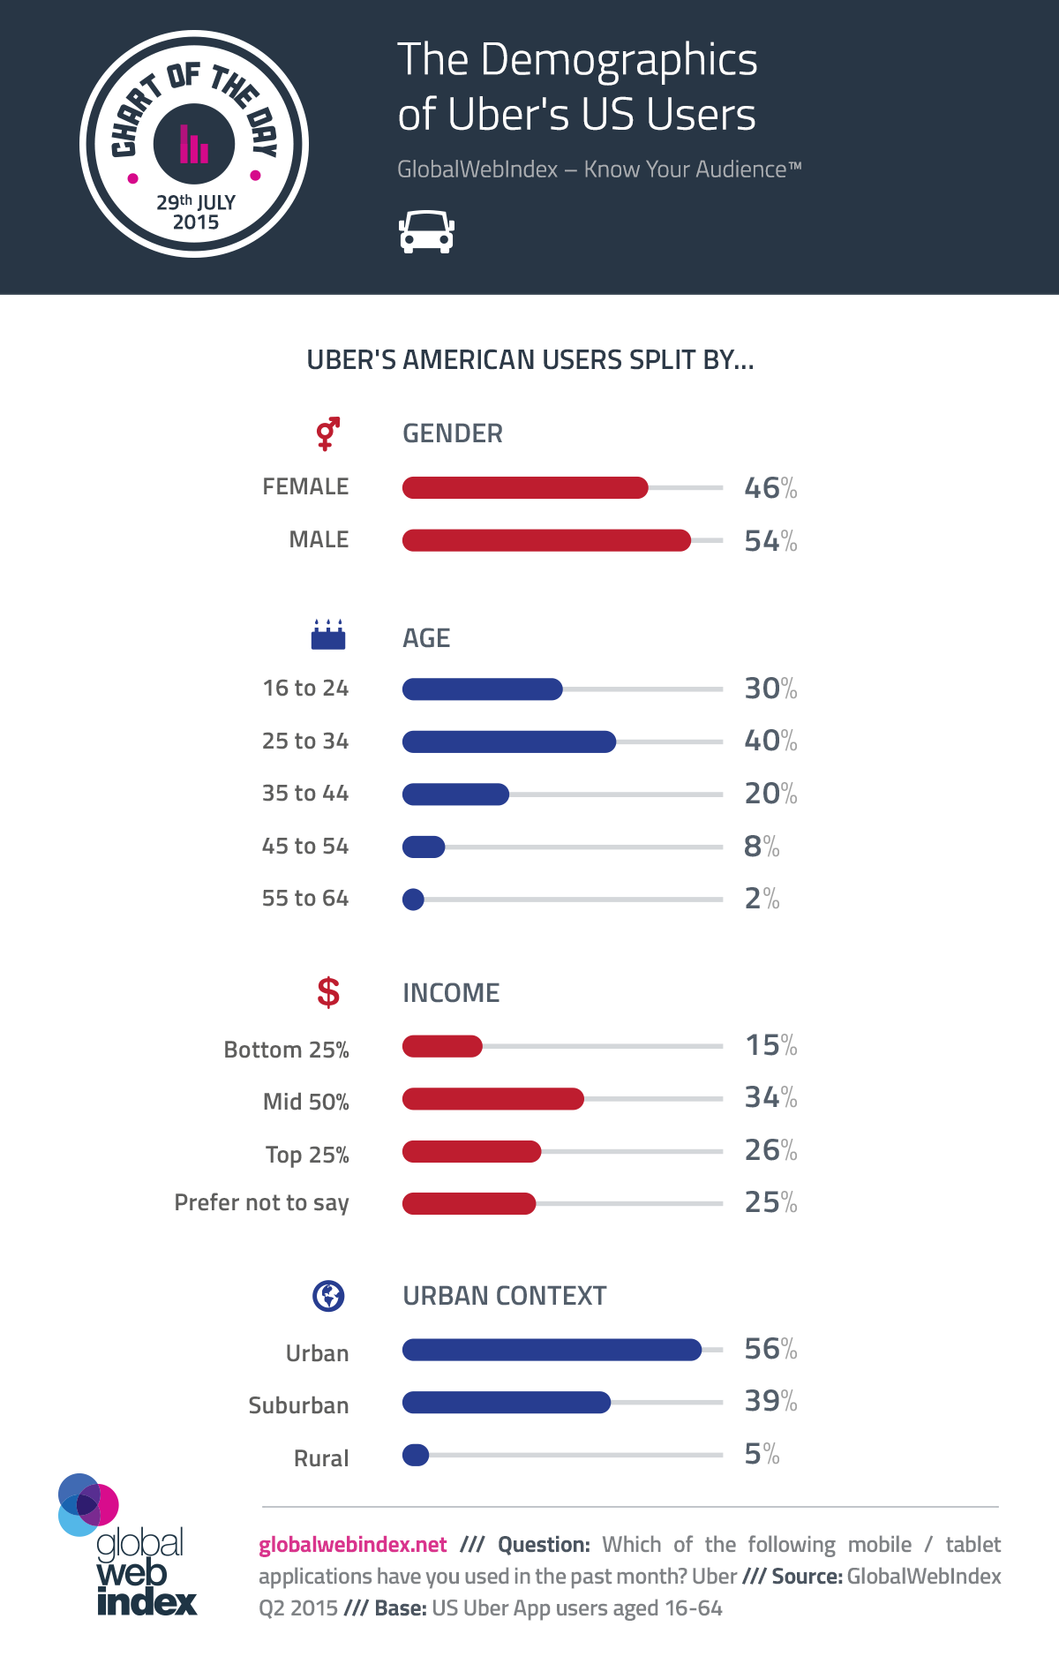

Reviews of Users to UBER

* Is UBER safe?
  + Driver profiles
  + Safe pickups
  + Displays the map
* Is UBER cheaper?
  + Discounts
  + Free Rides
* Does UBER provide a better service?
  + Accommodating drivers
  + Door-to-door

REFERENCES:

* <http://mashable.com/2015/07/25/uber-vs-taxis/#wTm2qkdDpsqw>
* <http://www.news.com.au/finance/business/travel/a-new-report-explores-the-benefits-of-uber/news-story/5e41687c9bc2614f07015f85eb784f7f>
* <https://www.globalwebindex.net/blog/the-demographics-of-ubers-us-users>
* <http://www.consumerreports.org/personal-finance/uber-vs-taxi-which-is-cheaper/>
* <https://www.uber.com/en-PH/ride/safety/>