# **Uber**

Oral Communication Competency Program 2

Professor: Mr. Leonardino R. Lapira

Belchez, Maica L.

Carlos, Christian Aleck S.

Heramia, Johanna Marisse C.

Jose, Chamber F.

Tadeo, Jose Lorenzo G.

Table of Contents

Uber 1

Background 3

Uber Users 3

Top 5 Users Worldwide 3

Uber’s Biggest Competitors 3

Features of Uber Application 3

How Successful Is Uber Now? 3

Advantages and Disadvantages of Using Uber Application 3

Reviews 3

Additional information 3

Recommendation 3

Conclusion 3

References 3

# **Background**

# 29th-July-2015-The-Demographics-of-Ubers-US-Users**Uber Users**

# **Top 5 Country Uber User**

1. United States
2. Brazil
3. China
4. Mexico
5. India

# **Uber’s Biggest Competitors**

1. Lyft
   1. Launched in 2012. It is a transportation company known for its fuzzy pink mustaches on the front or on dashboard of cars – silly, yet quite helpful when trying to sport your ride.
   2. It offers multiple level of service: Lyft Line (a shared ride option); Plain lyft (a ride for solo travelers or group up to four); and Lyft Plus (larger cars and SUVs perfect for those traveling with suitcases and boxes).
   3. Lyft is available in roughly 220 cities nationwide as well as nine cities within Indonesia, Malaysia, Singapore, Thailand, Philippines and Vietname.
2. Curb
   1. Formerly Taxi Magic (2009). Was born in 2014, and is a company that connects people with safe, reliable rides from professionals, insured, and fully licensed taxi and other for-hire drivers. Curb operates in more than 60 U.S. cities nationwide, partnering with 90 cab companies.
3. Didi Chuxing
   1. It is a ride-hailing service company made up of China’s two largets taxing-hailing films.
   2. It operates in over 400 cities across the region, versus UberChina’s humble 45 cities. Didi is also a strategic partner with Lyft.
   3. Well-funded and backed by tech giants Apple Inc., Tencent Holdings, and Alibaba
4. Grab
5. Ola
   1. Started as an online cab aggregator in Mumbai back in 2010. Ola currently has over $40,000 cars in its network across 22 cities. It also recently rolled out two news services: outstation and rental. Outstation allows customers to book a cab two hours in advance for intercity travel, while rental lets customers rent a car on an hourly basis.

# **Features of Uber Application**

# **How Successful Is Uber Now?**

# **Advantages and Disadvantages of Using Uber Application**

# **Rates of Uber**

1. Base fare – A flat fee charge at the beginning of the ride
2. Cost per minute –
3. Cost per mile
4. Booking Fee (Formerly known as the ‘Safe Rides Fee’) – A flat fee

*Your fare = Base Fare + (Cost per minute * time in ride) + (Cost per mile * ride distance) + Booking fee*

Uber cars have different base fare, therefore makes the price differs from the other.

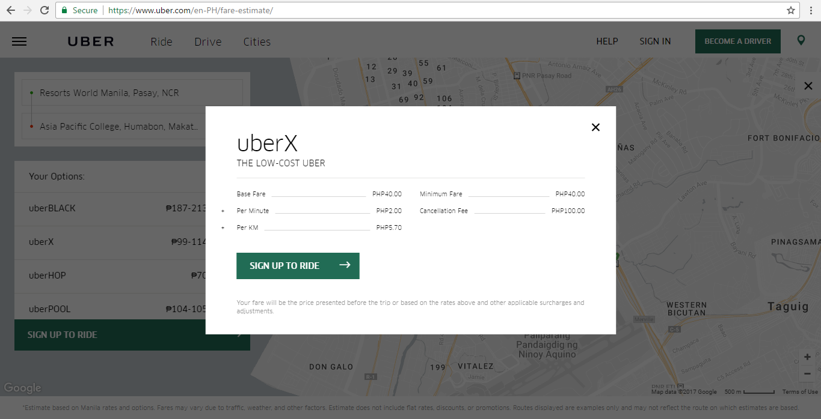

FAQs

1. What if a rider changes their destination, has multiple destinations or makes extra stops?
2. Can my UpFront Fares change even if I don’t change my destination?
3. How will you determine the upfront price?

# **Reviews**

# **Additional information**

* Surges

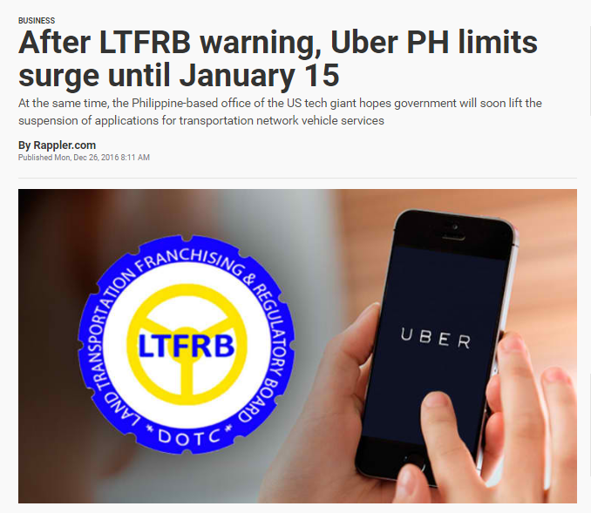

* Promo Codes
* VIP Loyalty Program

# **Recommendation**

# **Conclusion**

# **References**

Johnson, Madeline. *Who Are Uber’s Biggest Competitors.* Feburary 6, 2017. Retrieved from <https://www.zacks.com/stock/news/248328/who-are-ubers-biggest-competitors>

McGrath, Felim. *The Demographics of Uber’s US Users.* July 29, 2015. Retrieved from <https://www.globalwebindex.net/blog/the-demographics-of-ubers-us-users>

<http://uberestimator.com/cities>

<http://www.businessofapps.com/uber-usage-statistics-and-revenue/>

Dough. *How much does Uber cost? Uber fare estimator.* August 5, 2015. Retrieved from <http://www.ridesharingdriver.com/how-much-does-uber-cost-uber-fare-estimator/>

<https://newsroom.uber.com/india/upfront-fares-no-math-and-no-surprises/>

http://www.rappler.com/business/156625-uber-surge-price