Class 05 Graphics and plots with R

Joshua Chevez

January 25th, 2019

#Class 05 Graphics and plots with R  
#This is some narative text that I can style **bold** and *italic* and add links to [webpages](https://rmarkdown.rstudio.com/articles_report_from_r_script.html)  
  
#Section 2A: line plot  
  
weight <- read.table("bimm143_05_rstats/bimm143_05_rstats/weight_chart.txt", header = TRUE)  
  
plot(weight, pch=15, cex=1.5, lwd=2, ylim=c(2, 10), xlab="Age (months)", ylab="Weight (Kg)", main="Title", type="o", col="purple")

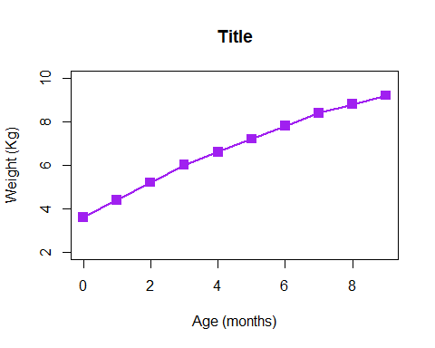

#Section 2B  
feat <- read.table("bimm143_05_rstats/bimm143_05_rstats/feature_counts.txt", header = TRUE, sep="\t")  
barplot(feat$Count, names.arg = feat$Feature, las=2, horiz = TRUE, ylab="Feature", main = "Figure 1")  
  
par(mar=c(5, 12, 4, 2))  
barplot(feat$Count, names.arg = feat$Feature, las=2, horiz = TRUE, ylab="Feature", main = "Figure 1")

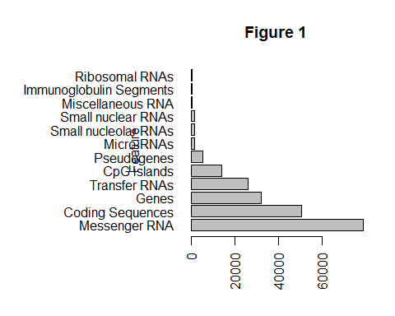

#Section 3A  
  
mf <- read.table("bimm143_05_rstats/bimm143_05_rstats/male_female_counts.txt", header = TRUE, sep = "\t")  
barplot(mf$Count, names.arg = mf$Sample, col=rainbow(c(nrow(mf))), las=2)

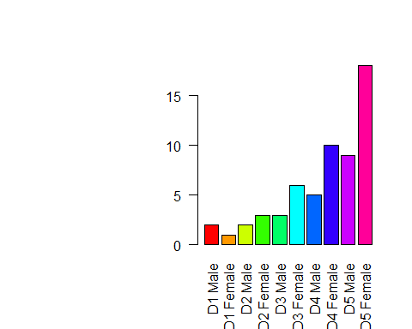

mfc <- read.delim("bimm143_05_rstats/bimm143_05_rstats/male_female_counts.txt")  
  
mf <- read.table("bimm143_05_rstats/bimm143_05_rstats/male_female_counts.txt", header = TRUE, sep = "\t")  
barplot(mf$Count, names.arg = mf$Sample, col=c("blue2", "red2"), las=2)

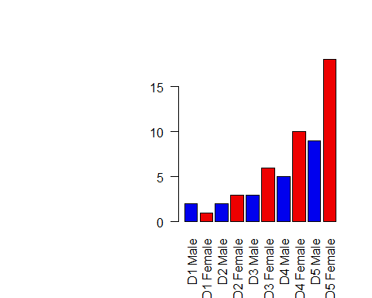

#Section 3B  
  
genes <- read.table("bimm143_05_rstats/bimm143_05_rstats/up_down_expression.txt", header = TRUE)  
plot(genes$State)

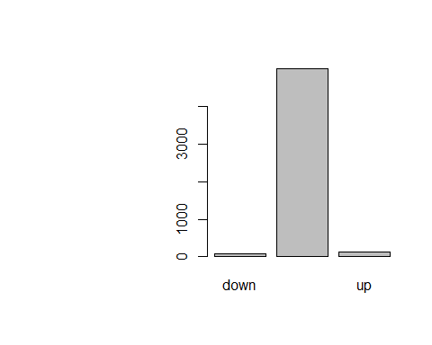

#Number of rows  
nrow(genes)

## [1] 5196

table(genes$State)

##   
## down unchanging up   
## 72 4997 127

palette(c("red", "green", "blue"))  
plot(genes$Condition1, genes$Condition2, col=genes$State)

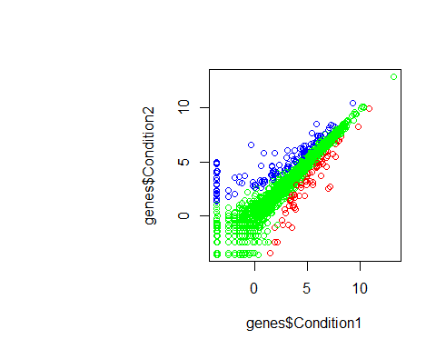

palette()

## [1] "red" "green" "blue"

levels(genes$State)

## [1] "down" "unchanging" "up"