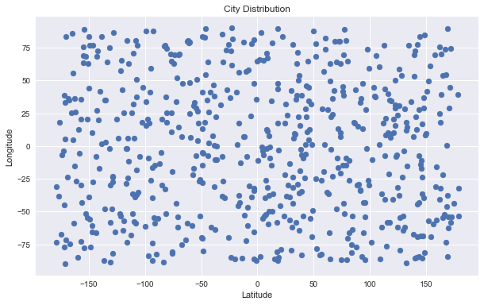

Each blue dot on the City Distribution chart equals one city. What we observe from the chart is: all the cities generated from citypy program are evenly distributed over Latitude and Longitude. They are representative of global weather pattern.

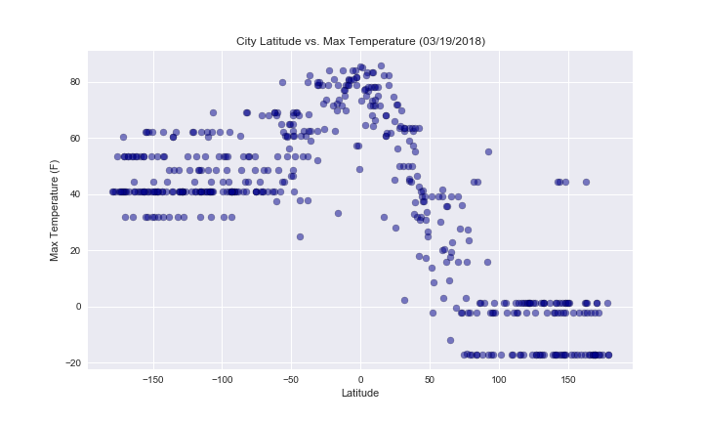

Based on City Latitude vs. Max Temperature on 3/19/18 chart, we observe that:

On northern hemisphere, from Latitude 180 to 0 (the equator), the temperature goes up rapidly. The nearer the latitude to equator, the higher the temperature.

On sourthern hemisphere, from Latitude -180 to 0 (equator), the temperature goes up rapidly as well. The nearer the latitude to equator, the higher the temperature.

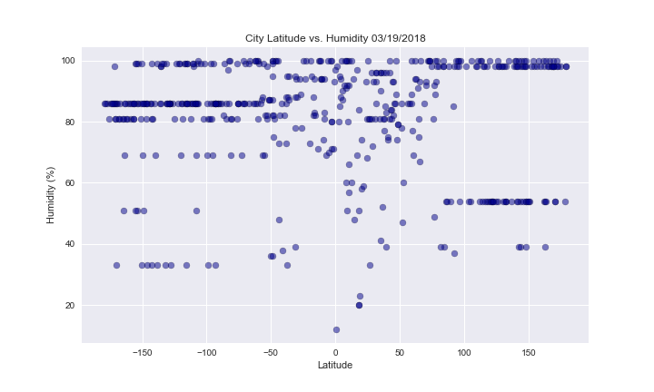

Based on City Latitude vs. Humidity chart 03/19/2018, what we find out is: the humidity around the globe is relatively high in March.

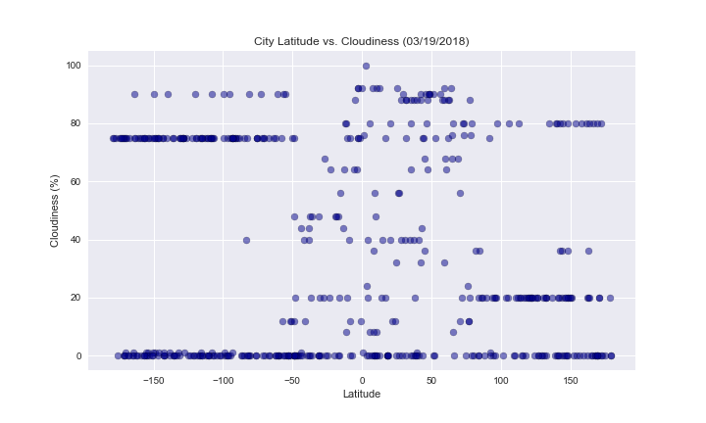

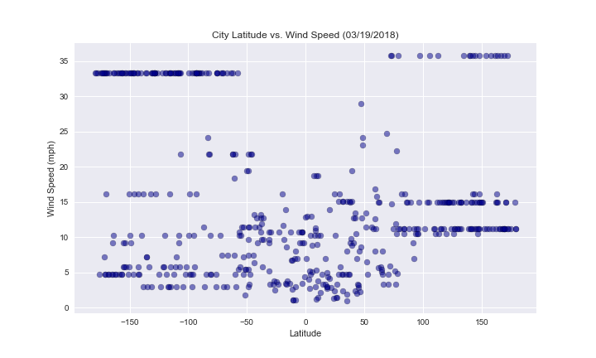

City Latitude vs. Cloudiness chart and City Latitude vs. Wind Speed chart tells us that cloudiness and wind speed are randomly distributed between the equator and the norther hemisphere and between the equator and southern hemisphere.