Group 7

*Dust Pan LLC: Database Project*

**By: James Chi, John Nicholson, John Snyder, Will Mathews**

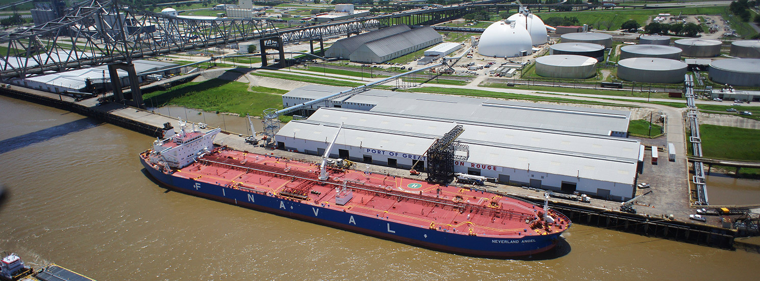

**Part I**

*Business Description:*

Dust Pan LLC strives to provide cargo information and tracking of the port of Baton Rouge inside our database. The Port of Greater Baton Rouge is strategically located on the Mississippi River and is an integral part of the national maritime industry and Louisiana economy. Handling a diverse range of cargo and accommodating special requests is a trademark of the Port of Greater Baton Rouge. The port's jurisdiction includes the parishes of Ascension, East Baton Rouge, Iberville and West Baton Rouge. Our mission statement is to build a better Port of Baton Rouge using data and analytics. Our objective is to use data and analytics to help the Port of Baton Rouge in becoming more efficient, effective and better at managing the administration of duties for their imports and exports. Our analytics should allow the Port to eliminate slack time and sufficiently track all aspects of each shipment. If a consumer wants to check when their shipment came there are records of dates arrived and the crew responsible for that cargo. So, this database will help with reliability when cargos go missing and consumers want to figure out who was in charge at the time of arrival. The database must also be capable of tracking and coordinating all the different components of the Port of Baton Rouge system. Including each cargo shipment, employee, ship, crew, and dock.

*Business Rules:*

1. Each **ship** is described by a unique IMO number, name, country registration, country registration code, city, year of construction, and tonnage.
2. Each **ship** delivers one to many cargos.
3. Each **cargo** is described by a unique cargo ID, cargo date, cargo weight, cargo goods class, cargo dangerous good, and cargo dangerous good classification.
4. Each **cargo** is delivered by one ship.
5. Each **cargo** is unloaded at one dock.
6. Each **cargo** is handled by one crew.
7. Each **dock** is described by a unique dock ID, dock name, and location.
8. Each **dock** unloads many cargos.
9. Each **dock** has one crew working there.
10. Each **crew** is described by a unique crew ID, crew day, and crew time.
11. Each **crew** handles one to many cargo shipments.
12. Each **crew** works at one to many docks to help with unloading cargo shipments.
13. Each **crew** is assigned one to many employees in the crew.
14. Each **employee** is described by a unique employee ID, first name, last name, job position, and salary.
15. Each **employee** is assigned to one to many crews to help at docks and unloading cargo.
16. A table **assign** is used to show the many to many relationship between employee and crew.

**Part II**

*ER Diagram:*

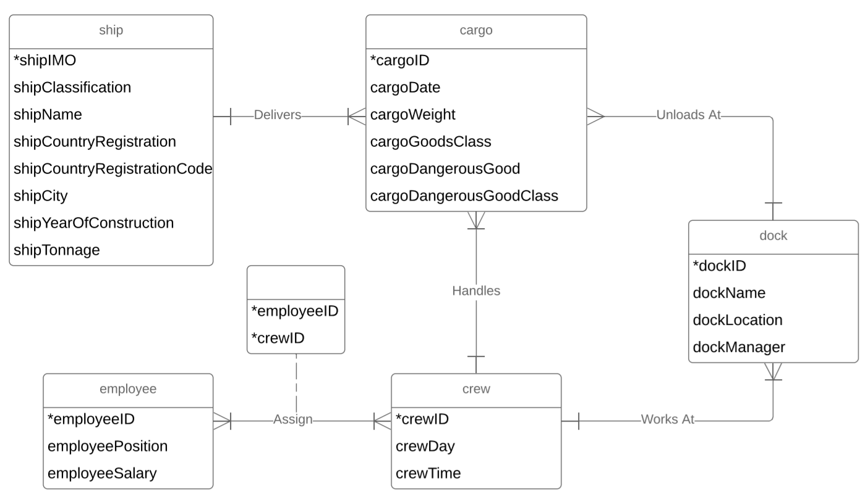

**Part III**

*Relational Model:*

SHIP(**imoNo,** classification, shipName, countryRegistration, countryRegistrationCode, city, yearOfConstruction, tonnage)

CARGO(**cargoID**, cargoDate, cargoWeight, cargoGoodsClass, cargoDangerousGood, cargoDangerousGoodClassification, /imoNo/, /dockID/, /crewID/)

DOCK(**dockID,** dockName, location, /crewID/)

CREW(**crewID,** crewDay, crewTime)

ASSIGN(**employeeID, crewID**, /employeeID/, /crewID/)

EMPLOYEE(**employeeID,** firstName, lastName, jobPosition, salary)

**Part IV**

*Query Matrix:*

|  |  |  |  |  |  |  |  |  |  |  |
| --- | --- | --- | --- | --- | --- | --- | --- | --- | --- | --- |
|  | **Q1** | **Q2** | **Q3** | **Q4** | **Q5** | **Q6** | **Q7** | **Q8** | **Q9** | **Q10** |
| **Multiple Join** | **x** |  | **x** | **x** | **x** | **x** | **x** | **x** | **x** | **x** |
| **Subquery** |  | **x** | **x** |  |  |  |  |  |  |  |
| **GROUP BY** | **x** | **x** |  |  | **x** |  |  |  |  |  |
| **GROUP BY HAVING** |  |  |  | **x** |  |  |  | **x** |  |  |
| **ORDER BY** |  | **x** |  |  | **x** | **x** | **x** |  |  | **x** |
| **Aggregate** | **x** | **x** |  | **x** | **x** |  |  |  | **x** |  |
| **Like** |  |  |  |  |  | **x** |  |  |  |  |
| **Date** |  |  |  |  |  |  | **x** |  |  |  |
| **IN/NOT IN** |  |  | **x** |  |  |  |  |  |  | **x** |
| **IS NULL** |  |  |  |  |  |  | **x** |  | **x** |  |

*Data Dictionary (Manipulation):*

**Ship**

|  |  |  |  |  |  |  |  |
| --- | --- | --- | --- | --- | --- | --- | --- |
| **imo** | **classification** | **ship**  **Name** | **country**  **Registration** | **country**  **RegistrationCode** | **city** | **yearOf**  **Construction** | **tonnage** |
| 2113287 | Reefer | Beetlestone | Russia | RU | Krasnoye | 2008 | 35984 |
| 3577247 | General | Cockayne | China | CN | Xiaolan | 1993 | 39129 |
| 9995215 | General | Vanyukhin | Indonesia | ID | Galis | 2009 | 34559 |
| 2007553 | Tanker | Akrigg | Indonesia | ID | Rukem | 2002 | 50597 |

**Cargo**

|  |  |  |  |  |  |
| --- | --- | --- | --- | --- | --- |
| **cargoID** | **cargoDate** | **cargoWeight** | **cargoGoodsClass** | **cargoDangerousGoods** | **cargoDangerousGoodsClass** |
| 1 | 03/12/2019 | 25849 | 21 | yes | 4 |
| 2 | 04/18/2018 | 23419 | 43 | no | Not Dangerous |
| 3 | 01/05/2017 | 34501 | 35 | yes | 7 |
| 4 | 11/24/2018 | 34145 | 42 | yes | 2 |

**Dock**

|  |  |  |
| --- | --- | --- |
| **dockID** | **dockName** | **location** |
| 1 | Echo | Port Allen |
| 2 | Charlie | Plaquemine |
| 3 | Papa | Baton Rouge |
| 4 | November | Port Allen |

**Crew**

|  |  |  |
| --- | --- | --- |
| **crewID** | **crewDay** | **crewTime** |
| 1 | Mon,Wed,Thurs | Morning |
| 2 | Wed,Fri,Sat | Afternoon |
| 3 | Tues,Thurs,Sun | Night |
| 4 | Tues,Fri,Sun | Morning |

**Assign**

|  |  |
| --- | --- |
| **employeeID** | **crewID** |
| 1 | 3 |
| 2 | 2 |
| 3 | 4 |
| 4 | 1 |

**Employee**

|  |  |  |  |  |
| --- | --- | --- | --- | --- |
| **employeeID** | **firstName** | **lastName** | **jobPosition** | **salary** |
| 1 | John | Doe | Worker | 25000 |
| 2 | Jane | Smith | Worker | 28000 |
| 3 | Martin | Johnson | Supervisor | 55000 |
| 4 | Henry | George | Manager | 40000 |