Dust Pan LLC

Proposal

**Client** - Port of Baton Rouge

The Port of Greater Baton Rouge is strategically located on the Mississippi River and is an integral part of the national maritime industry and Louisiana economy. Handling a diverse range of cargo and accommodating special requests is a trademark of the Port of Greater Baton Rouge. The port's jurisdiction includes the parishes of Ascension, East Baton Rouge, Iberville and West Baton Rouge.

**Description**

For each (meaning one) ship delivers 1 to however many cargo which is unloaded at 1 dock. A dock is able to take many cargo (shipments). The dock can have many crew (a team of employees) while the crew can work at 1 or many docks. Each crew handles 1 or many cargos. A crew is composed of many employees but each employee belongs to only 1 crew.

**Mission Statement**

Build a better Port of Baton Rouge through the use of data and analytics.

**Mission Objective**

To use data and analytics to help the Port of Baton Rouge in becoming more efficient, effective and better at managing the administration of duties for their imports and exports. Our analytics should allow the Port to eliminate slack time and sufficiently track all aspects of each shipment.

**Requirements Analysis**

The database must be capable of tracking and coordinating all the different components of the Port of Baton Rouge system. Including each shipment, employee, ship, crew, and dock.

**Entities**

Dock

Crew

Ship

Shipment

Employee

**Relationships**

1 Dock is worked by 1 Crew

1 Crew works at 1 to many Dock

1 Crew handles 1 to many Cargo

1 Cargo is handled by 1 Crew

1 Dock unloads many Cargo

1 Cargo is unloaded at 1 Dock

1 Ship delivers 1 to many Cargo

1 Cargo is delivered by 1 Ship

1 Crew assigns 1 to many employee

1 Employee is assigned to 1 to many Crew

**ER Model**

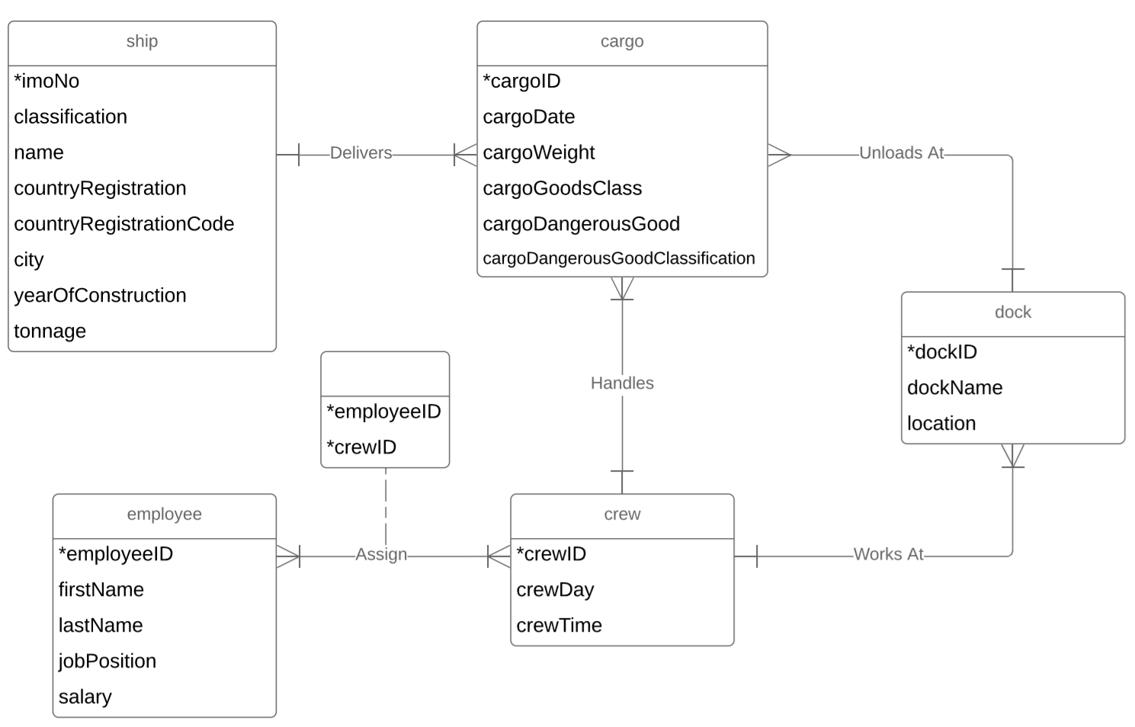

**Relational Model**

SHIP(**imoNo,** classification, shipName, countryRegistration, countryRegistrationCode, city, yearOfConstruction, tonnage)

CARGO(**cargoID**, cargoDate, cargoWeight, cargoGoodsClass, cargoDangerousGood, cargoDangerousGoodClassification, /imoNo/, /dockID/, /crewID/)

DOCK(**dockID,** dockName, location, /crewID/)

CREW(**crewID,** crewDay, crewTime)

ASSIGN(**employeeID, crewID**, /employeeID/, /crewID/)

EMPLOYEE(**employeeID,** firstName, lastName, jobPosition, salary)

**Data Dictionary**

**Ship**

|  |  |  |  |  |  |  |  |
| --- | --- | --- | --- | --- | --- | --- | --- |
| **shipIMO** | **ship**  **Classification** | **ship**  **Name** | **shipCountry**  **Registration** | **shipCountry**  **RegistrationCode** | **ship**  **City** | **shipYearOf**  **Construction** | **ship**  **Tonnage** |
| IMO2113287 | Reefer | Beetlestone | Russia | RU | Krasnoye | 2008 | 35984 |
| IMO3577247 | General | Cockayne | China | CN | Xiaolan | 1993 | 39129 |
| IMO9995215 | General | Vanyukhin | Indonesia | ID | Galis | 2009 | 34559 |
| IMO2007553 | Tanker | Akrigg | Indonesia | ID | Rukem | 2002 | 50597 |

**Cargo**

|  |  |  |  |  |  |
| --- | --- | --- | --- | --- | --- |
| **cargoID** | **cargoDate** | **cargoWeight** | **cargoGoodsClass** | **cargoDangerousGoods** | **cargoDangerousGoodsClass** |
| 1 | 03/12/2019 | 25849 | 21 | yes | 4 |
| 2 | 04/18/2018 | 23419 | 43 | no | Not Dangerous |
| 3 | 01/05/2017 | 34501 | 35 | yes | 7 |
| 4 | 11/24/2018 | 34145 | 42 | yes | 2 |

**Dock**

|  |  |  |  |
| --- | --- | --- | --- |
| **dockID** | **dockName** | **dockLocation** | **dockManager** |
| 1 | Echo | Port Allen | Megan |
| 2 | Charlie | Plaquemine | Arin |
| 3 | Papa | Baton Rouge | Frederigo |
| 4 | November | Port Allen | Weber |

**Crew**

|  |  |  |
| --- | --- | --- |
| **crewID** | **crewDay** | **crewTime** |
| 1 | Mon,Wed,Thurs | Morning |
| 2 | Wed,Fri,Sat | Afternoon |
| 3 | Tues,Thurs,Sun | Night |
| 4 | Tues,Fri,Sun | Morning |

**Assign**

|  |  |
| --- | --- |
| **employeeID** | **crewID** |
| 1 | 3 |
| 2 | 2 |
| 3 | 4 |
| 4 | 1 |

**Employee**

|  |  |  |  |  |
| --- | --- | --- | --- | --- |
| **employeeID** | **employeeFname** | **employeeLname** | **employeePosition** | **employeeSalary** |
| 1 | John | Doe | Worker | 25000 |
| 2 | Jane | Smith | Worker | 28000 |
| 3 | Martin | Johnson | Supervisor | 55000 |
| 4 | Henry | George | Manager | 40000 |

**Query Matrix**

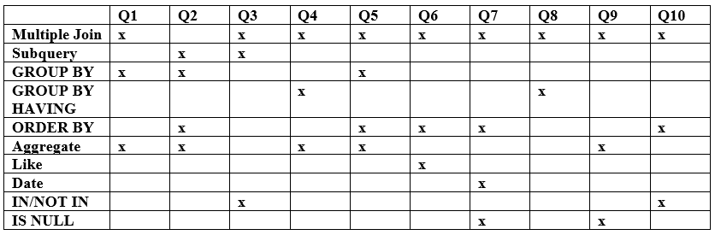

**Query Questions and Statements**

(1) Total salary earned within crew #3?

**SELECT crewID, sum(salary) as totalSalary**

**FROM employee e, assign a**

**WHERE e.employeeID = a.employeeID and crewID = 3**

**GROUP BY crewID;**

(2) Which crew handled the most dangerousGoods and the amount they handled?

**SELECT crewID, MAX(totalDangerousGoods)**

**FROM (**

**SELECT crewID, COUNT(cargoDangerousGoods) as totalDangerousGoods**

**FROM cargo**

**WHERE cargoDangerousGoods = 'yes'**

**GROUP BY crewID**

**ORDER BY totalDangerousGoods DESC**

**) AS maxDangerousGoods;**

(3) Display all cargo that is not handled by crew #10 on dock #3.

**SELECT \***

**FROM cargo**

**WHERE cargoID NOT IN**

**(**

**SELECT cargoID**

**FROM cargo c, dock d**

**WHERE c.crewID = d.crewID AND c.dockID = d.dockID AND d.crewID = 10 AND d.dockID = 3**

**);**

(4) What is the country's total cargo delivered from either China or Russia.

**SELECT s.countryRegistration, COUNT(*) as totalCargo**

**FROM cargo c, ship s**

**WHERE c.imoNo = s.imoNo**

**GROUP BY s.countryRegistration**

**HAVING s.countryRegistration = 'China' OR s.countryRegistration = 'Russia';**

(5) Which dock has the highest cargoPerMonth out of all the docks?

**SELECT d.dockID, d.dockName, COUNT(*)/12 as cargoPerMonth**

**FROM cargo c, dock d**

**WHERE c.dockID = d.dockID**

**GROUP BY d.dockID**

**ORDER BY cargoPerMonth DESC;**

(6) Which employees make over 25,000k and work in crew #3 or #6 also is in the morning shift?

**SELECT DISTINCT e.firstName, e.lastName, e.salary, a.crewID, c.crewDay, c.crewTime**

**FROM employee e, assign a, crew c**

**WHERE e.salary >= 25000 AND e.employeeID = a.employeeID AND a.crewID = c.crewID AND c.crewTime = 'Morning' AND c.crewDay LIKE '%Tues%' AND (a.crewID = 3 OR a.crewID = 6)**

**ORDER BY firstName, lastName DESC;**

(7) What managers were responsible for the crew that unloaded the cargo with cargoID "55"?

**SELECT e.firstName, e.lastName, e.jobPosition, a.crewID**

**FROM assign a, employee e, cargo r**

**WHERE a.employeeID = e.employeeID AND a.crewID = r.crewID AND e.jobPosition = 'manager' AND r.cargoID = '55' AND cargoDate = '2018-05-28' AND cargoID IS NOT NULL**

**ORDER BY e.firstName, e.lastName DESC;**

(8) Who is the highest paid manager who works in the morning on dock #4?

**SELECT e.firstName, e.lastName, e.salary, e.jobPosition, a.crewID, c.crewTime, d.dockID**

**FROM employee e, dock d, assign a, crew c**

**WHERE a.crewID = c.crewID AND c.crewID = d.crewID AND a.employeeID = e.employeeID AND c.crewTime = 'morning' AND e.jobPosition = 'manager'**

**HAVING MAX(salary);**

(9) How many ships arrived at dock #4 in January who had weights greater than 25,000?

**SELECT COUNT(*) AS totalArrivals**

**FROM ship s, dock d, cargo c**

**WHERE s.imoNo = c.imoNo AND c.dockID = d.dockID AND d.dockID = '4' AND c.cargoWeight > 25000 AND MONTH(c.cargoDate) = 1 and cargoWeight IS NOT NULL;**

(10) Which ships had to take several trips to bring cargo over by seeing that the cargoWeight is larger than the tonnage weight and within those ships, display those that were constructed in 2010, 2012, and 2011.

**SELECT \***

**FROM ship s**

**INNER JOIN cargo c**

**ON s.imoNO = c.imoNo**

**WHERE c.cargoWeight > tonnage AND s.yearOfConstruction IN ('2010', '2012', '2011')**

**ORDER BY s.imoNO;**