#Query1: Total salary earned within crew #3?

SELECT crewID, sum(salary) as totalSalary

FROM employee e, assign a

WHERE e.employeeID = a.employeeID and crewID = 3

GROUP BY crewID;



#Query2: Which crew handled the most dangerousgoods and the amount they handled?

SELECT crewID, MAX(totalDangerousGoods)

FROM (

SELECT crewID, COUNT(cargoDangerousGoods) as totalDangerousGoods

FROM cargo

WHERE cargoDangerousGoods = 'yes'

GROUP BY crewID

ORDER BY totalDangerousGoods DESC

) AS maxDangerousGoods;



#Query3: Display all cargo that is not handled by crew #10 on dock #3

SELECT \*

FROM cargo

WHERE cargoID NOT IN

(

SELECT cargoID

FROM cargo c, dock d

WHERE c.crewID = d.crewID AND c.dockID = d.dockID AND d.crewID = 10 AND d.dockID = 3

);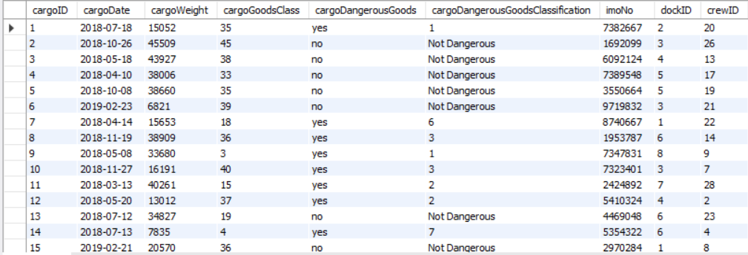

#Query4: Display the country's total cargo delivered from either China or Russia.

SELECT s.countryRegistration, COUNT(\*) as totalCargo

FROM cargo c, ship s

WHERE c.imoNo = s.imoNo

GROUP BY s.countryRegistration

HAVING s.countryRegistration = 'China' OR s.countryRegistration = 'Russia';

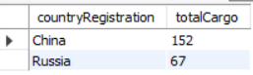

#Query5: Display the dockID's average cargo per month in ascending order

FROM cargo c, dock d

WHERE c.dockID = d.dockID

GROUP BY d.dockID

ORDER BY cargoPerMonth DESC;

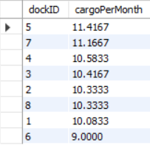

#Query6: Which employees make over 25,000k and work in crew #3 or #6 also is in the morning shift?

SELECT DISTINCT e.firstName, e.lastName, e.salary, a.crewID, c.crewDay, c.crewTime

FROM employee e, assign a, crew c

WHERE e.salary >= 25000 AND e.employeeID = a.employeeID AND a.crewID = c.crewID AND c.crewTime = 'Morning' AND c.crewDay LIKE '%Tues%' AND (a.crewID = 3 OR a.crewID = 6)

ORDER BY firstName, lastName DESC;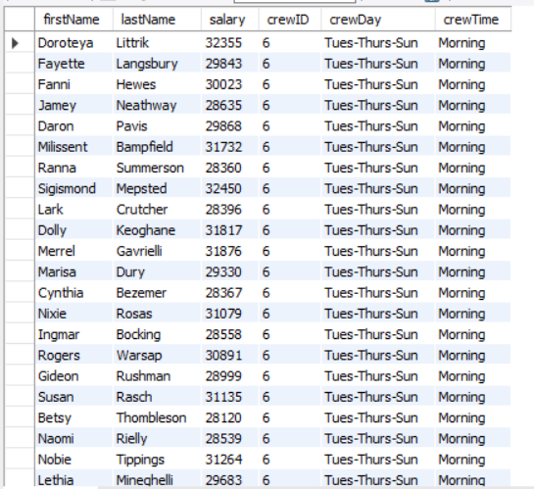

#Query7: What managers were responsible for the crew that unloaded the cargo with cargoID "55"?

SELECT e.firstName, e.lastName, e.jobPosition, a.crewID

FROM assign a, employee e, cargo r

WHERE a.employeeID = e.employeeID AND a.crewID = r.crewID AND e.jobPosition = 'manager' AND r.cargoID = '55' AND cargoDate = '2018-05-28' AND cargoID IS NOT NULL

ORDER BY e.firstName, e.lastName DESC;

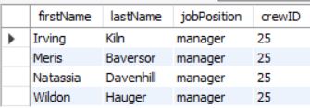

#Query8: Who is the highest paid manager who works in the morning on dock #4?

SELECT e.firstName, e.lastName, e.salary, e.jobPosition, a.crewID, c.crewTime, d.dockID

FROM employee e, dock d, assign a, crew c

WHERE a.crewID = c.crewID AND c.crewID = d.crewID AND a.employeeID = e.employeeID AND c.crewTime = 'morning' AND e.jobPosition = 'manager'

HAVING MAX(salary); 

#Query9: How many ships arrived at dock #4 in January who had weights greater than 25,000?

SELECT COUNT(\*) AS totalArrivals

FROM ship s, dock d, cargo c

WHERE s.imoNo = c.imoNo AND c.dockID = d.dockID AND d.dockID = '4' AND c.cargoWeight > 25000 AND MONTH(c.cargoDate) = 1 and cargoWeight IS NOT NULL;



#Query10: Display ships that had to take several trips to bring cargo over by seeing that the cargoWeight is larger than the tonnage weight and within those ships, display those that were constructed in 2010, 2012, and 2011.

SELECT \*

FROM ship s

INNER JOIN cargo c

ON s.imoNO = c.imoNo

WHERE c.cargoWeight > tonnage AND s.yearOfConstruction IN ('2010', '2012', '2011')

ORDER BY s.imoNO;

