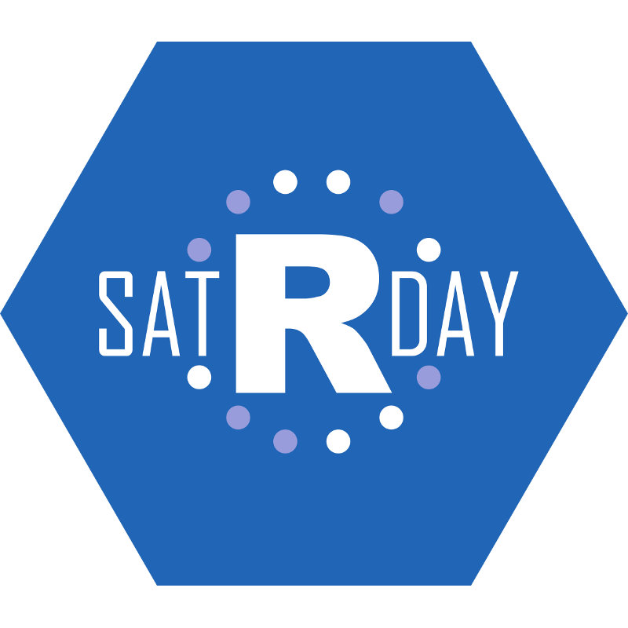#satRdayCapeTown

2017

Name

Affiliation

wifi(‘satrday’, ‘rstats4thewin’)