Hutchison Book Program Installation Instructions

Software Requirements
Java JDK version 7.0 + (Java 6.0 is about to expire so I wouldn't recommend going that route. There's currently a 0-Day exploit with the browser plugin for version 7, but we won't be using that.)
Tomcat version 6.0 or later. I test in version 7. Other Servlet 2.4/JSP 2.0 compliant web servers should also work.
A database – I prefer PostgreSQL and that's what the database dump is provided for, however the system with work with almost all other databases. The tool has been tested heavily against PostgreSQL, MySQL, HSQL, and Oracle. Any database with a reasonably complete JDBC driver should work.

Installation Pre-requisites
Install Java, Tomcat, and your database.

Java JDK Version 7.0 – Software can be downloaded from http://java.oracle.com. Tomcat can run with just the JRE, if it's already installed. If it's not, I recommend the full JDK as the compiler provided with Tomcat is not as capable as that provided by the JDK, and installing this now makes it easier to switch to the JDK compiler if it's necessary later.

Tomcat Version 6.0 or later – Software can be downloaded from http://tomcat.apache.org/. If installing on Windows, grab the “32-bit/64-bit Windows Service Installer”. If installed on Linux, grab package under “Core”. IMPORTANT: We refer to file locations relative to the location where you install Tomcat, your “Tomcat directory”, so please make a note of this for later reference.

PostgreSQL database. If installing on Windows, it can be downloaded from http://www.postgresql.org/. If installing on Linux, it'll be in your distribution's repositories. I've only installed on Windows once and that was quite a while ago. I'm afraid I can't help you much with this. I do know there's several GUI tools to help manage the database. The freebie is at http://www.pgadmin.org/

Database installation
Once postgres is installed and running, load up the bookroom database. First, create a user named “webuser” with the password “sOulcu8es”. That's a capital oh, not a zero. You can change those settings later, if you want, but this is what the current configuration files are setup for. Now use the attached “.sql” file to load the database. That'll set things up with the books as of Sept. 8, 2012.

MRALD installation
Once Tomcat is up and running, the next step is to install the book program.
    - Put the bookroom.war file to the webapps directory under your Tomcat directory.
    - Within a minute or so, Tomcat should automatically unpack the war file. If not, restart Tomcat using the method appropriate for your platform.

Now the basic configuration. Open a browser and go to http://127.0.0.1:8080/bookroom (assuming you are accessing it from the server – if not, replace 127.0.0.1 with your ip address). You will see the following screen:

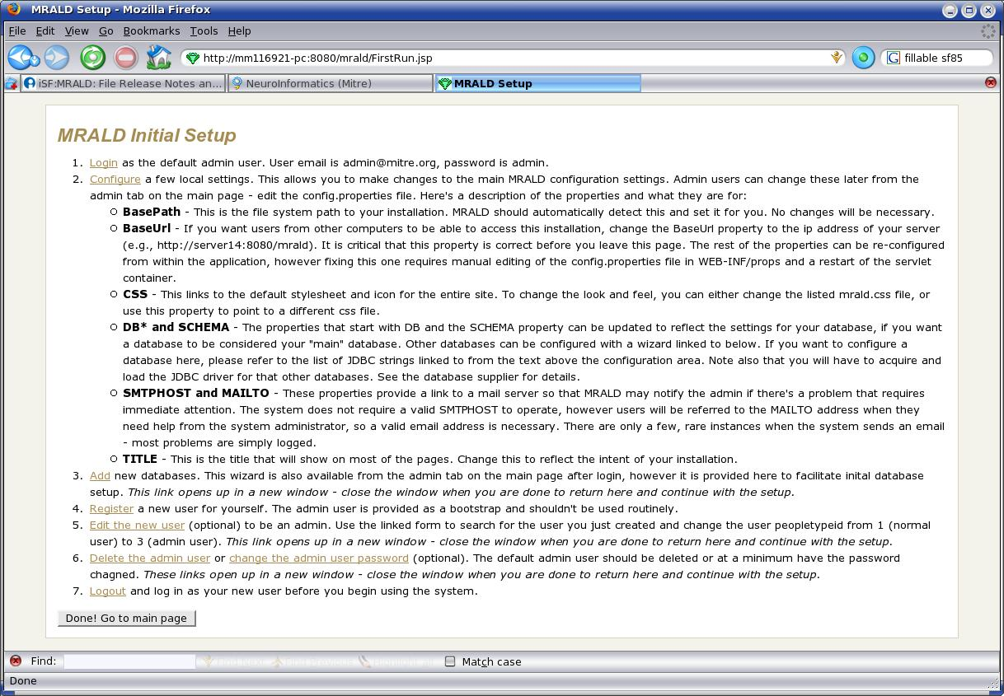
The program is now running. You shouldn't have to do any configuration here other than settings the BaseURL. This page exists for a generic installation, which yours is not. Feel free to poke around, though. Once you hit the “Done!” button, you won't be able to get back to this page, however you will be able to modify all these settings later. Note I think Jackie and Marci are using the admin user – don't delete that one until you are sure she has a new one. I can tell you how to make her an admin user later, which is necessary to add/modify/delete books. Once you are done, anyone who has network access to the machine on which you just installed it can access this page, by typing in the ip address, for example:
http://<ipaddress>:8080/bookroom

Note we can change this URL later if you want. New users can register using the “Register here” button on the login page and will automatically be able to search, but won't be able to change any books. If you have any questions or experience any problems please contact me at jchoyt@gmail.com or bug Marci and she'll hunt me down.

