Troop 51 2014 Mulch Delivery Navigator Packet
March 22, 2014

All routes are printed in this packet and can be accessed online using your cell phone at http://tinyurl.com/2014Troop51. There you'll find an overview of the routes for all trucks as well as links to individual route pages. There's nothing there that isn't in this packet, however the online versions have the advantage of letting you click on the links for addresses as well as overall Google maps for entire routes. That should integrate with the GPS capabilities of your phone so you don't have to type the address in. An overview of the route page is below.

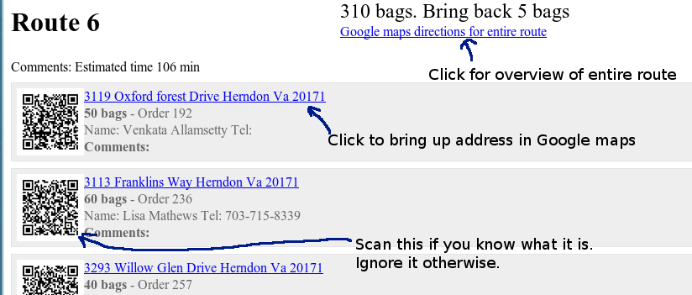
Each route shows the address, number of bags, and any request by the customer (in the Comments line). If we have a telephone number, we provide it here as well. The order number is provided so if there's a problem we can find the information faster.

Truck assignments:
Truck #1 – Crisp/Kelly
Truck #2 – Peake/Luttges
Truck #3 – Gregor/Turner
Truck #4 – Schantz/Willhite
Truck #5 – Stalzer/Auman

Contact information:
Jeff Hoyt 571-455-3539 (me)
John Lambright 703-403-7676

