**City Library Website Help and Documentation**

Welcome to the City Library documentation section, while most functions are working there are still some that are under construction.

Under Construction Items (If accessed, users will receive an Under Construction Message)

* Sign In Services
* Register Services

**Books Collection Documentation**

Users are allowed to view, add, update, and delete books as needed.

**View:**

Click on the Books Page to View Books

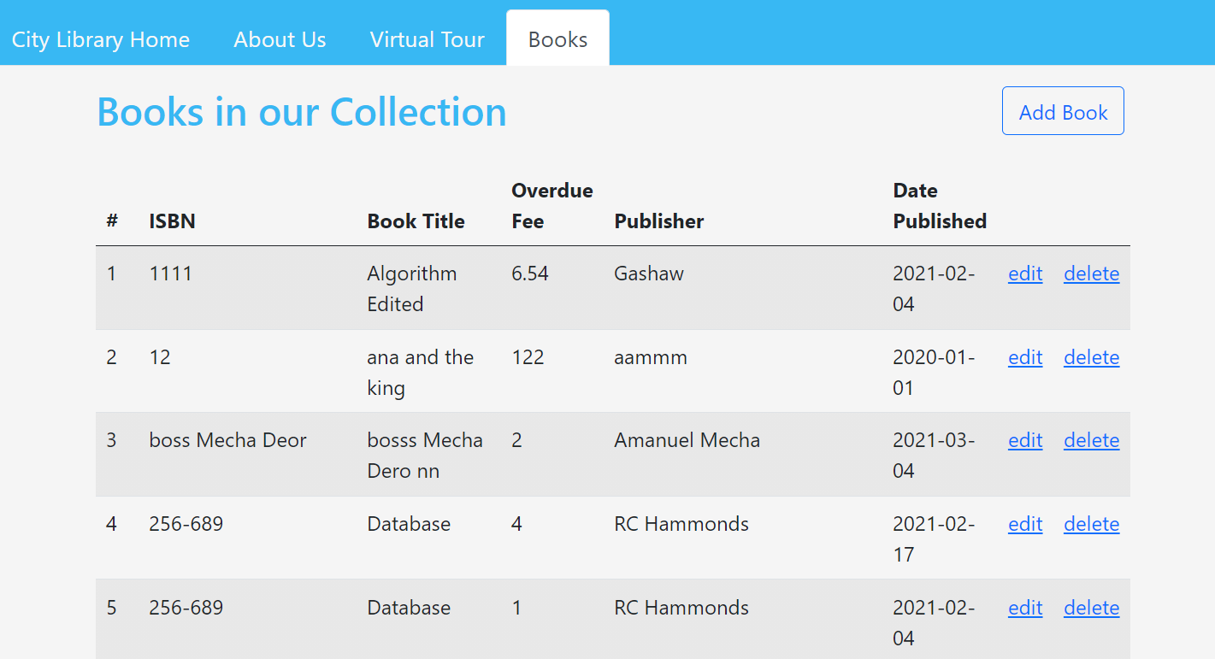

**Add:**

Click on Add Book from Books Page and fill in the form. Required Fields will be in red. Click Add after data is entered and a status message will appear.

Reset: Will clear all the data displayed.

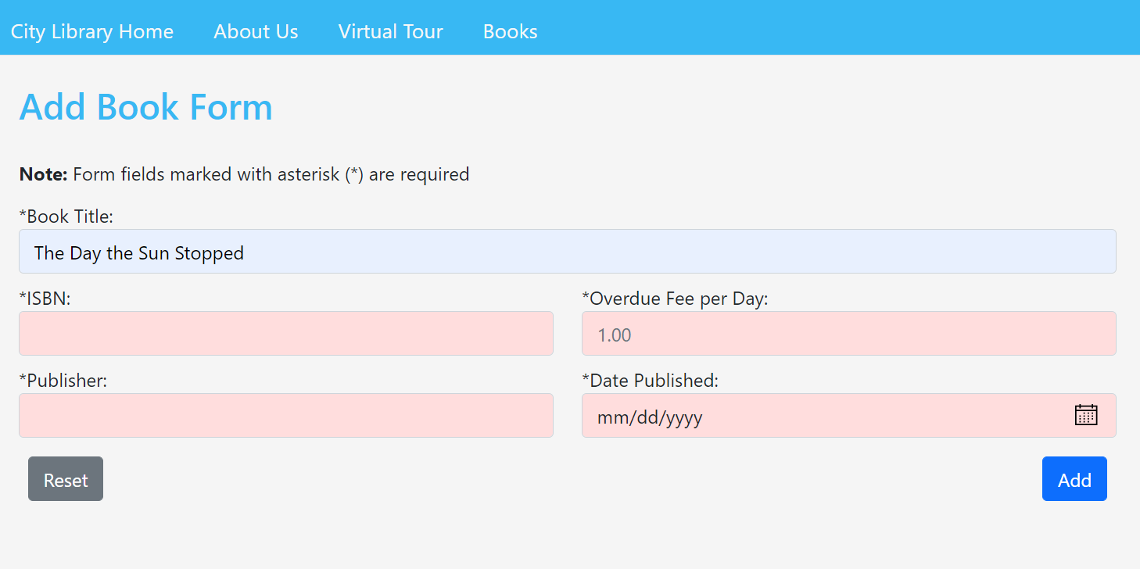

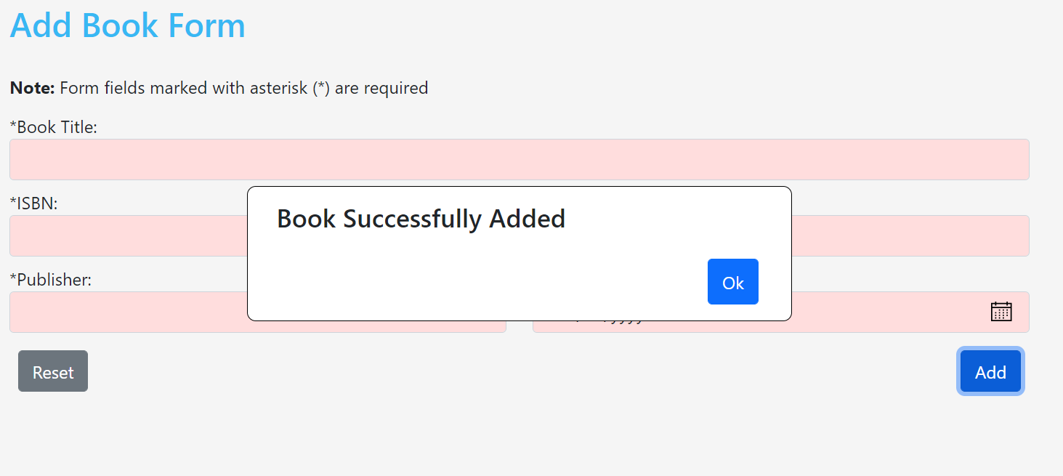

**Edit:**

To edit books find book on book page and click edit.

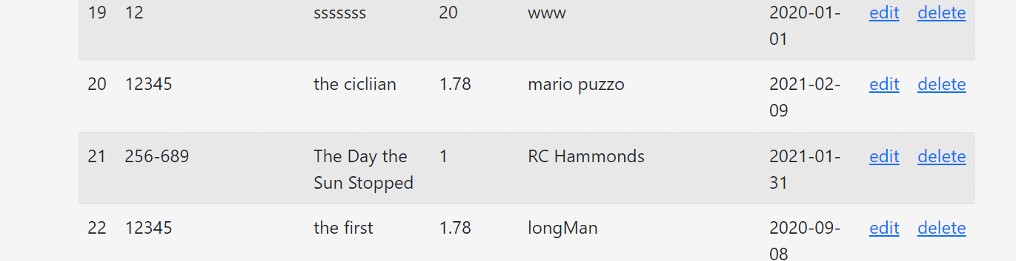

Edit: Change information and Click Edit to update.

Delete: Record can also be deleted buy clicking delete. A confirmation message will appear to confirm deletions.

Switch to Add Mode: You can also switch to add mode if you need to enter another book with similar data.

Reset: Will change the displayed data back to what the database has stored.

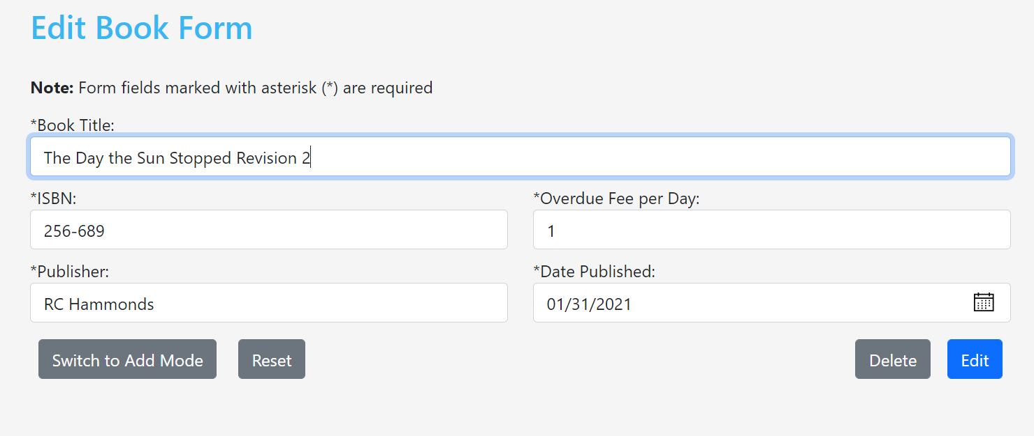

For Edits or Deletes User will recieve a status message

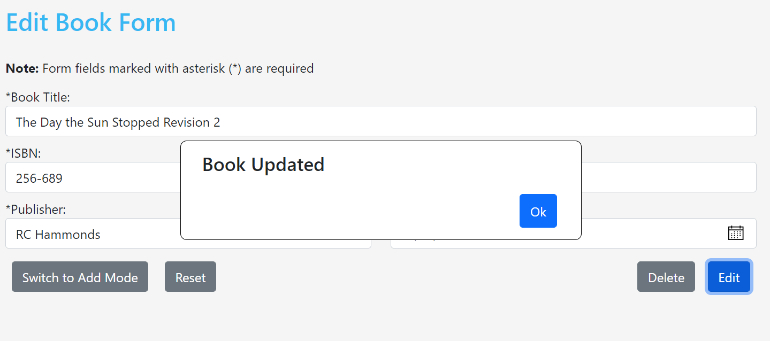

**Delete:**

Books Can be Deleted from either the Books page or Edit Page (see edit section)

To delete books find book on book page and click delete.



A delete confirmtion message will appear to verify deletion

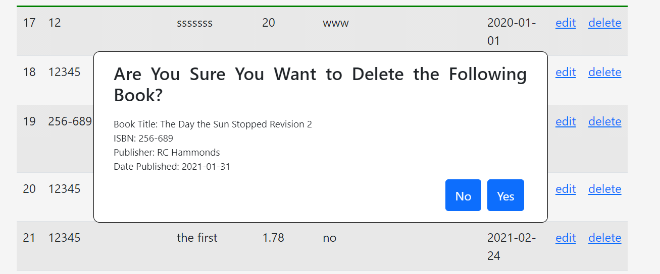

A deletion status message will appear

