# Item I: please describe how you get the theoretical distribution

I use $B^{*}\left(S\right)=\frac{u}{s+u}$、 $W^{*}\left(S\right)=\frac{S\left(1-ρ\right)}{S-λ+λB^{*}(S)}$、 $B^{*}\left(S\right)=B^{*}(S)\frac{S\left(1-ρ\right)}{S-λ+λB^{*}(S)}$

to calculate the theoretical distribution.

The cdf of M/M/1 waiting time distribution is $1-ρe^{-μ(1-ρ)y}$,

The cdf of M/M/1 system time distribution is $1-e^{-u(1-ρ)y}$

The cdf of M/H2/1 waiting time distribution for first case is

$1-\frac{1}{16}e^{-\frac{3}{2}λy}-\frac{9}{16}e^{-\frac{1}{2}λy}$

The cdf of M/H2/1 system time distribution for first case is

$1-\frac{5}{32}e^{-\frac{3}{2}λy}-\frac{27}{32}e^{-\frac{1}{2}λy}$

The cdf of M/H2/1 waiting time distribution for second case is

$1-\frac{6+4\sqrt{2}}{16}e^{-(\frac{2-\sqrt{2}}{2})λy}-\frac{6-4\sqrt{2}}{16}e^{-(\frac{2+\sqrt{2}}{2})λy}$

The cdf of M/H2/1 system time distribution for second case is

$1-\frac{8+5\sqrt{2}}{16}e^{-(\frac{2-\sqrt{2}}{2})λy}-\frac{8-5\sqrt{2}}{16}e^{-(\frac{2+\sqrt{2}}{2})λy}$

# Item II: please plot figures for two scenarios, each with two cases

Scenario I: Case I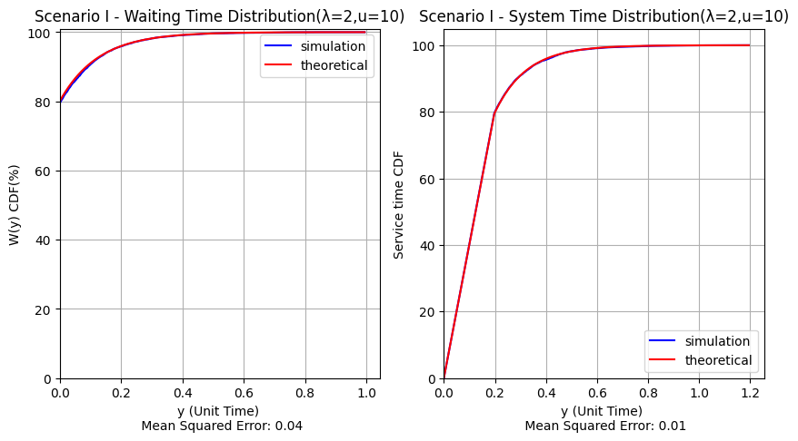

Scenario I: Case II 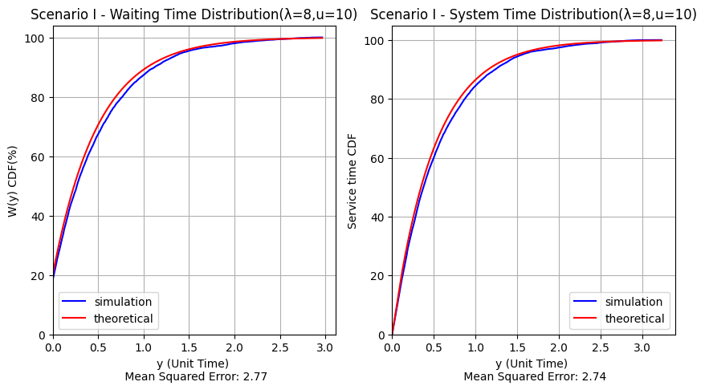

Scenario II: Case I 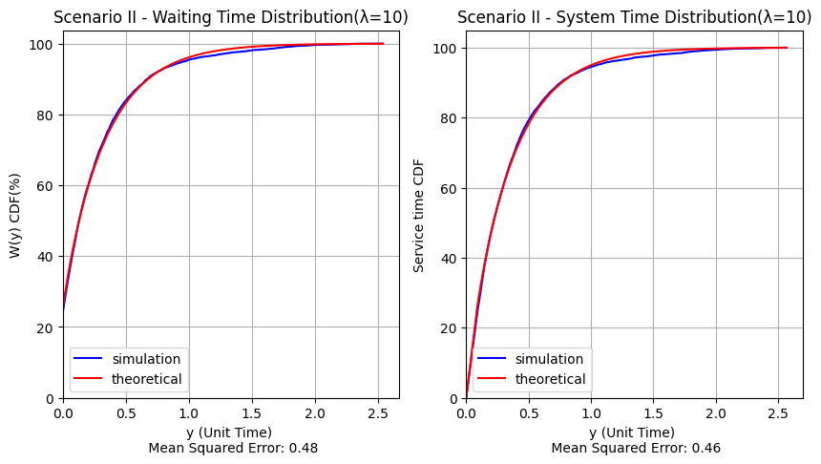

Scenario II: Case II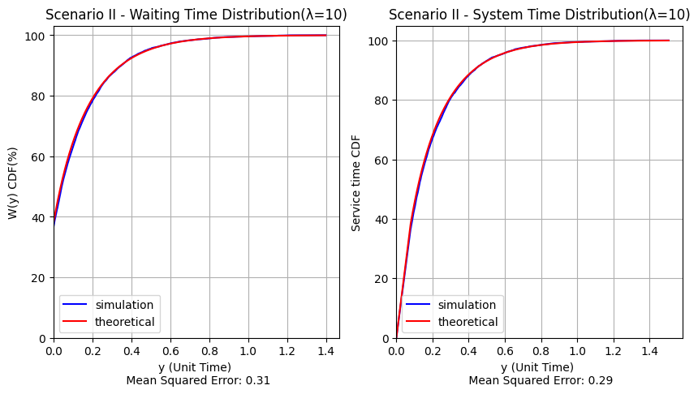

# Item III: please compare simulation and theoretical results for each case

In the Scenario I: Case I , there is no big difference between the simulated value and the theoretical value in MSE, so they are almost exactly the same.

In the Scenario I: Case II, the difference between the simulation value and the theoretical value becomes much larger in MSE, especially in the part where the waiting time is longer. This is because the processing time of the system is almost equal to the time when the guests enter. Therefore, when the number of guests increases, the system will Unable to handle, resulting in compression to the guests at the back.

In the Scenario II: Case I, when the unit time is less than 1, the simulated value is slightly more than the theoretical value, and when the unit time is 1~1.5, the number is slightly less than the theoretical value, but the difference between the two in MSE is only 0.5, so the two values are similar.

In the Scenario II: Case II, there is not much difference between the theoretical value and the simulated value in MSE, and not much difference can be seen from the graph.