PIZZA SALES QUERIES

KPIS key performance indicators
- Total revenue
SELECT SUM(total_price) as Total_revenue from pizza_sales
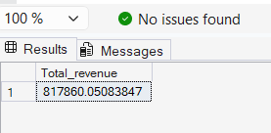

- Average order value (AOV)
SELECT SUM(total_price)/ COUNT(DISTINCT order_id) as Average_Order_Value from pizza_sales
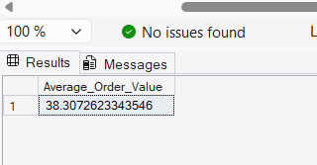
- Total pizza sold
SELECT SUM(quantity) as Total_Pizza_Sold from pizza_sales
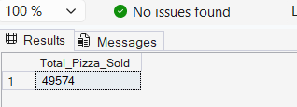
- Total orders
SELECT COUNT(DISTINCT order_id) as Total_orders from pizza_sales
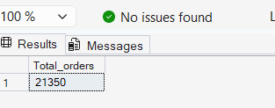
- Average_pizza_per_order
SELECT CAST(CAST(SUM(quantity) AS DECIMAL(10,2))/
CAST(COUNT(DISTINCT order_id) AS DECIMAL (10,2)) AS DECIMAL(10,2) ) AS Average_Pizza_Per_Order from pizza_sales

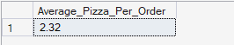

:::::::::::::::::::::::::::::::::::::::::::::::::::::::::::::::::::::::::::::::::::::::::::::::::

CHART RELATED QUERIES
- Daily trend of order

SELECT DATENAME(DW,order_date) as Weekday , COUNT(DISTINCT(order_id)) as Order_numbers
FROM pizza_sales
GROUP BY DATENAME(DW,order_date)

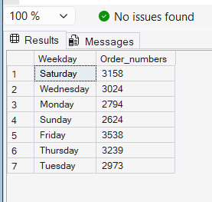

- Monthly trend of orders

SELECT DATENAME(MONTH, order_date) AS Month_name , COUNT(DISTINCT(Order_id)) AS Total_orders
FROM pizza_sales
GROUP BY DATENAME(MONTH, order_date)
ORDER BY Total_orders DESC
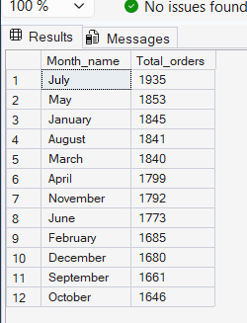
- Order percentage for different pizza category
SELECT pizza_category as Pizza_type, SUM(total_price)*100/( SELECT SUM(total_price) FROM pizza_sales
GROUP BY pizza_category
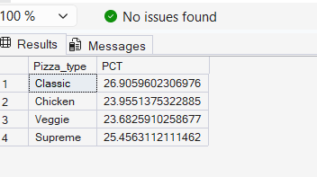
- Percentage of sales by pizza size
SELECT pizza_size, SUM(total_price) as Total_sales, CAST(sum(total_price)*100 /
(SELECT SUM(total_price) from pizza_sales) as DECIMAL(10,2)) as PCT
from pizza_sales
GROUP BY pizza_size
ORDER BY Total_sales DESC
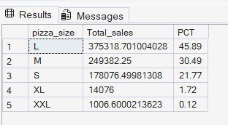
- Top five and bottom 5 pizza by revenue
SELECT TOP 5 pizza_name, SUM(total_price) AS Total_revenue FROM pizza_sales
GROUP BY pizza_name
ORDER BY Total_revenue DESC

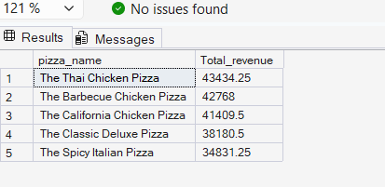
Bottom five
SELECT TOP 5 pizza_name, SUM(total_price) AS Total_revenue FROM pizza_sales
GROUP BY pizza_name
ORDER BY Total_revenue
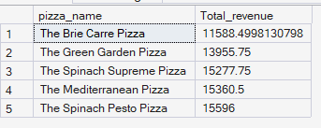

- Top and bottom 5 pizza by quantity
SELECT TOP 5 pizza_name, SUM(quantity) AS Total_quantity FROM pizza_sales
GROUP BY pizza_name
ORDER BY Total_Quantity DESC

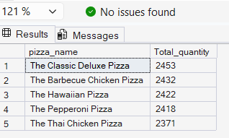

Bottom five
SELECT TOP 5 pizza_name, SUM(quantity) AS Total_quantity FROM pizza_sales
GROUP BY pizza_name
ORDER BY Total_Quantity
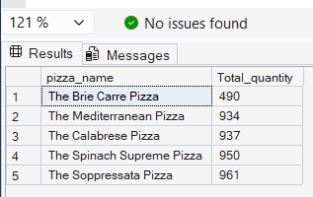
- Top and bottom five pizza by total orders

SELECT TOP 5 pizza_name, COUNT(DISTINCT order_id) AS Total_orders FROM pizza_sales
GROUP BY pizza_name
ORDER BY Total_orders DESC
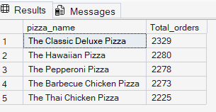
Bottom five
SELECT TOP 5 pizza_name, COUNT(DISTINCT order_id) AS Total_orders FROM pizza_sales
GROUP BY pizza_name
ORDER BY Total_orders

