SpeakEasy Design Program
based on the BASIC application developed by Robert L Caudle
based on the equations of D.B. Keele and Richard Small

Purpose:
This is a small C++ application that is a port of a program created by Robert L Caudle based on the calculations of D.B. Keele and Richard Small. The original application was written in DOS for the Radio Shack PC using BASIC in TRS DOS. This port will be written in C++ to take advantage of multiple platforms (*nix, OS X, Windows) using the C++ 17 compiler.

Program Structure:
This program will use a struct data type to enter/store data prior to performing speaker calculations. All source code will be stored locally for development. Revision control will be performed using github (Project name TBD).

The program will compute a closed box, vented box and driver parameters for a given speaker design. A graphical simulation will be incorporated at a later date. This is a command-line driven application that will present theoretical design results back to the user. Program flow will be as follows -

General Form:
The user will be expected to provide input about the specific speaker they wish to use. For example:
(For full parameter listing, see Appendix)

Product Specifications |  | Thiele-Small Parameters
Nominal Diameter | 8" | Resonant Frequency (Fs) | 52Hz
Power Handling (RMS) | 65 Watts | DC Resistance (Re) | 7.58Ω
Power Handling (MAX) | 90 Watts | Voice Coil Inductance (Le) | 1.09mH
Impedance | 8Ω | Mechanical Q (Qms) | 4.77
Frequency Response | 40 to 5,000Hz | Electromagnetic Q (Qes) | 1.45
Sensitivity | 85dB 2.83V/1m | Total Q (Qts) | 1.11
Voice Coil Diameter | 1.5" | Compliance Equivalent Volume (Vas) | 0.76ft³
 |  | Maximum Linear Excursion (Xmax) | 3mm

- User input of Thiel/Small parameters:
f_{s} = frequency of free air resistance
Q = total driver Q (aka Q_{ts})
V_{as} = Compliance equivalent volume
- Find:
V _{b}(ft³) – the net box volume
fb (Hz) box frequency response
f (Hz) The system cut-off frequency
Hump/dip in passband
- Compute:
A = f_{b}²/f_{s}²
B = A/Q + f_{B}/(7f_{s})
C = 1 + A + f_{B}/(7f_{s}Q) + V_{as}/V_{B}
D = 1/Q + f_{B}/(7f_{s})
Perform frequency sweep from f_{n}(f) = f/f_{s}
- where f = 20...20k Hz km
Response dB = 20 Log (f_{n}⁴/((f_{n}⁴ – Cf_{n}² + A)² + ( Bf_{n} – Df_{n}³)²)^{1/2})

If no change in box size:
- f3 = (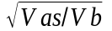
- fB = 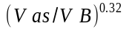
- Hump (db) = 20 log 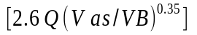

Program Flow
Typical program flow is shown below in Figure 1:

Figure 1

Program Usage
Launch the program from the CLI within a terminal window. A descriptive splash screen will be displayed for a period of 5 seconds. Once the splash screen clears, a system menu will be displayed (Figure 2):

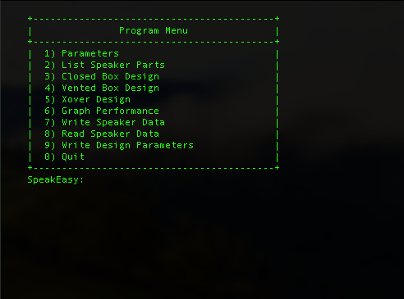

Figure 2

Speaker parameters:
The user can enter data for a given speaker. The data is stored in a data structure that contains the data used to construct the speaker simulation and display the performance via a graph. Speaker parameters can be entered via the command line OR they can be retrieved from the Speaker parameter file (*.sdb).
The Speaker parameter file is a comma delimited and lists speaker information that relates to a given speaker model. Speakers can be found from any number of online sources, such as Simply Speakers Madison Sound or Parts Express. The speaker data file contains the following data characteristics:

- Part_num - Product part number
- Type - Speaker type. One of Woof, Twet or Midr
- Vas - Equivalent Volume of cabinet dm^3
- Cms - Compliance
- Bl - BL Product (aka Force Factor)
- Qts - Total Q factor
- Qes - Electrical Q factor
- Qms - Mechanical Q factor
- Fs - Resonant Frequency
- Re - DC Resistance
- Rms - Mechanical resistance
- Z_nom - Nominal impedance (aka Impedance)
- Z_min - Minimum Impedance
- Z_max - Maximum Impedance
- Le - Voice Coil inductance (aka Lbm)
- Xmax - Maximum Linear Excursion
- Diam - Voice Coil Diameter
- Nom_Pwr - Nominal Power (aka RMS power)
- Max_Pwr - Maximum Power (aka Long-term max power)
- Freq_Low - Low-end of Freq Response
- Freq_Hi - Upper limit of Frequency Response
- Sensitivity - Sensitivity
- Vbs - Sealed Volume (user define dm^3)
- Vbv - Vented Volume (user define dm^3)
- f3_seal - 3db down point (rolloff)
- f3_vent - 3db down point (rolloff)
- v_diam - vent diameter (from data sheet – default)
- v_length - vent length (from data sheet - default)

To create a speaker database (*.sdb) file, the user selects the desired speaker from the a source of their choosing. Invoke the SpeakEasy program from the command line, then select the Parameters menu option. The user will see the following prompts:

+-----------------------------------------------------------
| Enter the speaker values as instructed below:
+-----------------------------------------------------------
Part Number : Morel_TICW__634Nd
Type (Woof/Twet/Midr) : Woof
Vas (dm^3) (aka liters): 25.4852
Compliance : 0
BL (Force Factor) : 0
Qts (Total Q factor) : 0.29
Qes (Electric Q factor): 0.31
Qms (Mech Q factor) : 3.4
Fs : 34
Re (ohms) : 3.7
RMS (kg*s) : 1.32
Z_nom (Nom Impedance) : 8
Z_min (Min Impedance) : 4
Z_max (Max Impedance) : 8
Le (mH) : 0.36
Xmax (mm) : 5.5
Diam (mm) : 220
Nom_Pwr (W) : 150
Max_Pwr (W) : 1000
Freq_Low (Hz) : 40
Freq_Hi (Hz) : 4500
Sensitivity (db 1w/1m) : 88
Box volume - sealed (m^3) : 0.0849505
Box volume - vented (m^3) : 0.169901
f3_seal (3db rolloff): 64
f3_vent (3db rolloff) : 34
v_diam (vent diameter) : 230
v_length (vent length) : 70
Part num: Morel_TICW__634Nd

The value displayed for Part num is the value that will be associated with the sdb file when the file is written to disk. A speaker simulation can be performed using just a single Woof(er), but for a complete speaker design (i.e. crossover, component selection, crossover frequencies), it is recommended to also select a tweeter and/or mid-range, if you wish to design a 3-way loudspeaker with associated crossover. If some Thiele/Small Parameters (TSP) are missing or nonexistent, depending on the loudspeaker design, the application will compute/store the values in the proper structure member. A typical data sheet will appear as shown Figure 3.

Once the data has been entered into the driver structure, the user can save the data by selecting Write Speaker Data. All of the drivers that have been created at this time will be saved to disk. If there are multiple drivers in use ( i.e. Woof, Midr(ange) and Twet(er)), each file be saved as its own unique sdb file based on the value of the Part num value displayed for that given driver. For example

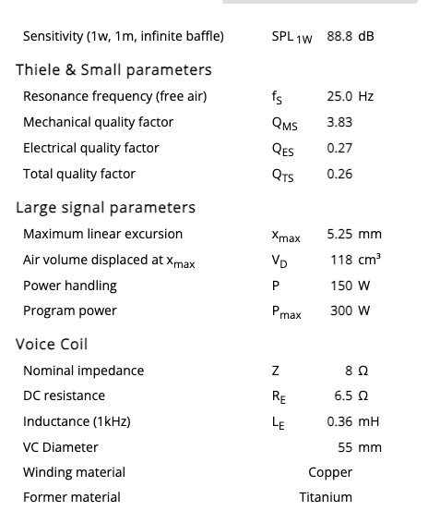 | 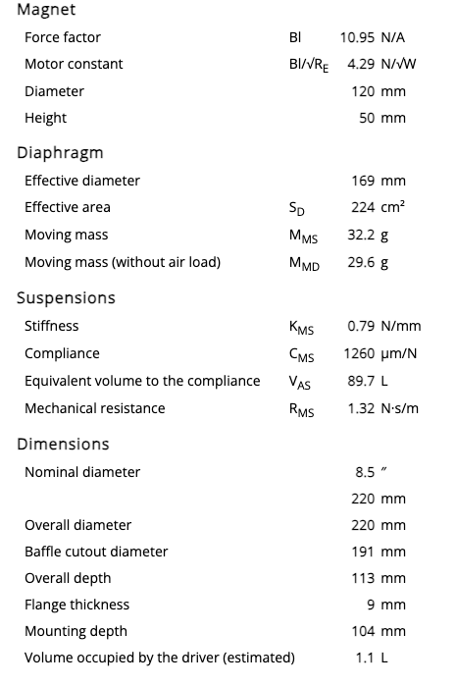

Figure 3
Speaker parameters can also be read-in from a previously created *.sdb file or simply used in a one-and-done use. The sdb file can contain multiple lines of entry. Refer to the section Read Data for instructions on how to perform this action.
Once the speaker specifications are written into the program data structure, the speaker values can be calculated/written to the speaker data structure when the cabinet structure is defined. Figure 4 details the execution flow to create/read speaker parameter data..

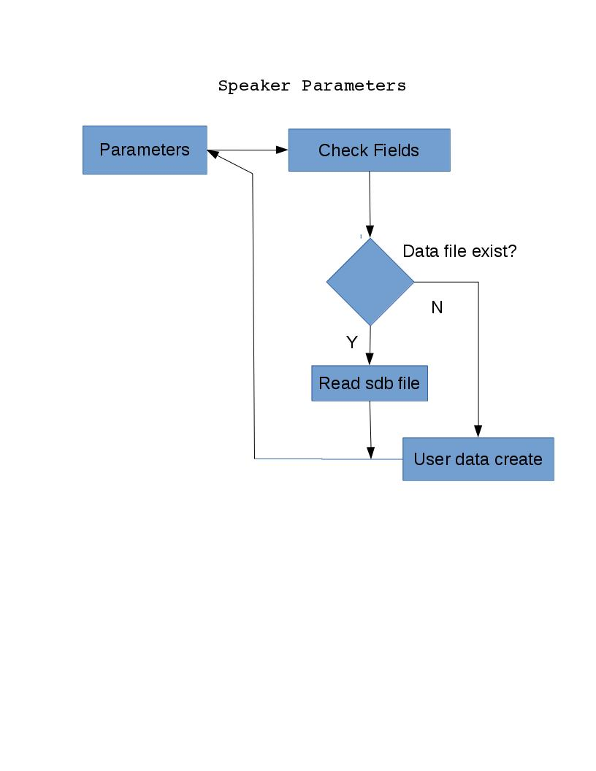
Figure 4

Closed /Vented Box:
The user can chose the type of speaker to design – either a closed or vented box. Each one uses the same basic Small/Thiele parameters, although there are some minor changes based on cabinet size, frequency tuning and vent aperture for the vented box speaker.The application will take data entered via the Speaker parameters menu selection. The Vented Box function will compute data based on the parameters that the user enters. See Figure 3.
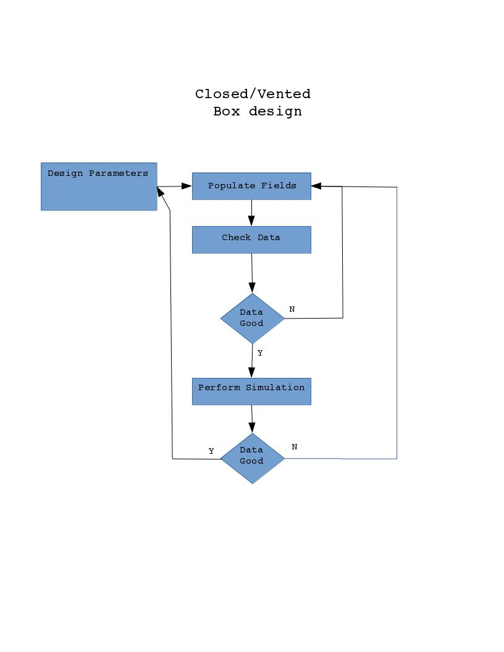

Figure 3

After the desired bass/Woofer driver has been loaded into the program, the user can select the Vented design option. The application will perform intermediate calculations based on the data read in from the sdb file (see Figure 4).

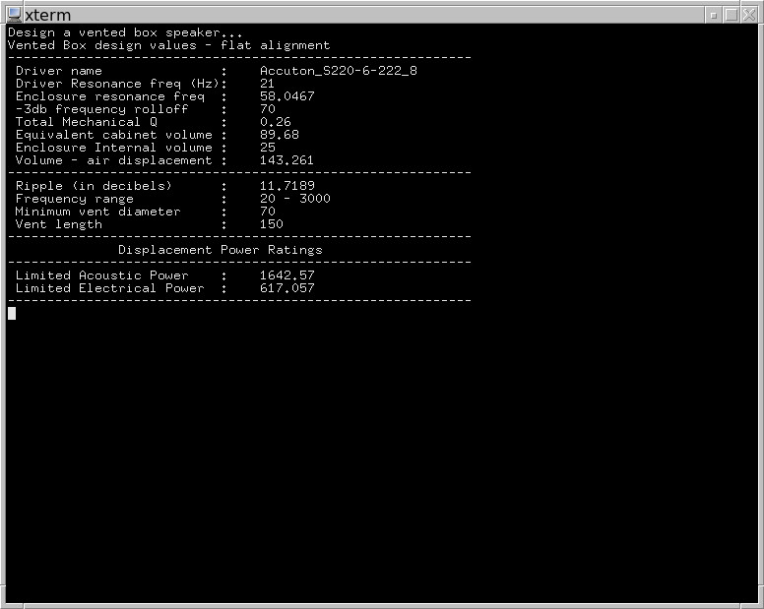

Figure 4

The information displayed in Figure 4 is derived from the Small/Thiele speaker parameters stored in the driver data file. The user will be prompted for the name of the speaker response file. This file stores the resulting logarithmic plot of the bass response over the range of the speaker bandwidth. The user can then plot the file using a 3rd party tool, such as gnuplot, librecalc, excel, etc. Once the data is displayed to the screen, the user can choose to accept the data and proceed with the next design phase, or perform minor modifications to the Small/Thiele values to change the frequency response.

Should the user make changes to the overall design, the program will prompt the user for the Small/Thiele parameters to modify that impact the overall vented box sound This is shown in Figure 5

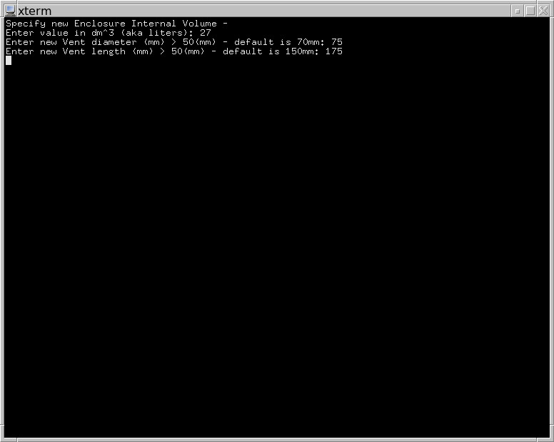

Figure 5

The application will then perform the necessary and display them back to the user. (See Figure 6) The new data presented below details the theoretical performance with the modified Small/Thiele parameters. The user will then be asked to once again select a name for the new frequency response file. If the user is happy with the data, they can exit the speaker design window and return to the main menu.

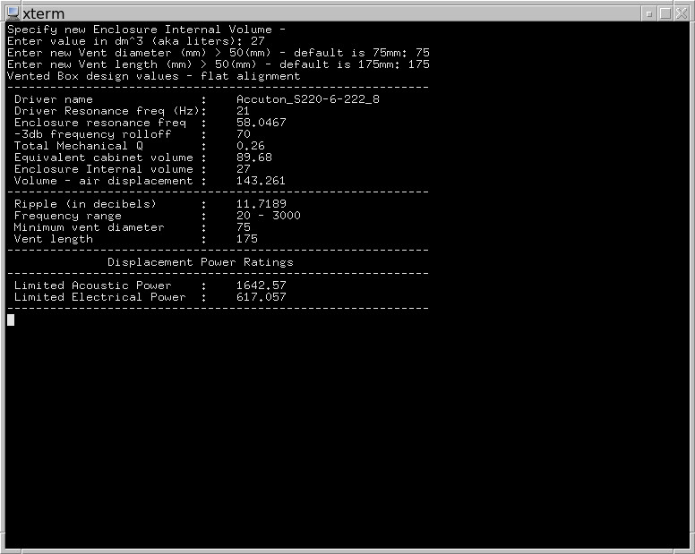

Figure 6

Closed box design is similar to the vented box design. The differnce is that due to the fact that this is a closed system, there are more factors that can impact the speaker design/sound performance.

Crossover design – Overview A crossover network is used to divide the input signal between the elements that will make up the loudspeaker. The design may be active or passive. A typical passive crossover network consists of a resister, capacitor and a signal source. Depending on the number of capacitive elements, the crossover network will be anywhere from a 1st order on up. The only limits are the size of the internal circuit board and the overall internal space available. A typical passive crossover element consists of a resistor ( R ) in parallel with a capacitive element ( C ) in parallel to a resistive load ( R_{L} ) as shown below(Figure 7):

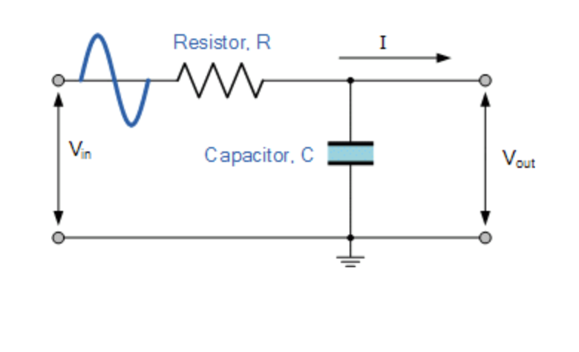

Figure 7

The image above displays a typical 1st-order, low-pass circuit. The Resistor is in parallel with the Capacitor. Both are in parallel across V_{out}, which is typically connected to a loudspeaker, which in this instance is a woofer or bass driver. A high-pass circuit will show the Resistor and Capacitor swap positions. In each instance, the program will solve for the resistive element. Speakers that utilize 3 speaker elements, a band-pass filter is required. A band pass filter uses both a low-pass and high-pass filter element cascaded together.
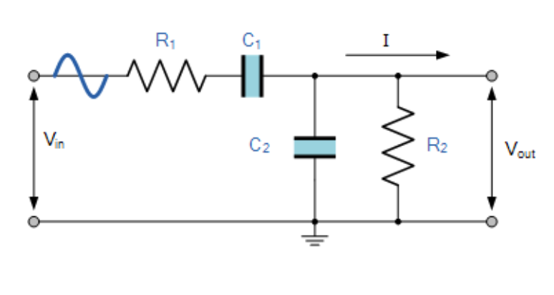

Figure 8

The correct way to understand the topology of Figure 8 is the low-pass crossover element is comprised of R₁ in parallel with C₂. The high-pass element of made up of R₂ in parallel with C₁. The circuit above is an example of how filter elements are cascaded together. Another feature of a band-pass filter is that it is always a 2nd order filter since, by definition, there are two capacitive elements (C_{1 /}C₂) that make up the circuit.
An active crossover network utilizes not only capacitive and resistive elements, but also an amplification element in the form of an OpAmp. The OpAmp requires external power (V+/V-) in order to power the circuit. Many active filters are external units with separate cable leads to each of the speakers housed in the cabinet. An active low-pass filter schematically appears below:

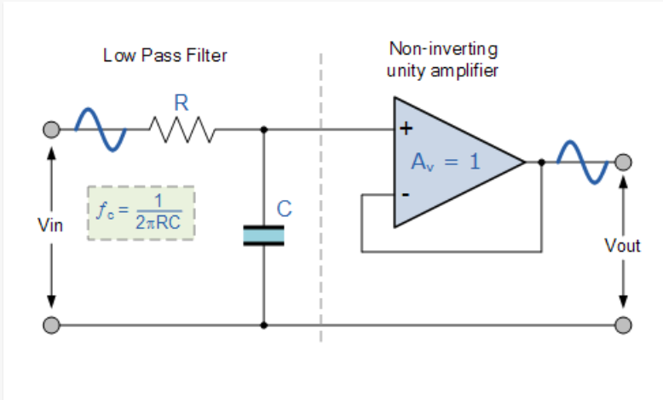

Figure 9

The filter looks similar to the passive low-pass filter shown in Figure 9. The difference is in the OpAmp element. Again, to create a high-pass filter, swap the placement of the resistor ( R ) and capacitor ( C ). As before, this is a 1st order filter due to the single capacitor element. An active band-pass filter is identical to the passive band-pass filter, except for the OpAmps:

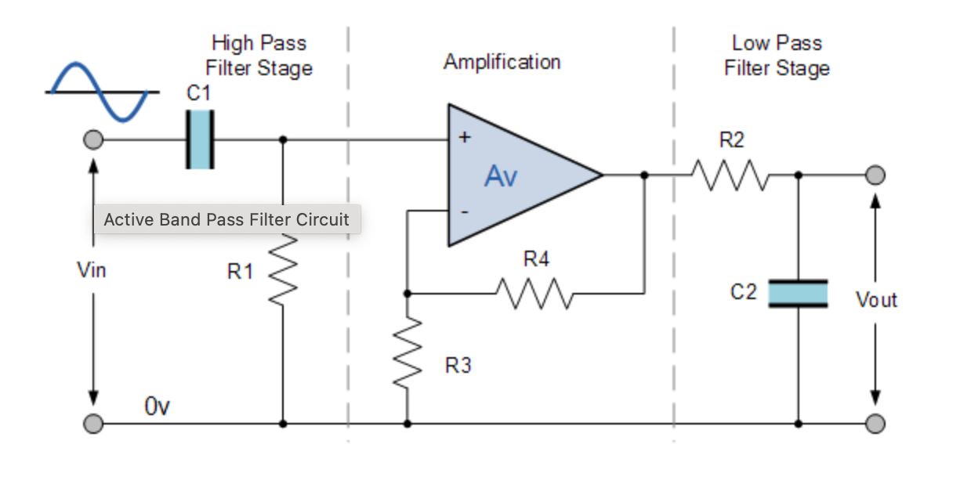

Figure 10

As previously stated, due to the capacitive elements, this is a 2nd-order filter. Active filter elements can be cascaded together to make higher order filters.

The order of a filter not only refers to the humber of reactive elements in the circuit, but also informs the user/designer of the steepness of the frequency response curve. At the value of f_{c} as shown on Figure 11, that is the frequency in which the signal changes and begins to decrease or attenuate. f_{c} is also called the -3db cut-off. At this point, the response curve for frequencies above f_{c} begin to drop towards 0db gain. This is shown in Figure 8 for N=1 and higher, where N refers to the order of the filter.

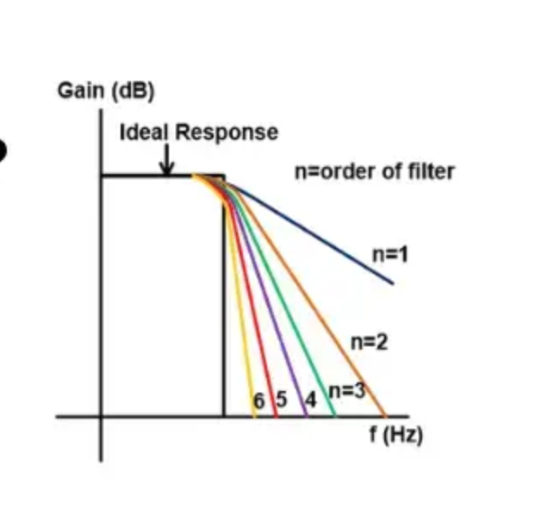

Figure 11

Each N-indice is equivalent to N * -20db slope. If N = 1, the slope is -20db/octave. For N = 3, the slope is -60db/octave.

Crossover Design:

When the user invokes the Xover menu option, the crossover design menu will appear:

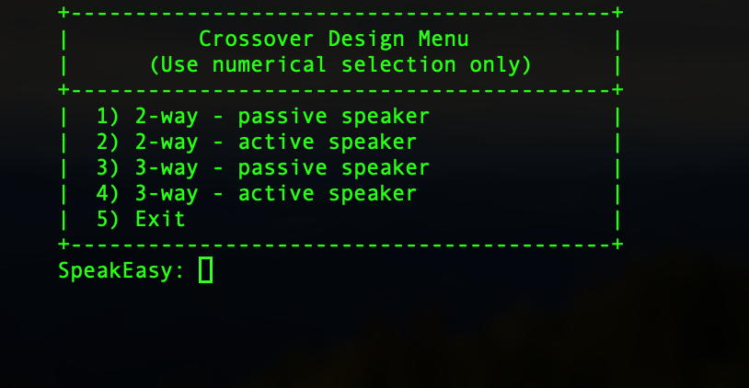

Figure 12

The menu offers both Active and Passive design options for 2- and 3-way speaker networks. The example screen below is for a 2-way passive network. The tool determines the crossover frequency from the frequency overlap of the bass and tweeter drivers. This crossover point (or points for a 3-way speaker) is used to determine the resistive/capacitive components. The user is asked to specify the capacitance value to determine the Resistance value. See Figure 11 below:

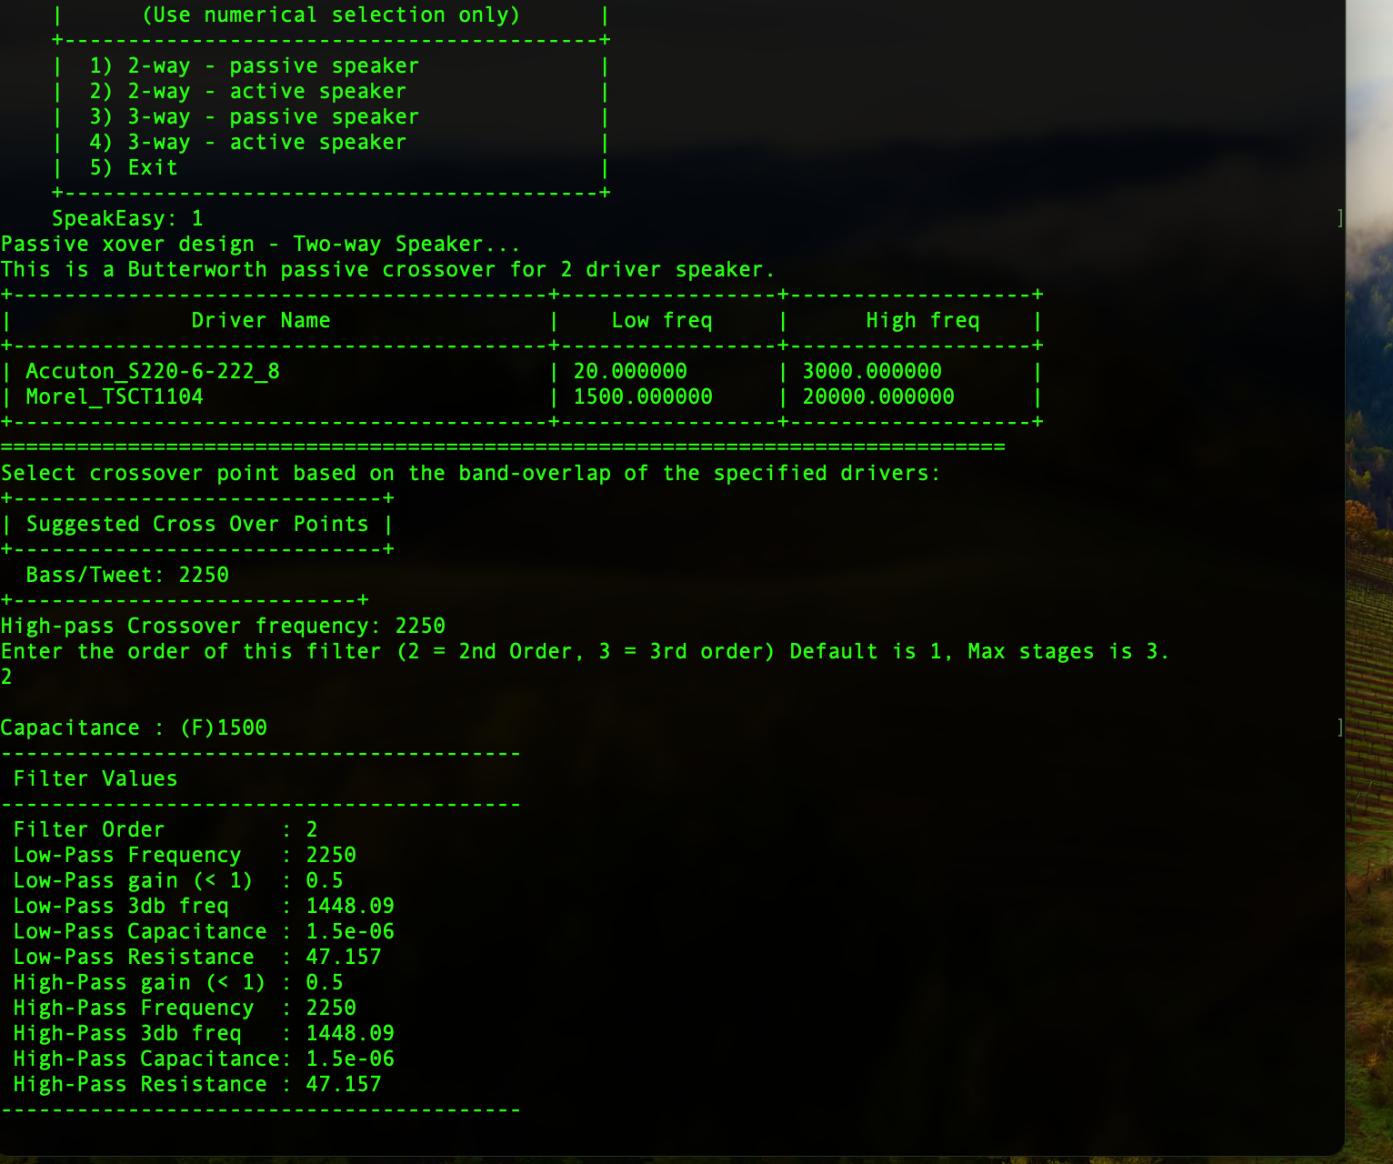
Figure 11

In the case of a 3-way crossover, the information displayed is similar. In the example shown below (Figure 11), an active crossover network is being designed. As with the 2-way network, the High/Low frequencies are displayed along with the driver name in the frequency table table, with the crossover frequency f_{c} computed and displayed. In the case of the Active Filter, there is a resonant frequency that is defined as the bandwidth frequency (midrange(high) – midrange(low)) For the selected drivers, this frequency bandwidth (aka resonant frequency) is centered at 2315 Hz. Since this is an Active filter using an OpAmp as an amplifier, there is a gain associated with the circuit. This gain is determined by the feedback path from V_{o} to V- on the OpAmp circuit. The gain is computed from the feedback path formed by R3 and R4. The values for these resistors are set internally such that R₃/R₄ → infinity. The computation is then V_{gain} = 1 + R₃/R₄. V_{gain} is effectively 1 as for this circuit, the role of the feedback is to simply clear up and noise that may be introduced by the circuit. As with the previous design, the user chooses the Capacitive load and the resistance for each cut-off frequency is determine. Since the bandpass filter already uses two capacitive elements, this is a 2nd order filter by default. Higher order filters can be implemented by cascading the bandwidth filters together, but the order will be an even value (N = 2, 4, 6,…)

Once the filter parameters have been submitted, the SpeakEasy tool computes the resistive element, displaying it along with the other component values (see Figure 12). The user can then either exit the sub-menu or change the crossover network parameters (# of stages, capacitive elements filter type – active or passive) and recalculate the filter parameter.

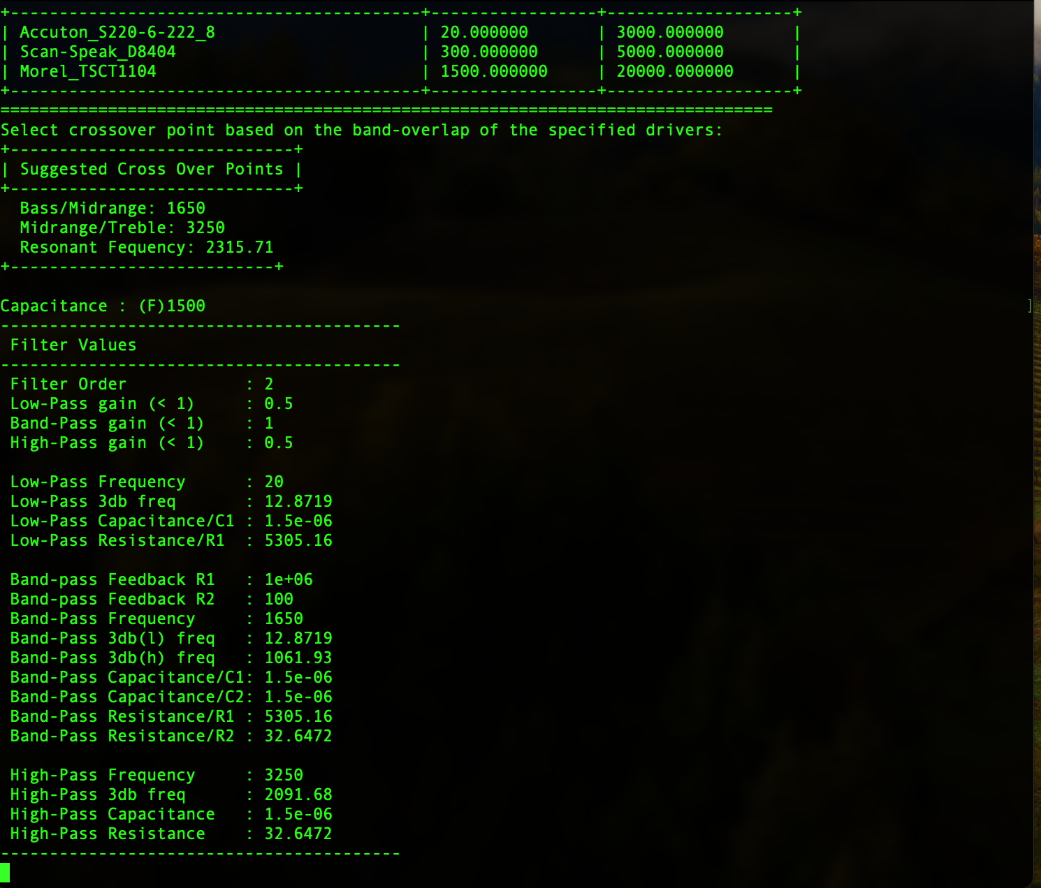

Figure 12

Graph Speaker:
The graphing function utilizes a 3rd-party software application to display the speaker characteristics in the form of a logarithmic graph. (plotting data can be easily imported into a spreadsheet app such as LibreCalc, Excel, Google Sheets. This feature is not fully implemented at this time.)

Save data:
xThe user can save design data to a file in the form of an ASCII-based text file. The saved data only stores the speaker parameters. The file will use the extension ‘.sdb’. Each of these files will specify the type of speaker driver (i.e. woofer, midrange, tweeter) and the associated Small/Thiele characteristics used to create an approximate design.

Read data:
The user can read design data from an ASCII-based text file. The file to be read uses the extension ‘.sdb’. Data is typically read in when the user is looking to:
- design a loudspeaker (closed or vented).
- create a passive crossover (2-way or 3-way).

Specific files are chosen via the Driver Selection Menu. Any driver files stored with an *.sdb extension are read/parsed/seperated by the file name/type of driver that corresponds to the selected driver type. The Driver Selection menu displays the three primary driver types available – Bass, Mid-range and Tweeter. (See Figure 13)

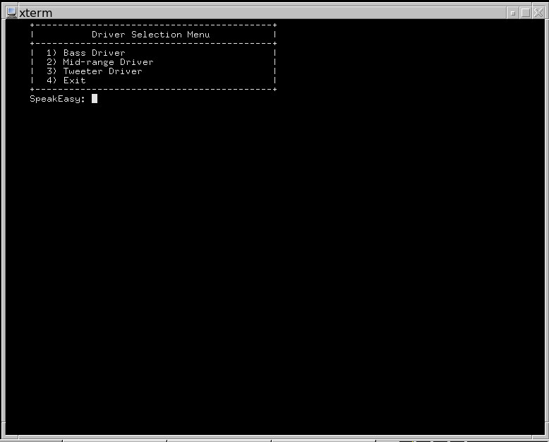

Figure 13

Choose the appropriate driver to load into the application. It is suggested to choose the Bass driver first. Since the speaker cabinet is designed around the bass driver, the cabinet dimensions and tuning factors can be determined first. The mid-range and tweeter can be uploaded after the cabinet is deigned, depending on the type of speaker (2-way vs 3-way). With the Bass driver selected, the list of available speakers are displayed for the user to choose from. (see Figure 14). In this instance, two bass drivers are listed (that were previously created/saved by the Write speaker menu). Once the <Enter> key is pressed, the Bass speaker is loaded into the application to design a cabinet or perform a crossover design. Selecting Mid-range and Tweeter perform the same steps for those speaker elements as well. (NOTE: Speaker elements are kept local to the SpeakEasy program itself. This reduces the overall footprint of the application in a dedicated drive and keeps the speaker componets local to the application.

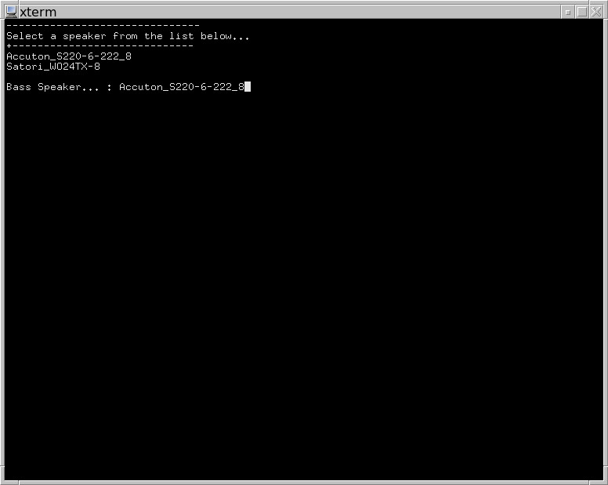
Figure 14

Write design data:
The user is able to store the finished design in a flat formatted text (*.ddf) file. The file can be opened/read by any editor that supports plain, unformatted txt format.

Exit application:
The program exits and returns control to the command-line.

Appendix

Speaker Model - Goldwood GW-8028 - 8 ohm 8" 100W Home Stereo Woofer

8" rubber edge poly-mica cone woofer.
SPECIFICATIONS  Nominal Diameter: 8.0", 203mm  Nominal Impedance: 8 ohms  Nominal Power: 100 W rms, 190 W max  Freq. Response: 25 Hz-6 kHz  Sensitivity: 90 db 1w/1m  Magnet Weight: 20.0 oz, 567 grams  Voice Coil Diameter: 1.5", 38mm  MOUNTING INFORMATION  Overall Diameter: 7.99", 203mm  Baffle Hole Dia: 7.125", 181mm  Number of Mounting Holes: 4  Mounting Hole BCD: 7.63", 194mm  Depth: 3.25", 81.25mm | T/S PARAMETERS  Fs: 36.0 Hz  Re: 7.2 ohms  Le: 0.5mH  Qms: 3.90  Qes: 1.21  Qts: 0.92  Vas: 43.6 L, 1.54 cuft  Xmax: 2.5mm  CONSTRUCTION  -Pressed steel basket  -Poly-mica cone with rubber edge  -Ferrite magnet

GRS 8PR-8 8" Poly Cone Rubber Surround Woofer
Product Specifications |  | Thiele-Small Parameters
Nominal Diameter | 8" | Resonant Frequency (Fs) | 52Hz
Power Handling (RMS) | 65 Watts | DC Resistance (Re) | 7.58Ω
Power Handling (MAX) | 90 Watts | Voice Coil Inductance (Le) | 1.09mH
Impedance | 8Ω | Mechanical Q (Qms) | 4.77
Frequency Response | 40 to 5,000Hz | Electromagnetic Q (Qes) | 1.45
Sensitivity | 85dB 2.83V/1m | Total Q (Qts) | 1.11
Voice Coil Diameter | 1.5" | Compliance Equivalent Volume (Vas) | 0.76ft³
 |  | Maximum Linear Excursion (Xmax) | 3mm

Parts Express Staff Recommended Enclosure Volume
Sealed Volume | 0.85ft³
Sealed F3 | 52.2Hz
Vented Volume | 0.85ft³
Vented F3 | 43.3Hz

G. Margolis, R. H. Small, “Personal Calculator Programs for Approximate Vented-Box and Closed-Box Loudspeaker System Design” Journal of the Audio Engineering Society Vol 29, No 6, 1981 June pp 421-441, No 11, 1981 November pp 824
In some instances, the database as supplied by the manufacturer may be incomplete. It is suggested to perform a google search for the specific driver you wish to use. A secondary resource will often provide the values needed for the sdb file
Since this is a command-line interface program, the system prompts above will be presented one line at a time until the full sdb structure is completed.
The order of a circuit is defined by the number of reactive (capacitor or inductor elements) in the circuit. Filter elements can be cascaded together to create higher-order filter networks.
- Anything above N = 4 doesn’t show any improved performance for a loudspeaker. Therefore I never go beyond a 4th order crossover network.
The goal is to implement the tool gnuplot for this feature. The Apple/Windows implementation is not available at this time.

