Speak Easy

A loudspeaker design simulation tool based on the equations of D.B. Keele and Richard Small from research performed by Neville Thiele, Richard Small and Gary Margolis as reported in The Journal of the Audio Engineering Society.

- Introduction
SpeakEasy is an application written in C++ with python3 support to aide and simply the design of loudspeakers. This application is based on work by D.B. Keel and Richard Small using the physical parameters defined by Richard Small and Neville Thiele.
- What is SpeakEasy
SpeakEasy IS NOT a hidden or clandestine place to have your favorite adult beverage. It IS a program created to make designing a loudspeaker/loudspeaker systems faster. Much of the calculations SpeakEasy performs are based on research performed by Gary Small and Richard Thiele (among others). With the advent personal computers, various PC programs were created – some large some small to speed up the design of loudspeakers. Many only covered the bass or sub-woofer cabinets, leaving the other parts of the speaker (mid-range, tweeter) to trial and error. Crossover networks were based on LRC) elements. SpeakEasy. What SpeakEasy cant do is design the full speaker. What it CAN do is determine the cabinet sizes, vent lengths/ports, configuration of baffles, setup of passive woofers and the design of the filter networks (low-pass, band-pass and high-pass) to complete the speaker design.
- Program Structure
SpeakEasy uses C++ Objects and structs to managed/manipulate/store data. The program is designed to enable the user to load data once, create a design, save/print the resulting design and create a new design with out exiting/closing out the application.

- Program Overview
Typical program flow is shown below in Figure 1:

Figure 1 – General program flow
The application will allow the user to either read in speaker driver (aka *.sdb files) as part of a stored set of libraries, or to create a driver on the fly (and possibly store it later) as part of the user’s design library.
- Download/Install/Execution
To download/install SpeakEasy, navigate to the github repository and retrieve the SpeakEasy.zip file. This zip file contains the following:
* speaker_easy.cpp/.h – The primary code and header file.
* main.cpp – The main file that consists of program flow and menu display.
* compute.cpp/.h – The ancillary compute functions and procedures.
* menus.cpp/.h – The menu display procedures.
* driver_area.py – python file used to read/display the specific .sdb file based on type (i.e. woofer, mid-range, etc)
* SpeakEasy.doc – The user documentation
* Sample .sdb files – these are files used to give the user a quick tutorial on how to use the application.
* Crossover circuit schematics – These give a schematic representation of the three crossover types: sub-woofer, two-way, three-way. Each schematic has a spice file that corresponds to the circuit.
* SPICE (*.sp) Template files. These are irrespective of sealed or vented cabinets types. They are files used to model circuit behavior of the crossover should the user choose.
* make.sh – Application make file
The file will be downloaded into the local Download space on your laptop/desktop.
Each platform must have the following requirements tools in place prior to installing/building/launching the application. Not every computer will install these tools by default, so the user will need to confirm the tools are installed and the path is configured to access them:
* Linux: C++17 compiler, python 3, a terminal tool (default term or xterm), zip/unzip. Use the standard linux methods to update the computer before downloading.
*MacOS: C+=17 compiler, python3, terminal tool (installed by default), zip/unzip utility. If these tools are missing, use the Apple package update utility to update the system.
* Windows 10: Windows has multiple options available to compile/execute the SpeakEasy application. At the very least, a C++17 compiler needs to be installed on the system. Either Windows Visual Studio C++ compiler or MinGW will work. Another useful environment is Cygwin or MobaXterm. Both of these tools require a little extra work (installing terminal windows, c++ compiler, python, etc) but they provide users a Linux-like environment which some people prefer.
- Program Usage
Launching and using SpeakEasy is simple. Start up a command tool on your desktop/laptop (which one depends on the OS you are using). At the command prompt, change directories to the location you installed the SpeakEasy application in. At the prompt, type in SpeakEasy. The SpeakEasy banner will be displayed before moving to display the top-level menu.
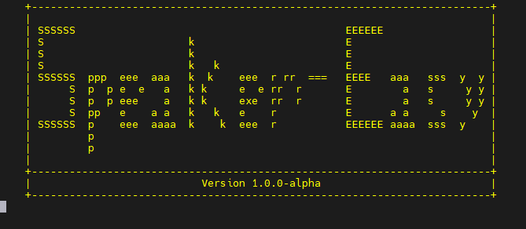
Figure 2 – Banner image
The banner page will change display the Top-level Menu (TLM) which displays the primary functions of SpeakEasy.
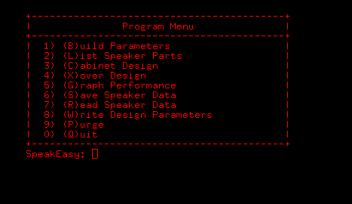
Figure 3 – Top-level menu
- Top-level Menu
Build Parameters:
Build Parameters allows the user to input the T/S and other physical characteristics for a given driver. The T/S data will not change. The physical characteristics (cabinet volume, port size, cabinet tuned frequency) will vary based on the information that the user supplies and/or the default values that are determined by various design choices. A sample speaker is shown below in Figure 4.
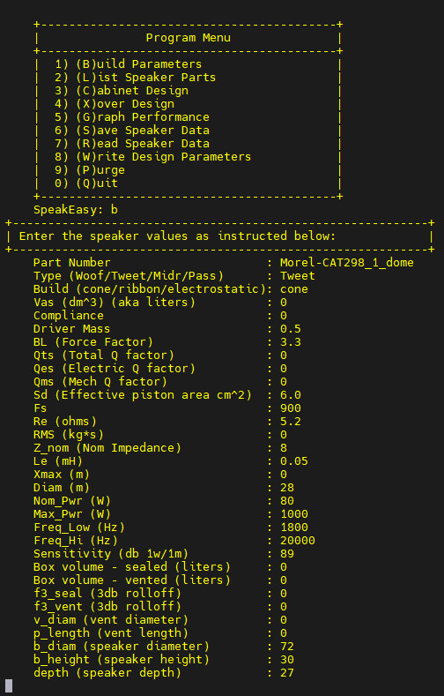
Figure 4 – Device creation screen
List Speaker Parts
Once a speaker has been loaded into the application, the user can choose to list speaker using the “List Speaker Parts” menu. This will ONLY display drivers that have been loaded into the application. It will display up to 4 unique drivers:
- Passive
- Woofer
- Midrange
- Tweeter
If no speaker(s) have been loaded or retrieved from the library, then this function will return a blank screen before it returns to the TLM. Figure 5 shows a listing for an Accuton S220 622 woofer.

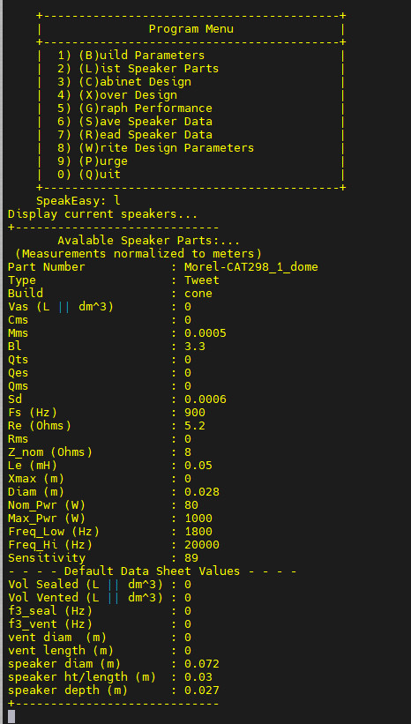
Figure 5 – Display Part: Accuton S220
Cabinet Design:
The Cabinet Design menu offers users one of three choices:
- Sub-woofer
- 2-way Speaker
- 3-way Speaker
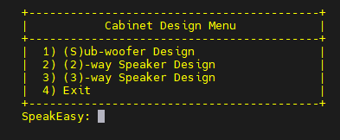
Figure 6 – Cabinet Design options

Within each option, the user can choose either a Sealed cabinet or a Vented cabinet. The both design have options that the user will be asked to answer. These will be discussed in the Design Flow tutorial section.
Once the user is satisfied with the values that SpeakEasy calculates, the user selects Exit or option 4. The application proceeds to determine the cabinet dimensions along with key performance parameters (Resonant frequency, roll-off frequency, internal H-W-D). If the user is designing something other than a sub-woofer (such as a 2- or 3-way speaker, then the application will proceed to the next ‘cabinet’ and determine the same design characteristics.
Typically Bass/Midrange cabinets are enclosed boxes of varying size, dependent on the V_{as} of the speaker driver. For cone tweeters, the cabinet will be somewhat small, based on the physical dimensions of the tweeter itself. If a ribbon/electrostatic mid-range/tweeter is being used in the design, then the dimensions will change and take on a triangular shape with vertical aperture along the back. This will aide in eliminating standing waves that could negatively impact the sound.
Xover Design:
Xover (aka Crossover) design is used to direct frequencies across the sound spectrum (20-20K Hz) between the speakers. The top-level Xover menu is show in Figure 8:

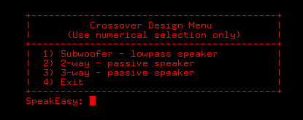
Figure 8 – Xover main menu
If the user attempts to select an option (for example – a 2-way passive speaker but only a bass or tweeter speaker have been loaded into the application), the application will inform the user that a driver(s) are missing and return to the main Xover menu as shown in Figure 9:
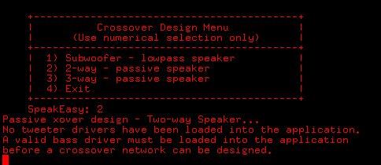
Figure 9 – Xover load error message
A more detailed example will be shown in the Design Flow section below.
Graph Performance:
Graph data is not available at this time. But the graph files are available and can be accessed using any spreadsheet application.

Save Speaker Data:
Save Speaker Data is typically used to write a newly created driver out disk. The application will save ANY file that is loaded into the application (Sub-woofer, Woofer, Midr(ange), Tweet(er)) and write it to disk.
Example: The first field of the loaded driver (Part_Number) is appended with the string “.sdb”. Any SpeakEasy file that is written will be a *.sdb file. In the case of the file that was loaded earlier, Morel-CAT298_1_dome, the Part_Num is parsed by SpeakEasy and the ‘.sdb’ string is appended to the Part_Num. The new library part is now Morel-CAT298_1_dome.sdb. Therefore, it is important the drivers have a unique identifier as the Part_Number.
Read Speaker Data:
Driver files are read in based on the TYPE of speaker/driver the user is looking to create. The top-level driver selection menu will look like Figure 10:
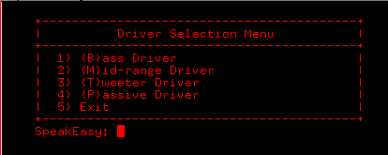
Figure 10 – Driver Selection Menu
If the user wants to build either a sub-woofer or a bass cabinet, the user would select 1 or B/b for “Bass Driver”. SpeakEasy will perform a query on all of the available *.sdb files looking for ‘Woofer’. The query is executed by the driver_area.py script. The script will display ALL *.sdb files that fit the criteria of “Woofer” as shown in Figure 11. The speaker type is queried from ALL of the *.sdb files, and will list only the files that are being searched for. In this case, all of the drivers that are of type “Woofer”. Once the speakers are listed, using the cursor, select and highlight the driver, paste it in the field for “Choose Speaker…:” then enter <Return>. The selected driver will be read into the application then, as before when the driver was initially created, the driver entry is copied over and ‘normalized’, converting all of the measurements – meters, centimeters, etc. into meters. This normalization makes the calculations consistent across the application. Once the computations and cabinet design is completed, the values are resolved back to their original units of measure.
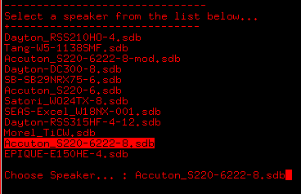
Figure 11 – Driver Selection screen

Write Design Parameters:
The Write Design Parameters formats and writes the speaker design to a Word-formatted document. All information related to cabinet measurements, cabinet volumes, port dimensions and crossover values will be written to the file chosen by the user. This can be used as a preliminary design phase where the user can revisit the interim design and start from the end point, or it can be final design. This is the first portion of the speaker design process. Once this information is archived, it is up to the user to complete the design phase – cabinet bracing, cabinet fill-material (if chosen), and circuit board layout for the crossover, input terminals and L-pads.
Purge:
The Purge command command is used to clear the loaded drivers and the current design data and start over. This allows the user to make a change mid-design and load different drivers, change the parameters of the design (sealed vs vented). Vary the cabinet size, change the port slot/length to create a different frequency response. Once the design is completed and the user is satisfied with it, then the user can write the final results out to disk (See the section o “Write Design Parameters”).
Quit:
Quit exits the application. Any and all driver data that HASN'T been saved into the user’s library, any designs or crossover circuits that were not written to disk via the Write Design Parameters
- Design Flow:
Regardless of the type of speaker option being designed, the general process is the same.
1) Select the speaker type
2) Choose the type of design (sealed or vented)
3) Answer the design prompts based on the characteristics of a given speaker desired.
4) Determine the crossover for the components selected.
5) Write the design data out to disk cor review later.
6) (Optional) If you are experienced with EDA (Electronic Design Automation) software, SPICE netlist templates have been included. You only need to download/install SPICE on your computer and can execute the SPICE application.
7) Once the initial design has been saved and the crossover network has been designed, it is suggested to determine the bracing and compute the volume that this material will add to the overall cabinet. This includes determining the size of the midrange/tweeter enclosures. It is suggested that the enclosures material thickness(for bass/midrange) be constructed out of 3/4” (19mm) thick material. For tweeters, the thickness can be thinner, ½” (12 mm) thick. The type of material is up to the user. Most DIY designs take advantage of MDX while others use Baltic Birch plywood and others use High-Density Fiberboard (HDF)/ The table below lists the pros/cons of each choice.

Material | Pros | Cons
MDF | - Excellent internal damping  (reduces resonance)  - Uniform density; easy to machine  - Smooth surface for paint or veneer  - Inexpensive & widely available  - High mass beneficial for bass enclosures | - Heavy  - Weak screw-holding;  prone to stripping  - Poor moisture resistance  (swells and breaks down)  - Brittle edges  - Dust hazard when cutting
Baltic Birch Plywood | - High stiffness-to-weight ratio  - Strong screw-holding  - Lightweight compared to MDF  - Durable and impact-resistant  - Suitable for portable and  rugged designs | - More resonant than MDF (requires damping)  - More expensive than MDF  - Surface may require filling for smooth paint finishes
Marine-Grade Plywood | - Extremely durable and weather-resistant  - Excellent for outdoor or high-humidity environments  - Good strength and screw retention | - Expensive  - Same acoustic cons as regular plywood (resonance)  - Overkill for indoor/home applications
HDF (High-Density Fiberboard) | - Higher density and damping than MDF  - Smooth, uniform surface  - Excellent for ultra-low-resonance designs | - Very heavy  - Difficult to machine; hard on tools  - Expensive  - Still moisture-sensitive like MDF
Table 1 – Recommend materials

- Design Tutorial:
This section will present a design tutorial for each speaker type and walk the user through what each of the design-screens signify. Although the overall time to design a speaker is somewhat quick, to the first time user, the program prompts and questions may be confusing. Review the tutorials and follow process.
Sub-woofer:
Designing a sub-woofer is the cabinet to design for. It is a single cabinet with a speaker and a crossover. The crossover often will have a selectable frequency option to change the crossover point of the sub-woofer. This is dependent on the users tastes and the subsequent design of the main speaker.
To begin the sub-woofer design, launch SpeakEasy from the command line. Once the splash screen goes away, the user is left with the main tool menu. Enter the command ‘R/r/7’ to bring up the ‘Read menu”:

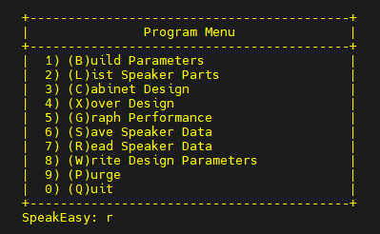
Figure 11 – Main Program Menu
Once the Driver Selection Menu is displayed, select option ‘1’. This will display the list of bass drivers to build a cabinet with. In this instance, the Accuton_S220-622-8-mod.sdb file is selected.:
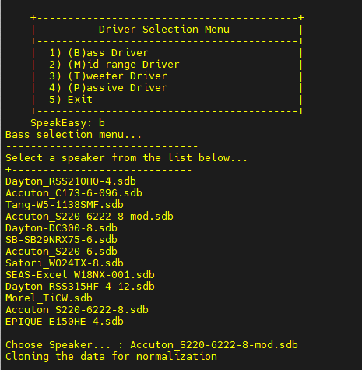
Figure 12 – Bass Selection
Once the speaker is selected, the driver is loaded into application memory and the data is ‘normalized’ into Meters. This allows for simpler, uniform calculations. The data is converted back into the original Metric format (or Imperial measure – inches/cubic-feet, etc) for printing purposes.
After the data has been loaded, the user can choose other drivers (such as a mid-range or tweeter if they are building a full-spectrum speaker) or they can exit and proceed to build a sub-woofer.
Once the user exists the ‘Read’ submenu, the main Program Menu appears. The user can then select the “Cabinet Design” option from the menu. Select 3/C/c to invoke the Cabinet Design Menu. From this menu, the user will select option ‘1’ and build a sub-woofer cabinet. After the option is specified, the user will see the “Sub-woofer Design menu”, the user then has the choice of building either a ‘Sealed’ or ‘Vented’ cabinet. In this instance, a sealed cabinet will be ‘built’ or simulated.

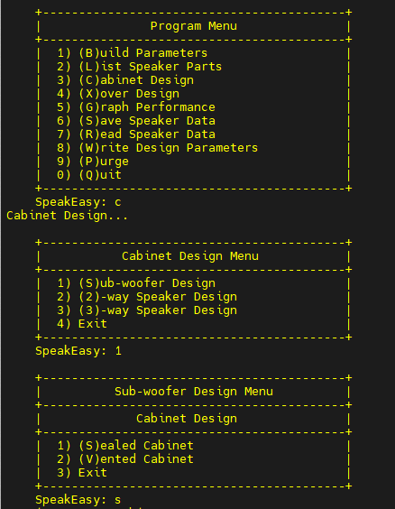
Figure 13 – Cabinet Design Menu
After the type of cabinet design is selected, the user will be given the option of using acoustic filling or not. In this case, acoustic filling is used in order to help dampen out internal standing waves and reduce internal resonances. The next menu displayed allows the user to tailor the cabinet for desired design specifics.
The user has the option of using the following options:
1 – Default values as defined by the Thiele/Small (T/S) parameters that the user used to create the speaker sdb file.
2 – Specify a specific box volume bu choosing a size larger or smaller than the reference volume initially created. Not that modifying the box volume will change the resonance frequency, frequency response and the -3db roll-off frequency of he cabinet.
3 – Design around the Q_{tc.} The default value for Q_{tc} is 0.707 or lower is known as a damped system. It will allow for the flatter frequency response, better transient response (noticeable on musical content with sharp impacts, such as percussion).
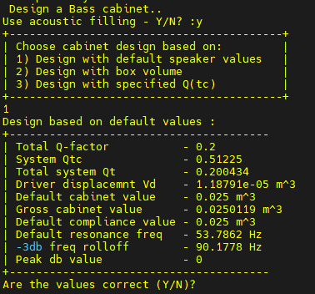
Figure 14 – Cabinet fine-tuning options
Once the cabinet options have been selected, the design parameters will be displayed. You will observe that the Peak db value is 0. This is the result of the value of Q_{tc} being >= 0. If the value of Qtc is less than 0, then the Peak db value would be a logarithmic relationship based 1/(Q_{tc}² – 2). The user will be asked to accept or reject the values for the design. If the user rejects them, then they can redo the design with differing parameter values or choose a different design (i.e. vented design).
If the values are accepted, then the final accepted values for the cabinet are displayed. The values are initially shown in metric units (normalized to meters). The use will then be asked to show the cabinet data as defined by the application. The user will be prompted to display the cabinet in either Metric or Imperials units of measure. In this example, Imperial methods are selected:
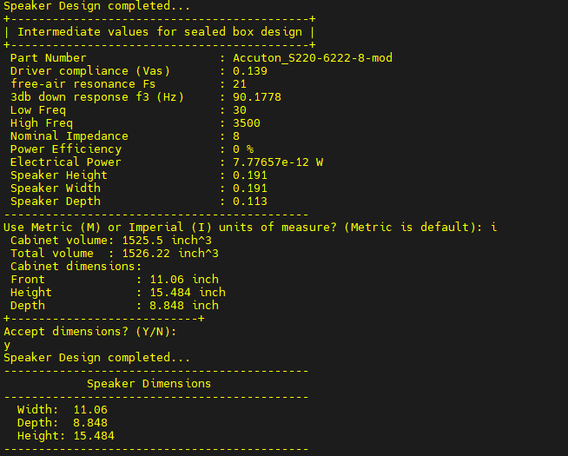
Figure 15 – Final design measurements
Once he final design is accepted and displayed, the application will return to the sub-woofer design menu. The user can choose to exit out or design/re-design a new cabinet. This will return the user to the main program menu once again (see Figure 11). Once the user is satisfied with the cabinet, they can then design/define the system crossover.
Crossovers for sub-woofers are simple in nature. It consists of a simple 2nd order Butterworth filter with a user-select able crossover point. The crossover menu is show below:
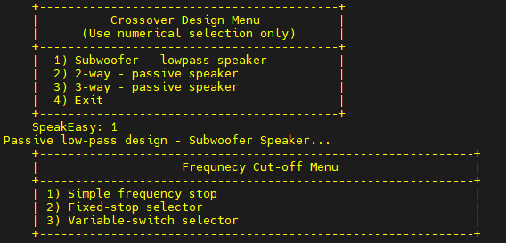
Figure 16 – Sub-woofer crossover menu
After the sub-woofer crossover option is selected, the user will be presented with three design options:
1) A single fixed crossover point as defined by the user.
2) Fixed-stop selector. This option will ask the user to define the number of crossover points and the start/end crossover frequencies.. A rotary fixed-detente knob will allow the user to select the desired crossover frequency.
3) Variable frequency. This will prompt the user to enter a range of frequencies over which the sub-woofer will operate.
For this example, option 2) – “Fixed-stop selector” been chosen. The application will prompt the user for the number of stop points (4) and the frequency range (120...160). The application will determine the frequency deltas and compute the inductance values for each frequency. Capacitance is per-selected at 1 micro-Farad (uF). The resulting values are displayed in the table below:
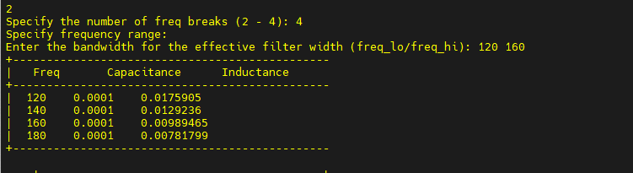
Figure 17 – Crossover design values
Once the user exits the crossover screen and they exit out to the main screen, they have the option to save the design to a file. From the main menu, the user will select option ‘8/W/w’. This will prompt the user for a name of the file to write to. The application will write the driver information, the cabinet design data, and the crossover values to a file. The user can then select then print out the file and begin the process of building their sub-woofer. For those who are familiar with SPICE, the basic sub-woofer schematic is listed in the Appendix along with the .spi template. The template is included with the zip file that includes the source code and this documentation.
NOTE: The initial cabinet design only shows the inner dimensions to meet the cabinet volume. Cabinet bracing, cabinet ports (if a vented or slotted design is used) must also be considered. For construction tips, there are two excellent books listed in the reference section of this guide.
Passive Radiator:
A Passive Radiator is a variant of a vented/ported speaker. If the the user chooses a speaker that requires a large cabinet volume to create a port around, then a passive radiator is a good 2nd choice.
A Passive Radiator is similar to a regular speaker, only it has no ‘electro-magnetic components (i.e. no magnet, no electrical connections). It operates due to the sound back-pressure from the bass driver. It is a sound reinforcement that allows bass to be extended similar to a ported/vented speaker design. It boosts low-frequencies without any electrical connections. It is simply a diaphragm. It does require weight to be added to the diaphragm to meet the requirements of the cabinet resonance frequency, however. This tutorial will create a sub-woofer using a passive radiator design, but the same principle applies to a full-frequency speaker also.
Launch Speakeasy as before and load a Bass speaker into the application from the Driver Selection menu. Once the Bass driver is loaded, the user can select a Passive Driver, or wait and make the decision later, depending on the design outcome of the vented design. For now, the Passive speaker will be selected later.
Once the bass driver is loaded, choose the Cabinet Design→Sub-woofer Design option from the menu options. When he Sub-Woofer design menu (see Figure 13), select the Vented Cabinet option.
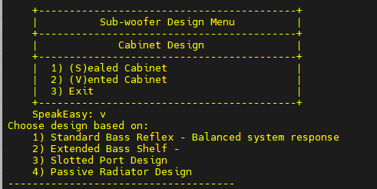
Figure 18 – Vented Speaker Design
The Vented cabinet menu
offers three choices:
1) Standard bass Reflex design - This is based off the values that are stored in the speaker file.
2) Extended Bass Shelf – This option uses a larger cabinet, larger port and extends the bass resonance frequency, allowing for a boomier bass sound.
3) Slotted Port Design – as the name implies. Instead of a bass port, a slot is designed. This to is an option to design a more compact cabinet.
4) Passive Radiator Design – this option makes use of a Passive Radiator in the cabinet design.
For now, select option (4). Since a Passive load wasn't selected, the Passive menu will be displayed:
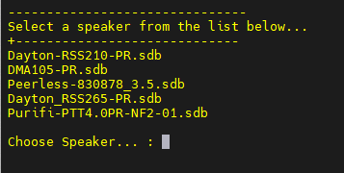
Figure 19 – Passive load options
For now, the Dayton RSS265-PR will be selected. Once the driver is loaded, the application will display the system recommendations for the Passive Radiator-based design:

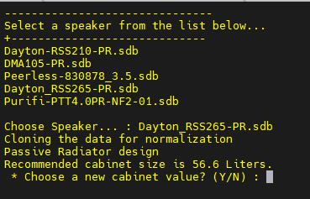
Figure 20 – Passive Load Selection
In the case of this Passive Radiator, the value required for the Passive Radiator to meet the resonance frequency is too low. So the design for this instance will be halted and a new design choice will be made that does not use a Passive Radiator.
(NOTE: There is some further work required for this feature, so this will be resolved in the next update for SpeakEasy)
Two-way/Three-way Speaker:
Two-/Three-way designs are nearly identical, other than the addition of a 3rd speaker (Mid-range). The basic design methodology is the same, therefore, this tutorial will ONLY cover three-way speakers.
To design a two-/three-way speaker, launch SpeakEasy from the command line. From the Main menu, select the Read Speaker Data option as before. In this instance, you will select the following drivers:
* Bass Driver (Accuton_S220-6222-8.sdb)
* Mid-range Driver (Satori_MR16P-8.sdb)
* Tweeter Driver (LCY-K100.sdb)
(For this tutorial, a Lcy Lazy Ribbon has been chosen for the tweeter. This will be covered in more detail shortly.)
Once the compliment of drivers have been selected, the cabinets can be designed. When designing a full-range speaker, the Cabinet Design Menu offers 2-way and 3-way design options in addition to the Sub-woofer option.
(See figure 16). Select the 3-way Speaker option. The application will then prompt the user to select between a Sealed and Vented cabinet. NOTE: this prompt ONLY pertains to the design for the Main or Bass cabinet. Typically, mid-range and tweeter enclosures are sealed, with the cabinet designed around a Q_{tc} of 0.707 for both mid-range and/or tweeter enclosures. This the flattest response and, since typically tweeters DO NOT have an associated V_{as} or defined V_{bs} due to the frequencies involved and the size of the cabinets. If a ribbon or electrostatic driver is used, the design of the enclosure will be similar to a ‘prism’ with a small aperture at the back. This is to reduce standing waves that can result from the ribbon/electrostatic driver. A typical cone or dome tweeter will utilize a more traditional ‘cubical’ enclosure. Although, if a cone mid-range or tweeter are expected to be used ‘outside’ of the main enclosure, a spherical enclosure could be utilized, as long as it meets the design requirements for the speaker.

Once the Bass cabinet is defined, the user will see the following displayed by the application:

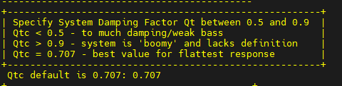

Figure 21 – Mid/Tweet design menu
The Mid-range design, in this case for the Satori MR16P, will return the following information back to the user:
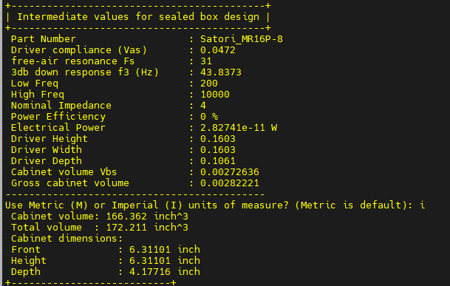
Figure 22 – Mid-range results
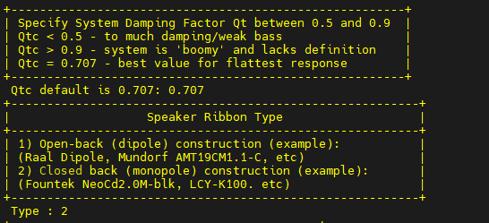
The tweeter values will be determined lastly. Again, since the driver selected is a ribbon tweeter, the user will be prompted to specify the type of deign for the driver. Again, 0.707 is the suggested/flat response and is what the system will default to. For a ribbon/electrostatic driver, the user will be asked to specify the ribbon construction.
Figure 23 – Ribbon/Tweeter construction
The user has a choice been a Open-back (aka Dipole construction) or a Closed-back (aka monopole) construction. To identify which is which, look at the data sheet for a given driver. If the image of the driver shows a small housing behind the driver itself, then the construction is a Closed or Monopole type. A flat or thin construct is an Open or Dipole driver.
The resulting enclosure dimensions will appear below:
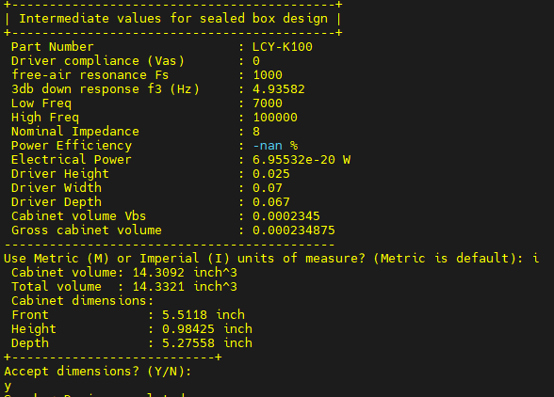
Figure 24 – Ribbon design data

The enclosure dimension for this speaker will be similar to that of a prism or wedge. The Depth will extend back roughly 5.3 in, while the width wil be just over 5 ½ in. This will allow the user to build a prism-like housing that extends past the back of the ribbon enclosure. The height itself is the height of the speaker ribbon that faces out towards the listening space.
Once the enclosure(s) are completed, the user can start to design the crossover. With a three-way crossover, there is a low-pass filter (for the bass), a band-pass filter (aka a low-pass cascaded with a high-pass filter) for the mid-range and a high-pass filter for the tweeter. Both the Low/high-pass filters are 2nd order passive Butterworth filters while the band-pass is a 4th order passive Butterworth filter. Users can define other filter types on their own, but those are not supported by SpeakEasy at this time.

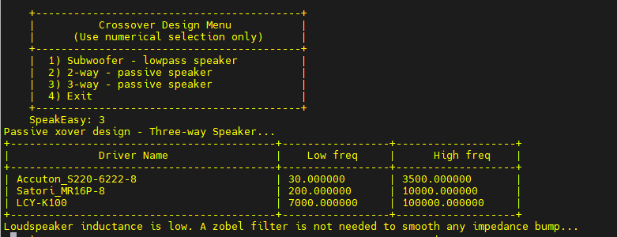
Figure 25 – 3_way design frequencies
SpeakEasy will compare the frequency badwidth of all of the speakers, display them in a table as well as check the inductance (L_{e}) of the bass driver to determine of a Zobel filer is required to sooth out any frequency bump that is the result of the impedance of the woofer being too high.
SpeakEasy will then begin to perform calculations to determine the crossover points from Low/Band-low and Band-high/Low filters. The resulting values for this driver selection can be seen below:
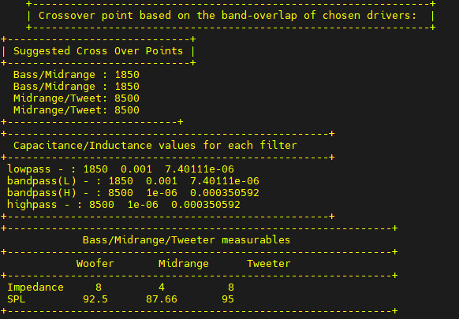
Figure 26 – Design parameters
Driver measurables displayed at the bottom (impedance and SPL) show that the selected speakers are relatively good matches. The need for an Lpad in the Mid-range/Tweeter circuits of the crossover is highly suggested however because of the impedance mismatch between the woofer/Mid-range and the SPL (Sound Pressure Level) between the Mid-range/Tweeter). The remainder of the crossover values will be stored in the filer structure.
Afer the crossover has been designed, the user can then write the cabinet and filter design data to disk. All of the needed data – cabinet size/dimensions, Speaker selections, filer design data will be written to disk. This information can then be used later to assist in cabinet build, parts requirements/sourcing for the crossover and give th designer an idea of the size of the build. At this point, the designer can make decisions if the proposed design will meet the designers needs.
- Conclusion:
SpeakEasy is an easy to use speaker simulation tool. It is meant to assist with the design of loudspeaker design. Once the design has been completed, it is up to the user to complete the design work of laying out the circuit board, sourcing necessary parts, and computing the volume of materials (such as bracing, port materials, etc). Physical design/layout can be assisted with the use of tools FreeCAD, SolidWorks, AutoCAD or Fusion 360. Circuit simulation tools such as SPICE can very filter components, design and network simulation. Once the design work is completed, it is up to you, the user, the assemble the cabinets. Depending on the design complexity, woodworking skills can be put to good use. Or, your design may come very close to any one of many DIY speaker kits (See PartsExpress, MadiSound).

- Appendix I– SPICE models:
SPICE stands for Simulation Program with Integrated Circuit Emphasis. It is a common design and simulation tool used to test/simulate/validate Large-Scale and Very Large-Scale Integrated circuits (LSI/VLSI). SPICE can also model/simulate analog and small-scale digital circuits also. The tutorials in this document were tested/validated against SPICE. The circuit models referenced here are written in a generic, portable SPICE format. You can download/install SPICE from the following locations:
* LTSpice – Analog Devices: Supports Windows/Mac
* NGSpice – SourceForge: Supports Windows, Mac, Linux, BSD, Solaris
* Oregano – GitHub: Supports Windows, Mac, Linux (although support on Oregano has fallen off. Other place and route/schematic capture tools may be better suited and supported.)
The models below are created in a template format, meaning you make a change in one location only and then execute the SPICE deck (SPICE simulation files are referred to as ‘decks’). SPICE will perform DC Analysis, AC Analysis, Frequency Analysis and allow users to perform ‘sweeps’ of values for specific parts. Ideal when checking the performance of Lpads and/or adjustable frequency cut-offs (F_{c}).
This application assumes a rudimentary knowledge of spice. The netlists included can be basically cut and pasted into a file and ngspice can be called from a terminal. If you have never used SPICE, a brief lesson will be given at the end of this Guide.
Low-Pass Sub-woofer with Zobel network
The circuit schematic below shows a sub-woofer speaker with a Zobel filter inserted. The Zobel filter (Rz/Cz) is only necessary if the inductance of the speaker is above a certain value.

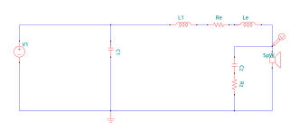
Figure 27 – Sub-woofer Schematic

The SPICE netlist for the Sub-woofer schematic is below.
NOTE – For all of the SPICE templates, columns that begin with a ‘*’ are commented out. Lines with an embedded ‘;’ indicates an inline comment
<sub-woofer_title_here>
*----------------------------------------------
* GNUCAP - NETLIST

.options OUT=120
*------------- Models -------------------------
* Each Lpad has its own .param value. This allows the user to adjust
* each Lpad in a 'real world' simulation

*------------- Power Supply -------------------
V_V1 1 0 dc 1.0 ac 1.0 sin(0 1 1000)

*------------- Circuit Description-------------
L_L1 1 2 Lxx

C_C1 2 0 Cxx

R_Sp_B 4 0 Rxx

* For a pot or Lpad, the connections are R_Lp <pos_node> <low_node>
* <adjust arm> in this instance node(s) [5/7] go to the high or signal node, * node(s) [6/8] connect to the pos side of the mid/tweeter speakers and
* node(s) [0] connect to the ground. 8 is the value of the lpad
* or potentiometer

*--- Loudspeaker Model based on T/S params ----
L_LeB 2 3 Lexx
R_ReB 3 4 Rexx

*-- Zobel Filter Values (optional based on Le --
C_Cz 4 5 0.0224994
R_Rz 5 0 6.7

*---------------- Analysis --------------------
.ac dec 100 20 50000
*.tran 0.1ms 100ms
*----------------------------------------------
*.print v(4) v(9)

.plot ac db(4)
.plot ac db(7)

*.print ac v(4)
*.print ac v(7)

*.tran 0.01ms 10ms
*.plot tran v(4)
*.plot tran v(7)

.end

Two-way circuit with Lpad attenuation
The schematic circuit below shows a circuit for a two-way speaker. The elements marked as as Le/Re are the internal values of the speaker resistance/inductance. These values are placed in series with the resistive load of the speaker. The inductance of the speaker is high-enough that a Zobel compensating filter is not required, as it was for the sub-woofer model above. However, depending on the bass speaker selected, a Zobel filter may need to be incorporated into the design.

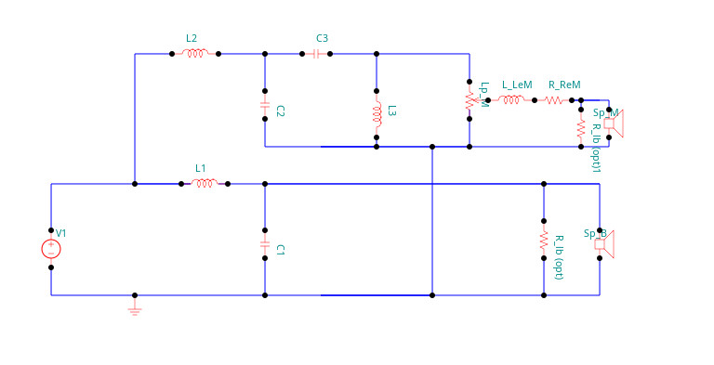
Figure 28 – Two-way crossover schematic
<2_way_title_here>
*----------------------------------------------
* GNUCAP - NETLIST

.options OUT=120
*------------- Models -------------------------
* Each Lpad has its own .param value. This allows the user to adjust
* each Lpad in a 'real world' simulation

.param R_pot_T=8
.param position_T=0.9

*------------- Power Supply -------------------
V_V1 1 0 dc 1.0 ac 1.0 sin(0 1 1000)

*------------- Circuit Description-------------
*R_Rb 4 0 X ;Load resistors to smooth out freq response
*R_Rm 6 0 X ;Load resistors to smooth out freq response

L_L1 1 2 Lyy
L_L2 5 0 Lyy

C_C1 2 0 Cxx
C_C2 1 5 Cxx

* For a pot or Lpad, the connections are R_Lp <pos_node> <low_node>
* <adjust arm> in this instance node(s) [5/7] go to the high or signal node,
* node(s) [6/8] connect to the pos side of the mid/tweeter speakers and
* node(s) [0] connect to the ground. 8 is the value of the lpad or
* potentiometer

* Lpad connection template

*----- Lpad circuitry used for Mid/Tweet ------
R_Lp_M_top 5 6 {R_pot_M * position_M}
R_Lp_M_bottom 6 0 {R_pot_M * (1 - position_M)}

*--- Loudspeaker Model based on T/S params ----
L_LeB 2 3 <Le_TS>
R_ReB 3 4 <Re_TS>

L_LeT 6 7 <Le_TS>
R_ReT 7 0 <Re_TS>

R_Sp_B 4 0 8
R_Sp_T 7 0 8

*---------------- Analysis --------------------
.ac dec 100 20 50000
*.tran 0.1ms 100ms
*----------------------------------------------
*.print v(4) v(9)

.plot ac db(4)
.plot ac db(7)

*.print ac v(4)
*.print ac v(7)

*.tran 0.01ms 10ms
*.plot tran v(4)
*.plot tran v(7)

.end
The entries marked as R_lpad/R_R1 are the for the Lpad circuit, which is part of the ‘Tweeter’ or High Frequency speaker. To evaluate how the Lpad changes circuit performance, modify the ‘param’ values R_pot_T/
position_T with values, load and run the circuit. Suggested values ‘compliment’ and sum tp 1, as the Lpad is behaving like a voltage divider.
Three-way crossover circuit with dual lpads

The schematic circuit below shows a circuit for a two-way speaker. The elements marked as as Le/Re are the internal values of the speaker resistance/inductance. These values are placed in series with the resistive load of the speaker. As previously, the inductance of the speaker is high-enough that a Zobel compensating filter is not required, as it was for the sub-woofer model.

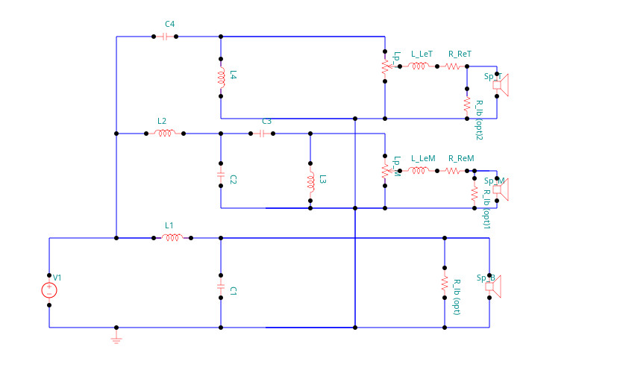

Figure 29 – Three-way crossover schematic

For the three-way crossover, there are two(2) Lpad attenuators, one for the bass and the midrange circuits. These are used to match the output levels of the bass, midrange and tweeter circuits. Both the bass and tweeter are 2nd-order circuits while the midrange, because it has both a band-pass and band-stop filter is considered a 4th order circuit. The netlist for the 3rd order circuit is shown here:

<3_way_title_here>
*----------------------------------------------
* GNUCAP - NETLIST
.options OUT=120
*------------- Models -------------------------
* Each Lpad has its own .param value. This allows the user to adjust
* each Lpad in a 'real world' simulation
.param R_pot_M=8
.param position_M=0.5

.param R_pot_T=8
.param position_T=0.9

*------------- Power Supply -------------------
V_V1 1 0 dc 1.0 ac 1.0 sin(0 1 1000)

*------------- Circuit Description-------------
*R_Rb 4 0 X ;Load resistors to smooth out freq response
*R_Rm 6 0 X ;Load resistors to smooth out freq response
*R_Rt 6 0 X ;Load resistors to smooth out freq response

L_L1 1 2 0.001
L_L2 1 5 0.001
L_L3 6 0 1e-06
L_L4 10 0 1e-06

C_C1 2 0 7.40111e-06
C_C2 5 0 7.40111e-06
C_C3 5 6 0.000727673
C_C4 1 10 0.000727673

* For a pot or Lpad, the connections are R_Lp <pos_node> <low_node> <adjust arm>
* in this instance node(s) [5/7] go to the high or signal node, node(s) [6/8] connect
* to the pos side of the mid/tweeter speakers and node(s) [0] connect to the ground.
* 8 is the value of the lpad or potentiometer

* Lpad connection template

*----- Lpad circuitry used for Mid/Tweet ------
R_Lp_M1_top 6 7 {R_pot_M * position_M}
R_Lp_M1_bottom 7 0 {R_pot_M * (1 - position_M)}

R_Lp_T1_top 10 11 {R_pot_T * position_T}
R_Lp_T1_bottom 11 0 {R_pot_T * (1 - position_T)}

*--- Loudspeaker Model based on T/S params ----
L_LeB 2 3 0.42
R_ReB 3 4 6.7

L_LeM 7 8 0.11
R_ReM 8 9 6.2

L_LeT 11 12 0.11
R_ReT 12 13 6.2

R_Sp_B1 4 0 8
R_Sp_M1 9 0 8
R_Sp_T1 13 0 8
*---------------- Analysis --------------------
.ac dec 100 20 50000
*.tran 0.1ms 100ms
*----------------------------------------------
*.op
*.print v(2) v(6) v(8)
.plot ac vm(4)
*.plot ac vm(6)
*.plot ac vm(8)

.plot ac db(4)
.plot ac db(9)
.plot ac db(13)

*.print ac v(2)
*.print ac v(6)
*.print ac v(8)
*.plot ac db(v(2) v(4) v(5))

*.tran 0.01ms 10ms
*.plot tran v(4)
*.plot tran v(6)
*.plot tran v(8)

.end

- Appendix II - How to use the SPICE models and tutorial
SPICE (Simulation Program with Integrated Circuit Emphasis) is a tool used to simulate/model electronic circuits. The use of SPICE for this application is to model and determine performance of the crossover circuits for each of the speaker types available available from SpeakEasy designing.
To perform spice simulations on the designs, locate the version of spice/ngspice for your platform:
* linux – Refer to the particular linux version you are running on your desktop
* Mac OS – google the install instructions on how to install SPICE/LTSpice on your Mac
* Windows 10/11 – Download LTSpice installer from the Analog Devices website then run the installer wizard
Once spice is installed and running on your platform, create a directory, preferably as a sub-directory where you have installed SpeakEasy and name it something simple and easily remembered (such as spice). Copy over the spice templates into this newly created directory:
* 2_way_template.sp
* 3-way-lpad.sp
* 3_way_template.sp
* subwoofer_template.sp
* highpass_template.sp
* low_pass_new.sp
These are all spice templates that you will used to create/execute your spice execution run.
The subwoofer that was designed earlier in this document will be used for this tutorial. Open the word document that was created when the subwoofer cabinet was created, or, use the subwoofer_tutorial.doc.
1) Go to the newly created spice folder and make a copy of the subwoofer_template.sp file. i.e. cp subwoofer_template.sp subwoofer_tutorial.sp (or anything that you prefer).
2) Open the newly created file for editing. It will look identical to the SPICE netlist example above
3) Change the name of the file on the 1st line of the file to the name of the file you just created.
4) Refer to the section marked “Subwoofer values determined by SpeakEasy:”. This section refers to the values that SpeakEasy determined for the speaker that was created. This includes the capacitors, inductors and resistors that make up the crossover circuit
5) Refer to the schematic file for the circuit under reference: in this case, Figure 27 – Subwoofer Schematic. Compare the open SPICE netlist file that was opened for editing against the names on the schematic and the values in the Subwoofer doc file is included or that was created by you, the user.
6) Edit the values listed under the section labeled “Circuit Description” with the values from the word doc file from the “Component LRC Values “ section. For example:
* Change L_L1 1 2 Lxx to L_L1 1 2 0.0175905
* Change C_C1 2 0 Cxx to C_C1 2 0 0.0001
* Change R_Sp_B 4 0 Rxx to R_Sp_B 4 0 8 (this is the value of Z_nom)
* Change L_LeB 2 3 Lexx to L_LeB 2 3 1.01 (This is the value of internal inductance, Le associated with the bass speaker)
* Change R_ReB 3 4 Rexx to R_ReB 3 4 6.7 (This is the value of the INTERNAL resistance, Re of the bass speaker)
* Change C_Cz 4 5 Czxxx to C_Cz 4 5 0.0224994 (This is the computed value of the Zobel filter inductance)
* Change R_Rz 5 0 Rzxxx to R_Rz 5 0 6.7 (This is the internal reistance of the bass driver)
NOTE: For this example, there are two(2) inductance values listed in the LRC table. This is implying a variable inductance value that the user can typically adjust from the back of the speaker. This allows the user to tune the subwoofer over the range of frequencies – in this case 120 Hz tp 150 Hz. The frequency response from SPICE can be varied by changing the value of L1.
A Zobel filter is used because the internal inductance of the bass speaker is greater than 1.00 milliHenrys (mH).
7) Save the edited file and launch SPICE from a terminal using the command-line interface or from a GUI.
8) Load the file into the simulator. For ngspice, using the command-line, use “% source subwoofer-test.sp”. Enter “% run”. The SPICE simulation returns and the circuit is ready to be evaluated.
9) Plot the the performance of the subwoofer crossover by ‘clamping’ a probe to the node located just above the positive(+) node of the speaker, in this case, node (4).
10) plot the signal using the following commands:
ngspice → 3 plot db(v(4))
ngspice will plot below shows the voltage over the frequency sweep measured by the voltage ‘probe’ on the pos(+) side of the speaker and is shown below:
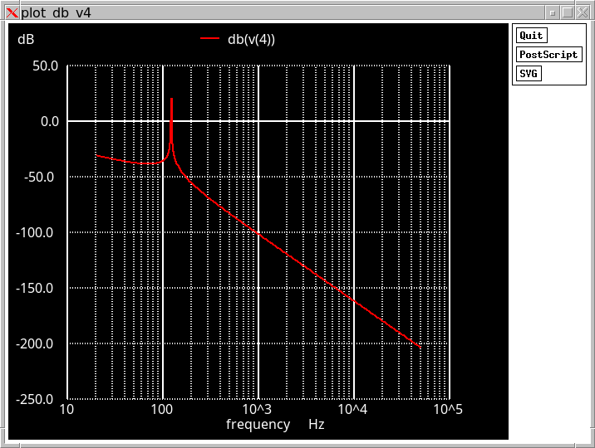
Figure 30 – Subwoofer Frequency Response
For the remaining spice templates, it is encouraged to play look at the files, become familiar with the structure and observe the clamp points on the speaker terminals. When a measurements are taken, they will be taken typically from the speaker pos(+) node. Although and node can be measured and is interesting to see how the voltages behave over the overall circuit topology.

- Appendix III– Reference
AI Assistance Acknowledgment
* Portions of this project were developed with the assistance of ChatGPT, a large language model by OpenAI (April 2025 version). This includes conceptual clarifications, design workflows, and technical explanations derived through extensive interactive discussions. All final decisions, implementations, and interpretations are the author's own.
Technical References
  - Savant, C. J., Roden, M. S., & Carpenter, G. L.
Electronic Circuit Design – Chapter: Classical Analog Filters, pp. 625–630.
  - Weems, D. B.
Designing, Building and Testing Your Own Speaker System – Chapter 7: Crossover Networks, pp. 108–125.
  - Margolis, G., & Small, R. H. (1981).
Personal Calculator Programs for Approximate Vented-Box and Closed-Box Loudspeaker Design. Audio Engineering Society Journal, Vol. 29, No. 6.
  - Dickason, Vance (2015)
Personal Loudspeaker Design Cookbook, 8th Edition – Madisound Speaker Store
5. Weems, David B (1084)
Designing, Building, and testing Your own Speaker Systems – TAB books

- Support
If you find any problems with this tool or have suggestions on how to make the application better, please send an email to:
jmcipale@gmail.com
In the subject line, use “SpeakEasy Support”. In the body of the email, let the author know of your suggestions, issues, problems. Turnaround time is fairly quick. Typically within 24 hrs.
Have fun, and happy designing!

- G. Margolis, R. H. Small, “Personal Calculator Programs for Approximate Vented-Box and Closed-Box Loudspeaker System Design” Journal of the Audio Engineering Society Vol 29, No 6, 1981 June pp 421-441, No 11, 1981 November pp 824
- Wikipedia – Small/Thiele Parameters
- LRC – abbreviations for Inductance (L), Resistance (R) and Capacitance (C).
- For the Accuton S220-6220 the actual value of Le is 0.42 mH. In a real-world design, there would be no need for a Zobel filter. This is for illustration purposes only.
- The spice templates will all have the same probe location. The Speaker will always connect between R_Sp_B <node> 0 R_ld. For the subwoofer circuit, node is ‘4’. Other circuits may see different node points. Refer to the netlist template.

