Fallen Earth Faction Wars

for Facebook
The primary goal for this project is to present the features and flavor of Fallen Earth to an audience that might not otherwise be familiar with the game. To that end, we will attempt to present the game’s existing systems, locations, and stories as much as possible. However, in order to ensure that the game is playable by a wider audience, the system should be kept as streamlined as possible, with some complexity removed in favor of a more accessible, engaging experience for the new player.
The following is a list of Web pages and features for the Faction Wars game, with most features listed under the page where they will appear. Descriptions frequently cross several pages, so it may be necessary to read several sections to fully understand how a feature works.

Character Selection page
This screen is the first thing the player sees upon installing the app. All six factions are presented with a short description and an image, and the player must choose one of the six as her character. Each faction has an advantage:
CHOTA | Faster stamina recharge
Enforcers | Faster health recharge, higher starting attack score
Lightbearer | Higher starting defense
Tech | Faster gamma recharge
Traveler | 5% chip reward bonus
Vista | 5% XP reward bonus
Once the player has chosen a faction and named her character, she will not need to return to this page. The player can drop a character at any time and create a new one for a penalty of several levels. Skills, xp, and other elements will be reduced by a fixed percentage appropriate to the levels lost. The player will also lose any items that are no longer appropriate to her new level.

Mission page
The mission page is divided into two parts. At the top is a map of the region marked with towns the player can visit. Towns and sectors are highlighted to indicate if they belong to one of the six factions. Below the map is a list of single-click missions that the player can do.
The player clicks on a town to select it and display missions associated with that town. Missions are broken down as follows:
Baseline town missions (3 per town): Always associated with the town, no matter which faction is in charge. Each baseline set includes one crafting mission, one kill a creature mission, and one story-based mission.
Faction missions (3 per town): Become available when a faction takes over the town but are only visible to the owning faction. These vary by town, but are the same no matter what faction is in charge. Includes a crafting mission, but the other two can be of any sort.
Special mission (1 per faction per town): Available when a faction takes over the town and is only visible to the owning faction. Varies depending on what faction owns the town (i.e., CHOTA owning a town will get a CHOTA-specific mission).

More about missions
Missions are divided by level and town. Many missions require the player to have special abilities (skills or mutations). These can be bought through the store or earned as rewards from other missions. Missions always award XP and money upon completion. Sometimes they will also award crafting raw materials or special abilities.
Most missions are story-based or creature-kill missions. When the player clicks the mission, rewards are automatically calculated, displayed and added to the player’s inventory. Each mission also includes a short text description of its outcome. Rewards can be any combination of XP, chips, and items and should increase as town level and gamma cost increase.
Crafting missions work just like regular missions, but they guarantee to give the player a particular item as a reward. The player must have the correct raw materials in order to start the mission. Flavor text describes the crafting process. XP and cash are both also awarded for crafting missions, although the chips rewarded will be lower than from a standard mission.
The number of missions the player can do in a day is determined by a regenerating energy system. Each player has a set amount of “gamma” that can be spent to carry out missions. If the player doesn’t have enough gamma for a mission, she may not attempt the mission. Gamma requirements vary by mission, increasing as town levels increase. Some factions may regenerate gamma faster than others. Players may be able to find/craft items that will help them regenerate energy even faster.
In addition, players may be required to have particular items in their inventories before undertaking a mission. Generally, these items aren’t part of the mission cost and aren’t destroyed on completing the mission. In the case of crafting missions, however, required ingredients are destroyed on use.

Merchant page
Like other pages, the sector map appears at the top of this page and the player can use it to see items associated with a particular town. In this case, each town has a set of items that the player can buy and sell there, including salvage items, special abilities, weapons, and armor. Each town also has a market for items the player has crafted through the crafting missions.
If a town is owned by the player’s faction, then an extra item will be available for purchase there. This item can be of any type and will vary from town to town. The item is always the same for each town, regardless of the faction owning the town. For instance, one town may have fuel available only to the faction owning the town, while another might have a special bit of salvage needed for crafting.

More about Special Abilities
Special abilities fall into two main categories: skills and mutations. By purchasing or earning special abilities, the player can customize her character and become more competitive in the PvP arena. The skills and mutations are drawn from a selection of those available in Fallen Earth. Players can buy multiple instances of a skill or mutation in order to improve it. Anything bought in this fashion does not expire.

Faction page
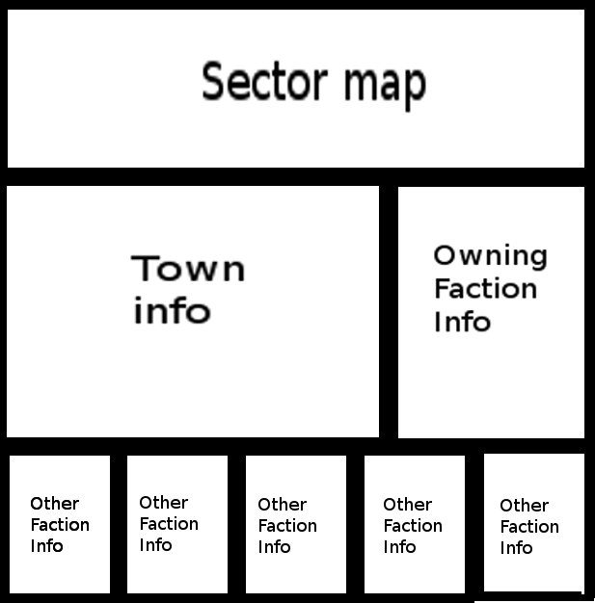
The sector map is displayed at the top of this page, and each town is marked with an icon that shows which town belongs to which faction. Clicking on a town will change the display below the map to show information related to a particular town. This is the only page that allows the player to click on any town regardless of her level.
The town info section at the left gives a short description of the town and displays an image for the town, if one exists. If there is any information about the town’s resources or missions, it is displayed here. To the right of this information, a panel displays the icon of the faction currently owning the town along with the date and time the faction gained ownership. Below those panels are smaller boxes with the icons and names of all the other factions along with their current score towards dominating the town.
Factions earn points to capture towns when their members either do missions or fight other players in the town. Once a faction has earned enough points to win a town, ownership is handed over to the new victor and every faction’s points for that town drop back to zero. The remaining five factions can then compete to become the next owner of the town. The current owner of the town cannot earn points to keep ownership, so no one faction can dominate ownership continuously.
Faction members win cash, favor points, and a raw material item when their faction takes over the town. If the faction owns all three towns in a sector, more rewards are given.
Town ownership rewards are given on a diminishing scale system if a faction wins a town more than once in a twenty-four hour period.
On this page, the player can also donate money and items to earn more points for her faction at the town level.

Character page/Home page
This page displays the character’s stats, money, and other details. It includes a picture of the character by faction and also lists any achievements or awards that the player has earned. On this page, the player can spend achievement points and faction points to update certain stats.
Achievement Point Stats |  | Faction Point Stats
STAT | COST | STAT | COST
Gamma | 1 | Gamma Recharge Rate | 30 Seconds for 5 pts
Stamina | 1 | Stamina Recharge | 30 Seconds for 5 pts
Health | 1
Attack | 1
Defense | 1

From this page, the player can also drop the current character and create a new one.

PvP page
The PvP page uses the sector map to allow the player to choose which town she wants to fight for. As with most other pages, towns on the PvP page only unlock when the player is of sufficient level for the town. When the player clicks on a town, a list of available PvP players is displayed below the sector map. The list provides some information about each potential opponent which the player can use to decide which player to attack. The PvP opponent list is built from a random sampling of players whose level is near that of the current player.
Players can engage one another in a simple, one-click battle system. When the player clicks and attacks an opponent, the game compares stats and displays the results for the player. PvP rewards include XP, chips, and faction points for the chosen town.
Faction affects XP earned during PvP fights. Players who fight members of their own faction will earn fewer points than if they fight allied factions. The most points are earned for fighting members of enemy factions on the opposite edge of the faction wheel.
Relationship | Percentage of Baseline XP earned
Same Faction | 50%
Allied Factions | 75%
Allies of Archenemy | 100%
Archenemy | 125%

Other features

Player stats
Each character has a wide range of statistics that record its progress through the game and determine its success in PvP combat. Some stats are the same for all players, while others are based on the character’s faction. Some stats can be raised by the player during the course of the game. The faction-related stats are listed above, in the “Character Selection Page” section. Other important stats include:
- player level, current xp, xp to level
- current gamma, total gamma, gamma update time
- current stamina, total stamina, stamina update time
- current health, total health, health update time
- chips
- name, faction id
- army size, fights won, fights lost
- base attack score, base defense score

Faction points
Earned by achievements, faction town control, or other special events. The player can trade faction points for more energy or attacks. Faction points can also be donated to the faction in exchange for more points toward winning a town.

Team building
Three possible mechanics for teams:
Army system—Invite friends to your army, and they become a permanent part of your group.
Auto-army system—Your army is made up of the total number of your friends who have the game installed. By inviting friends to the game or friending people who have the game installed, you grow your army.
Pay for help—Pick someone from your list of friends and pay them to accomplish a task (crafting, scavenging, mining, etc.). They get the money, but they don’t have to accept a request for you to benefit.

Player Stat HUD
At the top of each page are the game logo and a mini character sheet with the player’s most pertinent stats: energy, fights, money, XP.

Sector map
Appears in mission page and faction page. There are three sectors available at launch, each with three towns. Each sector has a level range, and towns within the sector have a level range for the missions that they offer. Players are limited to sectors and towns according to their level.
Sector | Town | Level Range
Sector One - Plateau |  | 1-15
 | Trailer Park | 1-5
 | Dry Flats
 | Slaughterville
Sector Two - Northfields |  | 16-30
 | The Dump
 | New Gallows
 | Tinkersdam
Sector Three – Kaibab Forest |  | 31-45
 | Waste Farm
 | Park City
 | Fender Gate

XP per level
1 | 100 | 5 | 1159 | 9 | 2389 | 13 | 3923
2 | 354 | 6 | 1445 | 10 | 2739 | 45 | 13375
3 | 618 | 7 | 1744 | 11 | 3110
4 | 884 | 8 | 2058 | 12 | 3504

Achievements
PvP
Brawler – Win 100 fights against CHOTA.
*Brawler 2 – Win 250 fights against CHOTA.
*Backstabber – Win 100 fights against members of your own faction.
*Patriot – Win 100 fights against members of your archenemy faction.
Dominator – Win 1000 fights.
Griefer – Win 100 fights against members of EVERY faction—including your own.
*Sturdy – Take 100 points of damage.
*Tough guy? – Take 1,000 points of damage.
*Stalwart – Take 10,000 points of damage.

Merchant
Vendor – Sell 100 salvage items.
Warbucks – Earn 100,000 chips.
Raking it in – Earn 1,000,000 chips.
*Own 100 lawnmower blades.
*Lamont Sanford – Own 1,000 lawnmower blades.
*Fred Sanford – Own 5,000 lawnmower blades.

Crafting
Good with tools – Run 100 crafting missions in any combination of towns.
Run 1,000 crafting missions in any combination of towns.
*Craft 100 (high-level item).
*Craft 1,000 (high-level item).

Mission
Trailer Park King – Master all missions in Trailer Park to level one.
Trailer Park King 2 – Master all missions in Trailer Park to level two.
Master all missions in Trailer Park to level three.

Ruler of Dry Flats – Master all missions in Dry Flats to level one.
Ruler of Dry Flats 2 – Master all missions in Dry Flats to level two.
Master all missions in Dry Flats to level three.

Master all missions in Slaughterville to level one.
Master all missions in Slaughterville to level two.
Master all missions in Slaughterville to level three.

Master all missions in New Gallows to level one.
Master all missions in New Gallows to level two.
Master all missions in New Gallows to level three.

Master all missions in The Dump to level one.
Master all missions in The Dump to level two.
Master all missions in The Dump to level three.

Master all missions in Tinkersdam to level one.
Master all missions in Tinkersdam to level two.
Master all missions in Tinkersdam to level three.

Master all missions in Waste Farm to level one.
Master all missions in Waste Farm to level two.
Master all missions in Waste Farm to level three.

Master all missions in Fender Gate to level one.
Master all missions in Fender Gate to level two.
Master all missions in Fender Gate to level three.

Master all missions in Park City to level one.
Master all missions in Park City to level two.
Master all missions in Park City to level three.

