Subjective status, Social Class and meritocracy perception

Perceived meritocracy is understood as how societies describe the functioning of meritocracy, the ideal that promotes the distribution of resources in society based on individual effort and ability. Said this, are subjective and objective positions associated with perceived meritocracy? To what extent is objective position’s influence on meritocracy perception moderated by subjective status? To answer these questions, we use nationally representative data from the 2018 wave of the Longitudinal Social Survey of Chile (N = 2,652). Regression analysis show that subjective social status has a robust positive association with perceived meritocracy, in line with the hypothesis. However, both positive and negative associations of income and occupational social class on perceived meritocracy were not confirmed. However, the hypothesis for education was confirmed, where higher educational attainment is associated with lower perceived meritocracy. Finally, we found that subjective status increases perceived meritocracy for those with higher incomes, tertiary education, and higher occupational social class.

Table of Contents

* Word count: 6923

# 1 Introduction

Meritocracy is an ideal that promotes the distribution of resources in a society based on individual effort and ability (Young, 1961). In modern societies, merit is commonly embraced as a fair way of achieving status, in opposition to drawing on connections or inheritance (Hadjar, 2008). The increasing levels of economic inequality (Piketty & Goldhammer, 2014) and the stagnation of social mobility (OECD, 2018) has increased the attention of social scientist on the subjective aspects of meritocracy, mainly how societies perceive the functioning of meritocracy and its role in justifying economic inequality (Mijs & Savage, 2020). The literature on subjective meritocracy has pointed out the distinction between the descriptive dimension represented by perception (how it is) and preference as the normative dimension (how it should be) (Castillo et al., 2018). The role of social position has been claimed as a key factor in perceived meritocracy by social-psychological studies focusing on subjective social status (Bernardo, 2021; Madeira et al., 2019). In the sociological literature, attention has been paid to income and education as objective status characteristics (Castillo et al., 2018; Duru-Bellat & Tenret, 2012), but also little consideration of authority and control over labour represented by occupational social class (M. Smith & Matějů, 2012). Both disciplinary approaches have been developing parallel research agendas on perceived meritocracy without an extensive dialogue.

Studies have shown the positive influence of economic self-interest (Morris et al., 2022) but also the negative association between education (Duru-Bellat & Tenret, 2012) and occupational social class (Canales, 2015) with meritocracy perception. In other words, income increases the perception of meritocracy, but education and social class decrease it. Regardless of the materialist explanations of perceived meritocracy (Goldthorpe, 2003), subjective social status and its anchoring in social comparison processes is another less-discussed social-psychological factor. The perceived standing in the social hierarchy of an individual or group depends on reference groups, such as top-bottom groups in society (Evans, 2004) or their neighbours and local community (Condon & Wichowsky, 2020b), and it has been demonstrated that it can positively influence perceived meritocracy (Castillo et al., 2018). Furthermore, the reference group and reality blend (R&R) hypothesis (Evans, 2004) has suggested that status perception and its discrepancies with objective position can be explained by the characteristics of reference groups involved in the comparison, arguing that status perception can lead to different outcomes than objective measures. Thus, what is the role of subjective social status on meritocracy perception? Furthermore, to what extent can the influence of objective position on perceived meritocracy be moderated by subjective status? We argue that subjective social status represents an independent process able to explain why some people perceive lower (or higher) meritocracy even when they hold (dis)advantageous positions in terms of income, educational attainment or occupational social class.

The present research aims to scrutinise the role of both subjective and objective social positions on perceived meritocracy. Regarding subjective social status, we claim that social comparison processes and reference groups play a crucial role in how individuals perceive meritocracy as an independent force. On the side of material factors, we examine the role of income and education as different status characteristics, but we also discussed the less addressed role of occupational social class. Finally, as an attempt to test the reference group and reality blend hypothesis, we tested the hypothesised positive moderating effect of subjective social status on the influence of objective status and social class.

## 1.1 Perception of meritocracy

Merit is understood as the combination of individual effort and ability (Sen, 2000). Moreover, the meritocratic ideal assumes that status achievement is not constrained by how opportunities are structured in society (McCall et al., 2017). Both constitute the substantive core of how meritocracy can be comprehended. However, studies on meritocracy have made undifferentiated use of concepts such as *Meritocratic Beliefs* (Bernardo, 2021; Mijs & Hoy, 2021) or *Perceived Meritocracy* (Duru-Bellat & Tenret, 2012). This lack of conceptual and empirical accuracy is often noticed in studies addressing meritocracy’s subjective aspect without distinguishing between descriptive and normative dimensions (Castillo et al., 2018). The research on subjective meritocracy has focused on structural inequality as an explanatory factor, mainly analysing the role of social status, reporting mixed results given by different measurement strategies of the concept.

The concept of *perception* is understood as the subjective description of an object (Janmaat, 2013). In this regard, the descriptive dimension (*how is*) does not consider the normative evaluation of the object (*should be*) understood as preferences (Janmaat, 2013). In this regard, Garcia (2001) suggests perceived meritocracy is the degree to which individuals consider their society complies with the meritocratic principles. In other words, to what extent effort and talent are rewarded, indicating “how meritocracy is” rather than “how it should be”. Previous evidence suggests that preferences, compared to perceptions, are more stable across status groups (Castillo et al., 2018, p. 10). Thus, we expect that subjective and objective social positions can explain the differences in meritocracy perception.

## 1.2 Subjective social status

The literature on subjective meritocracy has paid more attention to the structural position of individuals as an explanatory factor for perceptions of meritocracy. How individuals experience social inequality is affected by the status of the individuals’ or groups (Castillo et al., 2022). For example, perceived economic inequality in everyday life diminishes justification of inequality and increases demand for redistribution (García-Castro et al., 2020). Nevertheless, it has been demonstrated meritocracy primes reinforce negative evaluations of economically disadvantaged groups and strengthens internal attribution (Madeira et al., 2019).

Normative appraisals of qualitative or ascribed status characteristics such as gender or quantitative like income or educational level serve to explain status (Jasso, 2001). In this regard, social interactions serve as anchors through which individuals rationalise their societal position. The literature conceptualised it as subjective social status, understood as the perception of an individual or group’s standing in the social hierarchy compared to a reference group, such as society itself (Evans, 2004; Słomczyński & Kacprowicz, 1986) or local communities (Condon & Wichowsky, 2020a). A widely used measure is the MacArthur Scale of Subjective Social Status, in which individuals report social status on a ladder representing the strata of the social hierarchy (Adler et al., 2000).

The literature has shown a persistent bias toward the middle of the hierarchy, where low-status individuals tend to overestimate their position while high-status individuals underestimate it (Lindemann & Saar, 2014). In this regard, previous theoretical approaches have suggested that individuals are likely to compare themselves with people or groups perceived as similar. These reference groups contribute to diminishing cognitive dissonance and seek to assemble better estimations about their position in society (Festinger, 1954; Merton & Rossi, 1968).

Social perception of meritocracy may be influenced by an individual’s reference group and their perceived social standing within that group. The reference group and reality blend (R&R) hypothesis suggests that an individual’s cognitive biases may be shaped by an availability heuristic, reducing cognitive dissonance in situations with limited information (Evans, 2004; Kelley & Evans, 1995). Close reference groups can shape an individual’s subjective estimates of their social standing, and their imagined ideas about society may be influenced by the homophily within their social networks. Research has shown that individuals with networks consisting of people with high-status occupations have a higher subjective social status in Chinese society, where social capital is important (Kim & Lee, 2021). Membership in organizations or participation in hobbies may also shape cognitive patterns of homophily and influence an individual’s perceived social standing (Son et al., 2021).

The link of subjective status with attitudes toward inequality has been little studied. For example, Vargas-Salfate et al. (2018) found that higher subjective status is associated with higher system justification. Similarly, Schneider & Castillo (2015) evidence a positive association of subjective status with the perceived justice income inequality and higher internal poverty attributions. In addition, Castillo et al. (2018) found that higher subjective status is related to higher perceived meritocracy. Based on this evidence, our main prediction is:

: subjective social status is positively associated with perceived meritocracy

## 1.3 Income

According to the rational self-interest approach (Meltzer & Richard, 1981), individuals with higher incomes perceive higher meritocracy because they accumulated economic resources through effort and talent. High status is also associated with lower inequality perception (Evans & Kelley, 2017) and higher justification of income inequality (Trump, 2017).

There is evidence of a positive relationship between income and perceptions of meritocracy regarding the importance of individual merit in achieving success (Reynolds & Xian, 2014; Xian & Reynolds, 2017) and the extent to which intelligence and skills are rewarded (Castillo et al., 2018; Duru-Bellat & Tenret, 2012). However, there is mixed evidence on how lower-income individuals rationalize inequality and meritocracy. Some research supports the “activated conflict theory,” which suggests that the poor in unequal localities hold lower beliefs in meritocracy due to social comparisons that increase awareness of social status (Newman et al., 2015). Other research, based on the “relative power theory,” challenges this finding, arguing that the rich hold more power due to income and wealth concentration, allowing them to disseminate legitimizing ideas about economic inequality, and the poor are less critical of dominant beliefs like meritocracy as a psychological mechanism for coping with deprivation (Solt et al., 2016). However, other research shows that low-income individuals in highly unequal contexts have firmer meritocracy beliefs, but the differences tend to fade as inequality declines (Morris et al., 2022).

Based on the literature, we expect that individuals with higher economic resources will attribute more importance to merit and therefore perceive that rewards in society are distributed according to it. Therefore, we propose the following hypothesis:

: Income is positively correlated with perceived meritocracy.

## 1.4 Education

As income reflects an individual’s economic resources, studies on social stratification have raised the importance of educational attainment on status achievement (Goldthorpe, 2003). In this line, research on meritocracy perception have discussed two theoretical approaches. On the one hand, the *reproductionist* approach (Bernstein, 2003; Bourdieu & Passeron, 2009) supports the *socialisation* hypothesis, suggesting school socialisation operates as a normative reinforcement of meritocratic ideals, then educated individuals are more willing to support meritocracy as a legitimising mechanism (Lampert, 2013). On the other hand, the *instruction* hypothesis suggests perceived meritocracy tends to weaken in individuals with higher educational attainment because they would be more aware of the influence of structural factors on status achievement (Duru-Bellat & Tenret, 2012) considering experiences of educational mobility (Canales, 2015) and higher chances to engage with complex political ideas (Bubak, 2019).

On the one hand, evidence in favour of the socialisation hypothesis has pointed out education is associated with higher importance of individual factors in getting ahead in life (Mijs, 2021; Reynolds & Xian, 2014; Xian & Reynolds, 2017), but also as a determinant of wages (Kunovich & Slomczynski, 2007). On the other hand, evidence in favour of the instruction hypothesis shows that individuals more educated individuals disagree that people are rewarded for their effort and talent (Castillo et al., 2018; Duru-Bellat & Tenret, 2012). Additionally, the instructional hypothesis can be complemented by the fact that greater awareness of inequality may experience feelings of injustice and relative deprivation since individuals with the same educational attainment have access to unequal rewards (Adams, 1965; H. J. Smith et al., 2020). In this sense, it has been shown higher educational attainment is associated with higher perceived inequality (Castillo, 2012). Thus, this evidence leads us to suggest:

: education is negatively associated with perceived meritocracy.

## 1.5 Occupational Social Class

The relationship between structural position and meritocracy has mainly focused on income and educational attainment, setting occupational social class aside from the discussion. Occupational class not only represent the synthesis of educational achievement and income levels (Ganzeboom et al., 1992), but it also represents a symbol of power and authority in contemporary societies (Chan & Goldthorpe, 2007). Social class schemes draw on occupational characteristics, autonomy and authority in the workspace as meaningful distinctions to categorise individuals (Erikson & Goldthorpe, 1992), making them relatively homogeneous groups (Connelly et al., 2016). Social class also comprise individuals’ experience in the labour market regarding job opportunities and wages (Svallfors, 2006). For example, lower classes are exposed to higher labour market risk, such as the likelihood of job loss and lower wages, leading individuals to experience deprivation due to their risk exposure (Rehm, 2009).

The literature has paid little attention to occupational social class on meritocracy perception. For example, M. Smith & Matějů (2012) found that individuals belonging to the petty bourgeoisie perceive higher levels of meritocracy compared to wage earners. These findings are supported by Sandoval (2017), which found that skilled and service workers attribute more importance to effort in achieving success compared to unskilled workers. However, Canales (2015) found that upwardly mobile individuals in the service class perceived lower levels of meritocracy.

Even when individuals have improved their social class position from lower to non-manual or service classes (Torche, 2005), the stagnation of wages and persistent economic inequality (Espinoza & Núñez, 2014) can lead to negatively perceived meritocracy due to frustrated economic prospects (Barozet & Fierro, 2011) or by experiences of discrimination in the labour market (Cea, 2020). Achieving higher occupational social class positions may not always result in satisfactory outcomes, which can further negative meritocracy perceptions when confronted with labour market constraints (Canales, 2015). In this regard, we argue occupational social class position contributes with information about the labour market, such as job opportunities and wages, leading us to suggest that:

: Working in non-manual and service occupations is negatively associated with perceived meritocracy.

## 1.6 Interplay of subjective and objective reality

The R&R hypothesis suggests that both subjective and material experiences interact with each other (Evans & Kelley, 2017). Studies have shown that status and class positively influence subjective status, but it is less understood how subjective status moderates the effect of objective experiences on perceived meritocracy.

Higher-income individuals tend to have higher inconsistencies in perceived status (Castillo et al., 2013). For example, income, education, and occupational prestige have a positive non-linear relationship with subjective social status, with higher status individuals showing more variation in subjective status (Andersson, 2018). Inconsistencies between income level and educational attainment have been linked to political preferences Lenski (1967), and discrepancies between class identity and social class may also influence political preferences (Sosnaud et al., 2013), but these results are not consistently supported by socio-demographic controls.

Studies on subjective social status as a moderating factor have primarily focused on its relationship to other subjective variables, rather than how it interacts with income or education. One study using data from the International Social Survey Programme (ISSP) found that higher perceptions of inequality lead to higher preferences for redistribution and lower perceptions of meritocracy, and that the relationship between inequality and meritocracy perception becomes weaker for those who perceive themselves as having a higher societal position (Fatke, 2018). Another study in European countries showed that economic inequality does not influence preferences for redistribution when controlled by perceived inequality, but is positively moderated by subjective status (Bobzien, 2019). A study on bachelor students with high subjective social status found that those who perceive themselves as having a higher status and greater meritocracy tend to justify higher levels of economic inequality (Bernardo, 2021).

Experiments have shown that manipulating individuals’ perceptions of their social status can alter their attitudes towards inequality. For example, in Argentina, people in the lowest and highest income deciles tend to have the most bias, with those in the lowest stratum overestimating their position and those in the highest underestimating it. Manipulating this bias can change attitudes towards redistribution (Cruces et al., 2013). In Sweden, older, educated people with higher cognitive skills tend to be more accurate about their position in the income distribution. It is believed that those with strong meritocratic beliefs will not be affected by informational interventions and will have fewer preferences for redistribution (Karadja et al., 2017). Reference groups can also influence perceptions of distributive justice. Misperception is generally higher in large reference groups than in small ones. When informed of their actual position, those who overestimate their position around the median of any reference group, especially those in the lowest income stratum, tend to increase their perception of inequality and injustice (Hvidberg et al., 2020).

Studies have demonstrated that three factors interact to shape perceptions of social status: socioeconomic status, economic and social capital, and moral perceptions of individual achievement (MacClure et al., 2020). Individuals who identify as lower status tend to have low incomes, less education, and live in disadvantaged areas. However, some individuals who belong to middle or high socioeconomic strata may still identify as lower status due to living in affluent neighborhoods or having higher educational credentials, which symbolize higher social and cultural capital (MacClure et al., 2020). Those who identify as high status tend to consistently have higher socioeconomic status, with educational meritocracy often serving as a criterion for their social position (MacClure et al., 2020).

Subjective social status can reflect an individual’s position in the social structure as well as their experience of economic inequality through comparisons with nearby reference groups. Therefore, we predict that differences in subjective status can lead to differences in perceived meritocracy within socio-economic groups. Thus, we predict that:

: The association of objective status and social class on perceived meritocracy is positively moderated by subjective social status.

To summarise our hypothesis, Figure 1.1 depicts the theoretical model proposed in the study.

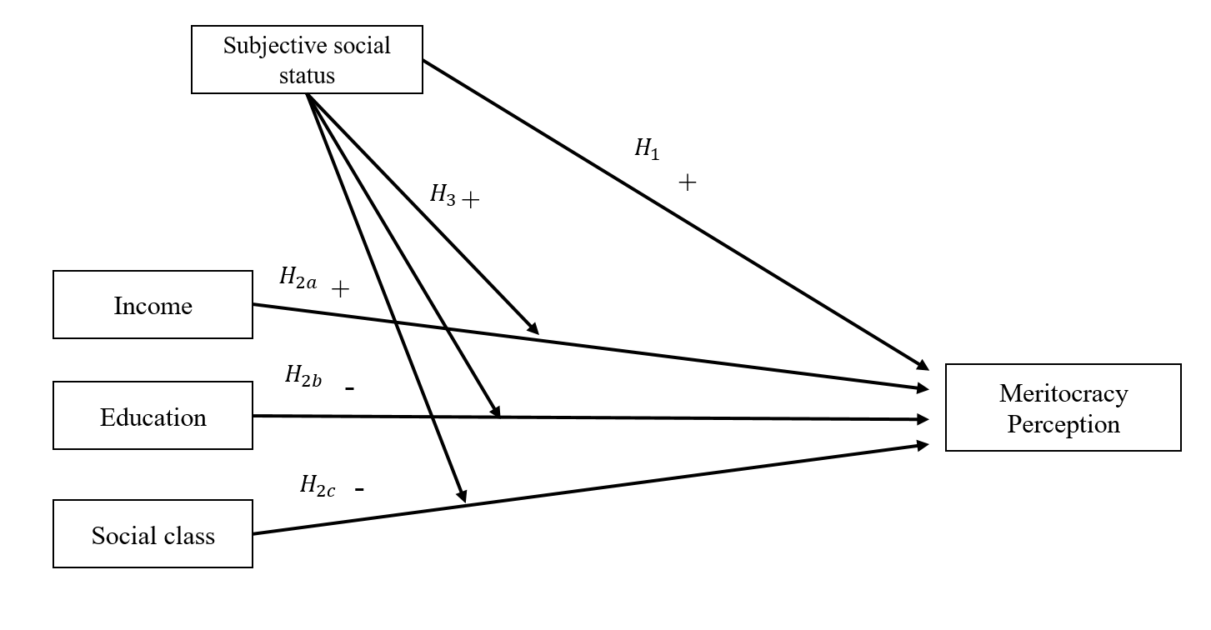

Figure 1.1: Theoretical model

# 2 Data, variables and methods

*Data*

The data used correspond to the third wave of the Longitudinal Social Study of Chile (COES, 2018), a survey developed to analyse the evolution of conflict and social cohesion in Chilean society over time. The sampling is probabilistic, stratified, clustered and multistage, with a total of 3748 participants aged between 18 and 75 years. An analytical sample of 2652 cases with complete information is used for the analyses.

*Variables*

The study variables and their description can be seen in Table 2.1. The main dependent variable is *perceived meritocracy*, operationalised through the average score of two indicators (*r* = 0.76) that capture the degree of agreement on whether effort and intelligence are rewarded in Chile and that have been used in international comparative studies (Duru-Bellat & Tenret, 2012). Both indicators are five-category Likert scales, where higher values represent higher perceptions of meritocracy.

*Subjective social status* is measured using an 11-point scale variable in which respondents identify themselves on the social ladder by answering *“In our society, some groups are usually at the higher levels, and others tend to be placed at the lower levels of society. Using the presented scale, where 0 is the lowest level, and 10 is the highest level, where would you put yourself in Chilean society?.”*, where higher values represent a higher perceived social status.

The objective position is measured through three variables. First, *Household Income Decile* is calculated using monthly per capita household income and categorised into deciles. Second, *Educational level* corresponds to the five categories for educational attainment following the International Standard Classification of Education (UNESCO, 2012). Finally, we use an adapted five-category version of the EGP class scheme (Connelly et al., 2016), a commonly used measurement in social stratification research (Solís et al., 2019). The Stata package isko was used for the computation of the class scheme (Hendrickx, 2002).

Control variables are age, gender, political identification and the perceived salary gap.

Table 2.1: Study variables

|  |
| --- |
|  |

*Method*

Considering the dependent variable as a continuous, stepwise ordinary least square regression models are used (OLS). First, models are estimated for each of the independent variables. Second, a series of models are estimated that consider the interaction term between objective position and subjective status. Interactions effects are presented using conditional linear predicted values .

# 3 Results

## 3.1 Descriptive

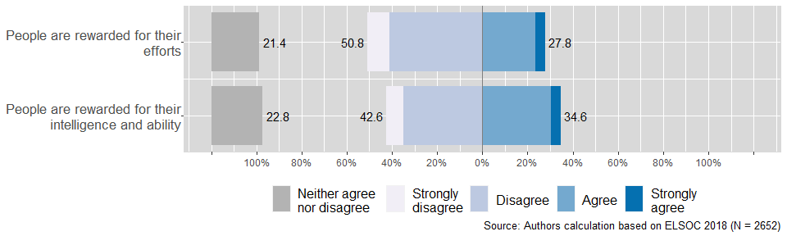

Figure 3.1: Perceived meritocracy items

Figure 3.1 depicts the distribution of responses of the two indicators for the perception of meritocracy, showing that most individuals tend to disagree or strongly disagree with the statement. For example, regarding the statement about how *effort* is rewarded, 50.8% answered that they disagree or strongly disagree. In the same direction, the perception regarding rewards from *intelligence and ability*, the level of disagreement decreases to 42.6%. Finally, about 22% of the respondents do not have a negative or positive perception of the link between rewards and merit in society.

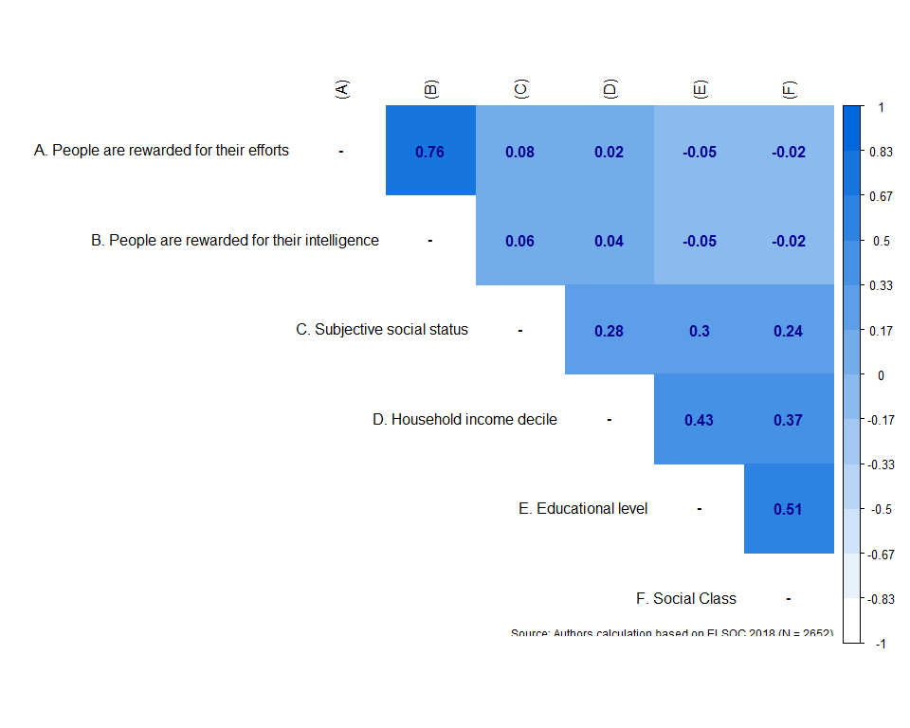

Figure 3.2: Correlation matrix between social status and perceived meritocracy

Figure 3.2 shows a positive correlation between perceived meritocracy and subjective status, with a slightly stronger association for the indicator for effort (r = 0.08) compared to intelligence (r = 0.06). Perceived meritocracy has a weak positive correlation with income decile, but weak negative correlations with education and social class.

## 3.2 Multivariate analysis

Table 3.1: Linear Regression for Perception of Meritocracy

Model 1

Model 2

Model 3

Model 4

Model 5

Model 6

Model 7

Model 8

Subjective Social Status (SSS)

0.04**

0.05***

-0.06*

-0.04

-0.01

(0.01)

(0.01)

(0.03)

(0.04)

(0.02)

Household Income Decile

0.00

0.01

-0.08***

0.00

0.00

(0.01)

(0.01)

(0.02)

(0.01)

(0.01)

Education (ref: Incomplete Primary or lower)

     Primary and Lower secondary

-0.26**

-0.27**

-0.26**

-0.49*

-0.27**

(0.09)

(0.09)

(0.09)

(0.23)

(0.09)

     Upper secondary

-0.23**

-0.26***

-0.24***

-0.54**

-0.25***

(0.07)

(0.07)

(0.07)

(0.18)

(0.07)

     Short-cycle tertiary

-0.33***

-0.38***

-0.36***

-0.91***

-0.36***

(0.08)

(0.09)

(0.09)

(0.23)

(0.09)

     Tertiary or higher

-0.25**

-0.33***

-0.34***

-0.92***

-0.33***

(0.08)

(0.09)

(0.09)

(0.22)

(0.09)

Social Class (ref: Unskilled worker)

     Skilled Manual Worker (V+VI)

-0.02

-0.01

-0.01

-0.01

-0.30

(0.06)

(0.06)

(0.06)

(0.06)

(0.17)

     Self-Employment (IV.ab)

0.09

0.10

0.09

0.10

-0.09

(0.06)

(0.06)

(0.06)

(0.06)

(0.19)

     Routine Non-manual (III)

-0.07

-0.05

-0.05

-0.05

-0.52**

(0.06)

(0.06)

(0.06)

(0.06)

(0.19)

     Service (I+II)

-0.02

-0.01

-0.03

-0.02

-0.46**

(0.05)

(0.06)

(0.06)

(0.06)

(0.17)

Int. (Income Decile x Subj. Status.)

0.02***

(0.00)

Int. (Education x Subj. Status.)

     Primary and Lower secondary x SSS

0.06

(0.05)

     Upper secondary x SSS

0.08

(0.04)

     Short-cycle tertiary x SSS

0.13**

(0.05)

     Tertiary or higher x SSS

0.14**

(0.05)

Int. (Class x Subj. Status.)

     Skilled Manual Worker (V+VI) x SSS

0.07

(0.04)

     Self-Employment (IVab) x SSS

0.05

(0.04)

     Routine Non-manual (III) x SSS

0.11**

(0.04)

     Service (I+II) x SSS

0.10**

(0.03)

Controls

Yes

Yes

Yes

Yes

Yes

Yes

Yes

Yes

R2

0.03

0.03

0.04

0.03

0.04

0.05

0.05

0.05

Adj. R2

0.03

0.03

0.03

0.03

0.04

0.04

0.04

0.04

Num. obs.

2652

2652

2652

2652

2652

2652

2652

2652

***p < 0.001; **p < 0.01; *p < 0.05

According to model 5, subjective social status has a strong, positive, and statistically significant association with perceived meritocracy in all specifications, supporting the reference group hypothesis (H1). Individuals with higher subjective social status tend to perceive higher meritocracy when comparing themselves with lower or higher groups in society and estimating their position on the social ladder.

Model 5 in Table 3.1 shows that household income has a positive but insignificant effect, therefore not supporting the rational self-interest hypothesis (H2a). Results shows that as educational level increases, perception of meritocracy decreases. This supports the instruction hypothesis (H2b) that people with higher education tend to view meritocracy more critically. It is worth noting that short-cycle tertiary education individuals perceive meritocracy slightly more than those with tertiary or higher education. Finally, Model 5 shows a negative effect of non-manual and service classes on social class, but the association is not statistically significant, therefore not supporting the labor market position hypothesis (H2c).

Table 3.1 shows the interaction between subjective social status, objective status, and social class in models 6 to 8, which are consistent with the hypothesized interaction of reference groups and objective reality (H3).

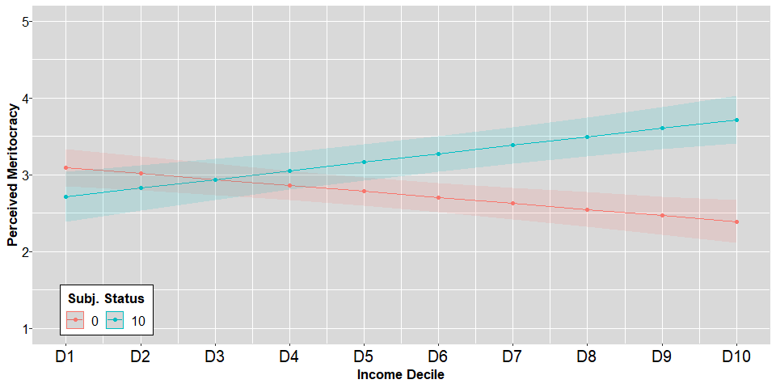

Figure 3.3: Conditional effects of income decile by subjective social status on perceived meritocracy

Model 6 shows that subjective social status positively moderates the association of household income with perceived meritocracy. Figure 3.3 depict that this association is lower for those with low subjective social status and higher for those with high subjective social status. Subjective social status does not significantly differentiate perceived meritocracy for individuals with household income below Decile 5, but does for those with income above Decile 6. This suggests that individuals with household income above the median and high subjective social status perceive that merit is rewarded in society.

Model 7 shows that subjective social status positively moderates the negative influence of educational level on perceived meritocracy, particularly among tertiary education groups. Figure 3.4 shows small differences in perceived meritocracy among groups with secondary or less education based on subjective social status. However, for short-cycle and tertiary education groups, perceived meritocracy is higher for those with high subjective social status and lower for those with low subjective social status. The negative association of education can be observed among individuals with tertiary education who perceive themselves as being close to the bottom of society and have a critical view of how merit is rewarded.

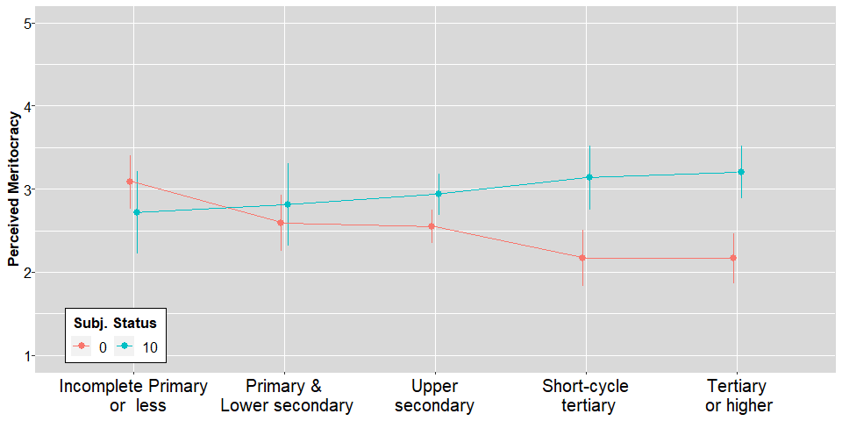

Figure 3.4: Conditional effects of Education by subjective social status on perceived meritocracy

Subjective social status moderates the relationship between perceived meritocracy and routine non-manual and service classes, as shown by Model 8. Figure 3.5 demonstrates that workers in these classes perceive lower meritocracy when they perceive themselves as lower on the social ladder, and higher meritocracy when they perceive themselves as higher on the social ladder. Our findings did not show significant differences in perceived meritocracy across social classes, but subjective social status does affect perceptions of meritocracy among clerks, sales workers, and higher-grade professionals, even when controlling for factors such as occupation, autonomy, and authority in the workplace.

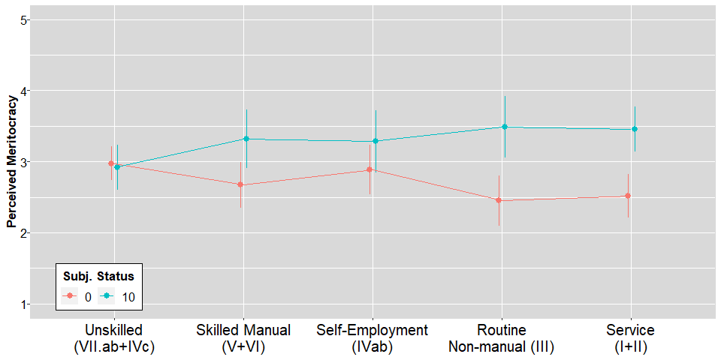

Figure 3.5: Conditional effects of Social class by subjective social status on perceived meritocracy

# 4 Dicussion

The reference group hypothesis (H1) proposes that an individual’s perceived position on the social ladder influences their perception of meritocracy. Specifically, how individuals rank themselves in relation to the top and bottom groups in society can impact their perception of meritocracy. For example, high-status groups are typically associated with high-income, educated, or prestigious occupations in society (Condon & Wichowsky, 2020b) and may be seen as deserved winners. Our results show that when individuals perceive themselves as being closer to high-status groups, they tend to agree that effort and talent are rewarded. These findings are consistent with previous research on individualistic poverty attributions (Schneider & Castillo, 2015) and perceived meritocracy (Castillo et al., 2018). In general, the results align with the prediction of the self-interest hypothesis, but perceived status is more important than material reality in explaining perceived meritocracy.

The results did not support the self-interest hypothesis (H2a), which predicts that material factors such as household income would significantly influence individuals’ perceptions of meritocracy. Specifically, household income was found to have no significant impact on perceived meritocracy. Previous research has suggested that the positive relationship between income and perceived meritocracy may be due to a within-group social comparison effect, as the association disappears when controlling for income distance from the average of an individual’s educational group (Castillo et al., 2018). However, our findings contradict previous evidence that poor individuals are more likely to support meritocracy in highly unequal contexts (Morris et al., 2022; Solt et al., 2016), as we did not observe significant differences in perceived meritocracy between individuals with low and high income.

Our results support the instruction hypothesis (H2b) prediction, which posits that higher levels of educational attainment are associated with lower levels of perceived meritocracy. This is in contrast to the socialisation hypothesis, which suggests that individuals internalise norms about meritocracy through socialisation (Lampert, 2013). Our findings suggest that higher levels of education may lead to more critical views of the distributive system and the idea that effort and talent are rewarded in society rather than reinforcing meritocratic preferences, as suggested by Duru-Bellat & Tenret (2012).

The labour market hypothesis (H2c), which predicts that non-manual and service social classes will have lower levels of perceived meritocracy, is not supported by the results. This suggests that labour market position does not influence individuals’ perceptions of meritocracy. While prior research has suggested that social class contributes to experiences in the labour market (Svallfors, 2006) and that negative job experiences or wages may lead to lower perceptions of meritocracy (Canales, 2015), the lack of significant differences among social classes in our study may be due to the lack of impact of income as a relevant labour market outcome.

As an empirical attempt to scrutinise the Reference Group and Reality blend (R&R) hypothesis, we tested the moderating role of subjective status on objective reality. The results align with previous evidence on the moderating role of subjective social status on objective (Bobzien, 2019) or perceived economic inequality (Fatke, 2018). Furthermore, we found that the conditional effect of status and class on perceived meritocracy can be observed among those on the top of the social hierarchy. In addition, apart from income levels, we took a step forward and explored the role of educational status and social class.

As suggested by the R&R approach, individuals who clearly understand their higher status/class positions tend to perceive higher levels of meritocracy following the principles of meritocracy. However, those with higher structural positions but lower subjective status tend to be more sceptical of meritocracy. Previous research (Kim & Lee, 2021) has indicated that social comparison through limited information resulting from homophily in social networks may lead to biased perception, but this assumption cannot be confirmed with the current data. Our findings align with previous research on the impact of status perception can lead to attitudinal change (Cruces et al., 2013; Hvidberg et al., 2020). Nevertheless, it is important to exercise caution when interpreting the correlational nature of our evidence.

One possible explanation for the observed patterns in our data is that social comparison processes (Festinger, 1954) may lead to subjective experiences of deprivation, even among those who are objectively at the top of the social hierarchy. As proposed by Condon & Wichowsky (2020a), upward comparisons may create anxiety among individuals of all status groups, resulting in deprivation, lower subjective status, and an increased preference for redistribution. Additionally, the Inequity theory (Adams, 1965) posits that feelings of being under-rewarded can lead to a sense of deprivation. In the context of meritocracy, merit can be understood as a representation of time and energy investment. Thus, it is expected that those who perceive themselves as lower in the social hierarchy will also perceive lower levels of meritocracy, especially among those with affluent, educated, and highly skilled jobs. While these groups may be objectively successful, some individuals may still perceive themselves as lower in society and hold a critical view of meritocracy.

# 5 Conclusion

One limitation of our study is using a two-item indicator to measure perceived meritocracy, which could be improved upon in future research. Additionally, operationalising the “bottom” and “top” groups in society to characterise reference groups could be more accurate if it considers other status characteristics such as gender, age, and migration status. It is also important to note that the correlational design of the study does not allow for causal conclusions. Future research using a panel design in the ELSOC survey will be able to more effectively better examine the relationship between structural change and its impact on perceived meritocracy.

Other areas for future research include the role of social network composition in understanding the influence of the closest reference group on status perception, the direct and moderating effects of subjective social status perceptions and preferences towards inequality, particularly to preferences for redistribution and justification of salary gaps, and the behaviour of individuals at the top of the social hierarchy who perceive themselves as lower in the ladder in regards to civic engagement, political participation, and altruistic behaviour.

# 6 References

Adams, J. S. (1965). Inequity In Social Exchange. In *Advances in experimental social psychology* (New York:, pp. 267–299).

Adler, N. E., Epel, E. S., Castellazzo, G., & Ickovics, J. R. (2000). Relationship of subjective and objective social status with psychological and physiological functioning: Preliminary data in healthy, White women. *Health Psychology*, *19*(6), 586–592. <https://doi.org/10.1037/0278-6133.19.6.586>

Andersson, M. A. (2018). An Odd Ladder to Climb: Socioeconomic Differences Across Levels of Subjective Social Status. *Social Indicators Research*, *136*(2), 621–643. <https://doi.org/10.1007/s11205-017-1559-7>

Barozet, E., & Fierro, J. (2011). La clase media en Chile: Algunas implicancias sociales y políticas, 147–158.

Bernardo, A. (2021). Meritocracy beliefs and intolerance towards wealth inequality among higher subjective social status Filipinos. *International Journal of Social Psychology*, *36*(3), 397–423. <https://doi.org/10.1080/02134748.2021.1940705>

Bernstein, B. B. (2003). *Class, codes, and control*. London ; New York: Routledge.

Bobzien, L. (2019). Polarized perceptions, polarized preferences? Understanding the relationship between inequality and preferences for redistribution. *Journal of European Social Policy*, 095892871987928. <https://doi.org/10.1177/0958928719879282>

Bourdieu, P., & Passeron, J.-C. (2009). *Los Herederos : Los Estudiantes y La Cultura*. *Sociología y política*. Siglo XXI.

Bubak, O. (2019). Perceptions of meritocracy: A note on China. *Asian Journal of Comparative Politics*, *4*(2), 192–209. <https://doi.org/10.1177/2057891118806065>

Canales, V. (2015). *Upwardly mobile individuals: Do they believe less strongly in meritocracy?* (Master’s thesis). London School of Economics; Political Science, London.

Castillo, J. C. (2012). Is Inequality Becoming Just? Changes in Public Opinion about Economic Distribution in Chile. *Bulletin of Latin American Research*, *31*(1), 1–18. <https://doi.org/10.1111/j.1470-9856.2011.00605.x>

Castillo, J. C., García-Castro, J.-D., & Venegas, M. (2022). Perception of economic inequality: Concepts, associated factors and prospects of a burgeoning research agenda. *International Journal of Social Psychology*, *37*(1), 180–207. <https://doi.org/10.1080/02134748.2021.2009275>

Castillo, J. C., Miranda, D., & Madero-Cabib, I. (2013). Todos somos de clase media: Sobre el estatus social subjetivo en Chile. *Latin American Research Review*, *48*(1), 155–173. <https://doi.org/10.1353/lar.2013.0006>

Castillo, J. C., Torres, A., Atria, J., & Maldonado, L. (2018). Meritocracia y desigualdad económica: Percepciones, preferencias e implicancias. *Revista Internacional de Sociología*, *77*(1), 117. <https://doi.org/10.3989/ris.2019.77.1.17.114>

Cea, P. (2020). *Discriminación por grupo socioeconómico y meritocracia en el mercado laboral de Chile* (Master’s thesis). Universidad de Chile.

Chan, T. W., & Goldthorpe, J. H. (2007). Class and Status: The Conceptual Distinction and its Empirical Relevance. *American Sociological Review*, *72*(4), 512–532. <https://doi.org/10.1177/000312240707200402>

COES. (2018). Estudio Longitudinal Social de Chile 2018. Harvard Dataverse. <https://doi.org/10.7910/DVN/H8OVMF>

Condon, M., & Wichowsky, A. (2020a). Inequality in the Social Mind: Social Comparison and Support for Redistribution. *The Journal of Politics*, *82*(1), 149–161. <https://doi.org/10.1086/705686>

Condon, M., & Wichowsky, A. (2020b). *The Economic Other: Inequality in the American Political Imagination*. University of Chicago Press. <https://doi.org/10.7208/chicago/9780226691909.001.0001>

Connelly, R., Gayle, V., & Lambert, P. S. (2016). A Review of occupation-based social classifications for social survey research. *Methodological Innovations*, *9*, 205979911663800. <https://doi.org/10.1177/2059799116638003>

Cruces, G., Pérez Truglia, R., & Tetaz, M. (2013). Biased perceptions of income distribution and preferences for redistribution: Evidence from a survey experiment. *Discussion Paper*, *98*(5699), 100–112. <https://doi.org/10.1016/j.jpubeco.2012.10.009>

Duru-Bellat, A. M., & Tenret, E. (2012). Who’s for Meritocracy? Individual and Contextual Variations in the Faith. *Comparative Education Review*, *56*(2), 223–247.

Erikson, R., & Goldthorpe, J. H. (1992). *The constant flux: A study of class mobility in industrial societies*. Oxford [England] : New York: Clarendon Press ; Oxford University Press.

Espinoza, V., & Núñez, J. (2014). Movilidad ocupacional en Chile 2001-2009. de ingresos con igualdad de oportunidades? *Revista Internacional de Sociología*, *72*(1), 57–82. <https://doi.org/10.3989/ris.2011.11.08>

Evans, M. D. R. (2004). Subjective Social Location: Data From 21 Nations. *International Journal of Public Opinion Research*, *16*(1), 3–38. <https://doi.org/10.1093/ijpor/16.1.3>

Evans, M. D. R., & Kelley, J. (2017). Communism, Capitalism, and Images of Class: Effects of Reference Groups, Reality, and Regime in 43 Nations and 110,000 Individuals, 1987-2009. *Cross-Cultural Research*, *51*(514), 315–359. <https://doi.org/10.1177/1069397116677963>

Fatke, M. (2018). Inequality Perceptions, Preferences Conducive to Redistribution, and the Conditioning Role of Social Position. *Societies*, *8*(4), 99. <https://doi.org/10.3390/soc8040099>

Festinger, L. (1954). A Theory of Social Comparison Processes. *Human Relations*, *7*(2), 117–140. <https://doi.org/10.1177/001872675400700202>

Ganzeboom, H., De Graaf, P. M., & Treiman, D. J. (1992). A Standard International Socio-Economic Index of Occupational Status. *Social Science Research*, *21*(1), 1–56. <https://doi.org/10.1016/0049-089X(92)90017-B>

Garcia, D. (2001). *The Perceptions of Meritocracy Inventory: Assessing beliefs in the association between rewards and merit*. ProQuest Dissertations Publishing.

García-Castro, J. D., Rodríguez-Bailón, R., & Willis, G. B. (2020). Perceiving economic inequality in everyday life decreases tolerance to inequality. *Journal of Experimental Social Psychology*, *90*, 104019. <https://doi.org/10.1016/j.jesp.2020.104019>

Goldthorpe, J. (2003). The myth of education-based meritocracy. Why the theory isn’t working. *New Economy*, *10*(4), 234–239. <https://doi.org/10.1046/j.1468-0041.2003.00324.x>

Hadjar, A. (2008). *Meritokratie als Legitimationsprinzip*. Wiesbaden: VS Verlag für Sozialwissenschaften.

Hendrickx, J. (2002). ISKO: Stata module to recode 4 digit ISCO-88 occupational codes.

Hvidberg, K., Kreiner, C., & Stantcheva, S. (2020). *Social Position and Fairness Views* (No. w28099) (p. w28099). Cambridge, MA: National Bureau of Economic Research. <https://doi.org/10.3386/w28099>

Janmaat, J. G. (2013). Subjective inequality: A review of international comparative studies on people’s views about inequality. *Archives Europeennes de Sociologie*, *54*(03), 357–389. <https://doi.org/10.1017/S0003975613000209>

Jasso, G. (2001). Studying Status: An Integrated Framework. *American Sociological Association*, *66*(1), 96–124.

Karadja, M., Mollerstrom, J., & Seim, D. (2017). Richer (and Holier) Than Thou? The Effect of Relative Income Improvements on Demand for Redistribution. *The Review of Economics and Statistics*, *99*(2), 201–212. <https://doi.org/10.1162/REST_a_00623>

Kelley, J., & Evans, M. D. R. (1995). Class and class conflict in six western nations. *American Sociological Review*, *60*(2), 157–178.

Kim, J. H., & Lee, C. S. (2021). Social Capital and Subjective Social Status: Heterogeneity within East Asia. *Social Indicators Research*. <https://doi.org/10.1007/s11205-020-02548-9>

Kreckel, R. (1993). Status Inconsistency and Status Deficiency in Meritocratic Society. In *Change and Strain in Social Hierarchies: Theory and Method in the Study of Status Inconsistency* (pp. 248–269). Ajanta Publications.

Kunovich, S., & Slomczynski, K. M. (2007). Systems of distribution and a sense of equity: A multilevel analysis of meritocratic attitudes in post-industrial societies. *European Sociological Review*, *23*(5), 649–663. <https://doi.org/10.1093/esr/jcm026>

Lampert, K. (2013). *Meritocratic education and social worthlessness*. *Meritocratic Education and Social Worthlessness*. <https://doi.org/10.1057/9781137324894>

Lenski, G. E. (1967). Status Inconsistency and the Vote: A Four Nation Test. *American Sociological Review*, *25*(2), 298–301.

Lindemann, K., & Saar, E. (2014). Contextual Effects on Subjective Social Position: Evidence from European Countries. *International Journal of Comparative Sociology*, *55*(1), 3–23. <https://doi.org/10.1177/0020715214527101>

MacClure, O., Barozet, E., & Valenzuela, A. M. (2020). Naming oneself in the social mirror: A vignette-based survey. *Current Sociology*, 001139212093295. <https://doi.org/10.1177/0011392120932953>

Madeira, A. F., Costa-Lopes, R., Dovidio, J. F., Freitas, G., & Mascarenhas, M. F. (2019). Primes and Consequences: A Systematic Review of Meritocracy in Intergroup Relations. *Frontiers in Psychology*, *10*, 2007. <https://doi.org/10.3389/fpsyg.2019.02007>

McCall, L., Burk, D., Laperrière, M., & Richeson, J. A. (2017). Exposure to Rising Inequality Shapes Americans’ Opportunity Beliefs and Policy Support. *Proceedings of the National Academy of Sciences*, 201706253.

Meltzer, A. H., & Richard, S. F. (1981). A Rational Theory of the Size of Government Author, *89*(5), 914–927.

Merton, R. K., & Rossi, A. (1968). Contributions to the Theory of Reference Group Behavior. *Social Theory and Social Structure*, 279–334.

Mijs, J. (2021). The paradox of inequality: Income inequality and belief in meritocracy go hand in hand. *Socio-Economic Review*, *19*(1), 7–35. <https://doi.org/10.1093/ser/mwy051>

Mijs, J., & Hoy, C. (2021). How Information About Economic Inequality Impacts Belief in Meritocracy: Evidence from a Randomized Survey Experiment in Australia, Indonesia and Mexico, *67*.

Mijs, J., & Savage, M. (2020). Meritocracy, Elitism and Inequality. *The Political Quarterly*, *91*(2), 397–404. <https://doi.org/10.1111/1467-923X.12828>

Morris, K., Bühlmann, F., Sommet, N., & Vandecasteele, L. (2022). The paradox of local inequality: Meritocratic beliefs in unequal localities. *The British Journal of Sociology*, *73*(2), 421–460. <https://doi.org/10.1111/1468-4446.12930>

Newman, B. J., Johnston, C. D., & Lown, P. L. (2015). False Consciousness or Class Awareness? Local Income Inequality, Personal Economic Position, and Belief in American Meritocracy. *American Journal of Political Science*, *59*(2), 326–340. <https://doi.org/10.1111/ajps.12153>

OECD. (2018). *A Broken Social Elevator? How to Promote Social Mobility*. Paris: OECD. https://doi.org/<https://doi.org/10.1787/9789264301085-en>

Piketty, T., & Goldhammer, A. (2014). *Capital in the Twenty-First Century*. Harvard University Press.

Rehm, P. (2009). Risks and Redistribution: An Individual-Level Analysis. *Comparative Political Studies*, *42*(7), 855–881. <https://doi.org/10.1177/0010414008330595>

Reynolds, J., & Xian, H. (2014). Perceptions of meritocracy in the land of opportunity. *Research in Social Stratification and Mobility*, *36*, 121–137. <https://doi.org/10.1016/j.rssm.2014.03.001>

Sandoval, D. (2017). *Merezco estar aquí. Un estudio multivinel sobre la relación entre meritocracia y educación.* (Master’s thesis). Pontificia Universidad Católica de Chile, Santiago de Chile.

Schneider, S. M., & Castillo, J. C. (2015). Poverty Attributions and the Perceived Justice of Income Inequality : A Comparison of East and West Germany. <https://doi.org/10.1177/0190272515589298>

Sen, A. (2000). Merit and Meritocracy. In *Meritocracy and Economic Inequality*. Princeton University Press.

Słomczyński, K. M., & Kacprowicz, G. (1986). The Subjective Evaluation of Social Status. *International Journal of Sociology*, *16*(1/2), 124–143.

Smith, H. J., Pettigrew, T. F., & Huo, Y. J. (2020). Relative Deprivation Theory: Advances and Applications. In *Social Comparison, Judgment, and Behavior* (pp. 495–526). Oxford University Press.

Smith, M., & Matějů, P. (2012). Two Decades of Value Change: The Crystallization of Meritocratic and Egalitarian Beliefs in the Czech Republic. *Social Justice Research*, *25*(4), 421–439. <https://doi.org/10.1007/s11211-012-0164-9>

Solís, P., Molina, E. C., & Cobos, D. (2019). Class Structure, Labor Market Heterogeneity, and Living Conditions in Latin America. *Latin American Research Review*, *54*(4), 854–876. <https://doi.org/10.25222/larr.442>

Solt, F., Hu, Y., Hudson, K., Song, J., & Yu, D. “Erico”. (2016). Economic inequality and belief in meritocracy in the United States. *Research & Politics*, *3*(4), 1–7. <https://doi.org/10.1177/2053168016672101>

Son, J.-Y., Bhandari, A., & FeldmanHall, O. (2021). Cognitive maps of social features enable flexible inference in social networks. *Proceedings of the National Academy of Sciences*, *118*(39), e2021699118. <https://doi.org/10.1073/pnas.2021699118>

Sosnaud, B., Brady, D., & Frenk, S. M. (2013). Class in Name Only: Subjective Class Identity, Objective Class Position, and Vote Choice in American Presidential Elections. *Social Problems*, *60*(1), 81–99. <https://doi.org/10.1525/sp.2013.10258.This>

Svallfors, S. (2006). *The moral economy of class: Class and attitudes in comparative perspective*. Stanford University Press. <https://doi.org/10.1515/9781503625624>

Torche, F. (2005). Unequal But Fluid: Social Mobility in Chile in Comparative Perspective. *American Sociological Review*, *70*(June), 422–450. <https://doi.org/10.1177/000312240507000304>

Trump, K.-S. (2017). Income Inequality Influences Perceptions of Legitimate Income Differences. *British Journal of Political Science*, (February), 1–24. <https://doi.org/10.1017/S0007123416000326>

UNESCO. (2012). *International standard classification of education: ISCED 2011*. Montreal, Quebec: UNESCO Institute for Statistics.

Vargas-Salfate, S., Paez, D., Liu, J. H., Pratto, F., & Gil de Zúñiga, H. (2018). A Comparison of Social Dominance Theory and System Justification: The Role of Social Status in 19 Nations. *Personality and Social Psychology Bulletin*, *44*(7), 1060–1076. <https://doi.org/10.1177/0146167218757455>

Xian, H., & Reynolds, J. (2017). Bootstraps, Buddies, and Bribes: Perceived Meritocracy in the United States and China. *Sociological Quarterly*, *58*(4), 622–647. <https://doi.org/10.1080/00380253.2017.1331719>

Young, M. (1961). *The Rise of the Meritocracy: An Essay on Education and Equality*. (P. Books, Ed.). Thames and Hudson.