# Executive Summary

I-Manage is designed to make managing your homework quick, easy, and painless.

# Specification

## Criteria

### Priority 1

The user should be confident that the web-app isn’t missing any upcoming assignments

*Justification:* If the web-app misses an assignment, the app has failed and the user will likely stop using it. Even if it doesn’t actually miss an assignment, but the user isn’t confident in the web-app, they will likely stop using it.

The user needs to be able to quickly determine what assignments are due soon.

*Justification:* If the web-app doesn’t make assignments more visible and easier to check than their previous method of homework management, the app has failed and the user will likely stop using it.

### Priority 2

The user should not be frustrated by the web-app when using the web-app

*Justification:* If a user gets frustrated with the app, they may stop using, but they may keep using it if it is less frustrating than their previous method of homework management.

## Persona

Arnold is a 24-year-old student studying computer science at Brigham Young University – Idaho. In the rare moments he is not working on school work, development, or researching about development, Arnold decided to use Habitica, a gamified to-do app, to keep track of his homework, but he has to copy everything in by hand, and he sometimes misses things. “I shouldn’t have to do this, I-Learn should do this automatically”, Arnold grumbles, as he searches I-Learn 3.0 to make sure he has all of his assignments recorded.

## Scenario

“Are you done with all of your homework yet?” Laura chides without looking up from her game. Just to make sure, Arnold navigates to the I-Manage website. After glancing at the display of upcoming assignments he exclaims, “I forgot the HCI project due tonight! Give me a couple hours and then I can play.” Arnold pulls up the project, grateful he noticed before it was due.

## Prototype

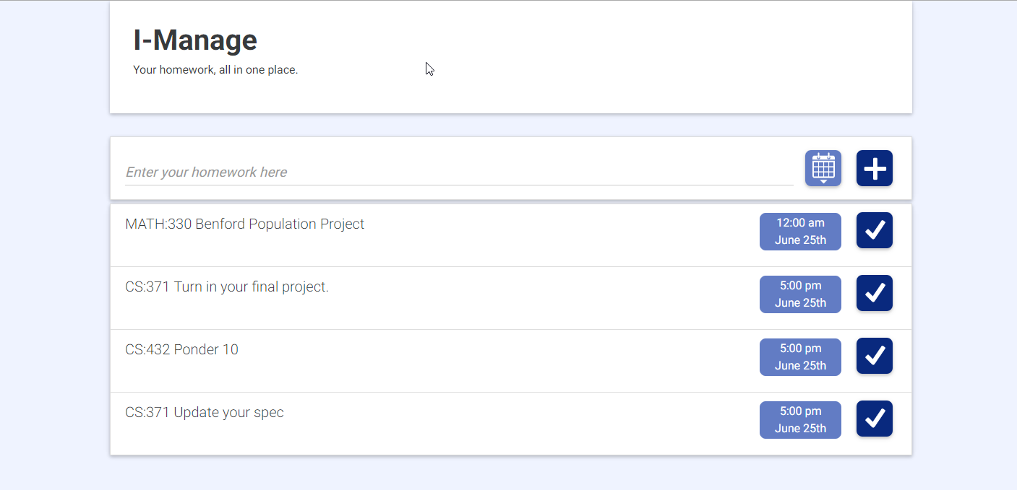

## Detailed Design

|  |  |  |
| --- | --- | --- |
| Description | Regular State | Pressed |
| Submit button to add an item to the list | 50px by 50px |  |
| Checkbox to remove an item from the list | 50px by 50px |  |
| Button to bring up date picker for an item | 50px by 50px |  |
| Due date indicator | Variable width to accommodate months. 50px high  15px padding-top 25px padding bottom | No pressing |
| Title of homework | 50px high,  15px padding-top 25px padding bottom | No pressing |
| Input for adding new item. Text for the title of a new homework item is typed here. | 50px high,  20px padding-top 20px padding bottom |  |
| Date Picker | 200 by 250 px |  |

Justifications: Monochromatic blue theme. Confidence and calming. Could be labeled boring. Icons rather than words whenever possible to conserve space and increase ease of use.

# Graveyard

## **June 18 2016**

Color and layout is better than June 11th version. The grouping of the homework is better, the checkbox is better, and the jumbotron takes up a lot less of the screen. A little bit of separation between the homework input and the homework items helps make the input distinct, but because the separation is small, the relationship between the input and the homework is still implied. The placeholder text size was increased, and I think that was good. The button alignment/spacing was improved, there now is a good rhythm between the input buttons and the date/submit button. The submit button is confusing. The submit button should be a + symbol, as that should be more familiar/intuitive to users.

## Prototype

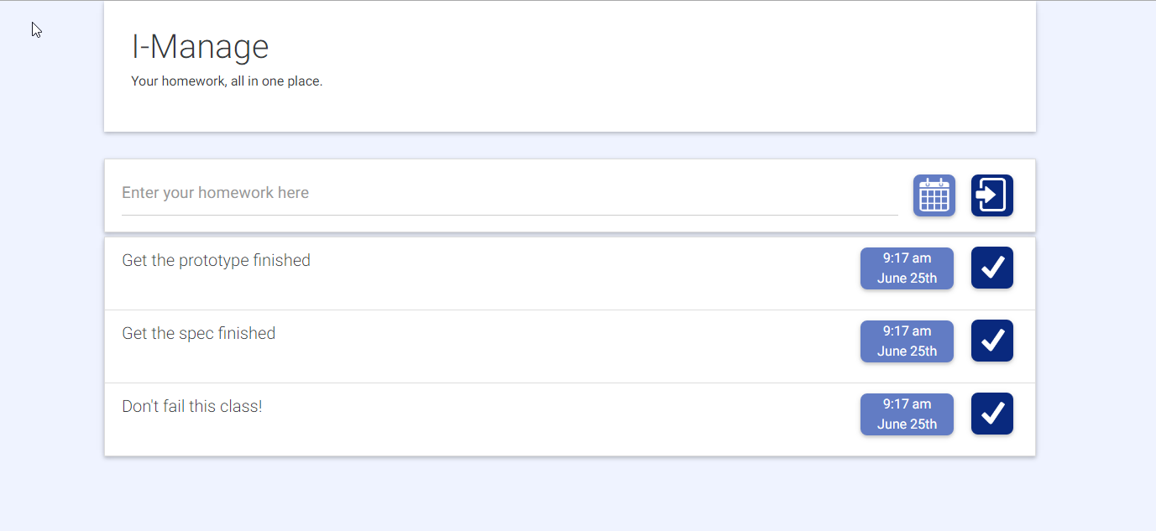

## **June 11 2016**

This design doesn’t use color or layout correctly. Also, the checkbox, submit, and due buttons are awful.

## Prototype

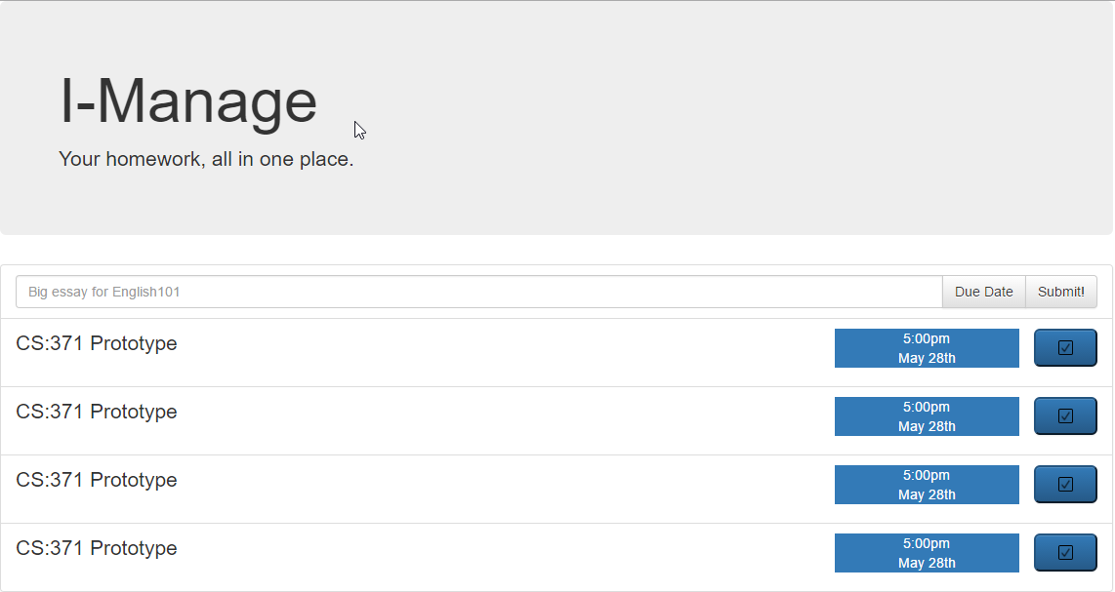

## Detailed Design

|  |  |  |
| --- | --- | --- |
| Description | Regular State | Pressed |
| Check box to remove an item from the list |  |  |
| Submit button to add an item to the list |  |  |
| Button to bring up date picker for an item |  |  |
| Due date indicator |  | No pressing |
| Title of homework |  | No pressing |
| Input for adding new item. Text for the title of a new homework item is typed here. |  |  |