SenIOR Project Risk Management Plan

CS 432

Joshua Jolley

# Version History

|  |  |  |  |
| --- | --- | --- | --- |
| Version # | Author | Date | Summary |
| 1.0 | Joshua Jolley | 7/16/2-16 | Initial Document |
|  |  |  |  |
|  |  |  |  |
|  |  |  |  |
|  |  |  |  |
|  |  |  |  |

# Introduction

## Purpose of The Risk Management Plan

To manage the risks of my senior project in such a way that I am able to earn an A on it.

# Risk Management Procedure

## Process

First, I Identified risks by thinking about what positive and negative risks I was likely to encounter while working on my senior project and reviewing what risks other people ran into while working with genetic algorithms by reading their documents about their experiences. I then analyzed each risk qualitatively by determining the probability of it happening and the impact it would have on my project. I then used the provided table to score each risk quantitatively. Following this, I created a response plan for each risk. Finally, I resolved to monitor and control the risks described and to record the results of this process in this document.

## Risk Identification

1. After repeated attempts, the best individuals created by my program cannot solve the maze.

2. Solving the maze takes a prohibitively long time.

3. I am unable to create a working genetic algorithm library.

4. My code is lost or destroyed.

5. The project turns out to be a lot easier than expected and I am under hours.

## Risk Analysis

### Qualitative Risk Analysis

**Risk 1:**

**Impact:** If this risk were realized, it would be a major setback to my project, as being able to solve the maze with my genetic algorithm library is proof of its validity, and an invalid project doesn’t earn a good grade.

**Probability:** The probability of this is rather low. I have confidence in my ability to program and as this has been completed by others before, I am likely to be able to do it.

**Risk 2:**

**Impact:** If solving the maze takes longer than people are willing to wait for it to solve, it would be a major setback to my project. The same reasoning used in Risk 1’s impact section applies here.

**Probability:** The probability of this is higher than the probability of Risk 1, but still fairly low. Since others have been able to solve mazes in relatively low amounts of time, I believe that I will be able to accomplish this as well.

**Risk 3:**

**Impact:** This risk is similar to Risk 1, as it has the same outcome, and the same reasoning behind its impact. That being said, if I am unable to create a genetic algorithm library at all, I might be in the wrong profession.

**Probability:** The chance of this risk being realized is likely the lowest of all of the risks.

**Risk 4:**

**Impact:** If I lose all of my code, I will have to re-write it. Depending on where in the process this happens, the severity will range from minor to major, proportional to whether it occurs early or late in the process.

**Probability:**

### Quantitative Risk Analysis

[For each risk, determine a quantitative score based on the following table:]

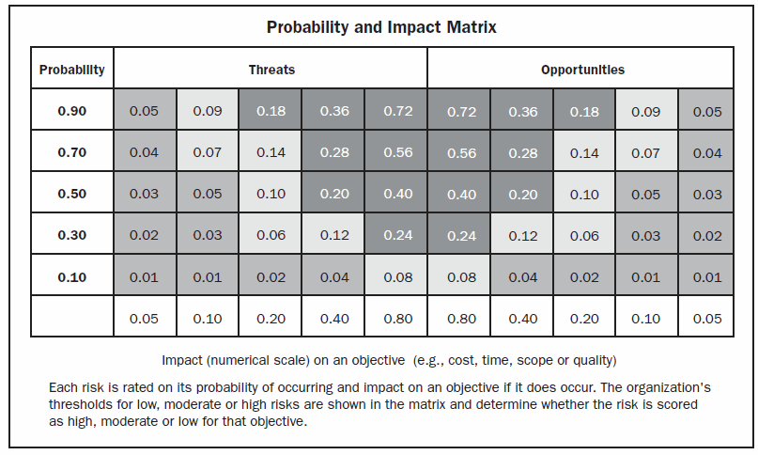

## Risk Response Planning

[See: “Planning Risk Response.” Additional resources may be necessary]

## Risk Monitoring, Controlling, and Reporting

[See: “Monitor and Control Risk” part of the reading]

# Appendix A: References

[Any document our source that was used to produce this document. Use the citation format used elsewhere in this class.]

# Appendix B: Key Terms

[If you use any terms in a special way, describe them here]

|  |  |
| --- | --- |
| Term | Definition |
|  |  |
|  |  |
|  |  |