SenIOR Project Risk Management Plan

CS 432

Joshua Jolley

# Version History

|  |  |  |  |
| --- | --- | --- | --- |
| Version # | Author | Date | Summary |
| 1.0 | Joshua Jolley | 7/16/2-16 | Initial Document |
|  |  |  |  |
|  |  |  |  |
|  |  |  |  |
|  |  |  |  |
|  |  |  |  |

# Introduction

## Purpose of The Risk Management Plan

To manage the risks of my senior project in such a way that I am able to earn an A on it.

# Risk Management Procedure

## Process

First, I Identified risks by thinking about what positive and negative risks I was likely to encounter while working on my senior project and reviewing what risks other people ran into while working with genetic algorithms by reading their documents about their experiences. I then analyzed each risk qualitatively by determining the probability of it happening and the impact it would have on my project. I then used the provided table to score each risk quantitatively. Following this, I created a response plan for each risk. Finally, I resolved to monitor and control the risks described and to record the results of this process in this document.

## Risk Identification

1. After repeated attempts, the best individuals created by my program cannot solve the maze.

2. Solving the maze takes a prohibitively long time.

3. I am unable to create a working genetic algorithm library.

4. My code is lost or destroyed.

5. The project turns out to be a lot easier than expected and I am under hours.

## Risk Analysis

### Qualitative Risk Analysis

**Risk 1:**

**Impact:** If this risk were realized, it would be a major setback to my project, as being able to solve the maze with my genetic algorithm library is proof of its validity, and an invalid project doesn’t earn a good grade.

**Probability:** The probability of this is rather low. I have confidence in my ability to program and as this has been completed by others before, I am likely to be able to do it.

**Risk 2:**

**Impact:** If solving the maze takes longer than people are willing to wait for it to solve, it would be a major setback to my project. The same reasoning used in Risk 1’s impact section applies here.

**Probability:** The probability of this is higher than the probability of Risk 1, but still fairly low. Since others have been able to solve mazes in relatively low amounts of time, I believe that I will be able to accomplish this as well.

**Risk 3:**

**Impact:** This risk is similar to Risk 1, as it has the same outcome, and the same reasoning behind its impact. That being said, if I am unable to create a genetic algorithm library at all, I might be in the wrong profession.

**Probability:** The chance of this risk being realized is likely the lowest of all of the risks.

**Risk 4:**

**Impact:** If I lose all of my code, I will have to re-write it. Depending on where in the process this happens, the severity will range from minor to major, proportional to whether it occurs early or late in the process.

**Probability:**  The likelihood of this occurring is rather low, but hard drives do occasionally fail, and my computer isn’t a spring chicken. This risk will likely have the lowest probability of occurring out of all of the risks.

**Risk 5:**

**Impact:** If I complete the project before working the required hours, I will need to expand the scope of my project. This is a minor impact.

**Probability:**  The probability of this occurring is low to medium. The scope of my project is somewhat small, but difficult enough that I expect to be at or just over hours on this project.

### Quantitative Risk Analysis

**Risk 1:** .08

**Risk 2:** .12

**Risk 3:** .04

**Risk 4:** .02

**Risk 5:** .20

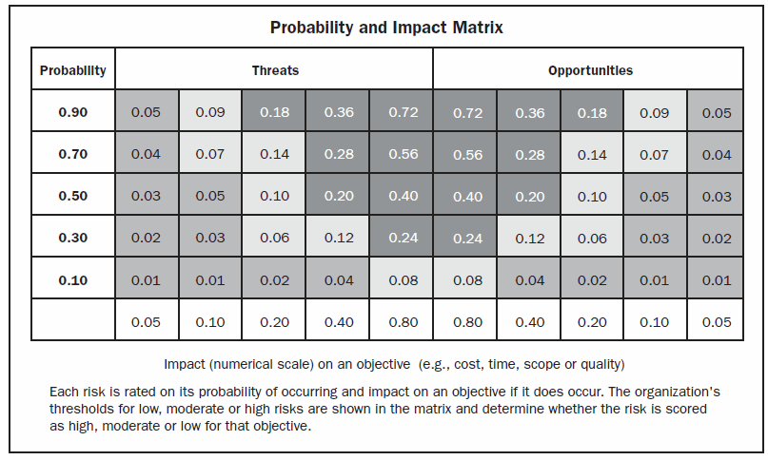

## Risk Response Planning

## Risk 1: I will *avoid* this risk by researching how others have tackled this problem in the past and using a similar approach. If the risk is realized, I will *mitigate* it by reaching out to Br. Burton for feedback on the problem, as he has experience with genetic algorithms.

## Risk 2: I will *avoid* this risk by profiling my application and optimizing the areas causing the slow down. If the risk is still realized, I will *mitigate* this risk by reducing the size of the space I am searching by shrinking the size of the maze.

## Risk 3: I will *avoid* this risk by doing thorough research, by iteratively programming the project, and testing each component as I go. If the risk is realized despite my efforts, I will *mitigate* this risk by reaching out to Br. Burton for help.

## Risk 4: I will *avoid* this risk by using a distributed version control system (git and github). When avoided, it will be almost impossible for this risk to be realized. In the event that it does occur, I will rewrite the code, and negotiate with Br. Burton for a reduced project scope as necessary.

## Risk 5: This risk is difficult to *avoid*. I *accept* this risk. If I finish early, I finish early. To *mitigate* this risk, I will work with Br. Burton to expand the scope of my project such that I will be able to fulfill the hours requirement of the project.

## Risk Monitoring, Controlling, and Reporting

At each stage of the project (research, design, prototype, code, deliver) I will monitor my project for these risks, control them using the plain laid out above, and record my success or failure in this section.

# Appendix A: References

# [1] S. Luke, Essentials of Metaheuristics, second. Lulu, 2013. [Online]. Available: https://cs.gmu. edu/~sean/book/metaheuristics/

# [2] T. Pasquier and J. Erdogan, “Genetic algorithm optimization in maze solving problem,” Institut Superieur d’Electronique de Paris, [Online]. Available: http://geneticmaze.googlecode. com/files/paper.pdf.

# [3] P. Charbonneau, “An introduction to genetic algorithms for numerical optimization,” NCAR Tech. Note TN-450+ IA, 74pp, 2002.

# [4] F. Usmani, "A Short Guide to Project Risk Management Plan," PM Study Circle, Jul. 2013 [Online] Available: <http://pmstudycircle.com/2013/07/a-short-guide-to-project-risk-management-plan/>

# Appendix B: Key Terms

[If you use any terms in a special way, describe them here]

|  |  |
| --- | --- |
| Term | Definition |
| Individual | A candidate solution [1]. |
| Genetic Algorithm | A genetic algorithm is a search heuristic. [2] Genetic algorithms search for a solution to a problem by mimicking evolution’s processes of crossover and mutation within a population. [3] |
| Avoid | In avoid risk response strategy you take measures to completely eliminate the threat or its effect [4]. |
| Mitigate | In mitigation, you try to reduce the chance of the risk occurring, or its impact [4]. |
| Accept | Here, you acknowledge the risk and document it, but do not take any action to mitigate it or its effect [4]. |