# Junaid Ahmad Chaudhary

**Mobile No: +91 987654321  
Email: jc.junaid.chaudhary@gmail.com  
Location: Mumbai,Maharashtra,India**

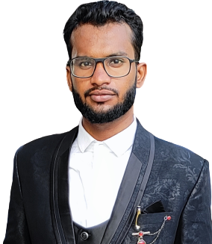

# Objective

Seeking the position of a Python Developer to further hone my skills in Python, Flask,Django, SQL Database to enhance organizational effectiveness

# Work Experience

**Python Developer**Olx Information Technology,Jogeshwari Mumbai.  
Working on following technologies in:  
Python3, Django, MySQL, REST API, HTML5,CCS3, JavaScript and GitHub.  
(May 2022 - present)

# Academic Background

**Bachelors of Engineering Information Technology(2023)**  
M.H Saboo Siddik College of Engineering | CGPA: 8.29

**Ramniranjan Jhunjhunwala college | HSC | (2019)** Score:64

**Yogiraj Shree Krishna Vidyalaya | SSC | (2017)** Score:89

# Projects

**Personalize Notebook**JSON based API, Based on Flask Framework, ORM tool used SQLALCHEMY Database Management Tool used MySQL | SQLit

# Technical Skills

python, Java, Django, Flask, GitHub, Angular, HTML, CSS

# Personal Deatils

Date of birth : may 2020  
Marital Status : Single  
Gender : Male  
Language :English, Hindi, Urdu

# Links

**LinkedIn:** <https://www.linkedin.com/in/juned-ahmad-chaudhary-25498720a/>

**GitHUb:** <https://github.com/jcjunaidchaudhary>