Document Title

Here is the first LaTeX equation:

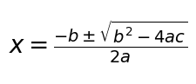

Here is the second LaTeX equation:

