Question Paper

Q1: The acceleration ‘a’ in m/s² of a particle is given by 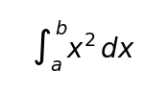

where t is the time. If the particle starts out with a velocity u = 2m/s at t = 0, then the velocity at the end of 2 seconds is.

Option A:

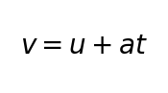

Option B:

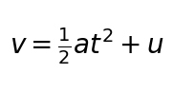

Option C:

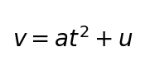

Option D:

