Question Paper

Q1: What is the solution to the quadratic equation 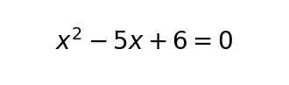

Option A:



Option B:



Option C:



Option D:



Q2: Evaluate the integral 

Option A:



Option B:



Option C:



Option D:



Q3: Evaluate the multiple integral 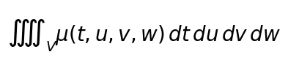

Option A:



Option B:



Option C:



Option D:

