Spring

The Spring Framework is divided into modules. Applications can choose which modules they need. At the heart are the modules of the core container, including a configuration model and a dependency injection mechanism. Beyond that, the Spring Framework provides foundational support for different application architectures, including messaging, transactional data and persistence, and web. It also includes the Servlet-based Spring MVC web framework and, in parallel, the Spring WebFlux reactive web framework.

- Core Technologies: IoC Container, Events, Resources, i18n, Validation, Data Binding, Type Conversion, Spring Expression Language (SpEL), AOP.

Introduction to the Spring IoC Container and Beans
This chapter covers the Spring Framework implementation of the Inversion of Control (IoC) principle. IoC is also known as dependency injection (DI). It is a process whereby objects define their dependencies (that is, the other objects they work with) only through constructor arguments, arguments to a factory method, or properties that are set on the object instance after it is constructed or returned from a factory method. The container then injects those dependencies when it creates the bean. This process is fundamentally the inverse (hence the name, Inversion of Control) of the bean itself controlling the instantiation or location of its dependencies by using direct construction of classes or a mechanism such as the Service Locator pattern.
The org.springframework.beans and org.springframework.context packages are the basis for Spring Framework’s IoC container. The BeanFactory interface provides an advanced configuration mechanism capable of managing any type of object. ApplicationContext is a sub-interface of BeanFactory. It adds:
- Easier integration with Spring’s AOP features
- Message resource handling (for use in internationalization)
- Event publication
- Application-layer specific contexts such as the WebApplicationContext for use in web applications.
In short, the BeanFactory provides the configuration framework and basic functionality, and the ApplicationContext adds more enterprise-specific functionality. The ApplicationContext is a complete superset of the BeanFactory and is used exclusively in this chapter in descriptions of Spring’s IoC container.
In Spring, the objects that form the backbone of your application and that are managed by the Spring IoC container are called beans. A bean is an object that is instantiated, assembled, and otherwise managed by a Spring IoC container. Otherwise, a bean is simply one of many objects in your application. Beans, and the dependencies among them, are reflected in the configuration metadata used by a container (which can be eg. an xml document or something else, see javabrains tutorial).

Container Overview
The org.springframework.context.ApplicationContext interface represents the Spring IoC container and is responsible for instantiating, configuring, and assembling the beans. The container gets its instructions on what objects to instantiate, configure, and assemble by reading configuration metadata. The configuration metadata is represented in XML, Java annotations, or Java code. It lets you express the objects that compose your application and the rich interdependencies between those objects.
In most application scenarios, explicit user code is not required to instantiate one or more instances of a Spring IoC container. For example, in a web application scenario, a simple eight (or so) lines of boilerplate web descriptor XML in the web.xml file of the application typically suffices (see Convenient ApplicationContext Instantiation for Web Applications). If you use the Spring Tool Suite (an Eclipse-powered development environment), you can easily create this boilerplate configuration with a few mouse clicks or keystrokes.
The Spring IoC container consumes a form of configuration metadata. This configuration metadata represents how you, as an application developer, tell the Spring container to instantiate, configure, and assemble the objects in your application.
Configuration metadata is traditionally supplied in a simple and intuitive XML format, which is what most of this chapter uses to convey key concepts and features of the Spring IoC container.
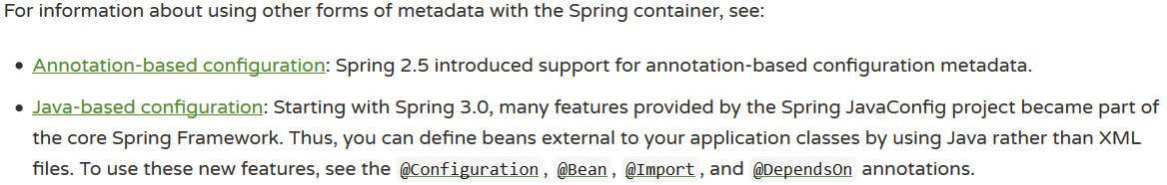
Spring configuration consists of at least one and typically more than one bean definition that the container must manage. XML-based configuration metadata configures these beans as <bean/> elements inside a top-level <beans/> element. Java configuration typically uses @Bean-annotated methods within a @Configuration class.
These bean definitions correspond to the actual objects that make up your application. Typically, you define service layer objects, data access objects (DAOs), presentation objects such as Struts Action instances, infrastructure objects such as Hibernate SessionFactories, JMS Queues, and so forth. Typically, one does not configure fine-grained domain objects in the container, because it is usually the responsibility of DAOs and business logic to create and load domain objects. However, you can use Spring’s integration with AspectJ to configure objects that have been created outside the control of an IoC container.

Instantiating a Container
The location path or paths supplied to an ApplicationContext constructor are resource strings that let the container load configuration metadata from a variety of external resources, such as the local file system, the Java CLASSPATH (meaning that you can add your .xml file to the src folder and it will find it), and so on.

The following example shows the service layer objects (services.xml) configuration file:
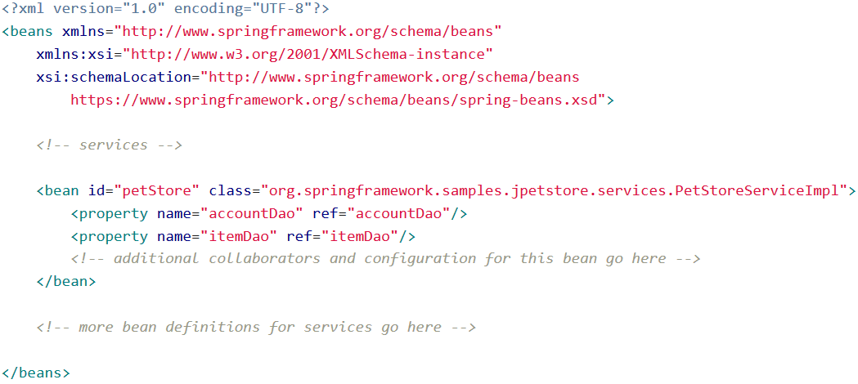

- The id attribute is a string that identifies the individual bean definition.
- The class attribute defines the type of the bean and uses the fully qualified classname.
The value of the id attribute refers to collaborating objects.

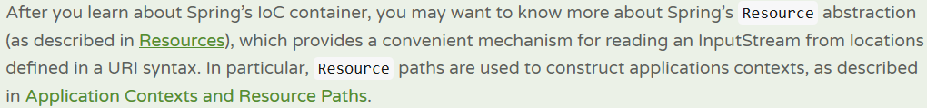

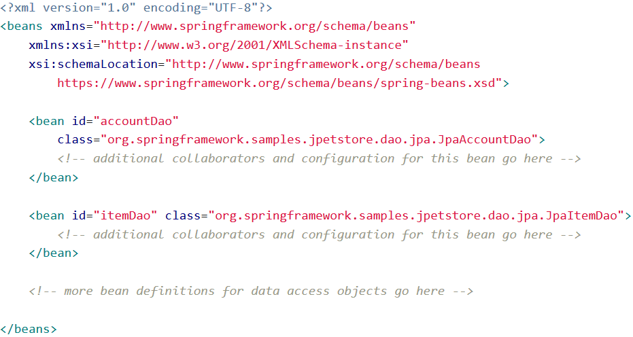
The following example shows the data access objects daos.xml file:

In the preceding example, the service layer consists of the PetStoreServiceImpl class and two data access objects of the types JpaAccountDao and JpaItemDao (based on the JPA Object-Relational Mapping standard). The property name element refers to the name of the JavaBean property, and the ref element refers to the name of another bean definition. This linkage between id and ref elements expresses the dependency between collaborating objects. For details of configuring an object’s dependencies, see Dependencies.
- You can also have a groovy configuration file.

Using the Container
The ApplicationContext is the interface for an advanced factory capable of maintaining a registry of different beans and their dependencies. By using the method T getBean(String name, Class<T> requiredType), you can retrieve instances of your beans.
The ApplicationContext lets you read bean definitions and access them, as the following example shows:
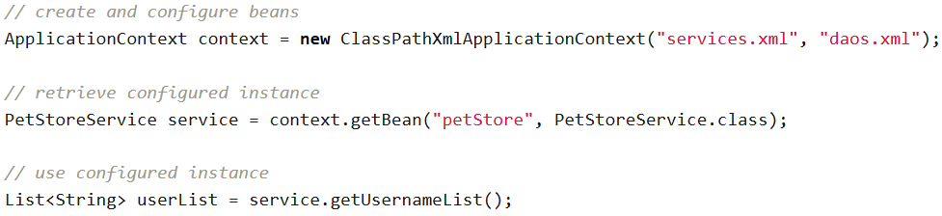

The ApplicationContext interface has a few other methods for retrieving beans, but, ideally, your application code should never use them. Indeed, your application code should have no calls to the getBean() method at all and thus have no dependency on Spring APIs at all. For example, Spring’s integration with web frameworks provides dependency injection for various web framework components such as controllers and JSF-managed beans, letting you declare a dependency on a specific bean through metadata (such as an autowiring annotation).

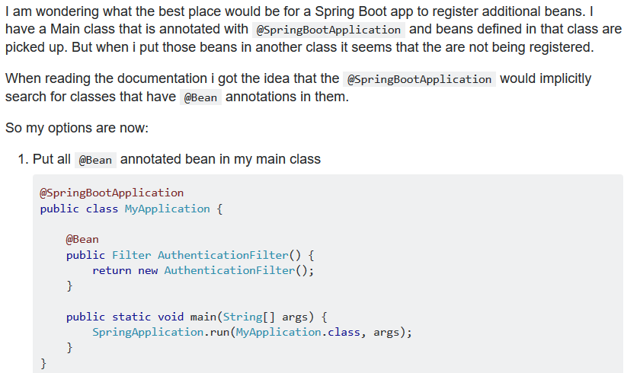

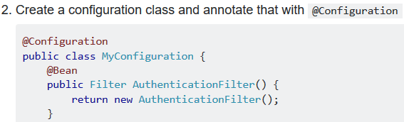

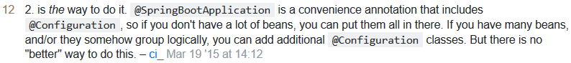

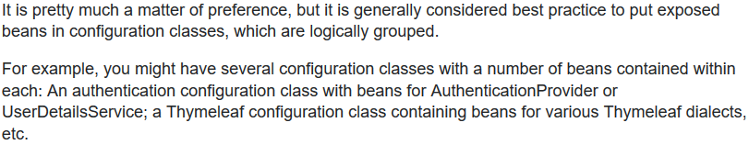

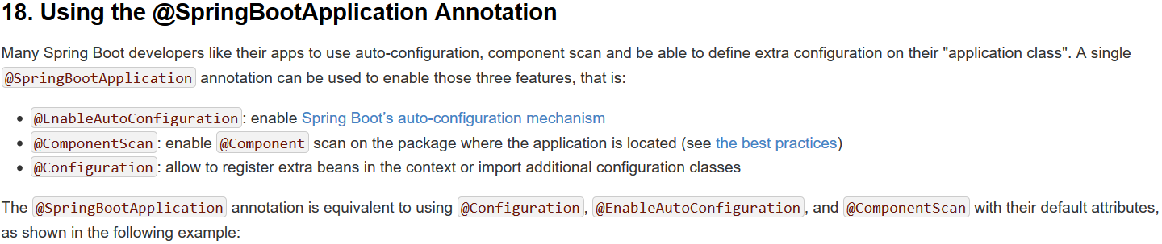

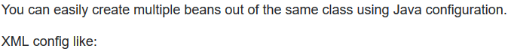
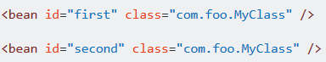
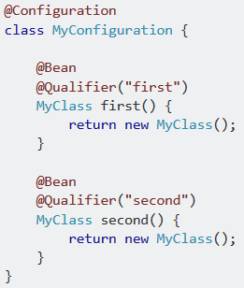
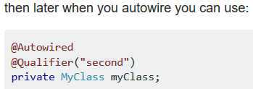
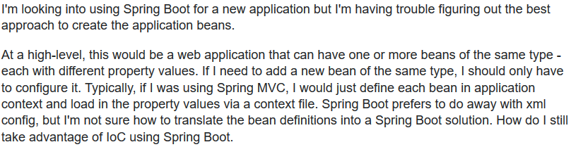
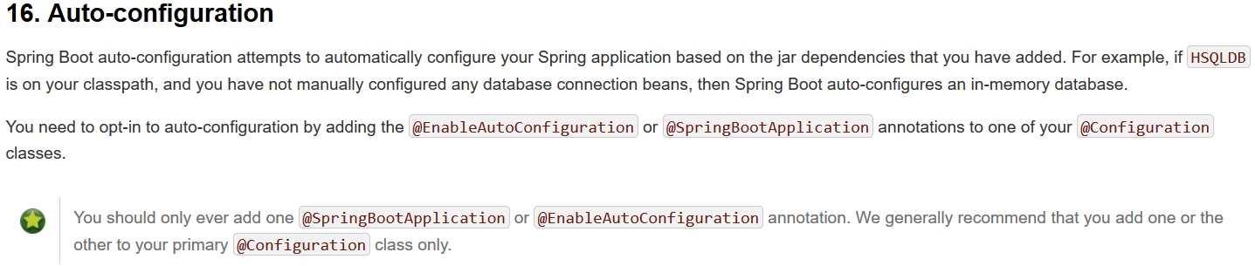
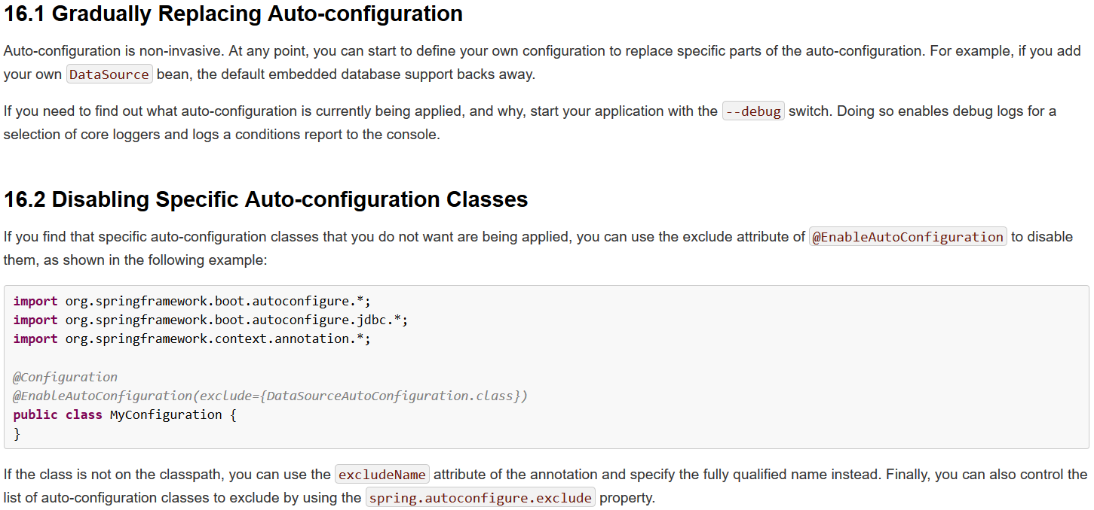
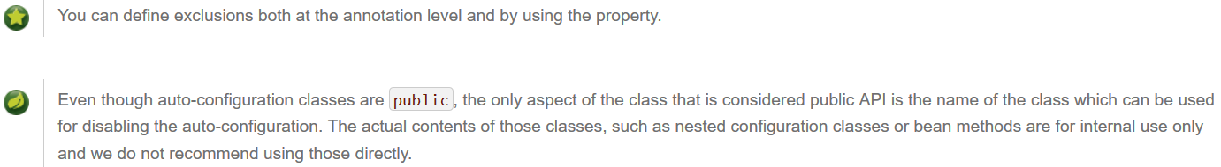
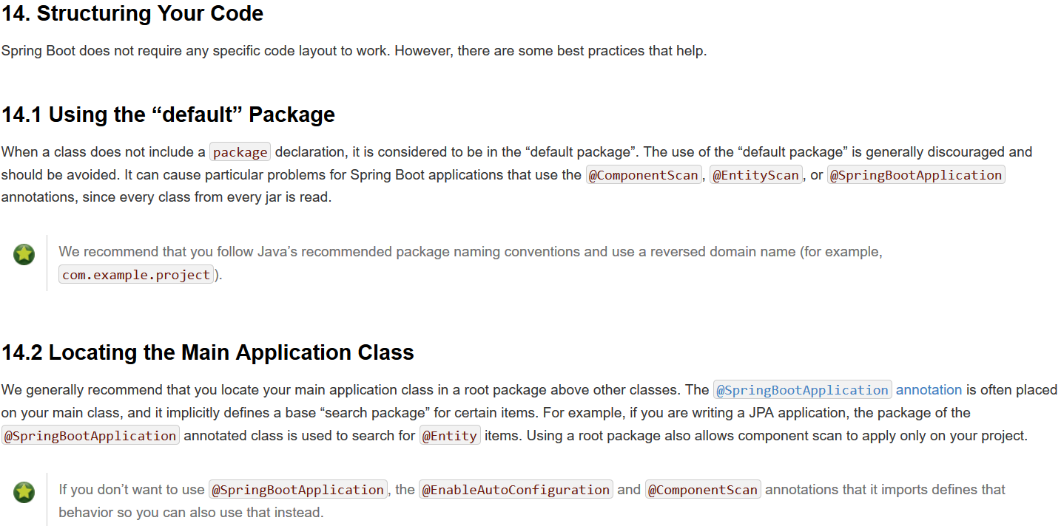

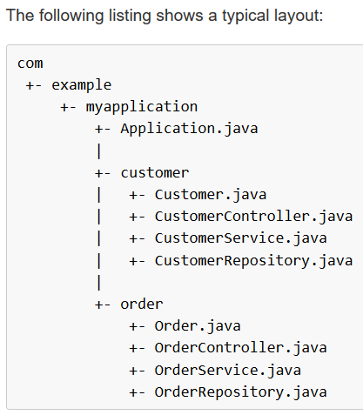
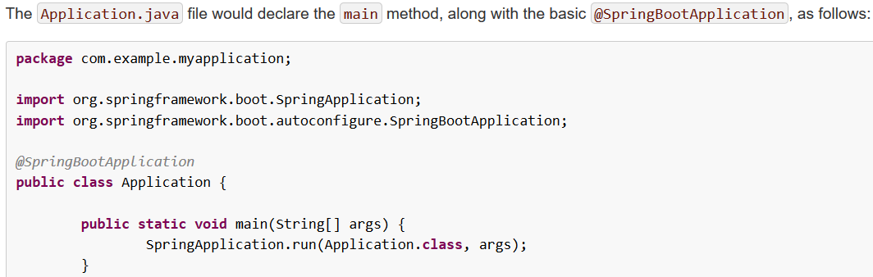

Component Scanning

https://www.baeldung.com/spring-component-scanning
https://www.baeldung.com/spring-bean-annotations
https://stackoverflow.com/questions/10604298/spring-component-versus-bean

Şu ana kadar anladığım:
You should not manage your beans yourself (by creating them, adding them to a container and then use getBean(…)) but instead rely on dependency injection, to get them back from the container.
If you have just one instance of a class then you don‘t need an id(?)
If you will have 2 or more beans/instances of the same class then you can use the @Qualifier annotation to give them an id (like the id given in the xml files above). Else you will get an exception (?)

