Thymeleaf
Thymeleaf is a modern server-side Java template engine for both web and standalone environments, capable ofprocessing HTML, XML, JavaScript, CSS and even plain text.
The main goal of Thymeleaf is to provide an elegant and highly-maintainable way of creating templates. To achieve this, it builds on the concept of Natural Templates to inject its logic into template files in a way that doesn’t affect the template from being used as a design prototype. This improves communication of design and bridges the gap between design and development teams.

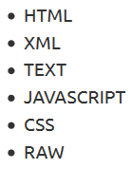
What kind of templates can Thymeleaf process?
Out-of-the-box, Thymeleaf allows you to process six kinds of templates, each of which is called a Template Mode:
There are two markup template modes (HTML and XML), three textual template modes (TEXT, JAVASCRIPT and CSS) and a no-op template mode (RAW).

Dialects: The Standard Dialect
Thymeleaf is an extremely extensible template engine (in fact it could be called a template engine framework) that allows you to define and customize the way your templates will be processed to a fine level of detail.
An object that applies some logic to a markup artifact (a tag, some text, a comment, or a mere placeholder if templates are not markup) is called a processor, and a set of these processors – plus perhaps some extra artifacts – is what a dialect is normally comprised of. Out of the box, Thymeleaf’s core library provides a dialect called the Standard Dialect, which should be enough for most users.
- The official thymeleaf-spring3 and thymeleaf-spring4 integration packages both define a dialect called the “SpringStandard Dialect”, which is mostly the same as the Standard Dialect, but with small adaptations to make better use of some features in the Spring Framework (for example, by using Spring Expression Language or SpringEL instead of OGNL). So if you are a Spring MVC user you are not wasting your time, as almost everything you learn here will be of use in your Spring applications.
Most of the processors of the Standard Dialect are attribute processors. This allows browsers to correctly display HTML template files even before being processed because they will simply ignore the additional attributes. For example, while a JSP using tag libraries could include a fragment of code not directly displayable by a browser like:
…the Thymeleaf Standard Dialect would allow us to achieve the same functionality with:
Not only will this be correctly displayed by browsers, but this also allow us to (optionally) specify a value attribute in it (“James Carrot”, in this case) that will be displayed when the prototype is statically opened in a browser, and that will be substituted by the value resulting from the evaluation of ${user.name} during processing of the template. Meaning the value of th:value will replace the „value“ attribute after thymeleaf processes it and when it generates a resulting html file. If opened statically (left click) then th:value is ignored and everything looks normal.
This helps your designer and developer to work on the very same template file and reduce the effort required to transform a static prototype into a working template file. The ability to do this is a feature called Natural Templating.

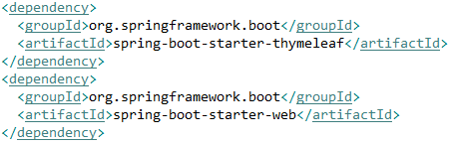
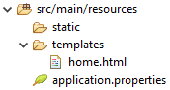
Start using Thymeleaf with Spring Boot
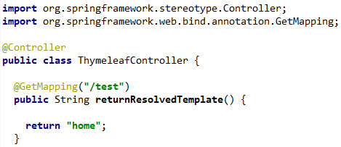



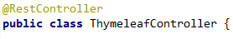
Important: if you use a @RestController, the returning string won‘t be considered a template name. Instead it will return the string itself, since it is a REST controller.

Important: if you have an error in your template you will see an error page like this.
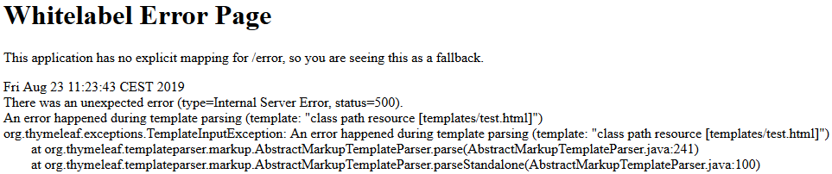

A multi-language welcome
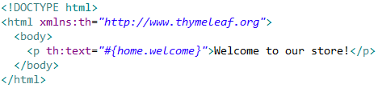
Our first task will be to create a home page for our site
The first thing you will notice is that this file is HTML5 that can be correctly displayed by any browser because it does not include any non-HTML tags (browsers ignore all attributes they don’t understand, like th:text).

But you may also notice that this template is not really a valid HTML5 document, because these non-standard attributes we are using in the th:* form are not allowed by the HTML5 specification. In fact, we are even adding an xmlns:th attribute to our <html> tag, something absolutely non-HTML5-ish …which has no influence at all in template processing, but works as an incantation that prevents our IDE from complaining about the lack of a namespace definition for all those th:* attributes.
So what if we wanted to make this template HTML5-valid? Easy: switch to Thymeleaf’s data attribute syntax, using the data- prefix for attribute names and hyphen (-) separators instead of semi-colons (:):
Custom data- prefixed attributes are allowed by the HTML5 specification, so, with this code above, our template would be a valid HTML5 document.
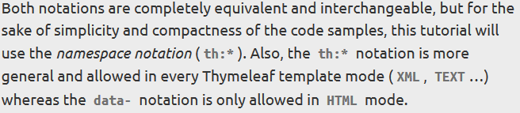

Using th:text and externalizing text
Externalizing text is extracting fragments of template code out of template files so that they can be kept in separate files (typically .properties files) and that they can be easily replaced with equivalent texts written in other languages (a process called internationalization or simply i18n). Externalized fragments of text are usually called “messages”. Basically we keep some „fragments“ of templates in a separate file.
Messages always have a key that identifies them, and Thymeleaf allows you to specify that a text should correspond to a specific message with the #{...} syntax:
What we can see here are in fact two different features of the Thymeleaf Standard Dialect:
- The th:text attribute, which evaluates its value expression and sets the result as the body of the host tag, effectively replacing the “Welcome to our grocery store!” text we see in the code.
- The #{home.welcome} expression, specified in the Standard Expression Syntax, instructing that the text to be used by the th:text attribute should be the message with the home.welcome key corresponding to whichever locale we are processing the template with.
Now, where is this externalized text?
The location of externalized text in Thymeleaf is fully configurable, and it will depend on the specific org.thymeleaf.messageresolver.IMessageResolver implementation being used. Normally, an implementation based on .properties files will be used, but we could create our own implementations if we wanted, for example, to obtain messages from a database.
However, we have not specified a message resolver for our template engine during initialization, and that means that our application is using the Standard Message Resolver, implemented by org.thymeleaf.messageresolver.StandardMessageResolver.
With spring boot the messages are expected to be under .../src/main/resources in .properties files. By default, a Spring Boot application will look for message files containing internationalization keys and values in the src/main/resources folder. The file for the default locale will have the name messages.properties, and files for each locale will be named messages_XX.properties, where XX is the locale code.
- /src/main/resources/messages_en.properties for English texts.
- /src/main/resources/messages_es.properties for Spanish language texts.
- /src/main/resources/messages_pt_BR.properties for Portuguese (Brazil) language texts.
- /src/main/resources/messages.properties for default texts (if the locale is not matched).
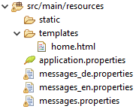
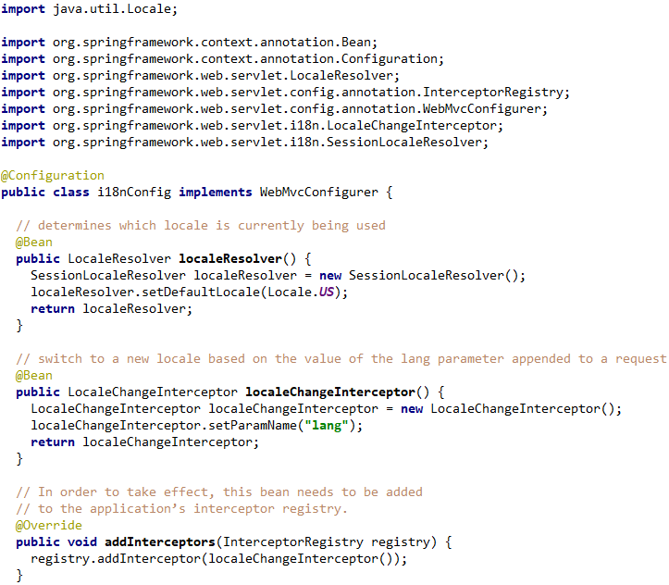

Testing our applicaion

Other examples found in the internet uses a deprecated class →

- If a key does not exist in a certain requested locale, then the application will fall back to the default locale value. Something like this: („??messages.home.en_US??“)

Changing Message Source Folder
Spring Boot supports localized messages so that your application can cater to users of different language preferences. By default, Spring Boot looks for the presence of a messages resource bundle at the root of the classpath.
The basename of the resource bundle as well as several other attributes can be configured using the spring.messages namespace, as shown in the following example:

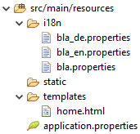

- This works!!!

In this example the default properties file will be called if the request cannot be matched with a locale. We set our locale as US, thats why going to /test shows the en locale. If we enter /test?lang=zz → now it can‘t find a .properties file and calls the default properties file

First call to /test gives the en locale, If I call /test?lang=de and after that /test, it will still show me the german text? How to make all calls to /test to show en?

Unescaped Text
If we want to use html tags inside our text then we need to use th:utext. This is the default behaviour of the th:text attribute. If we want Thymeleaf to respect our HTML tags and not escape them, we will have to use a different attribute: th:utext (for “unescaped text”):
with th:text → home.welcome=Welcome to our <b>fantastic</b> grocery store!
<p>Welcome to our &lt;b&gt;fantastic&lt;/b&gt; grocery store!</p>

Standard Expression Syntax
One of the most important parts of the Thymeleaf Standard Dialect: the Thymeleaf Standard Expression syntax.
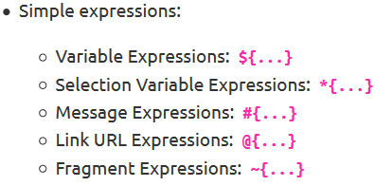
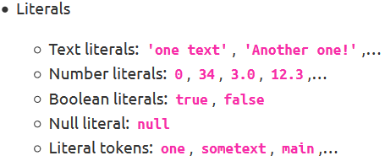
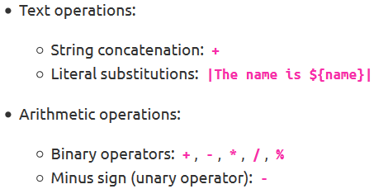
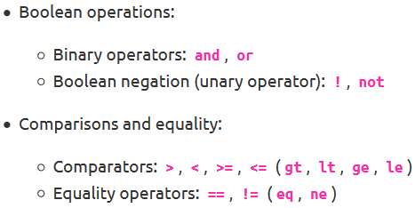
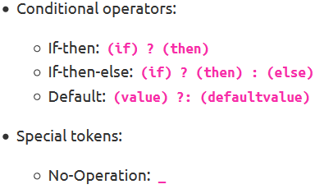

All these features can be combined and nested:

Messages
There’s one aspect we still haven’t thought of: what happens if the message text is not completely static? What if, for example, our application knew who is the user visiting the site at any moment and we wanted to greet them by name?
- <p>¡Bienvenido a nuestra tienda de comestibles, John Apricot!</p>
Parameters are specified according to the java.text.MessageFormat standard syntax, which means you can format to numbers and dates as specified in the API docs for classes in the java.text.* package.
In order to specify a value for our parameter, and given an HTTP session attribute called user, we could have:
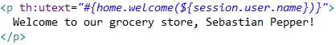

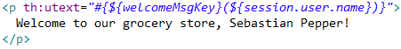
- Several parameters can be specified, separated by commas.
The message key itself can come from a variable:
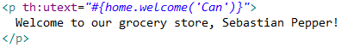

Spring MVC and Thymeleaf: how to access data from templates
In a typical Spring MVC application, @Controller classes are responsible for preparing a model map with data and selecting a view to be rendered. This model map allows for the complete abstraction of the view technology and, in the case of Thymeleaf, it is transformed into a Thymeleaf context object (part of the Thymeleaf template execution context) that makes all the defined variables available to expressions executed in templates.

Learn more about @controller – model map.

1. Spring model attributes / Thymeleaf context variables
Spring MVC calls the pieces of data that can be accessed during the execution of views: model attributes.
The equivalent term in Thymeleaf language is context variables.
There are several ways of adding model attributes to a view in Spring MVC. Below you will find some common cases:

- Add attribute to Model via its addAttribute() method:

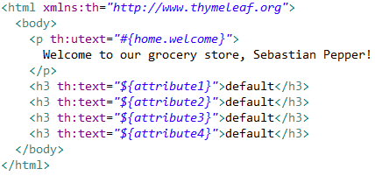
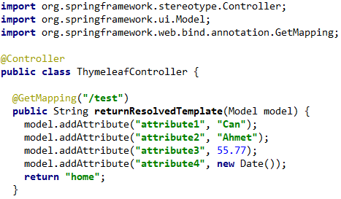
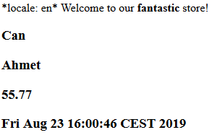

- Return ModelAndView with model attributes included:
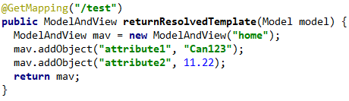
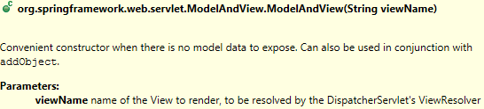

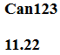

- Expose common attributes via methods annotated with @ModelAttribute:
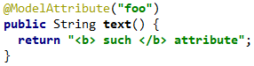

In Thymeleaf, these model attributes (or context variables in Thymeleaf jargon) can be accessed with the following syntax:
${attributeName}, where attributeName in our case is messages. This is a Spring EL expression. In short, Spring EL (Spring Expression Language) is a language that supports querying and manipulating an object graph at runtime.
2. Request parameters
Request parameters can be easily accessed in Thymeleaf views. Request parameters are passed from the client to server like: https://example.com/query?q=Thymeleaf+Is+Great!
I have the same controller class:

In the above example if parameter q is not present, empty string will be displayed in the above paragraph otherwise the value of q will be shown.
Since parameters can be multivalued (e.g. `https://example.com/query?q=Thymeleaf%20Is%20Great!&q=Really%3F) you may access them using brackets syntax:

- Note: If you access multivalued parameter with ${param.q} you will get a serialized array as a value.

Another way to access request parameters is by using the special #request object that gives you direct access to the javax.servlet.http.HttpServletRequest object

3. Session attributes
Similarly to the request parameters, session attributes can be access by using the session. Prefix:
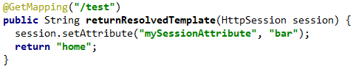

Or by using #session, that gives you direct access to the javax.servlet.http.HttpSession object:
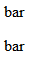
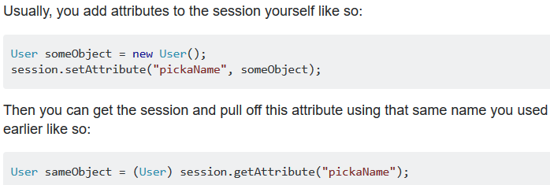

4. ServletContext attributes
The ServletContext attributes are shared between requests and sessions. In order to access ServletContext attributes in Thymeleaf you can use the #servletContext. Prefix:

5. Spring beans
Thymeleaf allows accessing beans registered at the Spring Application Context with the @beanName syntax, for example:
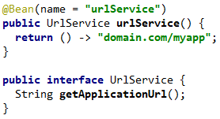

Variables
We already mentioned that ${...} expressions are in fact OGNL (Object-Graph Navigation Language) expressions executed on the map of variables contained in the context.
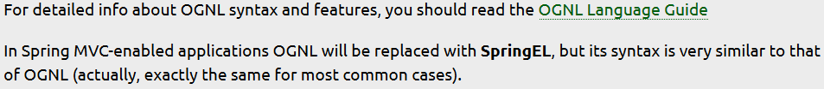

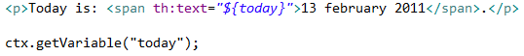
From OGNL’s syntax, we know that these expressions are equivalent.
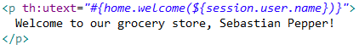
But OGNL allows us to create quite more powerful expressions, and that’s how this: …obtains the user name by executing:

But getter method navigation is just one of OGNL’s features. Let’s see some more:
