PROTOCOLS
Protocol, in computer science, a set of rules or procedures for transmitting data between electronic devices, such as computers. In order for computers to exchange information, there must be a preexisting agreement as to how the information will be structured and how each side will send and receive it. Without a protocol, a transmitting computer, for example, could be sending its data in 8-bit packets while the receiving computer might expect the data in 16-bit packets. Protocols are established by international or industrywide organizations. Perhaps the most important computer protocol is OSI (Open Systems Interconnection), a set of guidelines for implementing networking communications between computers. Among the most important sets of Internet protocols are TCP/IP, HTTPS, SMTP, and DNS.
In telecommunications, a proprietary protocol is a communications protocol owned by a single organization or individual. Only the cooperation that created it is allowed to change it and if you want to use them you need to pay them for a license.
Open protocols: creating a standard, other people are allowed to look at them and modify them but it should be a variation of it, like the 802.11n, 802.11b. The core standard is there but they enhanced it.

OSI Model
The Open Systems Interconnection model (OSI model) is a conceptual model that characterizes and standardizes the communication functions of a telecommunication or computing system without regard to its underlying internal structure and technology. Its goal is the interoperability of diverse communication systems with standard protocols. The model partitions a communication system into abstraction layers. The original version of the model defined seven layers.
Most network protocol suites are viewed as structured in layers. This is a result of the Open Systems Interconnect (OSI) Reference Model designed by the International Standards Organization (ISO). The OSI model describes network activities as having a structure of seven layers, each of which has one or more protocols associated with it. The layers represent data transfer operations common to all types of data transfers among cooperating networks.
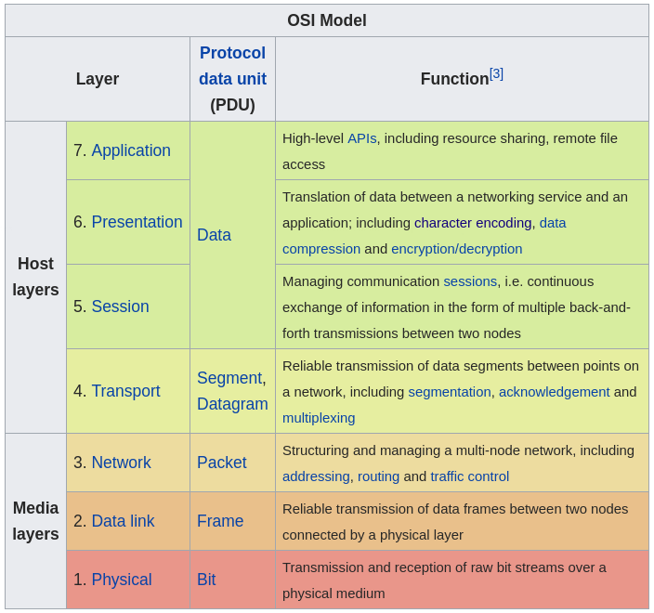
Application Layer: Sitting at Layer 7 -- the very top of the Open Systems Interconnection (OSI) communications model -- the application layer provides services for an application program to ensure that effective communication with another application program on a network is possible. The application layer should not be thought of as an application as most people understand it. Instead, the application layer is a component within an application that controls the communication method to other devices. It's an abstraction layer service that masks the rest of the application from the transmission process. The application layer relies on all the layers below it to complete its process. At this stage, the data, or the application, is presented in a visual form the user can understand.
Functions of the application layer
- Ensures that the receiving device is identified, can be reached and is ready to accept data.
- Enables, if appropriate, authentication to occur between devices for an extra layer of security.
Makes sure necessary communication interfaces exist. For example, is there an Ethernet or Wi-Fi interface in the sender's computer?
- Ensures agreement at both ends about error recovery procedures, data integrity and privacy.
- Determines protocol and data syntax rules at the application level.
- Presents the data on the receiving end to the user application.
The presentation layer Provides a context for communication between layers, ASCII Characters. Also Encryption and decryption, compression happens here. Way to remember: It prepares the data coming from lower levels for the upper level for presentation.
The session layer controls the dialogues (connections) between computers (Handshaking takes place). Also controls duplexing, termination and restarts.
Transport Layer: The Job of this layer is to act as a assembler/disassembler of data. This layer will get the data and also the dest/src port numbers. Then it will chop up this piece of data into smaller pieces and giving them a sequencing number. These data pieces then are called Segments.
Different protocols are used on this layer.
- TCP for reliable connections → More overhead, slower and takes more time/bandwidth but making sure that all the data pieces will arrive at the destination, error checking, conformation of delivery. When we need to make sure all of the data should arrive then we use TCP.
- UDP for unreliable connections → Less overhead, segments are bigger and thats why its more faster. But the data could be lost on the way. Best for things like video / audio streaming services. When latency is an issue you use UDP
Network Layer: Provides connections between hosts on different networks. This is where routers operate, routing of the packets. At this layer the hardware devices come in to play. It takes each of the segments from the transport layer and generally adds a src and destination ip address to it. The data then is called packets. There are different protocols used on this layer but most common are IPv4 and IPv6.
Data Link Layer: Provides connections between hosts on the same network, ethernet and mac addresses operate on layer 2. The data on this layer are called frames. Adds a dest/src mac address, length (type) and a footer fcs to each of the packets coming from the upper layer.
IP packets sit within frames ! This is the concept of encapsulation. Encapsulating the data coming from the upper layers more and more, like Matrushkas.
The ethernet frame will never change, it will always be the same no matter what type of medium we use, UTP or Fiber Optic cables etc.
Physical Layer: Describes electrical and physical specifications for devices. Cable, connectors, hubs, repeaters. Bits.
Ethernet Frame
Ethernet defines two units of transmission, packet and frame.
The frame includes not just the "payload" of data being transmitted but also addressing information identifying the physical "Media Access Control" (MAC) addresses of both sender and receiver, VLAN tagging and quality of service information, and error-correction information to detect problems in transmission.
Each frame is wrapped in a packet, which affixes several bytes of information used in establishing the connection and marking where the frame starts.
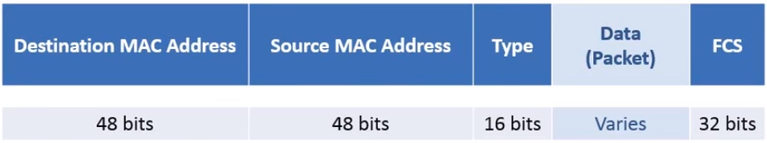

Mac Address is a 48-bit value that is composed of 2 parts:
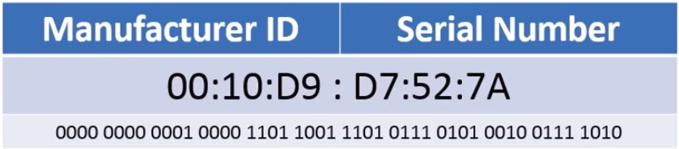

Manufacturer ID: Let say you are Intel and you want to make Network Interface Cards, you apply to IEEE and you pay a fee and you get a distinct Manufacturer ID (first 24-bits) .
Serial Number: The manufacturer will assign a number to each individual card that they produce. The idea is every single network interface card on earth should have a different number but sometimes errors might occur where 2 cards have the same MAC address.
This is the Layer 2 address, windows calls it the physical address, some people hardware address, usually its called MAC address.Type field: The type field is designed to accommodate a message to the next layer up. The type field is a message to the network layer saying “Hey, I’m about to send you {this} type of packet”. So it will specify either IPv4 or IPv6. One of the codes seen in the picture.
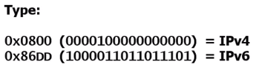
There were several other versions of network protocols in the past like ipx, xns. But most of them are not in use today. We are mostly left with Internet Protocol (IP) version 4 or 6.
FCS (Frame Check Sequence): Uses a Cyclical Redundancy Check (CRC) to create a hash. A unique id for a much bigger set of data. So we take a hash of the entire piece of data: Dest. Mac + Src Mac+ type + Data. We come up with the hash value and we tick it at the end of the frame. Then we send the frame out.
When the frame is received at the other end, the switch/receiving device can then run its own calculation against the data that was received and compare it to the value that is in the FCF field. If the values match, the frame has integrity. Meaning that the frame sent is exactly the same as the frame received, the frame was not modified. If the hashes don’t match the frame will be thrown away. What can modify the frame? Could be interference, router could be dropping packets, the link that was sending it could be poor and dropping information there.
Unfortunetaly there is no mechanism built into Ethernet to re-request the missing information. That takes at other layers of the OSI-Model, one protocol in particular that does it really well, at the transport layer: it is TCP. TCP is going to do our requesting for missing segments if some fcs values don’t match.
TCP/IP Protocol Architecture Model

The Internet protocol suite is the conceptual model and set of communications protocols used on the Internet and similar computer networks. It is commonly known as TCP/IP because the foundational protocols in the suite are the Transmission Control Protocol (TCP) and the Internet Protocol (IP).
The Internet protocol suite provides end-to-end data communication specifying how data should be packetized, addressed, transmitted, routed, and received. This functionality is organized into four abstraction layers, which classify all related protocols according to the scope of networking involved.[1][2] From lowest to highest, the layers are the link layer, containing communication methods for data that remains within a single network segment (link); the internet layer, providing internetworking between independent networks; the transport layer, handling host-to-host communication; and the application layer, providing process-to-process data exchange for applications.

The OSI model describes an idealized network communications protocol family.
TCP/IP does not correspond to this model directly, as it either combines several OSI layers into a single layer, or does not use certain layers at all. The following table shows the layers of the Solaris implementation of TCP/IP, listed from topmost layer (application) to lowest (physical network).

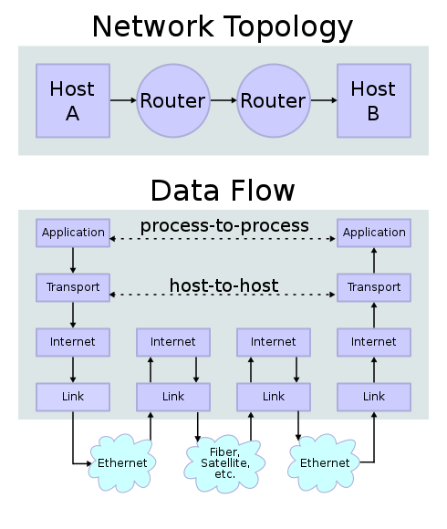
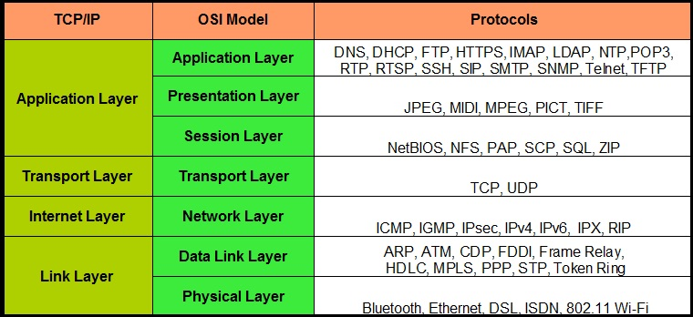

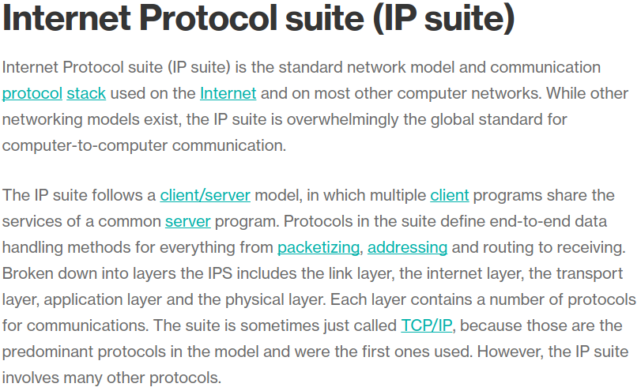
Ethernet / Networking
Ethernet is a protocol describing how data should be transmitted over a network. Ethernet is a link layer protocol in the TCP/IP stack, It touches both Layer 1 (the physical layer) and Layer 2 (the data link layer) on the OSI network protocol model. Ethernet is really a standard for computer network technologies that describes both hardware (such as what kinds of cables/ports should be used) and communication protocols (how the data should be packaged and receive). Ethernet was commercially introduced in 1980 and has largely replaced other wired network technologies.
Since it’s a standard, it can use different mediums to transport data, like UTP (Unshielded Twisted Pair) Cables or Fiber Optic Cables. There are gadgets converting digital signals into light signals, but the type of signal doesn’t matter since the bits that are transmitted are the exact same.
To send and receive data we are using something called a Network Interface Card (NIC). The NIC contains the electronic circuitry required to communicate using a wired connection (e.g., Ethernet) or a wireless connection (e.g., WiFi). Network cards usually implement the first two layers of the OSI model (Protocols there), that is the physical layer, and the data link layer. Today, most network cards use Ethernet. Since Ethernet is so widely used, most modern computers have a NIC built into the motherboard. If a motherboard does not have a wifi card, there are usually external PCI-E x1 wifi cards that can be plugged (usually it is better to buy it extra, rather than buying a motherboard with a onboard wifi card (?))
- PCIe x1 vs PCIe x16: PCIe cards can always operate in PCIe slots with the same or more lanes than the card. For example, an x8 card can operate in a slot with x8, x16, or x32 lanes. Similarly, an x1 card can operate in any PCIe slot. Graphics cards usually have a PCIe x16 (GEN 3) connector. Wifi cards usually PICe x1 Sata != M2 != PCIe
Specified in the family of standards known as IEEE 802.3, Ethernet was originally developed by Xerox in the 1970s. Ethernet was initially designed to run over coaxial cables, but a typical Ethernet LAN now uses special grades of twisted pair cables, or fiber optical cabling. Wi-Fi standards (IEEE 802.11a, b, g, n and now ac) define the equivalent of Ethernet for Wireless LANs.)
IEEE 802.11 is a set of media access control (MAC) and physical layer (PHY) specifications for implementing wireless local area network (WLAN) computer communication in the 900 MHz and 2.4, 3.6, 5, and 60 GHz frequency bands. They are the world's most widely used wireless computer networking standards, used in most home and office networks to allow laptops, printers, and smartphones to talk to each other and access the Internet without connecting wires
Channels and frequencies: 802.11b, 802.11g, and 802.11n-2.4 utilize the 2.400–2.500 GHz spectrum, one of the ISM bands. 802.11a, 802.11n and 802.11ac use the more heavily regulated 4.915–5.825 GHz band. These are commonly referred to as the "2.4 GHz and 5 GHz bands" in most sales literature.
Each spectrum is sub-divided into channels with a center frequency and bandwidth, analogous to the way radio and TV broadcast bands are sub-divided. The 2.4 GHz band is divided into 14 channels spaced 5 MHz apart, beginning with channel 1, which is centered on 2.412 GHz. The latter channels have additional restrictions or are unavailable for use in some regulatory domains.
Basitçe bu standartlar çeşitli frekans aralığı üzerine kurallar koyuyor, o frekans aralığında nasıl iletişim kurulacağını anlatıyor. Veri transfer hızı da o standartın frekans aralığı ile doğru orantılı artıp azalıyor.
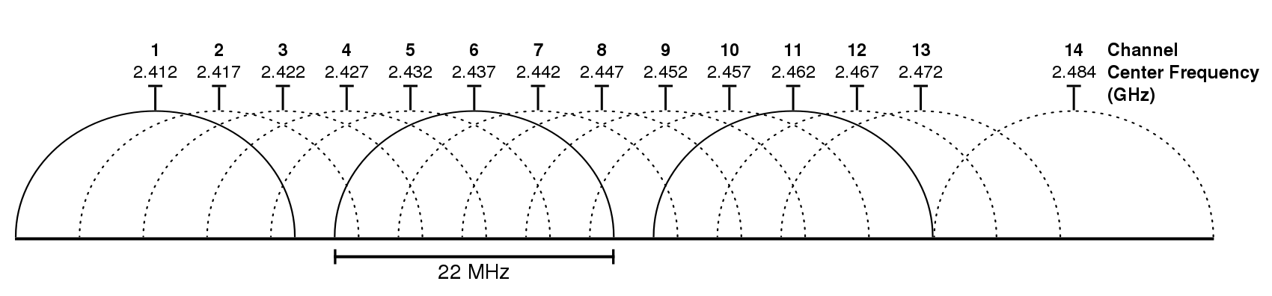

- Wi-Fi that we use is technically a standard protocol which is defined as 802.11 a/b/c/g/n where ‘a’ to ‘n’ are the latest versions.
- Wi-Fi standards like 802.11ac and 802.11n offer maximum speeds of 866.7 Mb/s and 150 Mb/s, respectively.
- But you would hardly be knowing that a significant part of this bandwidth is also used for other purposes by our Wi-Fi router. So, likely you won’t get anywhere near close to these speeds.
- Similarly, there are standards for Ethernet cables like cat-5, cat-5e, cat-6 cables etc. Theoretically, a wired Ethernet connection can offer up to 10 Gb/s if you have cat-6 cable. However, the most common cat-5e cable supports up to 1 Gb/s. These cables usually have RJ-45 Connectors. There a lot of different kinds of cables that have different connectors (Registered Jack)
My Internet connection is (max) 50.000 Kb/s == 50 Mb/s == 6 MB/s

https://stackoverflow.com/questions/16125987/how-does-a-packet-travel-from-one-computer-to-another-over-the-internet-based-on

Type == number of bytes 0x080 …

Ip address + Port numbers = Socket

A packet refers to the encapsulated unit created at the nework layer of the OSI model. One of the most commonly encountered packets is the IP packet, which contains control information such as the source and destination IP addresses, differentiated services flags and so on. Thus, a packet typically contains logical address information.
A frame, on the other hand, refers to the encapsulated unit created at the data link layer. One of the most commonly encountered frames is the Ethernet frame, which contains information such as source and destination MAC addresses etc. Thus a frame typically contains physical address information.
It is worth noting that a packet is encapsulated within a frame and hence the packet would always form the data part of the frame. For a transmitting host, data is first encapsulated within the packet, which is further encapsulated in a frame. This is then sent out over the physical layer as a bit stream.
For a receiving host, the physical bit stream is picked up, translated into a frame and the frame headers are stripped off (decapsulated), thereby retrieving the packet, which is then further decapsulated to retrieve higher layer information.
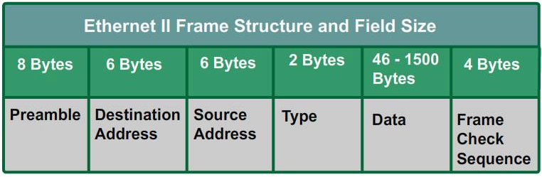

What implements TCP
All operating system(windows, Linux, Unix etc ) comes with inbuilt TCP/IP stack.
The transport layer is available as a library usually shipping with Operating System.
What the OSI model calls the transport layer corresponds fairly closely to the TCP layer in TCP/IP. That is, it gives guaranteed delivery/error recovery, and transparent transfers between hosts -- you don't need to pay attention to how the data is routed from one host to another -- you just specify a destination, and the network figures out how to get it there.
As far as where that's implemented: well, mostly in the TCP/IP stack, which is typically part of the OS. Modern hardware can implement at least a few bits and pieces in the hardware though (e.g., TCP checksum and flow control). The network stack will offload those parts of the TCP operation to the hardware via the device driver.

https://www.youtube.com/watch?v=PWFa3zSEdSQ

frames can change on the way but ip packets dont change

Switches vs routers vs hubs

https://www.youtube.com/watch?v=Z4DTIgYiUVE

http://www.cellbiol.com/bioinformatics_web_development/chapter-1-internet-networks-and-tcp-ip/data-transmission-on-the-internet/
https://web.stanford.edu/class/msande91si/www-spr04/readings/week1/InternetWhitepaper.htm

tcp ip / iso model / encapsulation videos.

Size of frames 1500 bytes ?

