Advanced JAX-RS

This chapter is an overview of various server-side environments currently capable of running JAX-RS applications on top of Jersey server runtime. Jersey supports wide range of server environments from lightweight http containers up to full-fledged Java EE servers. Jersey applications can also run in an OSGi runtime. The way how the application is published depends on whether the application shall run in a Java SE environment or within a container.
Note: This chapter is focused on server-side Jersey deployment models. The Jersey client runtime does not have any specific container requirements and runs in plain Java SE 6 or higher runtime.
In a Servlet container, JAX-RS defines multiple deployment options depending on the Servlet API version supported by the Servlet container. Following sections describe these options in detail.
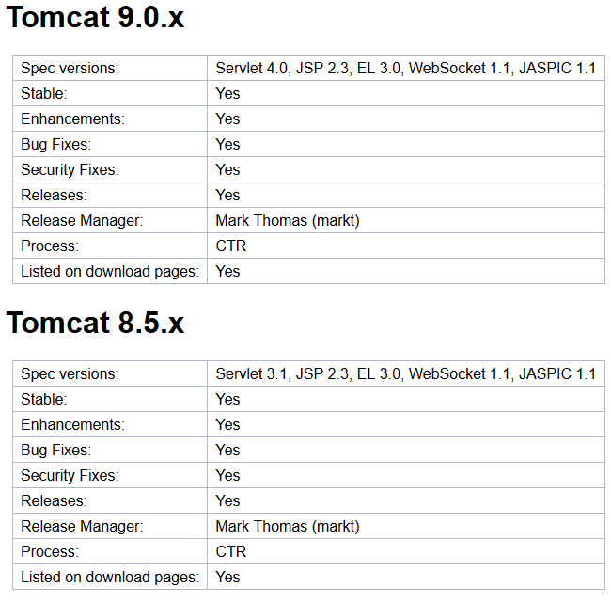
Servlet 2.x Container
Jersey integrates with any Servlet containers supporting at least Servlet 2.5 specification. Running on a Servlet container that supports Servlet API 3.0 or later gives you the advantage of wider feature set (especially asynchronous request processing support) and easier and more flexible deployment options.
In this section we will focus on the basic deployment models available in any Servlet 2.5 or higher container. In Servlet 2.5 environment, you have to explicitly declare the Jersey container Servlet in your Web application's web.xml deployment descriptor file.

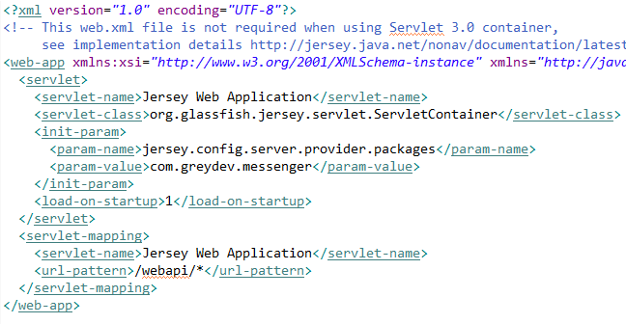
So here we created a servlet which pointed to a class called ServletContainer. The init param told the application where the resource classes are (with @Path()). So we basically told jersey where to look for those classes.
And the last thing was we mapped a url pattern to this servlet.

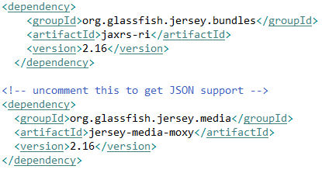
For the new and easier way: For jersey you only need the first dependency, for json conversion we need moxy.
Descriptor-less deployment
So with this new way we extend Application from the package javax.ws.rs.core.Application. So we created a class in the classpath “MyApp” and extended the Application class. This is actually all Jersey needs to define your application.
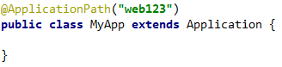
The second thing was where our resources are. Right now with this class we don’t have that configuration (see example right). Jersey looks to all classes in your classpath and tries to find a class with a @Path annotation.
Third: We defined the url mapping @ApplicationPath(“web123”) means that all endings with that will trigger Jersey. .../messenger/web123. So it exposes all the resources at path web123/*.
But Application is an abstract class and has some methods that we can overwrite.
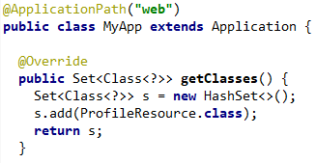
JAX-RS provides a deployment agnostic abstract class Application for declaring root resource and provider classes, and root resource and provider singleton instances. A Web service may extend this class to declare root resource and provider classes. For example,

Alternatively it is possible to reuse ResourceConfig - Jersey's own implementations of Application class. This class can either be directly instantiated and then configured or it can be extended and the configuration code placed into the constructor of the extending class. The approach typically depends on the chosen deployment runtime.
Compared to Application, the ResourceConfig provides advanced capabilities to simplify registration of JAX-RS components, such as scanning for root resource and provider classes in a provided classpath or a in a set of package names etc. All JAX-RS component classes that are either manually registered or found during scanning are automatically added to the set of classes that are returned by getClasses. For example, the following application class that extends from ResourceConfig scans during deployment for JAX-RS components in packages org.foo.rest and org.bar.rest:
Note: Package scanning ignores an inheritance and therefore @Path annotation on parent classes and interfaces will be ignored. These classes won't be registered as the JAX-RS component classes.

There are multiple deployment options in the Servlet 3.0 container for a JAX-RS application defined by implementing a custom Application subclass. For simple deployments, no web.xml is necessary at all. Instead, an @ApplicationPath annotation can be used to annotate the custom Application subclass and define the base application URI for all JAX-RS resources configured in the application.
In case you are not providing web.xml deployment descriptor for your maven-based web application project, you need to configure your maven-war-plugin to ignore the missing web.xml file by setting failOnMissingWebXml configuration property to false in your project pom.xml file. But it is still possible to use web.xml with servlet 3.0.
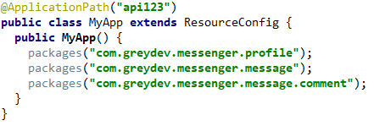
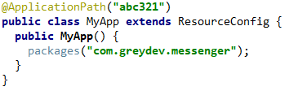
← same as →

Resource Lifecycle
What causes a resource to be created? When does it get initialized?
2 Types of life-cycles:
- New resource instance per request (default)
- Singleton Instance

The default behaviour: Every time an api request comesin, Jax-rs is creating a new instance of the required resource class. It never shares the same instance. These instances are Request Scoped. Which means the scope of a resource instance is about the request. So when a new request comes in and the old one is removed, that instance is also gone.
We can change it to a Singleton. All we have to do is annotate the class with @Singleton.

Param Annotations and Member Variables
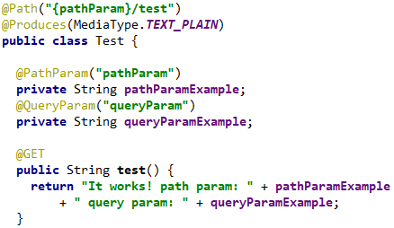
Now we will talk about a unique use of param annotations and the implication of singleton on them.
@QueryParam and @PathParam annotations (and all other @*Param annotations) apply to member variables as well. In the previous project we annotated method arguments, now we are annotating member variables. Its the same thing.

This works because: the resource instance ‘Test’ is created after we make a request. A new instance per request. It injects the values because we gave the correct params in our request and the code is annotated. One reason we would want those as fields is when we want to access those variables from many different methods inside the Test resource class.
What happens when we make it a singleton? We will get a compilation error. The ModelValidator tells us The singleton instance is created before the request. Thats why the injection cannot happen (even when the fields are public or with getters and setters).
“Parameter pathParamExample of public java.lang.String com.greydev.messenger.message.Test.pathParamExample cannot be injected into singleton resource.

Param Converters
Think about passing a pathParam or queryParam which is an integer but is sent as a string. In our resource we can capture that variable as an integer like we did before. Things are always sent as string on HTTP, we don’t know the data types of the sent data.
There is an implicit conversion going on. Jax-rs that takes that value, examines the method argument or the fields (see above) that we annotated and does a conversion of our choice. ParamConverters makes this happen. Jersey comes with a bundle of param converters.
Lets say we have our own data type but jersey won’t know how to convert a string to our data type. Here we can implement our own param converters.
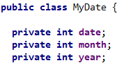
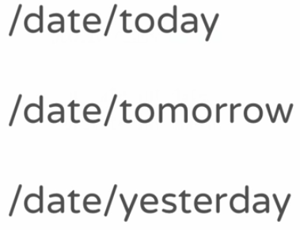
Our goal is to convert these url’s to a MyDate instance.
For this conversion to happen we need to learn about 2 classes:
- ParamConverter
- ParamConverterProvider

ParamConverter: Whenever we need to convert any of the parameters to a custom data type, we need to implement this. It’s an interface with methods which we need to implement and which will do the conversion.
ParamConverterProvider: This tells jersey that whenever it sees a conversion to a type that we will declare (in this case MyDate), it should use the converter that we already implemented.
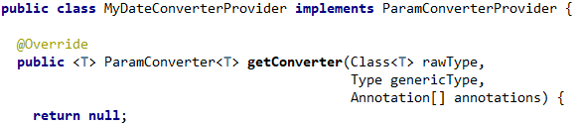
We need to implement one method with 3 arguments. These 3 arguments are what Jersey send to all the ParamConverterProviders to see if any of them can provide a converter back. Basically asking them if they know how to convert a type.
RawType: the type which we will convert to. GenericType: incase we are dealing with generics. Annotations: an array, in case of pathParam, pathParam would be one of the annotations that would be sent here. We are just interested in the rawType atm.
In the getConverter method we need to return a ParamConverter<T> which we will implement here.

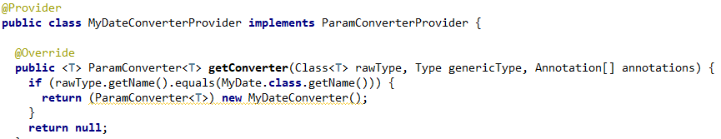
We will now implement the logic of the conversion. We need to implement the interface ParamConverter<T> and some methods inside it. And during runtime, we will return Jersey an instance of this coverter. But we need to cast it to from ParamConverter<MyDate> to ParamConverter<T>
- Don’t forget the @Provider annotation

Important: Calendar.DAY is just a number that indicates/means the day of the month. It DOES NOT return the actual day of the month. It is used inside the get() method of a calendar instance.
Important: The first day of the month starts at 1. But January starts at 0. So we need to add 1 to the month integer when displaying it. March will be 2, April will be 3 which is wrong.
Here we are interested in the fromString method. We should also create a toString() method for MyDate
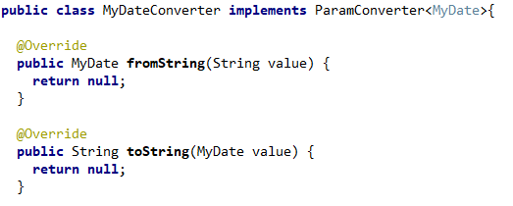
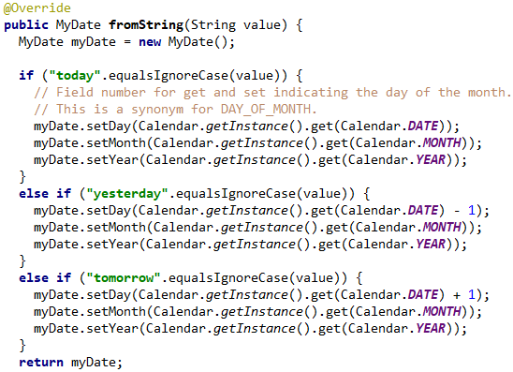
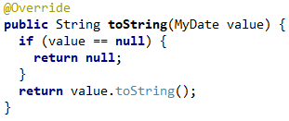

MessageBodyReader and MessageBodyWriter
These are what converts the raw data types to the response we send and vice versa. When we annotate a method with @produces(json), there is something that has to take our return object and convert it to json and send it to the client. This conversion happens thanks to a MessageBodyWriter. Its writing to message body. Whenever we need to send an object in the message body, the conversion to a string/json/xml etc is done by this writer. Same as when we accept input in json/xml/… the reader is reading the body and converts that data to our wanted object type.
- Difference between MessageBodyWriter/Reader and ParamConverter: Message body is basically dealing with the content of the message that comes to us e.g. with a PUT request or a message body that we will send back as a response to a GET request. ParamConverters deal with the parameters of the request and not the content of the request itself.
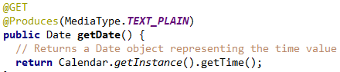
Lets say we want to return a Date object as a plain text response. Since Jersey doesn’t know how to convert it to a plain text, it will give us an error.
In our previous project we gave Jersey different kinds of objects and it was able to convert them to Json and Xml. Because it had message body readers and writers in the classpath which knows how to convert and object to json or xml. In this case there is no such converter that will convert from Date to Text.Plain.

We will create our own custom MessageBodyWriter which takes an instance of Date and return a text.
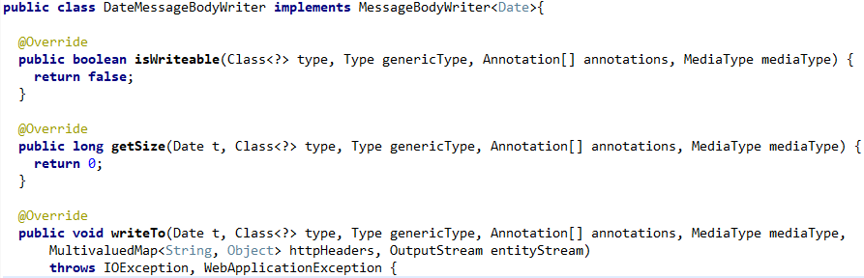

This is a provider, don’t forget to annotate @Provider.
Our class needs to implement 3 methods from the MessageBodyWriter<T> interface.
- isWritable() → Lets jersey know if a certain type is something this writer can handle, maps it if jersey will come looking for it. Now we will check here if the type we get is a Date type.
- GetSize() → This is currently deprecated (used in jax-rs 1.0). The best practice is to return -1.
- WriteTo() → This is where we will convert our object and write it to an output stream. This output stream is what will be sent over as a http response.
One other thing we have to do is declare which media types this writer can handle. We could potentially have multiple messageBodyWriters for different mediaTypes and one class could handle multiple mediaType request (I think). We will use it now just for plain text alone.

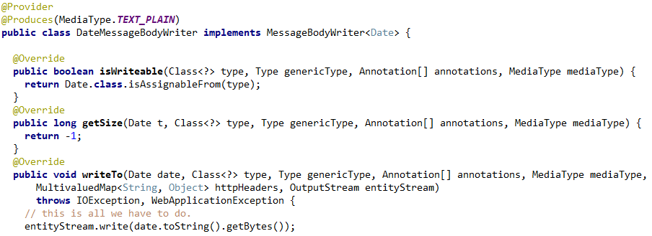
MessageBodyReader is very similar to this. Implement the interface MessageBodyReader and it has smth like a readFrom(str, …) and you have to convert it from a string to your wanted type.
Custom Media Types
Not only can MBR and MBW’s be implemented for common MediaTypes, we could also implement our custom media types and implement mbr and mbw.
A string like Application.Json is a media type but its just a string. We can create our own ‘Application/blabla’ media type if we want and have MBR and MBW to be implemented for it.

- Write your custom string inside the @Produces annotation.
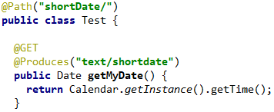
- Create a new MessageBodyWriter which knows how to convert from Date to our new custom media type.
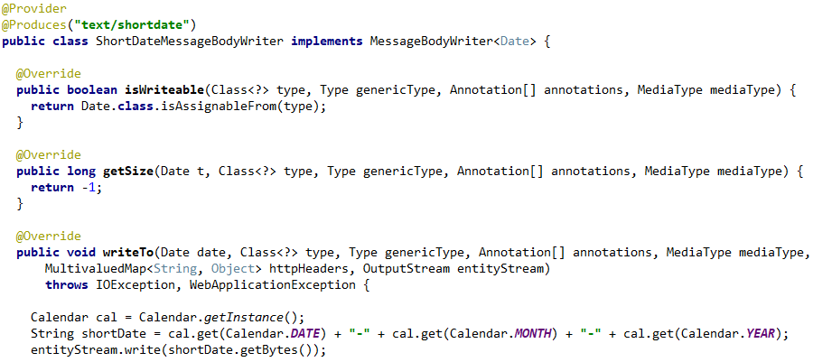

- When there are multiple MediaTypes inside an @Produces(plain + shortDate) and when both have a messageBodyWriter, the user can choose with accept headers which type the response can be. Like we did in the previous project with json and xml produces, the user could send an Accept header and get the right resoponse.

JAX-RS Client
So far we used Postman to make our requests. What if we wanted to do that programatically, accesing a rest api using java.
Before JAX-RS 2.0, there were different libraries which allowed you to make calls to rest apis and examine the responses and construct objects out of them. But there was no standard. With JAX-RS 2.0, the spec lays out a standard for building rest api clients, this means it is much more portable if we use this 2.0 api.
We will use Jersey since it also has support for those client api’s that comes with JAX-RS.
When we writing a client, we shouldn’t be worried about the technology used on the server side. The server could be implemented using any technology.

