Hibernate

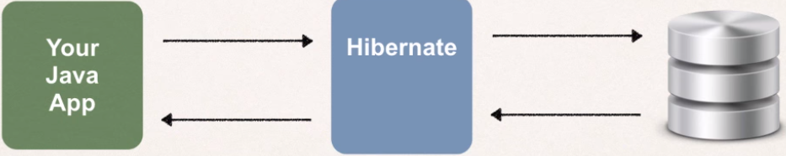
Hibernate ORM (Hibernate in short) is an object-relational mapping tool for the Java programming language. It provides a framework for mapping an object-oriented domain model to a relational database. Simply put its a framework for persisting / saving Java objects to a database.
- Used in the data layer of applications
- Implements JPA
JPA: A set of standards / specifications that have been set. When a persistence app implements these standards/rules (JPA), it will be certified as a java persistence api implementation. It means later if you don’t want to use Hibernate but another api which implements JPA, you can do that with minimal code changes. (( persist is another word for save))

The Problems that an ORM-Tool solve:
- Mapping member variables to columns
- Mapping relationships: Lets say a User object has a reference to an address object. We would probably have an address table and a user table. If we would do all these manually to show the dependency we would write a primary and a foreign key in each table and still we have to map every object to every table and so on
- Handling data types: If we have a boolean in our object which have the values of true and false. Most databases don’t have boolean types. So will we represent it as an integer 1/0 or char y/n? We would have to handle the data type conversion ourselves.
- Managing changes to the object state: If an object state will change we would have to manually write that it also should update the database.

Benefits of Hibernate:
- Hibernate handles all of the low-level SQL
- Minimizes the amount of JDBC code you have to write
- Provides the Object-Relational mapping (ORM)

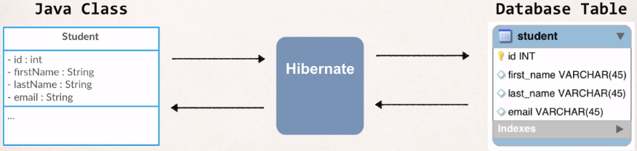
Object-Retaional Mapping

As a developer, we need to tell Hibernate how our Java class or object maps to data in the database. We will map our class to a given database table.
We will tell Hibernate that this Java class student maps to this database table student and Hibernate will set up the one to one mapping between the fields and columns in the database.
- This mapping can be set up via an XML file or Java Annotations.

Object-relational mapping (ORM, O/RM, and O/R mapping tool) in computer science is a programming technique for converting data between incompatible type systems using object-oriented programming languages. This creates, in effect, a "virtual object database" that can be used from within the programming language.
In object-oriented programming, data-management tasks act on object-oriented (OO) objects that are almost always non-scalar values. For example, consider an address book entry that represents a single person along with zero or more phone numbers and zero or more addresses. This could be modeled in an object-oriented implementation by a "Person object" with attributes/fields to hold each data item that the entry comprises: the person's name, a list of phone numbers, and a list of addresses. The list of phone numbers would itself contain "PhoneNumber objects" and so on. The address-book entry is treated as a single object by the programming language (it can be referenced by a single variable containing a pointer to the object, for instance). Various methods can be associated with the object, such as a method to return the preferred phone number, the home address, and so on.
However, many popular database products such as SQL database management systems (DBMS) can only store and manipulate scalar values such as integers and strings organized within tables. The programmer must either convert the object values into groups of simpler values for storage in the database (and convert them back upon retrieval), or only use simple scalar values within the program. Object-relational mapping implements the first approach.
The heart of the problem involves translating the logical representation of the objects into an atomized form that is capable of being stored in the database, while preserving the properties of the objects and their relationships so that they can be reloaded as objects when needed. If this storage and retrieval functionality is implemented, the objects are said to be persistent.
Persistence : In computer science, persistence refers to the characteristic of state that outlives the process that created it. This is achieved in practice by storing the state as data in computer data storage. Programs have to transfer data to and from storage devices and have to provide mappings from the native programming-language data structures to the storage device data structures

Connection Pools
Connection pooling is a technique to open/prepare/close connections. A connection pooling mechanism is a piece of software (component), to which you delegate the function of managing connections. Your application would just ask for a connection, use it, and deliver it back to the pool. The component is responsible for opening N connections and leave them ready for when your application asks. If a connection is stale, the pooling mechanism would then close it and reopen a new one. This represents a better usage of connections, as you don't need to wait for the connection to be established during the actual execution of your code and you don't have to worry about stale connections.
Hibernate doesn't really ship any real connection pooling mechanism. It provides an internal connection manager, which is very rudimentary. The reason is simple: almost (if not all) Application Servers (like JBoss AS) and Servlet Containers (like Tomcat) provides a connection pooling mechanism by default. Thus, your application don't have to worry about the details about it. It just asks the AS for a connection.
In my opinion, there are only two cases where you need to worry about connection pooling:
- You are dealing with a standalone application (which doesn't run inside a container)
- You are really expert in connection pooling and none of the existing suits your needs.
But in my experience, most people that uses an "external" connection pooling do so for lack of knowledge about connection pooling and lack of knowledge about their container.
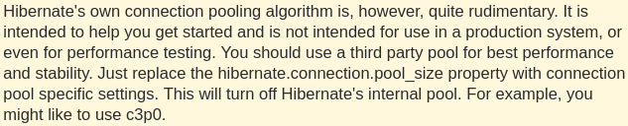
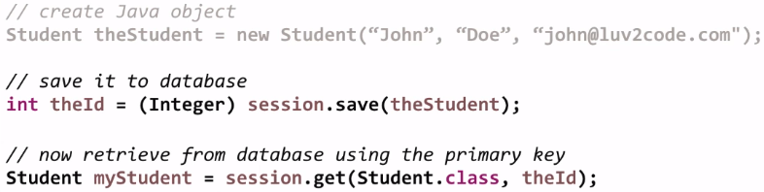
A basic example:

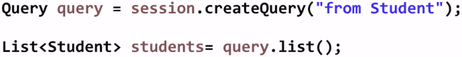

- query.list() → returns a list of Student objects from the database.
- “from Student” → here we make use of Hibernate Query Language (HQL)

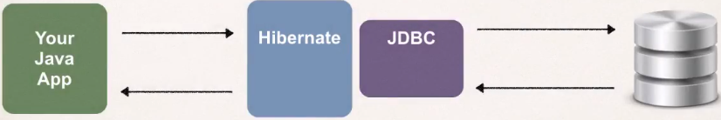
How does Hibernate relate to JDBC ?
Hibernate actually uses JDBC for all database communications. Hibernate is another layer of abstraction on top of JDBC. So when our application uses the Hibernate framework, it will store and retrieve objects using Hibernate API. In the background Hibernate does all of the low level JDBC work, submitting the SQL queries and so on. But in the background everything goes through the JDBC API.

Setup Hibernate in Eclipse
- Create (Basic) Eclipse Project:
  - Create new folder “lib” in your project.
- Download Hibernate Files
  - hibernate.org → Download Hibernate ORM (latest version 5.8.0) and unzip it
  - Go to the lib directory of the downloaded folder, lib has all the Hibernate JAR files. All of the JAR files that are required as a bare minimum are in the “required” folder. Copy all of the jars there and paste it into your lib folder in your project.
- Download MySQL JDBC Driver
  - dev.mysql.com → Downloads, Community, MySQL Connectors (has all the connectors for different languages) , Connector/J (for Java) and download, extract the zip/tar file.
  - Copy the jar file in that folder, paste it into the lib directory in your project.
- Add JAR files to Eclipse Project … Build Path
  - Right click on project, properties, Java Build Path, Libraries, Add JARs, go to your lib directory in your project and select all the jar files that we want to add
  - Now we have a new folder called “Referenced Libraries” in out project. These are all the jar files on our class path.

Test to make sure JDBC connection works fine
Right click, run as : Java Application. If we see “success” it means we established a connection. Else it will show us an error like “Access denied for user 'root'@'localhost'” (wrong credentials)
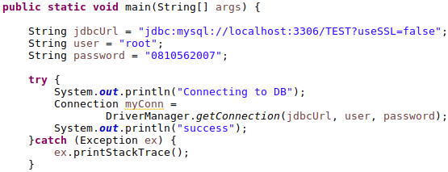
Hibernate Development Process
- Add Hibernate configuration file (JDBC DB configuration)
- Annotate Java class (Telling our Model objects)
- Develop Java code to which uses the Hibernate API perform database operations.

- Yukarıda User classının main methodunda yazdığımız code sadace test amaçlıydı. Bağlanıp bağlanmadığını kontrol ettik. Hibernate ile bir alakası yok. User mainde yazdığımız bağlantı amaçlı şeyleri Hibernate Config File’ın içine yazacağız.

Hibernate Configuration
The config file basically tells Hibernate how to connect to the database. Most of the information we will have there will be the JDBC configuration (JDBC url, userID, password…)
- Create the config file : hibernate.cfg.xml (default name for this file, Hibernate looks for it)
- The configurations file has to be directly in the “src” directory
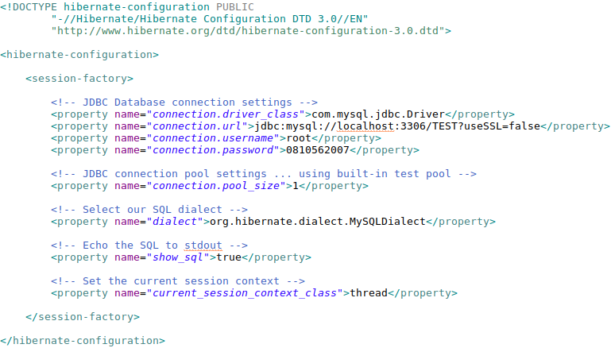

dialect : SQL is a standart, however each database has different implementations. So with “dialect” we select which type of dialect hibernate should use to talk to our database. Usually there are dialects for different databases too.
show_sql : When hibernate executes, it will also print the sql it sends to the database. Useful for development and testing, to see what hibernate is actually sending.
As we said before mapping can be set up via an XML file or Java Annotations.
In the config file we can write which classes should be mapped and we also should annotate those classes(?) 7 sene öncesi, we can also configure it by XML (?) Example:
- <mapping class="packageName.className1"/>
- <mapping class="packageName.className2"/>
- <mapping class="packageName.className3"/>
Does Hibernate create the database/tables automatically for us or should we create all of them before ?

- Hibernate WON’T create databases for you, only the tables. To create the database you need to tell MySQL to create it if it does'nt already exist by adding a parameter to the URL.
- The order of the columns will be different if we use hbm2dll.auto. If we create it manually then we can decide which order we want. create table user (1.column, 2.column, ...)

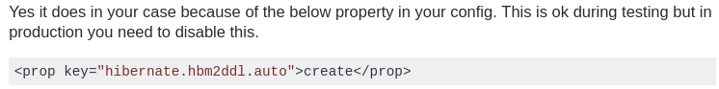

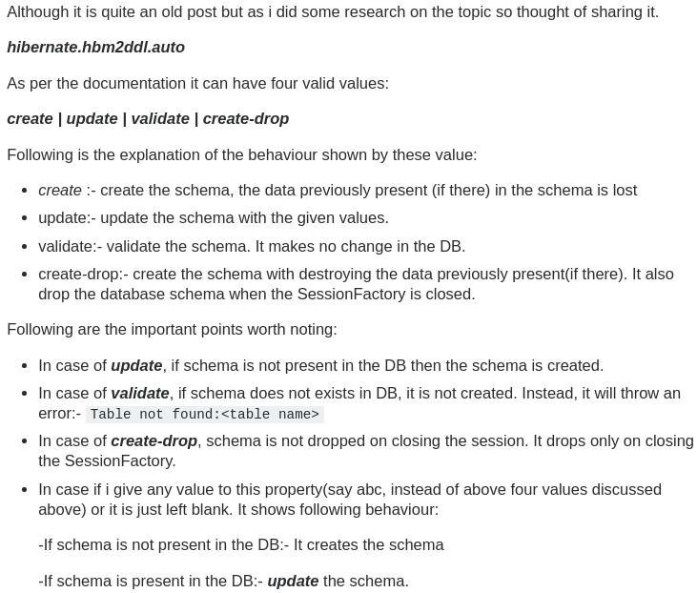

Hibernate.hbm2ddl.auto in Production?
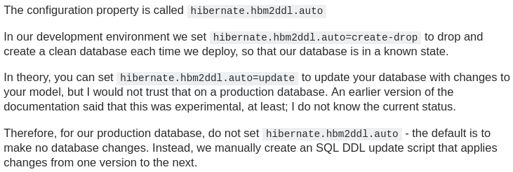
Hibernate Annotations
Hibernate has this concept called an “Entity Class”. Its just a fancy name for a Java class that is mapped to a database table with the help of annotations.
Two options for mapping :
- XML config file (legacy)
- Java Annotations (modern, preferred, this is what we will do)
Java Annotations:
- Map class to database table
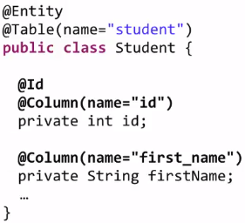
- Map fields to database columns
1. Mapping a class to a database table is done by using the @Entity and @Table annotations. @Entity lets it know that this is an entity that we will map to a database table. @Table(name = “...”) we give the actual name of the database table where we want to map.
2. Mapping fields to database columns is done with @Column annotation. @Id defines the primary key
- The field name and column names can be different of course, that is why we use the name = “...” . But if they are the same there is no need to use the @Column annotation. But that is bad programming practice.
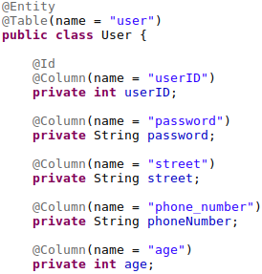
Here we mapped our class to a table and also mapped the fields to columns in that table.
- Annotations can either be written on top of the fields, in that situation it picks up the values of the fields.
- Another option is to write annotations on top of the getter methods of the fields. Then they will picks the return values of the getter methods.
To have more control of how hibernate converting java types into database types we can use the following annotations:
Default : If we wont annotate fields then Hibernate still persists every field and creates a column for each.
@Basic: (Default) Hibernate knows to treat this field as a default. Using this annotation makes only sense if we also use the properties of it.
@Transient: Hibernate wont automatically persist this field. Can be used for static fields or for fields we don’t want to save.
@Temporal (value): is a JPA annotation which can be used to store only TIME (java.sql.Time), DATE(java.sql.Date) or TIMESTAMP (java.sql.Timestamp) in the database table. Generally when we declare a Date field in the class and try to store it. It will store the timestamp in the database. the stored value looks like 08-07-17 04:33:35.870000000 PM If we want to store only the Date in the database, we can use this annotation with DATE attribute. @Temporal(TemporalType.DATE) This time, it would store 08-07-17 in database.
@Lob: saves the data in BLOB or CLOB. If data is text and is not enough to save in VARCHAR, then that data should be saved in CLOB. In case of double byte character large data is saved in BLOB data type.
Really Important !
DON’T USE org.hibernate.annotations.Entity. This is deprecated
USE : javax.persistence.Entity
Careful : I downloaded a wrong version of “hibernate search”, which is 5.8.0 and the @Entity annotations did not work. It also had no javax.persistence package.
When I downloaded Hibernate-release-5.2.12.Final and copied the jars from the required to lib, everything worked fine. It has the javax.persistence package.
Develop Java code to perform database operations
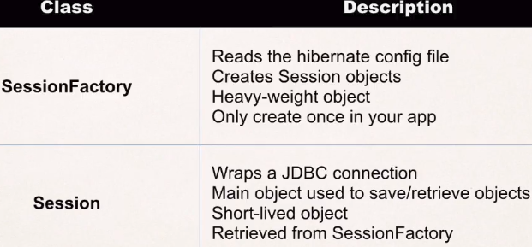
SessionFactory : Creates a session, gets a connection to a db. Heavy-weight meaning you only create it once and you use it over and over again in your application. It is a factory, so it creates Session objects. You should create one Factory* in your application but the factory creates Session objects which you can use and then throw away
Session : Just a wrapper. You use it and then throw it away. Then get a new one etc. Each database operations will be done with a separate session.

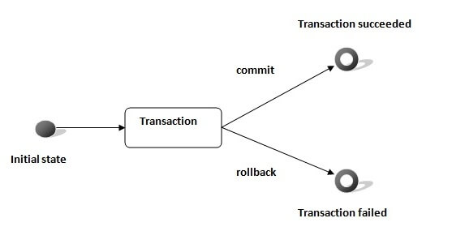
Transaction
A transaction simply represents a unit of work. In such case, if one step fails, the whole transaction fails (which is termed as atomicity). A transaction can be described by ACID properties (Atomicity, Consistency, Isolation and Durability).

In hibernate framework, we have Transaction interface that defines the unit of work. It maintains abstraction from the transaction implementation (JTA,JDBC).
A transaction is associated with Session and instantiated by calling session.beginTransaction().
The methods of Transaction interface are as follows:
- void begin() starts a new transaction.
- void commit() ends the unit of work unless we are in FlushMode.NEVER.
- void rollback() forces this transaction to rollback.
- void setTimeout(int seconds) it sets a transaction timeout for any transaction started by a subsequent call to begin on this instance.
- boolean isAlive() checks if the transaction is still alive. void registerSynchronization(Synchronization s) registers a user synchronization callback for this transaction.
- boolean wasCommited() checks if the transaction is commited successfully.
- boolean wasRolledBack() checks if the transaction is rolledback successfully.

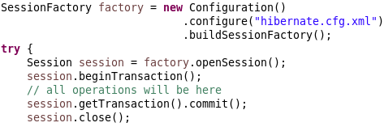
Session
A Session is used to get a physical connection with a database. The Session object is lightweight and designed to be instantiated each time an interaction is needed with the database. Persistent objects are saved and retrieved through a Session object.
The session objects should not be kept open for a long time because they are not usually thread safe and they should be created and destroyed them as needed. The main function of the Session is to offer, create, read, and delete operations for instances of mapped entity classes.
Instances may exist in one of the following three states at a given point in time
- transient − A new instance of a persistent class, which is not associated with a Session and has no representation in the database and no identifier value is considered transient by Hibernate.
- persistent − You can make a transient instance persistent by associating it with a Session. A persistent instance has a representation in the database, an identifier value and is associated with a Session.
- detached − Once we close the Hibernate Session, the persistent instance will become a detached instance.
Session Interface Methods
Transaction beginTransaction() Begin a unit of work and return the associated Transaction object.
void cancelQuery() Cancel the execution of the current query.
void clear() Completely clear the session.
Connection close() End the session by releasing the JDBC connection and cleaning up.
SQLQuery createSQLQuery(String queryString) Create a new instance of SQLQuery for the given SQL query string.
void delete(Object object) Remove a persistent instance from the datastore.
void delete(String entityName, Object object) Remove a persistent instance from the datastore.
Session get(String entityName, Serializable id) Return the persistent instance of the given named entity with the given identifier, or null if there is no such persistent instance.
SessionFactory getSessionFactory() Get the session factory which created this session.
Transaction getTransaction() Get the Transaction instance associated with this session.
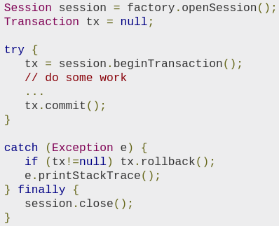
boolean isConnected() Check if the session is currently connected.

A Session instance is serializable if its persistent classes are serializable. A typical transaction should use the following idiom −
If the Session throws an exception, the transaction must be rolled back and the session must be discarded.
If we talk about SessionFactory.openSession()
- It always create new Session object.
- You need to explicitly flush and close session objects.
- In single threaded environment it is slower than getCurrentSession.
- You do not need to configure any property to call this method.
And If we talk about SessionFactory.getCurrentSession()
- It creates a new Session if not exists, else use same session which is in current hibernate context.
- You do not need to flush and close session objects, it will be automatically taken care by Hibernate internally.
- In single threaded environment it is faster than openSession.
- You need to configure additional property. "hibernate.current_session_context_class" to call getCurrentSession method, otherwise it will throw an exception.
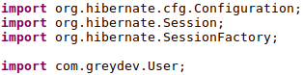
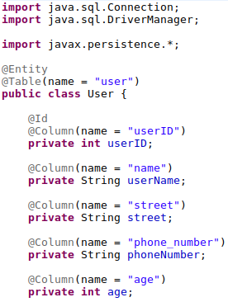

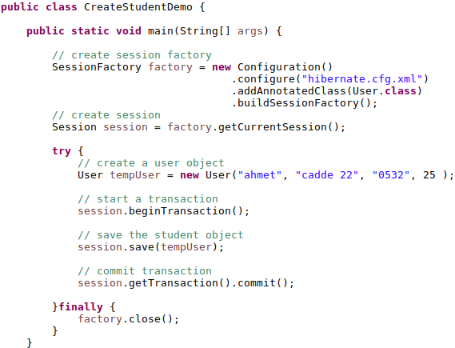

“hibernate.cfg.xml” inside .configure() is optional. Hibernate looks for “hibernate.cfg.xml” by default.
Usually we will have a try catch or try finally block. We will get a session from our factory with factory.getCurrentSession(); Inside the try block we can use this session to save the Java objects or retrieve the Java objects.
Hibernate knows how to connect to the database because of the configuration file, it also knows how to map the class to the table because of the annotations
Our output we get when we run this app (because show_sql true property) :

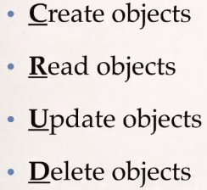

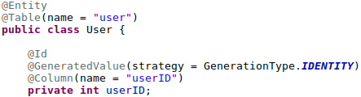
The database can use “auto_increment” to give a different value to the primary key of the table, each time a new item is added to the table.
@Id is telling hibernate this field is a primary key. So this field maps to a column in a database table. We leave it up to the database to generate a primary key for us.
We can also explicitly tell Hibernate how to perform the generation of that key for a field. There are different strategies. If none is given, by default it will use the appropriate strategy for the data base implementation.
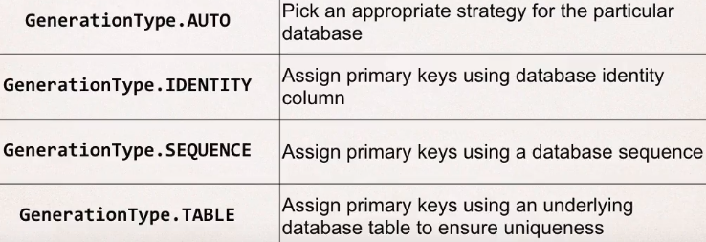
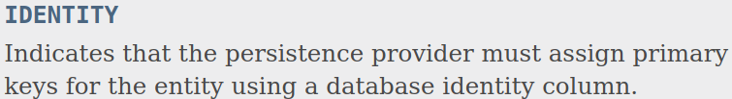

We have to look at our database and find out which of these are supported. Most commonly used for MySQL “auto_increment” is GenerationType.IDENTITY
- We can define our own custom generation strategy
- Create subclass of org.hibernate.id.SequenceGenerator
- Override the method: public Serializable generate(…) [ The generator has to always create a unique value, it has to work fine in a high volume, multi-threaded, clustered enviroment! ]
We can change the auto_increment value in SQL, the new value must be larger then the previous values:
ALTER TABLE <DatabaseName>.<tableName> AUTO_INCREMENT=3000

Reading Objects from the Database
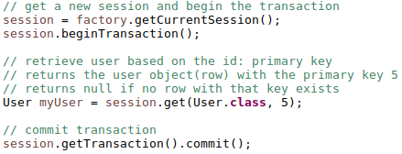
There are many ways to fetch data from the database with Hibernate:
- Using session.get(class, key) (?)
- Writing SQL Queries
- Using HQL (Hibernate Query Language)

In Hibernate we always make use of Transactions. For updates and also for reads.
session.get(Class Name, primary key) Returns an Object of the given class as the return value.

Natural key (Such values that can be naturally distinct) vs Surrogate Key (When there are no natural key candidates we can add a serial number for example, the only purpose is to be distinct for each, it does not have a business use)
If we have a surrogate key, we can ask hibernate to generate a new key for each insertion (?)
@GeneratedValue(strategy = GenerationType.IDENTITY)
AUTO (Default): Let hibernate make a decision about the strategy.
Identity: Use the feature identity columns (a feature provided by some databases) to generate the key.
Sequence: Uses the sequence object in the database in order to come up with a new key.
Table: We can have a separate table and that table will have the records of the last used key, so we can generate a new key. If this option is selected, hibernate will create a new table and manage it.

What if one of the fields is a reference to another object, an array or a list, how will it be represented in the database?

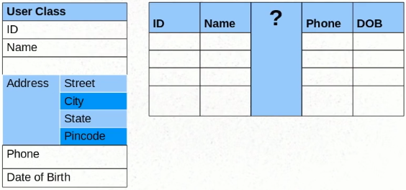
First we will look at a simple implementation, later also seeing advanced implementations.
Simple way (separate columns): To have all the fields inside the Address class inside the user class, this means each field in Address will get a column in the db.
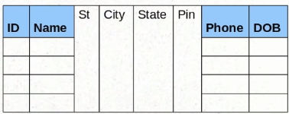

This approach works fine if the Object inside this user class (Address) is a value object.
In Hibernate we see 2 kind of objects: Objects of Value Type and Objects of Entity type. An Object of value type has data in it and that data needs to be saved to the db but the object itself does not have a meaning, it provides meaning to another object. In this example we don’t care about the each address object we only care about the values it provides → Value Object
There are different approaches for different situations. We could also have an Entity object inside an Entity (will see that later).
Embedding Objects with Hibernate
In order to mark this class so that Hibernate wont create a separate table for it we need the annotation @Embedded or @Embeddable.
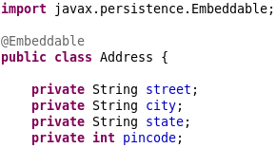
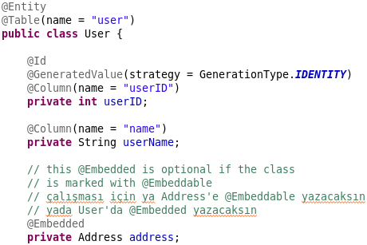

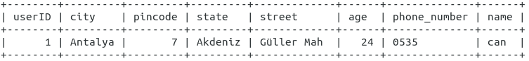

How do we configure all the columns inside of the Embedded Class/Table?
Lets say we want the name of the table “city” to be “city_name” in my table. There are a couple ways:
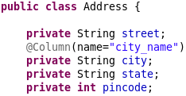
- Annotate the single fields in the Embedded Class that we want to modify. It will carry those configurations if this class is embedded within another class
- Overriding each Attribute in our Class that embeds Address
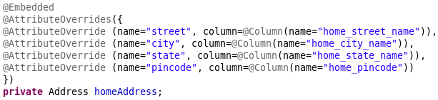
Lets say we want to have a home address and a office address for every user. Even if the Address class is annotated with column names, we can still override it in our original user class that embeds this address class.


Meaning: Override the street property of the homeAddress with this → @Column(name”...”)
If we want to override multiple attributes then use @AttributeOverrides({ 1,2,3... })
One special case: If we have an Object with different fields as our primary key then we need to annotate that primary key field with @EmbeddedId. (if this used then no need for @Id)
We can still use @AttributeOverride on that field and other configurations.
Difference between Entities and Value Objects
So for example, a Person could be an Object within our application. A person will have a name, email address and password as well as many other attributes. Within our database this person is represented by an id. This means that the person could change their name, email and password but it would still be the same person. When an object can change it’s attributes but remain the same object we call it an Entity. An Entity is mutable because it can change it’s attributes without changing the identity of the object. The Entity object will maintain the identity because it has an id in the database.
Imagine that our application allows the person to track their current location. When the person is able to successfully connect to the internet and authenticate with our application a new Location object is created. This Location object has attributes for longitude and latitude. The Location object is a Value Object because we don’t care about the specific instance of the object we only care that it is a location.
When the person changes location, we don’t have to update the Location object, we can simply create a new Location object. The Location object never changes it’s attributes from the moment it is created until the moment it is destroyed. When an object’s attributes cannot be changed, it is known as immutable.
Another important distinction is, Value Objects equality is not based upon identity. So for example, when you create two Location objects with the same longitude and latitude attributes those two objects will be equal to one another. The Person object on the other hand does base equality on identity because it is a single representation with an id. If you had two people with the exact same name, they would not be the same person.
How to identify Value Objects?
So hopefully you can see that we can generally make the distinction between an Entity and a Value Object when an object is represented with an id.
An Entity’s attributes can change, but it remains the same representation within our system because of it’s unique identifier. Whereas a Value Object is a single instance of an object that is created and then destroyed. We don’t care about a specific instance of a Value Object and we can’t change it’s attributes.
So how do you know when to use an Entity and when to use a Value Object? Well the decision really comes down to the context of the application.
Imagine that in the example from earlier, our application is not just a generic social application, it is actually Foursquare. Now every individual Location object does have a unique identifier because many different users can checkin to that location over time. Now the Location object is an Entity, not a Value Object.
On the other hand, imagine that we are the owner of a power plant that records activity around it’s security fence. The security fence has many locations where activity is recorded for monitoring purposes. Each location around the fence is an Entity because we care about recording activity at those specific locations. Whenever a suspicious person walks past one of our locations an incident is recorded in the database. In this example, a person is a Value Object because we don’t care about any particular person, we only care that a person triggered one of the security locations.
Distinction between Value Objects and Entity Objects
Firstly, when you have two Entities with the same attributes, these two objects are not the same because they have two different identities. However, when you have two Value Objects with the same values, these two objects do have equality and can therefore can be interchanged freely. When you can substitute one object for another, the object is a Value object (in other words, the value is in the object, rather than the identity of the object). You couldn’t interchange Entities because there would be unwanted side effects.
Secondly, overtime an Entity’s properties will change, but it will remain the same Entity. For example, if a user changes their email address. However when your application needs to change a Value Object property, the whole object needs to be destroyed and a new one should replace it. For example, when you make a payment, the money object isn’t given back to you as change, you are given a new money object of a lower value.
Question
I'm trying to design a pretty simple app and am getting myself a bit confused with Hibernate's definition of entity and value objects (as defined in Chapter 4 of Java Persistence with Hibernate). What I have is an app with customers, who can place orders (one to many relationship). Each of these orders has many order lines (also one to many). Now, I think that customers have identity (customer number) and so do orders (order numbers) so they are therefore entity objects? My confusion comes in with the order lines. An order line has quantity, product number and price. An order line can't exist without its order and has no identity of its own, therefore I see it as a value object. But I can't make order line a part of the order table as there is a one to many relationship between an order and its order lines. How do one to many relationships work with the definition of a value object? From the Hibernate book:

Answer
Hibernate's documentation makes a distinction between Entity Type and Value Type, not Value Object.
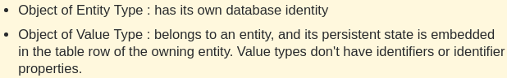

As far as I can remember, the book uses a sample with an address represented as a single String and a user object, which contains an address String:
- Implemented as a value type (which typically means a column in the same table at the database level), if the user is deleted, then so is its address. The address cannot live without the user and can't be shared.
- Implemented as an entity type (which likely means using a separate table), the addresses would exist in their own right without the user and two users would be able to share the same address.
In your case, an order line doesn't belong to an order, its persistent state isn't embedded in the order row (doesn't make sense), it has its own identity (made of the orderId and productId). Order line is definitely not a Value Type, it is an Entity Type.
Actually, as soon as you are thinking in terms of associations (one-to-one, one-to-many, etc), you are for sure manipulating entities.
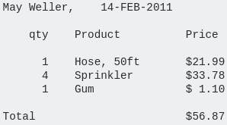
What is an Order Line?
It refers to a "Purchase Order" which typically consists of one or more lines, called "Order Lines".
As almost every business on earth has some similar record of it's orders, purchases and/or sales, it has been the canonical real-world data example of a Parent-Child (or Master-Detail) relationship for as long as databases have existed (well over forty years). It might look like this:
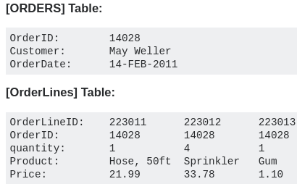
This would typically be stored as one row in an [ORDERS] table and three additional rows in an [Order-Lines] table, that all point back to the parent row in [ORDERS]. Which could look something like this --→
(NOTE: yes, I know that this is not fully normalized yet).
Order – An order is a list of products with a status.
Line Item – Every product on the order is referenced by a record that includes quantity and a reference to which order it belongs. This record is known as a line item. There are other kinds of line items (like taxes, or discounts) but those don't really play that much of a role in a shopping cart.
Saving Collections
What if we do not know how many objects we have and we want a member variable to be a collection. In our example we want to keep track of every single address that a user has lived in over the years. Since we don’t know how many addresses the user will live in, we cannot instantiate them statically.
There are a few collection types that Hibernate supports, one of them is a Set. We cannot use a HashSet as the reference type, we need to use Set* (?)
Using @ElementCollection
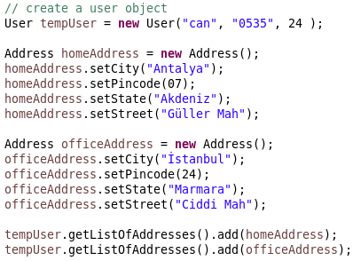
Address has to be annotated with @Embeddable !!!
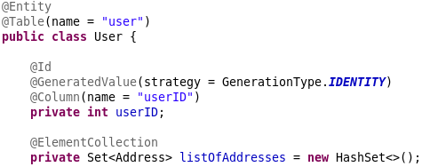

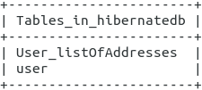
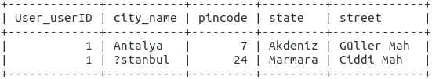
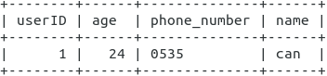

Hibernate generated a foreign key “User_userID” in the new table “User_listOfAddresses” which references to the “userID” in the user table.

Difference between session.get() and session.load() ?
The one difference between get() and load() is how they indicate that the instance could not be found. If no row with the given identifier value exists in the database, get() returns null. The load() method throws an ObjectNotFoundException. It’s your choice what error-handling you prefer.
More important, the load() method may return a proxy, a placeholder, without hitting the database. A consequence of this is that you may get an ObjectNotFoundException later, as soon as you try to access the returned placeholder and force its initialization (this is also called lazy loading; we discuss load optimization in later chapters.) The load() method always tries to return a proxy, and only returns an initialized object instance if it’s already managed by the current persistence context. In the example shown earlier, no database hit occurs at all! The get() method on the other hand never returns a proxy, it always hits the database.
You may ask why this option is useful—after all, you retrieve an object to access it. It’s common to obtain a persistent instance to assign it as a reference to another instance. For example, imagine that you need the item only for a single purpose: to set an association with a Comment: aComment.setForAuction(item). If this is all you plan to do with the item, a proxy will do fine; there is no need to hit the database. In other words, when the Comment is saved, you need the foreign key value of an item inserted into the COMMENT table. The proxy of an Item provides just that: an identifier value wrapped in a placeholder that looks like the real thing.
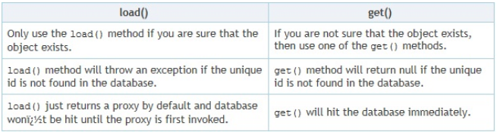

Configuring Collections
We want to change the name since its not a really user friendly name.

Change the collection table name: @JoinTable is mandatory if we wont configure our collection but right now we want to change the name, that’s why we have to write it.
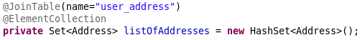
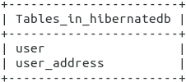

Change the foreign key name: The column that joins both of the tables (foreign key) == @JoinColumn
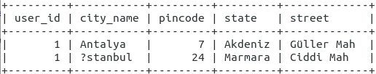
Define an ID for a collection which is inside your Entity class: In order to do that we need to use a data type that supports it. HashSet does not support indexing each entry. ArrayList do.
- Until now we always used annotations from javax.persistence.*; All these annotations are compliant with the JPA standard.
- This time we will use a different annotation specific to hibernate (not provided by the JPA standards). So changing our persistence implementation from Hibernate to some other tool will not include this annotation but the other ones will come with the new implementation since they also implement JPA.
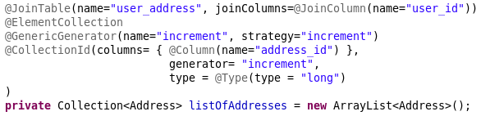

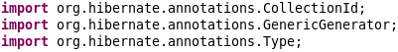

Hilo is one type of generator hibernate provides. We define a generator and then pass it as the argument.
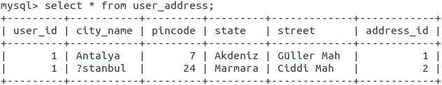
Our primary key column will be named “address_id” and the type of the values will be long
***All these are hibernate annotations, not in JPA.
***Collection yerine List yazsak da oluyor

*** Proxy Objects and Eager and Lazy Fetch Types ***
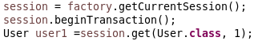
Normally when we do an sql query on a db, we would first get the user from the user table and then the addresses of that user from another table
Lets say our user has 100 addresses

Fetch strategy: If we just want the user information without the 100 addresses, we can tell hiberante NOT to fetch all the addresses. THIS IS THE DEFAULT BEHAVIOUR!!!
This is called Lazy Initialization in Hibernate. Meaning you do not initialize the entire object. You only initialize the first level member variables of the object, then you initialize the list only when you try to access it. The opposite of that is Eager Initialization.
However the moment when we do user1.getListOfAddresses() (???) hibernate goes and does another query to get all the addresses.
Why? If we are just interested about certain data, hibernate shouldn’t get all the data with every single operation. Those data should be fetched only when we try to access it. Takes a lot of resources.

Lazy fetching (or initialization) is the opposite of eager fetching. Lazy fetching, the default in hibernate, means that when a record is loaded from the database, the one-to-many relationship child rows are not loaded.
Eager Loading is a design pattern in which data initialization occurs on the spot
Lazy Loading is a design pattern which is used to defer initialization of an object as long as it’s possible
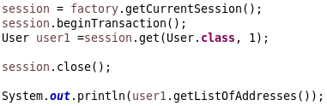

Before annotating my collection with @ElementCollection(fetch = FetchType.EAGER), I got an exception. User1.getListOfAddresses() invoked hibernate to make a call but it could not because the session was closed.
Since with eager fetching hibernate loads everything on the spot, the above code ran normally.
- Important: Only the annotated fields will be fetched eagerly!
- The fields without the fetch = FetchType.EAGER configuration will be fetched lazily.

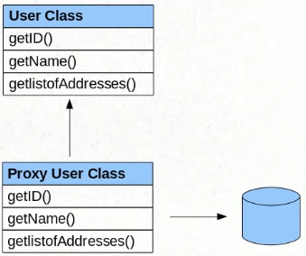
Proxy Objects: Hibernate creates proxy objects with the same values for all the first level fields. We are getting this proxy object back when we call .get().
This is how hibernate knows it must retrieve the other information when we try to access not initialized fields. (Like our list)

One To One Mapping
So far we saw how to represent
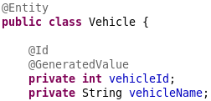
- a single Object inside an entity,
- a collection of objects in an entity
We will see how to implement one Entity inside another Entitiy.
- Created a new Entity called Vehicle
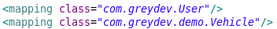
- Added these lines to my config file, changed pool to 2 (?)

So right now both are independent Entities. In order to establish a 1 to 1 relationship between them I need to add a Vehicle field to my User class. All we need is the @OneToOne annotation inside User.
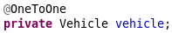
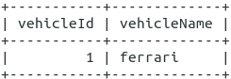
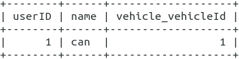

- One to One relationships are generally avoided in database design. They are represented (usually) in one table
- This can be added to the vehicle field inside User to change the column name
- One-to-one: Use a foreign key to the referenced table.

One to Many / Many to One Mapping

We converted our single instance of vehicle to a collection of vehicles and added the @OneToMany annotation to represent that a user can have one or more vehicles but a vehicle belongs to only one user.
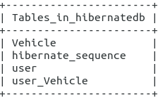
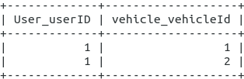
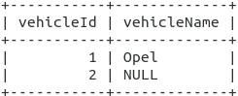
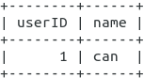

Right now when we run our program, these tables are created. The user knows about the Vehicles. But the Vehicles don’t have any information about their user. This is because in our model classes we didn’t reference a user inside our vehicle class.
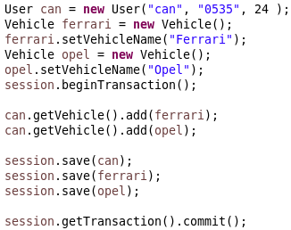
Created one user and 2 vehicles,
added those vehicles to our users vehicle list,
Saved all of the objects to the database. If we try to not save the opel, it will give us an error. Because opel is in the list of the user and we are saving the user. Opel has to be accessible when we fetch the user instance, that’s why it forces us to save every other objects that is reachable from user or the ferrari object.
- With this approach user knows about the vehicles but if we get a vehicle object we cannot reach/know the user!
Also when we get a vehicle back, we want to see to which user it belongs to. We should define that connection by creating a new field “user” inside the Vehicle class and annotate it with @ManyToOne. This way when we get a vehicle object back from the database, we can do vehicle.getUser() and will be able to access the user that the vehicle is connected with.
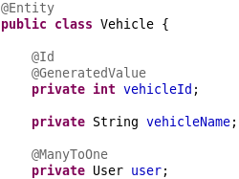
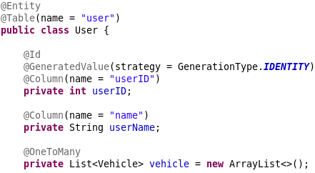
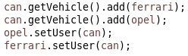

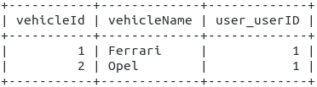
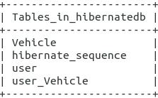
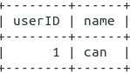
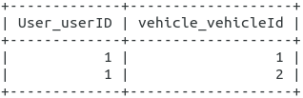

- Problem: Here we can see hibernate adds an extra table user_Vehicle
- Tipp: Whenever when we want to associate a user with a vehicle, we need to do 2 things. First adding the vehicle to the user’s list, then adding the user to the vehicle class. We can have one convenience method in our User or Vehicle class and add both of these operations there.

Normal way:
- One-to-many: Use a foreign key on the many side of the relationship linking back to the "one" side. This is how we would do it normally (while designing the db)
To achieve this (without an extra table like we saw in the previous example):
- add the property mappedBy=”user” to the list of vehicles in the user class
- Specify the join column in the Vehicle class. (The name of the column can be changed with (name=”new_
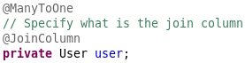

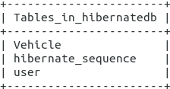
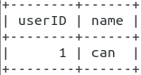
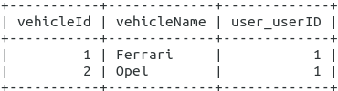

ManyToMany
Only way to represent it is with a mapping table?
We will represent a rental service where a vehicle can be owned by many users and vice versa. We will continue to keep our bidirectional (many to many) relationship.

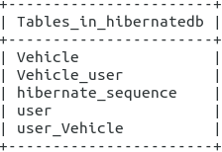
- Hibernate does not know we want just one table for mapping User to Vehicle. It’s creating 2 REDUNDANT tables to represent the relationships between user and vehicle.

We need to tell hibernate to use just one table for mapping:
- Right now both @ManyToMany annotations are doing the mapping and we get 2 redundant tables because of it.
- We have to configure one of the @ManyToMany annotations to tell it is already being mapped by something else → @ManyToMany (mappedBy=”vehicleList”).



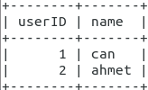
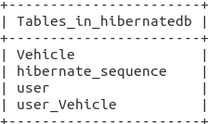
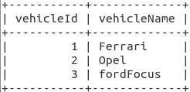
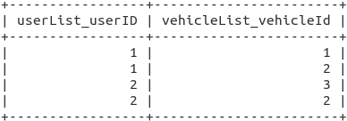
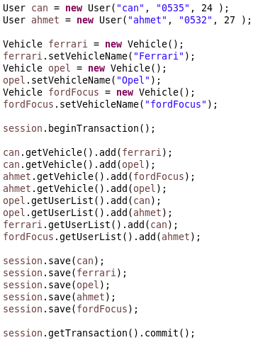

@NotFound(action=NotFoundAction.IGNORE)
private User user;
If the user is not found then ignore it. This is a hibernate annotation, not JPA.

Hibernate Collections:
- Bag semantic – List / ArrayList
- Bag semantic with ID – List / ArrayList
- List semantic – List / ArrayList (can be ordered, sorted)
- Set semantic – Set
- Map semantic - Map
Hibernate is using one of these semantics behind the scenes in order to maintain the collection.

Cascade
Doing an operation (update, delete, create) for a user, the same operation needs to be done for all the vehicles effected from that operation. This makes the code long and messy.
If an entity has a reference to another entity, Example: User has a list of vehicles as a field and a one to many relationship. When we try to session.save() only the User object, hibernate will throw us an error. Saying that we also should save the other referenced Entities/Objects.
The reason why hibernate wont save them too automatically is because vehicles are entities too and hibernate don’t want to assume any operations on different entities. If vehicle was a value object than its a different story but because vehicle is an Entity hibernate wont do operations on its own. It wants us to specify when and which operation should be done.
That’s why we save the user and all the vehicles individually. The problem starts if we will have 100 vehicles for a user. Would we do a session.save() for each of them?
- Telling hibernate if you come across this collection while I’m saving the user in this example and there are unsaved objects in the list, go ahead and save them too

Instead of session.save(can) we have to use session.persist(can).
CascadeType. ALL, DETACH, MERGE, PERSIST, REFRESH, REMOVE

* Eğer aynı vehicle daha önce kayıt edilmiş ise hata veriyor. Session.persist(can); session.persist(ahmet); yapınca Can ve Ahmetin listesinde Opel olduğu için ilk opeli can’da kaydediyor 2.kezde ahmette kayıtlı objeyi tekrar kaydetmem diyor. Duplicate entry , ConstraintViolationException

Implementing Inheritance
Inheritance is specific to OOP. Relation models does not have an equivalent to that. Its a challenge for relational modeling tools.
Example: Vehicle Base Class will be inherited from other classes, 2 wheeler, 4 wheeler Vehicle.
Why bother about implementing the inheritance relationship for our database, since 2 wheeler and vehicle base classes are both entities can’t we just make them separate tables and not show the relationship between?
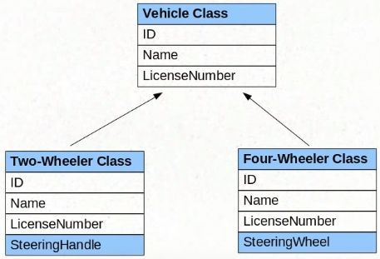
Vehicle is an abstract class, so we won’t have objects created of it.
- One option is to mark both classes as entities. Both will go to separate tables and that is also a way to persist data.
But there are some problems with that. Polymorphism: If a user class has a Vehicle reference, we wouldn’t know which class it can be until runtime. Lets say we want to persist also the User class. Which foreign key will the Vehicle column get? The Id of Two-wheeler or the Id of four-wheeler? We wouldn’t know until runtime.
Another problem is when we change our abstract vehicle class, the changes won’t show up in our database tables. We would have to do it manually
- If we want to utilize all the features of inheritance then we can use hibernates functionalities for those
Single Table Strategy
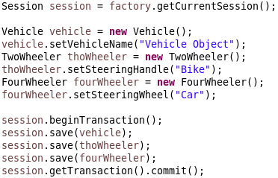
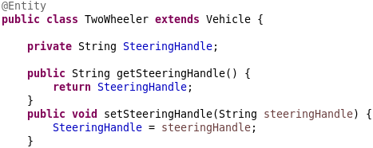

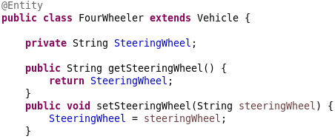

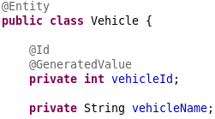

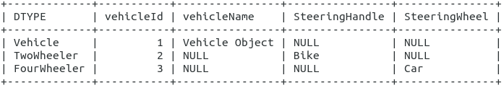

Hibernate implemented BY DEFAULT a strategy called Single Table Strategy. No matter what you inheritance structure/hierarchy is, it will create one table for all objects. If a new class “Opel” inherited FourWheeler and added a separate field in its class (e.g. color). Then that field would still be in the same Table, just as another column and the object would be a row in the table.
Note that if SteeringHandle was a public field and “Opel” extended FourWheeler, then Opel would have both values in the SteeringHandle column and the new Color colum, the rest would be NULL.
DTYPE is the class names, NOT the reference variable names!
Note that the field “vehicleId” is a private field and it is set to be the key. Child classes each still have key even though for them the “vehicleId” field is not visible. (?)
Discriminator is the DTYPE. If lets say our ThoWheeler did not initialize SteeringHandle, so that column would be null too. Then how can we distinct what the type of each row is? With DTYPE.

Configuring the inheritance Strategy:
- Annotating the base class with @Inheritance: Not mandatory, if this is set without any values or if we wont write this at all, the default strategy is Single Table Strategy.
- @Inheritance (strategy=InheritanceType.SINGLE_TABLE):
- @Inheritance (strategy=InheritanceType.TABLE_PER_CLASS)
- @Inheritance (strategy=InheritanceType.JOINED)

Configuring the discriminator:
- @DiscriminatorColumn
- Configure the column name with (name=”VEHICLE_TYPE”). The default it is the class name.
- Tells hibernate what the data type of the discriminator is with (discriminatorTpe=DiscriminatorType.CHAR / INTEGER / STRING). String is the default.
- @DiscriminatorValue(“Car”) can be added on top of our Entity classes. It wont show the class name as the discriminator value, it will show “Car”.

- The Single Table Strategy is fine for simple inheritance. But if we anticipate a lot of queries among different types of Vehicles and our inheritance hierarchy might grow in the future. Then it might lead up to complicated queries because everything is in a single table.
- Select * from Vehicle where DiscriminatorName = TwoWheeler ...

Table per Class Strategy
Since all the objects of different classes were dumped in a single table we needed the Discriminator. But since we will handle it with different tables, we wont need a discriminator anymore. If we will have a TwoWheeler we would query the TwoWheeler table and the same for other types.
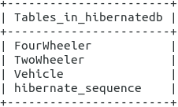
@Id and @GeneratedValue annotations for VehicleId is also inherited.

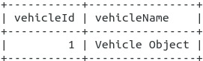
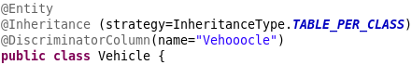

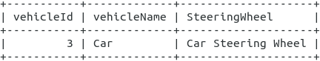
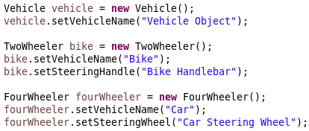

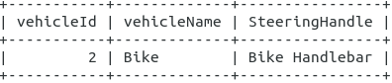

- Note that even if our fields and methods are private in the Vehicle class, Hibernate can still access them! When I made Vehicle.VehicleName, the setter and the getter method of it private, the child classes still had a column for VehicleName.
- How can hibernate access a private field? Hibernate uses Reflection which can gain access to private instance vairables as well as private methods. So subclasses also inherit private fields and methods of the parent class somehow and it creates separate columns for those.
- Is there a way to prevent that, maybe with an annotation?

Advantages of Table per Class strategy:
- No need for a discriminator, everything is separated to tables
- It is in a normalized form(?). We don’t have extra columns which do no have data.
- Every table has only the properties its needed. No blank columns. More efficient
- If we wouldn’t use hibernate we would do it this way. It is the most common way.
- Negative: The child classes/Tables has always duplicate columns.

Joined Strategy
If we don’t want to save the inherited fields from the parent class, we can use the JOINED strategy.
Only the columns that are specific to the subclasses will go also to the subclass table. We can extract the full information about subclasses by doing a join.
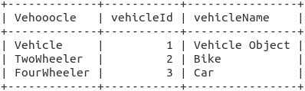
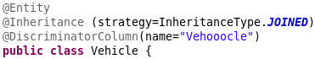

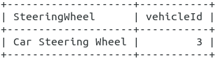
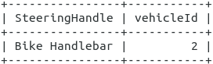
CRUD Operations
session.save/persist(objectToBeSaved) → Create
session.get(Class.name, primary key) → Read
session.update(updatedObject) → Update
session.delete(objectToBeDeleted) → Delete
Update: after getting your object, you can modify it and then put the modified object into the session.update() method as the argument.
Transient, Persistent and Detached (States) Objects
If an object is created / instantiated but not saved to the database with session.save() then it is a transient object. Not saved, hibernate doesn’t know to save that object. Transient: lasting only for a short time; impermanent.
When that object is saved to the database with session.save/persist() then it is persisted, it’s called a persistent object. Persistent state, bir objenin bir session’ın içinde olup olmadığı gibi de düşünülebilir.
Hibernate watches the object(?): We created an object, and called session.save(obj). After session.save() and before session.getTransaction().commit() hibernate follows the object to see if any changes occurred.
- When session.save(obj) is called, hibernate does an insert obj
- After .save, when the object is updated with something like obj.setName(“bla”); then hibernate sees that the object has changed and it sends an update command to the database, changing the value of the obj.
How does hibernate know what changes to reflect to the db?
- Once we pass an Entity object to a session.save(), any change we will make on the object will go as an update statement to the database. The last state of the object will also be in the database, meaning the last state before we call commit and close.
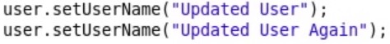
- If we change our object like this twice, hibernate will still do only one update. Hibernate intelligently looks for how it can do the least amount of updates in order to save the objects last state.
- Hibernate does not track transient objects and detached objects, it tracks only persistent objects.
Once we do a session.close(); our object becomes a detached object. Hibernate does not track detached objects.
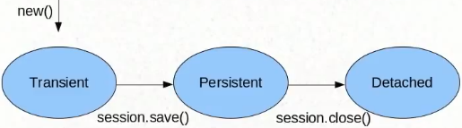
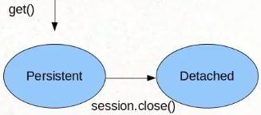
Create → Read →

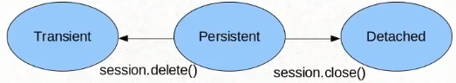
Delete →

We can’t use session.update on a transient object(newly created obj) if that object does not already exist in the db, First .save is required. But lets say if a user obj with id 6 exist in the db, we can create a new obj, set id to 6, set a new name and .update(). The existing obj in the db will be updated: Id will be same name will be changed.After.update(obj),obj will be in a persistent state(any changes will update)
Hibernate Query Language (HQL) and Query Object

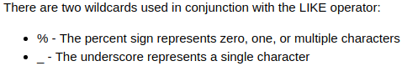
- Query language for retrieving objects
- Similar in nature to SQL not the exact same.
- where, like order by, join, in, etc…
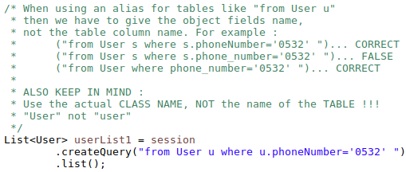
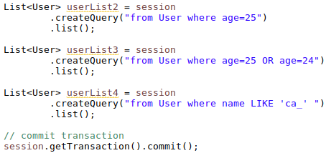

In standard SQL we think about tables but in HQL we are thinking about objects and classes.
In order to use HQL we need to use a query object. Session.createQuery() returns a query object.
Differences JDBC SQL / HQL :
- SQL uses table names, column names / HQL uses class names, field names
- no select *, assumes you do a select
- Returns not records but objects.
- HQL queries are written against the object model, not against the database schema.
Our query template will be like this:
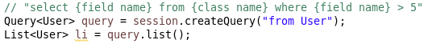

select * will be added by default. But we can select field names that we want to fetch. First call these methods and after that use the query object to get/manipulate your objects. Example query.list();
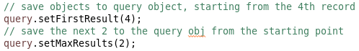

Limiting the data that hibernate pulls up : "select {field name} from {class name} where {field name} > 5"

All the aggregation functions will still work: max(), avg() … returns one value
Hibernate takes records, converts them into Entity objects and gives them to us. Not much control about it, maybe we just want a field, not the whole object.

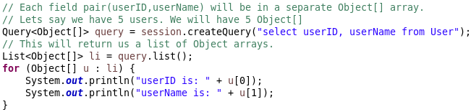
Selecting multiple fields:
Parameter Binding

Appending parameters to queries is BAD… Can cause SQL Injection, No good. Solution: parameter substitution / parameter binding.
Gives us an Error →
- You can't bind a column name as a parameter. Only a column value. This name has to be known when the execution plan is computed, before binding parameter values and executing the query. If you really want to have such a dynamic query, use the Criteria API, or some other way of dynamically creating a query.
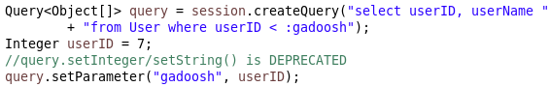
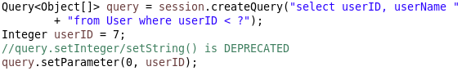
Query.setParameter(index, value);
Query.setParameter(stringVarName, value);
positionIndicator: when we have multiple placeholders ?, ?, ?… then we can set which placeholder will be substituted.
- Positional parameter are considered deprecated; use named parameters or JPA-style positional parameters instead.
- Named Parameters is the way to go. More readable and … why ????
sessionFactory vs EntityManager???

If a parameter has a where clause in it and we try to substitute it with a placeholder, Hibernate will give us an error ?? Test…
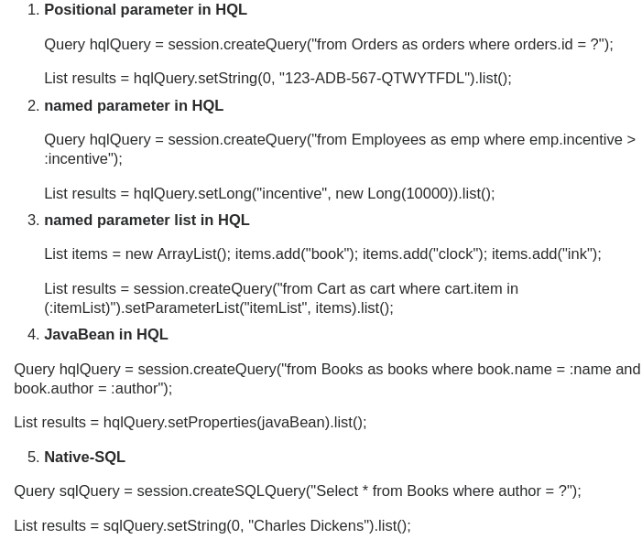

Named Queries
It’s a good practice to have a place where we group all the queries that we use. Because if we want to do a change, we will know where to go. Class ismini başa yazmak good practice(?). Operation name’i kafamıza göre verebiliyoruz sanırım. Burda da positional parameter ya da named parameter kullanabiliriz. Ancak UNUTMA, positional parameter == DEPRECATED
Kısaca: Tek tek bütün querieleri yazmak yerine, kullanacağımız querylere bir isim verip onları önceden yazıp bir yere topluyoruz (ki hepsi gözümüzün önünde olsun ve birşey değiştirmek istediğimizde sadace tek bir yeri değiştirelim. Diğer türlü 20 kere yazdıysak 20 sini de değiştirmek gerekir)
@NamedQuery(name = “ClassName.operationName”, query = “select xxx from ClassName where ...”)
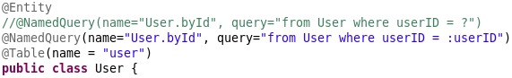
- We wrote HQL queries in this example, but we could also write plain SQL queries with the use of @NamedNativeQuery() annotation!
- When writing native SQL Hibernate wont know what the result object type has to be, we could also provide a class name at the end, so Hibernate knows casting the result to that
- It is better to use HQL, since we want to get away from SQL by using Hibernate.
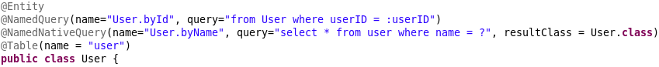
- In this last example the ? is NOT the same as the positional parameter in HQL. It is a pure SQL property. ? is used in Prepared Statements. It is a placeholder for values. It can prevent SQL Injection attacks because the values replaced with ? will not be considered as a part of the SQL statement, it will only seen as data (but dont know for sure, maybe there are some details)

Criteria API
We saw 2 ways to fetch data from our database, there is another way:
- session.get(ClassName.class, primaryKey): really limited.
- Writing Queries using HQL / SQL: After some point HQL also becomes more or less like SQL. In real life applications there will be a lot of complex queries and those will also grow.
- Using Criteria API: It is very ideal and elegant for creating dyamic queries and simple to add ordering, restrictions and paginations while fetching data from supported databases.

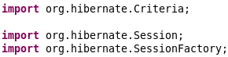
session.createCriteria is DEPRECATED → This is provided by Hibernate

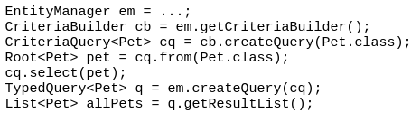
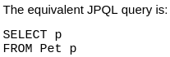
The JPA specification implementation has CriteriaBuilder and CriteriaQuery.

- So far we always used session. But it is provided by hibernate and its not a JPA standard(?).
- JPA defines another standard similar to a sessionFactory / session. It is called EntityManagerFactory / EntityManager.

Hibernate Cache
First level cash: within one session. First level cache is implemented by the Session Class.
Second level cash: across different sessions. We can implement a second level cache too. Why do we need it? Because a session is not something we will hold for a long period of time. A session factory is there for the whole lifetime of the application but a session is something short, used for single operation.
If we want to access data that is processes by another session, then the second level of cache is needed.
Second level cache can be implemented in different ways:
- Across sessions in an application
- Across applications: if they are all using hibernate and if they are working on the same data set.
- Across cluster: different applications deployed on different servers and they are all talking to the same database.
Lets say we run this line in our session1:
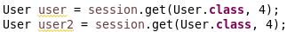
Hibernate will do only one select query as expected. But in the same session (session1) if we try to get the same user with another statement like this, We will see again that only one query is done by Hibernate, it gives the same object to us from the cache:

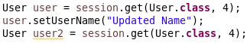
Even if we update the user before trying to get the same user from the db again, there will only be one select query. Because the first object is already there in the cache. The user2 that hibernate should fetch is actually the same as user, so hibernate sees that and justs gives us the updated object which is already there:

But when we try to open a new session then these things wont be applied there because the object wont be in the cache (first level).
- With the help of first and second level caches, the resources are used efficiently. We wont need to talk to the db unless it is absolutely required.

Second Level Cache: Allows that the objects retrieved from a session can also be seen and used by another session. With this line we can set a second level cache provider. Right now its disabled.

If we want to enable second level cache, we need to find a class that is the cash implementer/provider and write the name into the property element in our configuration file. And a new element with the value of cache.use_second_level_cache = true.
Also we need to annotate Entities that are cacheable with the @Cacheable annotation, in our example the User class has to be annotated. Not all Entities are cached by default.
Using Query Cache: While our second level cache is active, what if we wont use session.get() but use a query object to get the data?
In our session1 :

In our session2:

We are now seeing 2 select queries sent by hibernate. So the second level cache seems to be not working.
- In order to use query cache we need to specific a query cache separately:

The same way like Entities, we need to tell Hibernate, “make this query cached” (Not all queries are cached by default)

Now when we run our program, only one select query will be sent. Both query objects need to be set as cacheable=true in order to use the query cache.
- Use query cache carefully!

How should equals and hashcode be implemented when using JPA and Hibernate?
