Hibernate 2
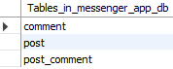
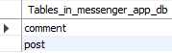
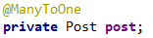
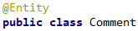
Remember: hibernate adds an additional (and unnecessary) table if you don’t use mappedBy=”...”.

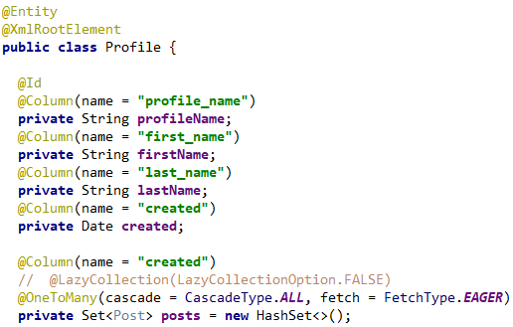

org.hibernate.loader.MultipleBagFetchException: cannot simultaneously fetch multiple bags: [com.greydev.messenger.profile.Profile.posts, com.greydev.messenger.post.Post.comments]
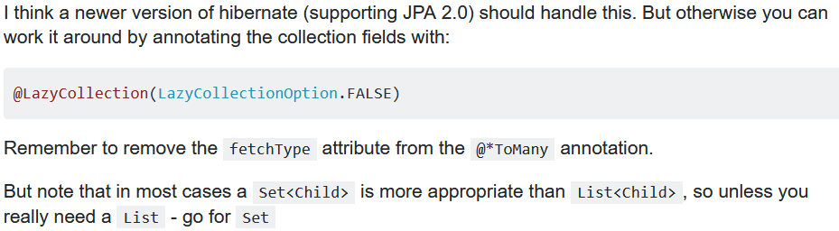

both @Lazy.. and changing the List to a set worked for me.

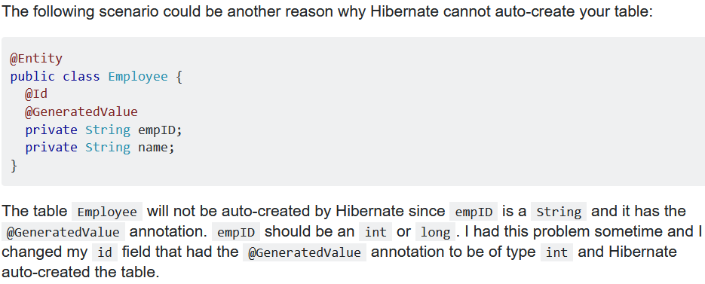
RESULTED IN OTHER EXCEPTIONS:
java.sql.SQLSyntaxErrorException: Table 'messenger_app_db.profile' doesn't exist
org.hibernate.exception.SQLGrammarException: could not extract ResultSet

Solution: CHANGE DIALECT !? WOW...
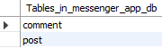

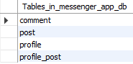
Don’t get confused: session.update(obj) this methods find the corresponding object in the database by looking at only at the ID of the argument ‘obj’. Meaning naturally you will pass a different java object but since (and if) they will have the same ID, hibernate will update the old object with the new ‘obj’.
This is probably same for session.delete(obj) but not sure.

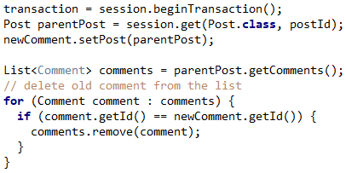

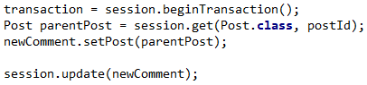
org.hibernate.NonUniqueObjectException: A different object with the same identifier value was already associated with the session : [com.greydev.messenger.post.comment.Comment#55]
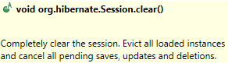
Adding session.clear() before .update() solved it.

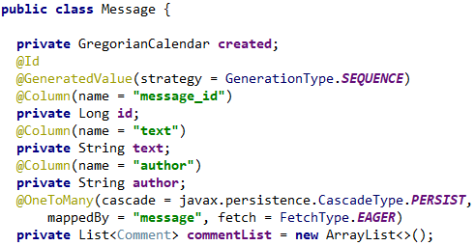

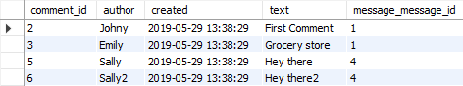
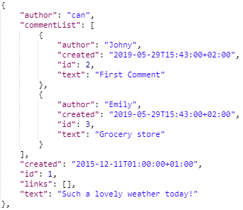

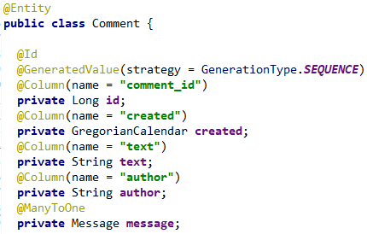


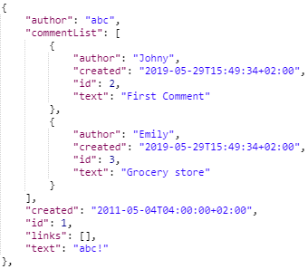
SAME PROBLEM: POST a new message with comments inside, comment list is not persisted!

Caused by: org.hibernate.StaleObjectStateException: Row was updated or deleted by another transaction (or unsaved-value mapping was incorrect) : [com.greydev.messenger.message.comment.Comment#881]
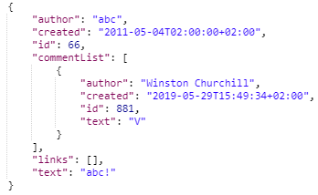
I wanted to sent a POST request to add a new message with a comment collection inside. This is the payload.
The message itself would be saved without a problem but the comment list wasn’t saved. Because I ignored the message.id value inside the payload!!!
The cause for this exception was the comment id. I redirected the message to hibernate without changing anything. Hibernate saw that there is a comment with the id 881, so it searches the database but couldn’t find it so it got confused.
Solution: Setting every comment id to null solved the problem. Now hibernate will assign a new id for each comment.

Comment id was already assigned, so Hibernate probably didn’t see it as a ‘brand new’ transient object.

SAME PROBLEM with PUT: When I sent a PUT request like /messages/55, I want it to update the message if it exists (works fine) but if the message does not exist I want to save it with the ID of 55. But when adding new message, since the message has an ID, hibernate throws the same exception because it can’t find anything with that id and does not create a new one.
Example: sending a PUT request to .../messages/881 (doesn’t exist) with a payload which contains a Message with one comment inside it. Both ID fields inside comment and message is SEQUENCE. Comment id is not an issue in this example since I’m generating it even I receive a comment with an id set.
POST /messages/ works fine for every version. Generates a new message with the next sequence number.
Caused by: org.hibernate.PersistentObjectException: detached entity passed to persist: com.greydev.messenger.message.Message

Caused by: org.hibernate.StaleObjectStateException: Row was updated or deleted by another transaction (or unsaved-value mapping was incorrect) : [com.greydev.messenger.message.comment.Comment#881]

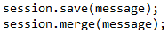
These are not throwing any exceptions BUT these completely ignore the id of the message (881) and pick the next number from the SEQUENCE generator with each same request.

Solution
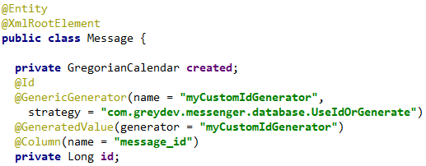
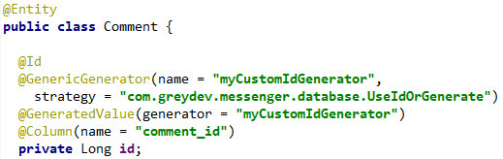

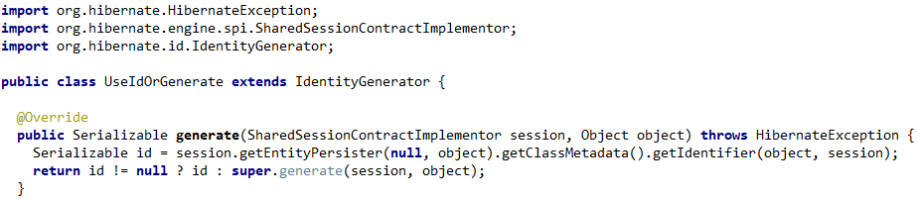
Ne sonuç aldığını anlat…

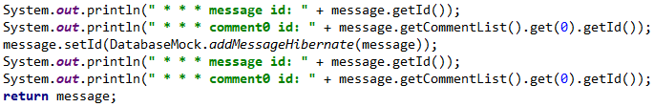

Important: Hibernate will set the field with @Id annotation to the generated id! So if the ID of the message was null before saving, once you save the value will be changed from hibernate. Same for the child entity id’s.
Important: When you delete an object with session.delete(obj), hibernate will not do anything to the object inside the java program, meaning we can easily return it back in our REST response to tell which object was successfully deleted.
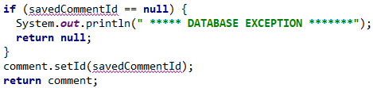
No need to check for id==null. Since hibernate sets the id of the comment when it saves it to the DB.

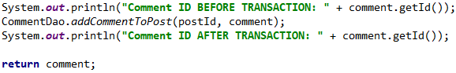
That’s why we can return the comment immediately without setting anything

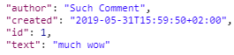
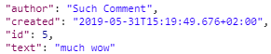


After going through the life cycle, the question that comes into mind is that, how does hibernate know whether an object is transient, persistent or detached? A range of options are available for that.
Hibernate will assume that an instance is unsavedTransient instance if:
- The identifier property is null
- The version property (if exists) is null.
- You supply an unsaved-value attribute in and the value of the identifier propertymatches.d) You supply Hibernate Interceptor and return Boolean.TRUE from Interceptor.isUnsaved()after checking the instance in your code.
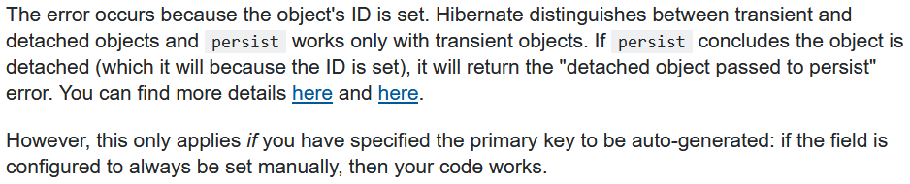
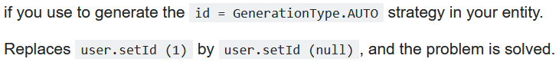

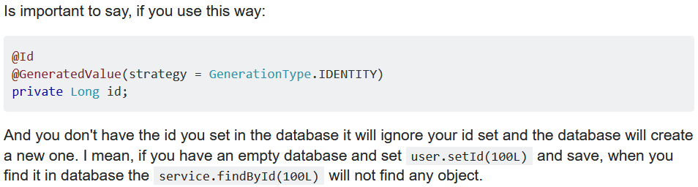

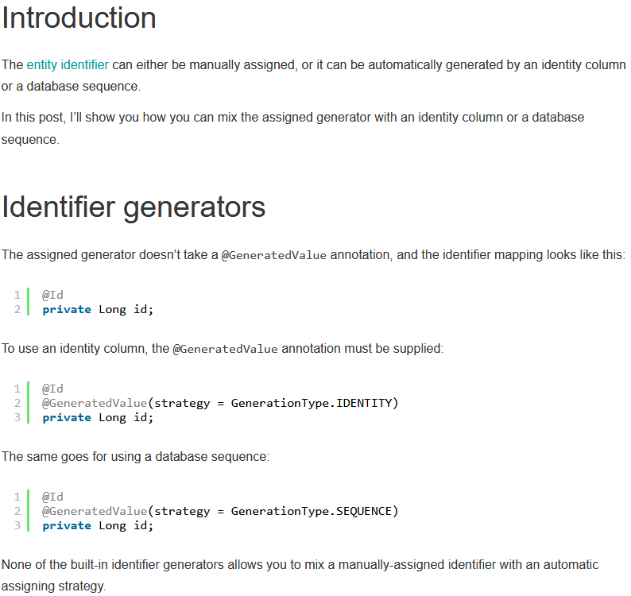

@GeneratedValue annotation doesn't allow the user to set the value manually.

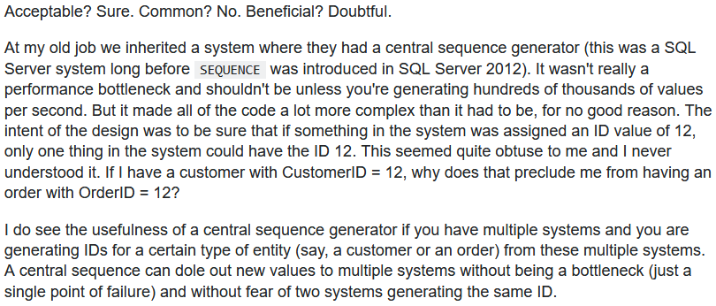

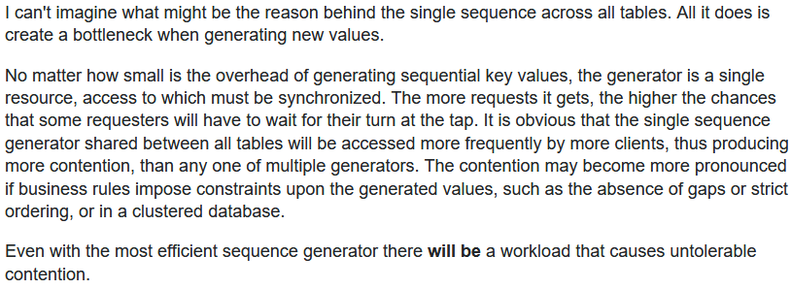

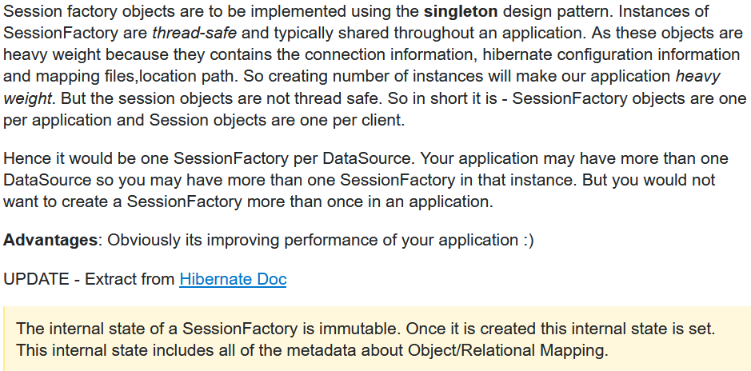


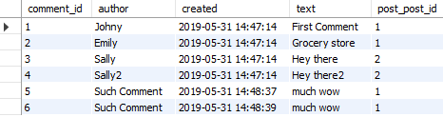
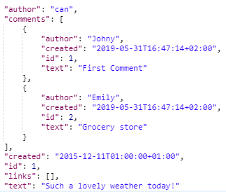
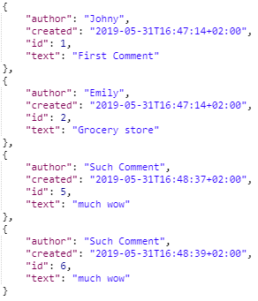
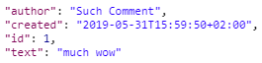

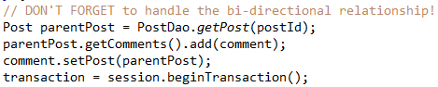

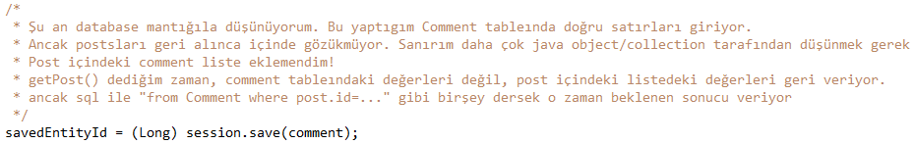
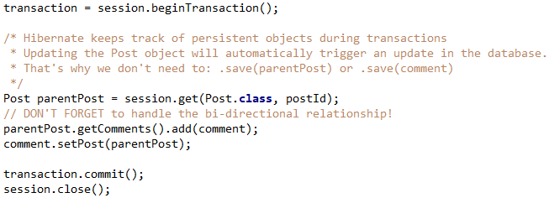
Without comment.setPost(parentPost) the ‘post_post_id’ column of the new comment would be null.
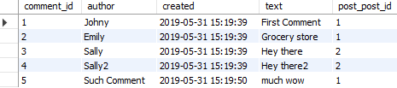
And without parentPost.getComments().add(comment), we wouldn’t see the comment when we did a GET request to /post (as I showed at the beginning)
- LATER :I also had to add session.save(comment) for the case when the comment had a specific ID
PUT /posts/1/comments/77
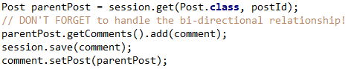
Else it would throw ‘Row was updated or deleted by another transaction’ exception. Çünkü comment.setPost() dediğimizde, hibernate update yapmaya çalışıyor, ama comment 77 bulamıyor.
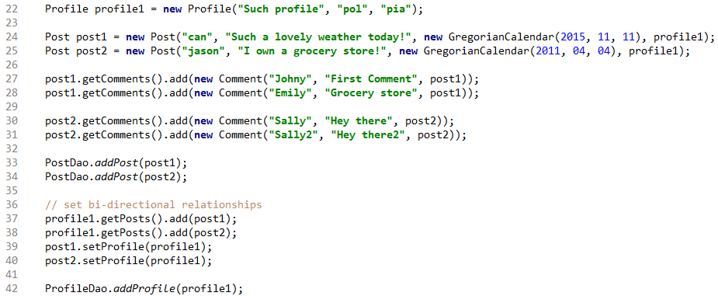

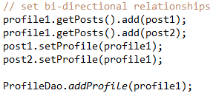
- Adding first the Post instance (line 33, 34) threw [org.hibernate.exception.ConstraintViolationException: could not execute statement] because inside a post there is a parent instance which is not saved yet (line 42).
- But! First adding the profile, after that adding the posts worked with trowing some exceptions. This was for a reason we saw before. Since cascade.ALL only saving the parent will automatically save all posts and comments attached to it! No need for line 33, 34.

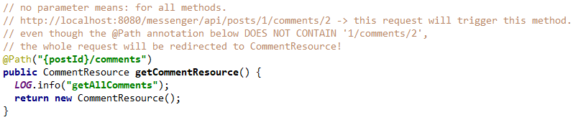
Important to remember

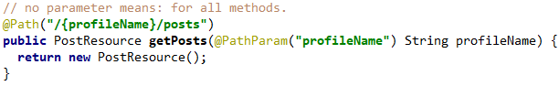

http://localhost:8080/messenger/api/profiles/ccc/posts/1/comments -> This resource will first go to ProfileResource, will trigger the above method where it will be redirected to PostResource. There it will trigger the first method seen above, which will redirect it again to CommentResource and finally CommentResource will handle the request.
- That’s why when I expose 2 endpoints /api/profiles/{id}/posts/{id} and /api/posts/{id}, these will have only one point/method where everything is processed. That’s why no need to create identical logic for different endpoints, since they will redirect the request to the correct place.

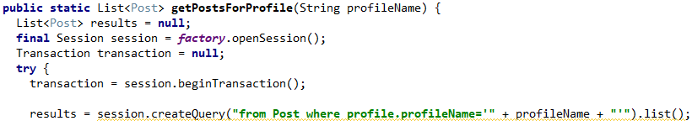

This exception was thrown because I didn’t use quotation marks to wrap the string profileName in the while clause. It should be as shown above: where profile.profileName=’ccc’ and if the searched term is a number then you should directly write the number where profile.profileName=5.

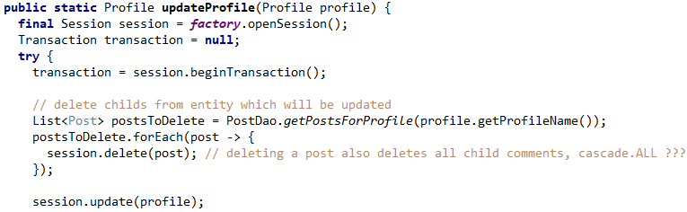

--> Updating a profile, only need to delete posts from the ‘old’ profile. Because when you do an update without anything, the profile correctly updates with new children inside (because we set all the id’s to null before) but the children from the ‘old’ profile will still stay in the database.

Using Generated Timestamps
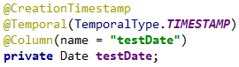

- Without updatable = false when you send a PUT request with a timestamp attached to the entity, it WILL UPDATE the ‘created’ timestamp. If you add updatable = false then even if you update the whole entity, the created column won’t change
- Even when you provide ‘created’ in the payload on a new entity POST request, it is still generated correctly.
- Adding should make it so that it is always generated and never null but atm I’m getting an exception ‘not-null property references a null or transient value’. “ this error message can also mean "you have it referencing a foreign object that hasn't been saved to the DB yet" (even though it's there, and is non null).”

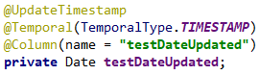

- The idea here is to save the LAST UPDATED timestamp
- On resource creation: POST request, ‘created’ and ‘updated’ will be initialized, the same timestamp.
- On UPDATE, only the ‘updated’ column will change with a new timestamp (because we wrote updatable=false to creationTimestamp), even if we provide a custom updated column on our request! So this works great.

Date Inconsistency between the app and the database
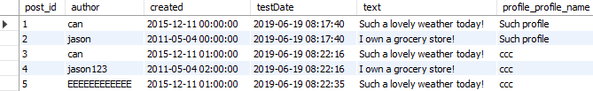

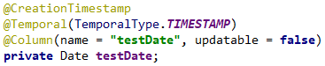

--> There is a 2 hours shift between the apps response and the database when making hibernate generate a timestamp. Why?

