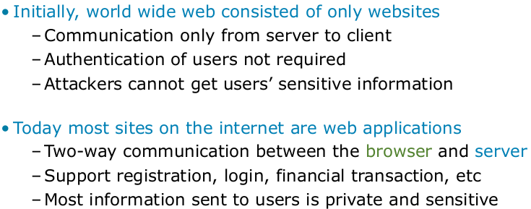
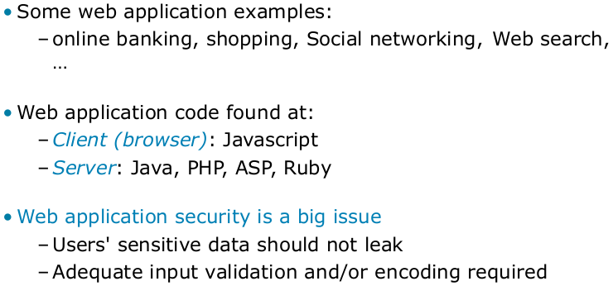

In this course (OWASP Web Top 10 for 2013): Injection, Broken Authentication and Session Management, XSS, CSRF.
OWASP: The Open Web Application Security Project, an online community, produces freely-available articles, methodologies, documentation, tools, and technologies in the field of web application security.


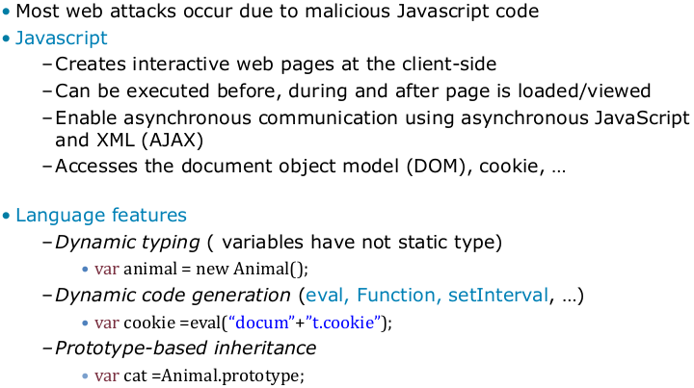
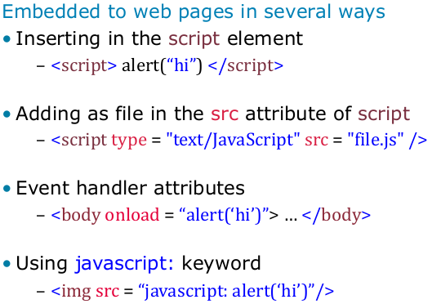

- JS is basically the language of the whole web. Other client-side languages are dead. Web-Assembly is coming up these days.
- Why can JS be attacked so easily? JS was not meant to be a server-side language, also it wasn’t created having security in mind. You can introduce new code at runtime e.g. with eval, Takes a string and excecutes as it is source code. There are so many different places where you can add/embed js.

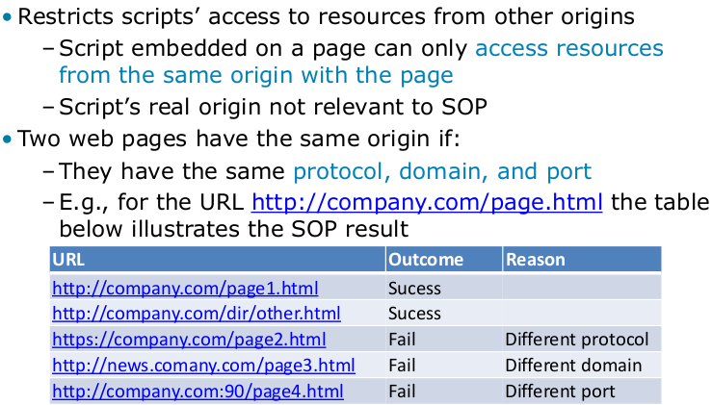
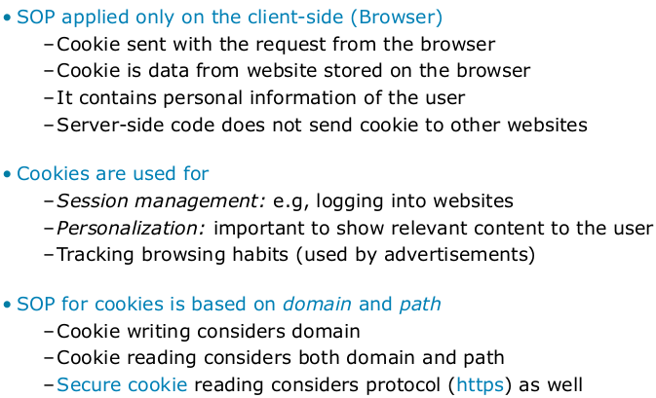

To make the JS vulnerabilities a little bit more secure SOP was introduced. This policy says that you cannot get information about a different web site in your browser. Why is that important? If I have 2 tabs open, one is my bank account and the other is smth else, then I do not want to get the other side and information about my bank account. They should be clearly separated. This is what SOP tries to enforce.
It’s not really consistent and not working for everything. The SOP ist just some best effort, it works but not super great, can be avoided in some cases. Only applied on the client side.
Same-origin policy
The same-origin policy restricts how a document or script loaded from one origin can interact with a resource from another origin. It is a critical security mechanism for isolating potentially malicious documents.
In computing, the same-origin policy is an important concept in the web application security model. Under the policy, a web browser permits scripts contained in a first web page to access data in a second web page, but only if both web pages have the same origin. An origin is defined as a combination of URI scheme, host name, and port number. This policy prevents a malicious script on one page from obtaining access to sensitive data on another web page through that page's Document Object Model.
This mechanism bears a particular significance for modern web applications that extensively depend on HTTP cookies to maintain authenticated user sessions, as servers act based on the HTTP cookie information to reveal sensitive information or take state-changing actions. A strict separation between content provided by unrelated sites must be maintained on the client-side to prevent the loss of data confidentiality or integrity.
The same-origin policy mainly applies to data access from scripts; embedding resources across origins, such as images, CSS and scripts via the corresponding HTML tags is not restricted (with fonts being a notable exception).
History: The concept of same-origin policy dates back to Netscape Navigator 2 in 1995. The policy was originally designed to protect access to the Document Object Model, but has since been broadened to protect sensitive parts of the global JavaScript object.
Implementation: All modern browsers implement some form of the Same-Origin Policy as it is an important security cornerstone. The policies are not required to match an exact specification but are often extended to define roughly compatible security boundaries for other web technologies, such as Microsoft Silverlight, Adobe Flash, or Adobe Acrobat, or for mechanisms other than direct DOM manipulation, such as XMLHttpRequest.

Security Applications
The same-origin policy helps protect sites that use authenticated sessions. The following example illustrates a potential security risk that could arise without the same-origin policy. Assume that a user is visiting a banking website and doesn't log out. Then, the user goes to another site that has some malicious JavaScript code running in the background that requests data from the banking site. Because the user is still logged in on the banking site, the malicious code could do anything the user could do on the banking site. For example, it could get a list of the user's last transactions, create a new transaction, etc. This is because the browser can send and receive session cookies to the banking site based on the domain of the banking site.
The user visiting the malicious site would expect that the site he or she is visiting has no access to the banking session cookie. While it is true that the JavaScript has no direct access to the banking session cookie, it could still send and receive requests to the banking site with the banking site's session cookie. Because the script can essentially do the same as the user would do, even CSRF protections by the banking site would not be effective.

Every time you send a request the answer contains a cookie, saying this is a certain person for example. Each web site can store a little bit of data on your browser saying this is the person I was interacting with.
It has to be clear on the server-side that the same cookie is only sent to one person, not more than one.
Cookies are used for – Session management: When you login to a website and when next time you access the same web server, that web server needs to know that is still you. But HTTP is stateless. So it doesn’t know you ever contacted/visited that web site. The only way to make that clear is by sending additional information from the browser back to the server that “proofs” that you are the same person. This is a cookie, it’s a secret information that nobody else knows about and only those people that have the cookie can use the service/website the way you are allowed to use it.
This means if someone is able to steal your cookie, he can do the same things as you do, since the server won’t check if the cookie comes from the same browser.
Even if you are not logged in, sites still use cookies. Most website that use cookies has to adhere to some EU-Union regulation that they have to tell you that they use cookies. Only option is to say “ok”. Basically it is used for some kind of a personalization, so when you come back it will know that last time you were looking for a certain thing and maybe they will use that information in a meaningful way, suggestions etc.
This is particularly interesting for advertisers, they will track what you are doing on the internet. They can even do that in multiple websites that you are browsing and will know everything about you. What google, facebook etc is doing. What you were searching yesterday, with whom did you interact and so on, then they will show you ads e.g. All of this is possible with those cookies.
- The same that applies for the web page directly is also true for cookies. Cookies cannot be accessed by some other websites, otherwise they could steal your credentials (bank account).
- You have the option to say that cookies can only be sent to the server if you are using https. Because if the cookie is sent over the internet without encryption then everybody could steal that cookie and pretend that they are you. There is an option nowadays on browsers, telling it not to send a cookie without using https.

Secure cookies are a type of cookie that are transmitted over encrypted HTTP connections. When setting the cookie, the Secure attribute instructs the browser that the cookie should only be returned to the application over encrypted connections. The secure attribute does not protect the cookie in transit from the application to the browser; both Firefox and Internet Explorer allow cookies with the Secure attribute to be set over HTTP.
To fully protect a cookie, the HttpOnly and SameSite attributes should also be applied to the cookie. The HttpOnly protects the cookie from being accessed by, for instance, JavaScript, while the SameSite attribute only allows the cookie to be sent to the application if the request originated from the same domain.

An HTTP cookie is a small packet of data that is sent from a web server to a user's web browser. Since HTTP is a stateless protocol, it cannot relay information from one page to the other and so there was a need of a cookie. There are two types of cookies:
- Persistent cookies - Cookies that store information in user's browser for a long time.
- Non-persistent cookies - Cookies that generally expire once the browser is closed.
The cookies could contain sensitive information such as passwords and credit card numbers. These are sent over an HTTP connection and are stored in web browsers as plain text, and so can be targeted and be used by attackers to steal the information stored in it. To prevent such information exposure cookies are secured with attributes.
Various cookie hijacking techniques exist. All the methods are not difficult to implement and can do a significant damage to a user or an organization.
- Network threats Cookies that are sent over unencrypted channels can be subject to eavesdropping, i.e. the contents of the cookie can be read by the attacker.
- End system threats Cookies can be stolen or copied from the user, which could either reveal the information in the cookies or allow the attacker to edit the contents of the cookies and impersonate the users.
- Cookie harvesting The attacker can try to impersonate a website by accepting cookies from the users. Once the attacker gets the cookies, he can use these harvested cookies for websites that accept third-party cookies.

The Set-Cookie HTTP response header is used to send cookies from the server to the user agent.
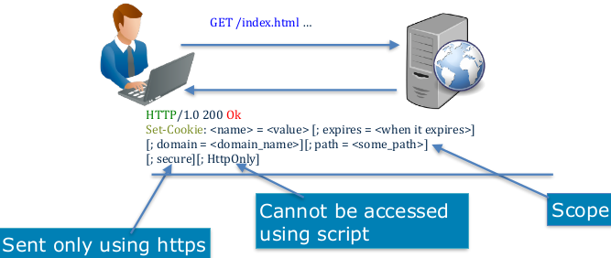
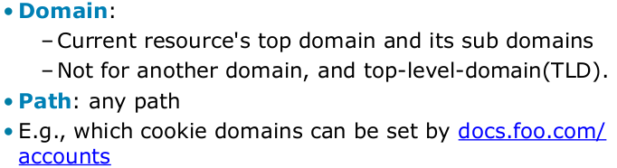

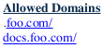
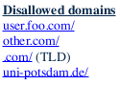

Setting the HttpOnly flag on a cookie makes it a little bit safer since JS cannot access that cookie.
But this is only enabled if the web server tells you so! If not any JS can access.

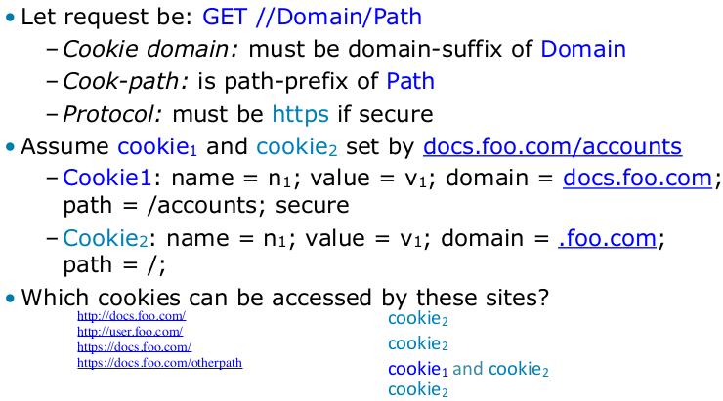
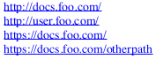
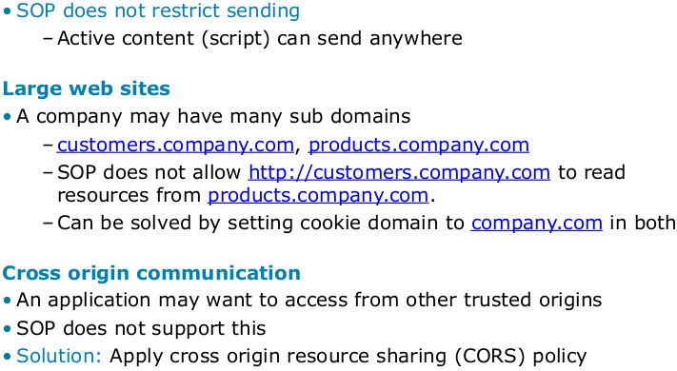


SOP does not restrict sending. E.g. you can always send out a request for an image, and nobody will check if the image is on another domain. That means if you can send out a request to some other server, you can encode something in the URL that has additional information, leaking info to the internet.

If your server allows it. Cross-Origin Resource Sharing (CORS) is a mechanism that uses additional HTTP headers to tell a browser to let a web application running at one origin (domain) have permission to access selected resources from a server at a different origin. A web application makes a cross-origin HTTP request when it requests a resource that has a different origin (domain, protocol, and port) than its own origin.

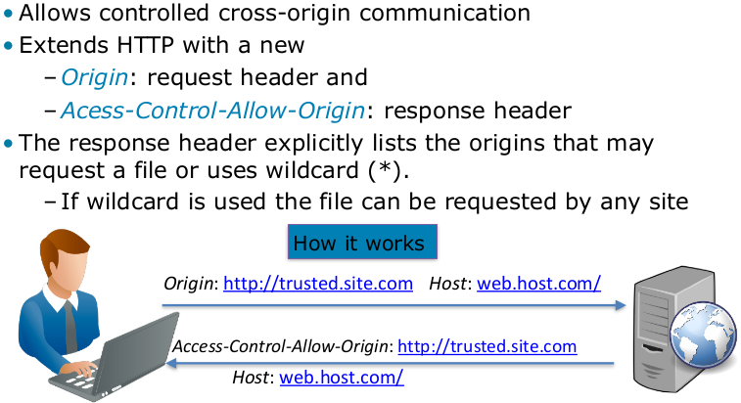
→ Your browser is now allowed to also access something from the “trusted.site.com”.
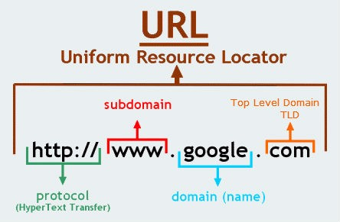
This way SOP allows it! This way your browser will do everyting as if it were the same domain

Origin header: where its coming from and Access-Control-Allow-Origin is also a header.
For security reasons, browsers restrict cross-origin HTTP requests initiated from within scripts. For example, XMLHttpRequest and the Fetch API follow the same-origin policy. This means that a web application using those APIs can only request HTTP resources from the same origin the application was loaded from, unless the response from the other origin includes the right CORS headers. (?)

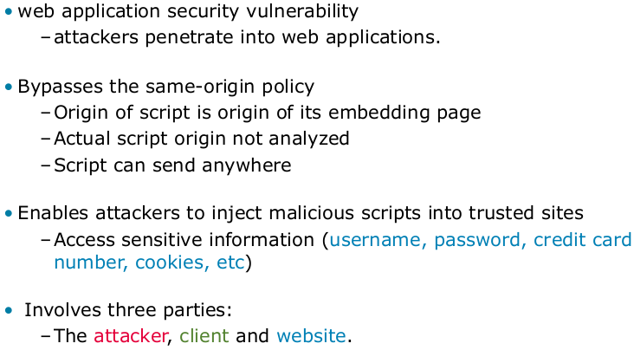
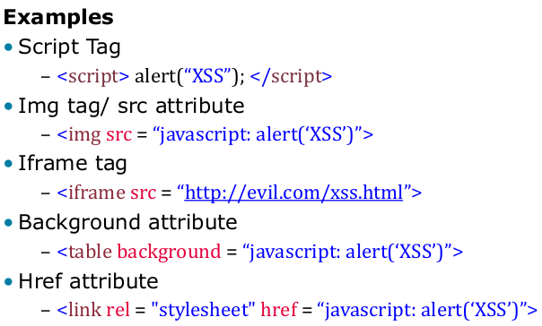

Injection attacks basically work by adding additional scripts somewhere into a web page. The art for the attacker is to find out how and where he can inject it



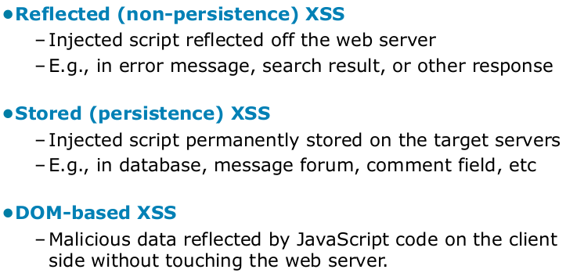
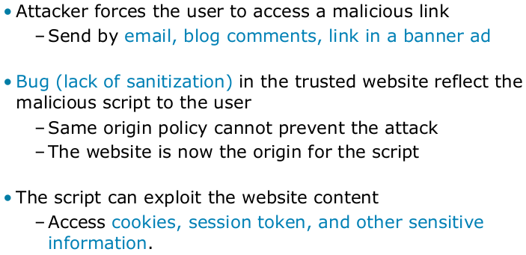

Cross Site Scripting is a vulnerability that allows an attacker to inject JavaScript code into a website, so that it originates from the attacked website from the browser point of view.
This can happen if user input is not sufficiently sanitised. For example a search function may display the string "Your search results for [userinput]". If [userinput] is not escaped an attacker may search for:
<script>alert(document.cookie)</script>
The browser has no way to detect that this code was not provided by the website owner, so it will execute it. Nowadays cross site scripting is a major issue, so there is work done to prevent this vulnerability. Most notable is the Content Security Policy approach.

- Sadece XSS yapılan internet sitesinin bilgileri çalınabilir. Böyle değil: 2 tab açık, banka ve shop.com. Shop.com xss vulnerabilitysi var. Ben linke tıkladım, shop.com’a request gönderildi. Shop.com’un serverında yeni bir HTML page generate ediliyor (mesela php ile, yada java). O xss scriptli olan HTML sayfası bana response olarak geri gönderiliyor. Ve shop.com’dan gelen bir script olduğu için bizim broswer (same origin’den geldiği için policy) kabul ediyor ve o scrip çalışınca shop.com ile alakalı her türlü bilgiye ulaşma imkanı oluyor. Ancak yan sekmedeki banka verilerine ulamaşamaz çünkü SOP, script bize shop.com’dan geldi.
With DOM-based XSS, the advantage is that any kind of filtering on the server side will be avoided, since it never goes to the server.
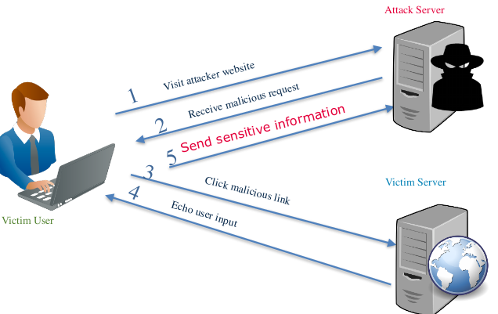

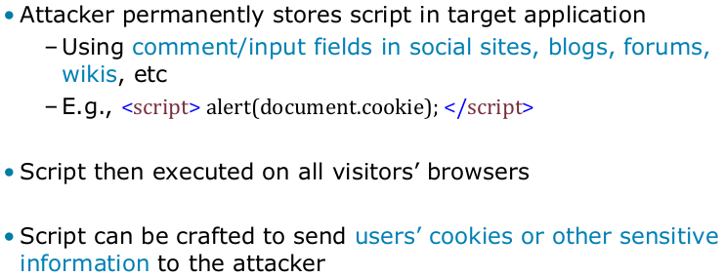

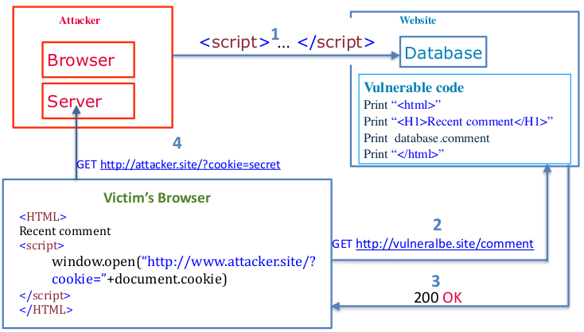
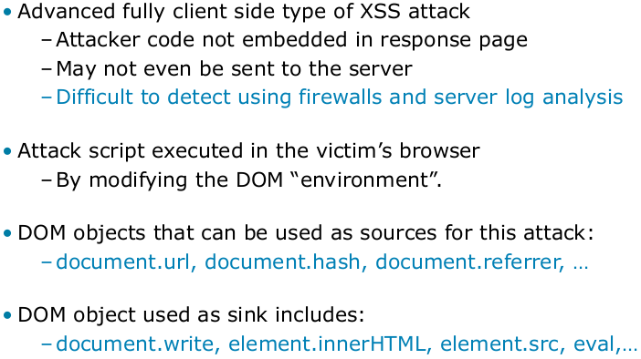

DOM Based XSS simply means a Cross-site scripting vulnerability that appears in the DOM (Document Object Model) instead of part of the HTML. In reflective and stored Cross-site scripting attacks you can see the vulnerability payload in the response page but in DOM based cross-site scripting, the HTML source code and response of the attack will be exactly the same, i.e. the payload cannot be found in the response. It can only be observed on runtime or by investigating the DOM of the page.
The Document Object Model is a convention for representing and working with objects in an HTML document (as well as in other document types). Basically all HTML documents have an associated DOM, consisting of objects representing the document properties from the point of view of the browser. Whenever a script is executed client-side, the browser provides the code with the DOM of the HTML page where the script runs, thus, offering access to various properties of the page and their values, populated by the browser from its perspective.
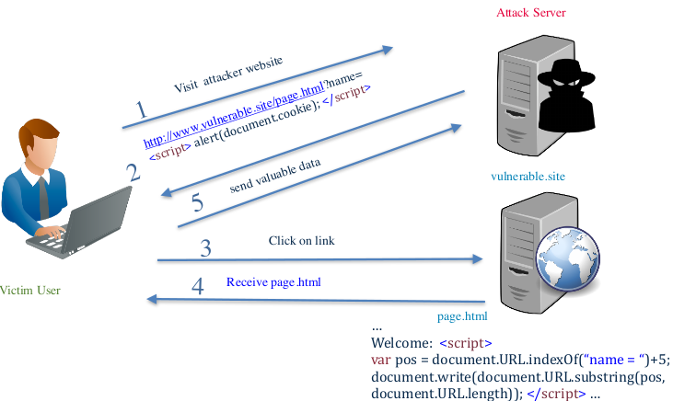
Server does not use the script, but your code on the client side uses the parameters after ? In a wrong way. E.g it looks for the “name” parameter and writes that name on the webpage. But if its not your name and its a script then it writes the script to the webpage.
In this example the server still sees the attack, even though they dont use it!
There are ways to encode a URL such that you don’t send certain parts of it for example. (instead of ? Using # gibi)
Or you can manipulate some other resources in the browser that will be used as input
→ There are many ways, some of them won’t be sent to the server.
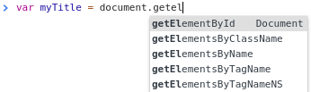
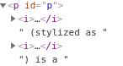
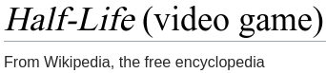
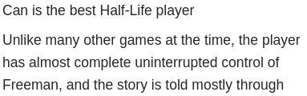

textContent changes just the text. innerHTML can also add different text as well as text.

What is the DOM?
The Document Object Model (DOM) is a programming interface for HTML and XML documents. It represents the page so that programs can change the document structure, style, and content. The DOM represents the document as nodes and objects. That way, programming languages can connect to the page.
A Web page is a document. This document can be either displayed in the browser window or as the HTML source. But it is the same document in both cases. The Document Object Model (DOM) represents that same document so it can be manipulated. The DOM is an object-oriented representation of the web page, which can be modified with a scripting language such as JavaScript.
DOM XSS is a type of cross site scripting attack which relies on inappropriate handling, in the HTML page, of the data from its associated DOM. Among the objects in the DOM, there are several which the attacker can manipulate in order to generate the XSS condition, and the most popular, from this perspective, are the document.url, document.location and document.referrer objects.
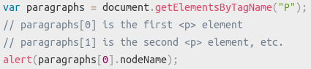
The W3C DOM and WHATWG DOM standards are implemented in most modern browsers. Many browsers extend the standard, so care must be exercised when using them on the web where documents may be accessed by various browsers with different DOMs.
For example, the standard DOM specifies that the getElementsByTagName method in the code below must return a list of all the <P> elements in the document:
All of the properties, methods, and events available for manipulating and creating web pages are organized into objects (e.g., the document object that represents the document itself, the table object that implements the special HTMLTableElement DOM interface for accessing HTML tables, and so forth). This documentation provides an object-by-object reference to the DOM implemented in Gecko-based browsers.
DOM and JavaScript
The short example above, like nearly all of the examples in this reference, is JavaScript. That is to say, it's written in JavaScript, but it uses the DOM to access the document and its elements. The DOM is not a programming language, but without it, the JavaScript language wouldn't have any model or notion of web pages, HTML documents, XML documents, and their component parts (e.g. elements). Every element in a document—the document as a whole, the head, tables within the document, table headers, text within the table cells—is part of the document object model for that document, so they can all be accessed and manipulated using the DOM and a scripting language like JavaScript.
In the beginning, JavaScript and the DOM were tightly intertwined, but eventually, they evolved into separate entities. The page content is stored in the DOM and may be accessed and manipulated via JavaScript, so that we may write this approximative equation: API (HTML or XML page) = DOM + JS (scripting language)
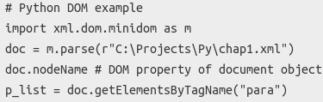
The DOM was designed to be independent of any particular programming language, making the structural representation of the document available from a single, consistent API. Though we focus exclusively on JavaScript in this reference documentation, implementations of the DOM can be built for any language, as this Python example demonstrates:
How Do I Access the DOM?
You don't have to do anything special to begin using the DOM. Different browsers have different implementations of the DOM, and these implementations exhibit varying degrees of conformance to the actual DOM standard (a subject we try to avoid in this documentation), but every web browser uses some document object model to make web pages accessible via JavaScript.
When you create a script–whether it's inline in a <script> element or included in the web page by means of a script loading instruction–you can immediately begin using the API for the document or window elements to manipulate the document itself or to get at the children of that document, which are the various elements in the web page. Your DOM programming may be something as simple as the following, which displays an alert message by using the alert() function from the window object, or it may use more sophisticated DOM methods to actually create new content, as in the longer example below.
This following JavaScript will display an alert when the document is loaded (and when the whole DOM is available for use):
Another example. This function creates a new H1 element, adds text to that element, and then adds the H1 to the tree for this document:
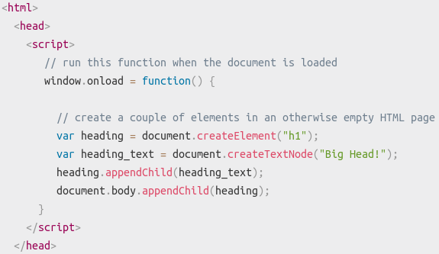

A Typical Example of a DOM XSS Attack
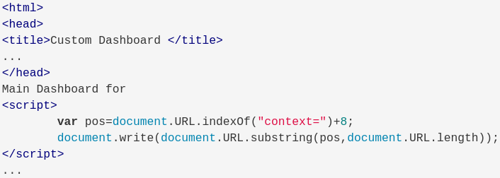
Let’s take the basic example of a page which provides users with customized content, depending on their user name which is encoded in the URL, and uses their name on the resulting page: In this case the HTML source of http://www.example.com/userdashboard.html would look like this:

The result of http://www.example.com/userdashboard.html?context=Mary would be a customized dashboard for Mary, containing the string “Main Dashboard for Mary” at the top. The malicious script can be embedded in the URL as follows

- Whereas traditional XSS takes advantage of vulnerable back-end CGI scripts to directly emit the code into served pages, DOM-based XSS takes advantage of vulnerable JavaScript scripts which execute directly in the user's browser. Writing user input directly into the document content without escaping.
Furthermore, the victim’s browser receives the above URL and sends a HTTP request to http://www.example.com, receiving the static HTML page described above. Then, the browser starts building the DOM of the page, and populates the document.url property, of the document object with the URL containing the malicious script.
When the browser arrives to the script which gets the user name from the URL, referencing the document.url property, it runs it and consequently updates the raw HTML body of the page, resulting in

Next, the browser finds the malicious code in the HTML body and executes it, thus finalizing the DOM XSS attack. In reality, the attacker would hide the contents of the payload in the URL using encoding so that it is not obvious that the URL contains a script.
Note however, that some browsers may encode the < and > characters in the URL, causing the attack to fail. However there are other scenarios which do not require the use of these characters, nor embedding the code into the URL directly, so these browsers are not entirely immune to this type of attack either.
Başka bir örnek
Mesela basit bir websiten var. item name ve price giriyosun. send’e basınca tabelada gözüküyor yazdıkların. Bunlar servera gitmiyor! Senin inputun JS ile alınıp DOM manipule ediliyor ve senin yazdığıın şeyler o şekilde ekranda gözüküyor. Sen oraya bir script tagi koyarsan, eğer HTML’in içindeki JS senin girdiğin şeyleri kontrol etmez ise (escaping/sanitize) o zaman onu olduğu gibi DOMa yazıyor. Document.write() dediği zaman HTML fileına yazıyor. Yani senin browserın o scripti excecute ediyor. Cookieler vs çalınabilir o sayede.
- Genel olarak bir HTML içindeki JS, DOMu user inputlar ile manipule ediyorsa (O html sayfasına dynamic olarak değiştiriyor ise) ve o user inputları kontrol etmiyorsa, DOM based XSS vulnerabilitysi olabilir.

How is DOM XSS different?
Using the above example, we can observe that:
- The HTML page is static, and there is no malicious script embedded into the page, as in the case of other types of XSS attacks; T
- he script code never gets to the server, if the “#” character is used; it is seen as fragment and the browser does not forward it further.
Hence server-side attack detection tools will fail to detect this attack; in some cases, depending on the type of the URL, the payload might get to the server and it may be impossible to hide it. Hence, the main characteristics of XSS, as reviewed in the introduction of this article, are not valid in the case of DOM XSS. Instead, DOM XSS exploits inappropriate manipulation of the associated DOM objects and properties in the client-side code.
Defending against DOM XSS attacks
Since the root of the problem still resides in the code of the page, this time the client-side code, the same sanitization and prevention techniques apply, but in this case the code review as well as the implementation of sanitization functionality needs to be performed on the client-side code.

- InnerHTML = … is vulnerable because tags can be written to the page as well as text. If innerText would be used it can prevent <script> elements written to the page.

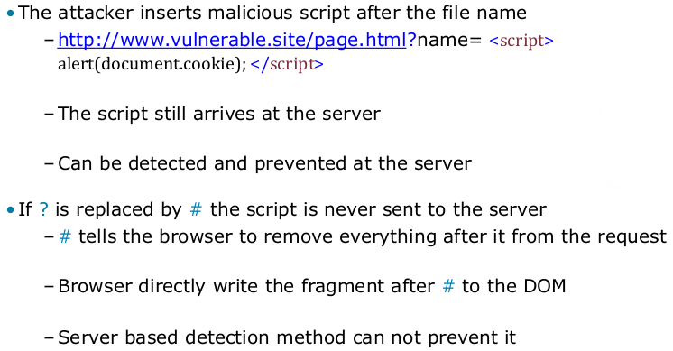

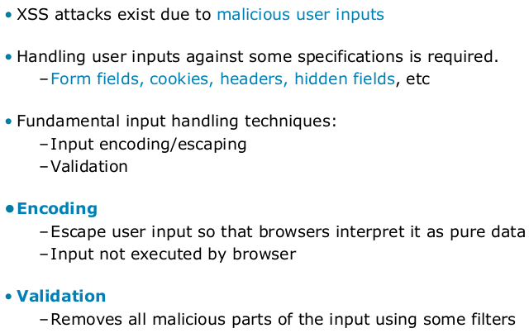


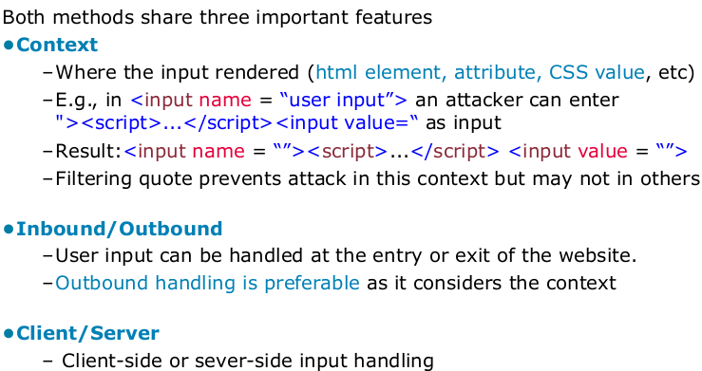
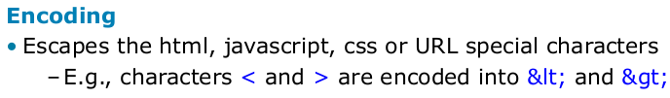

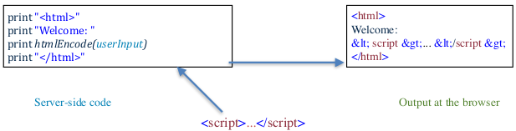

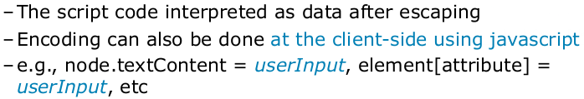

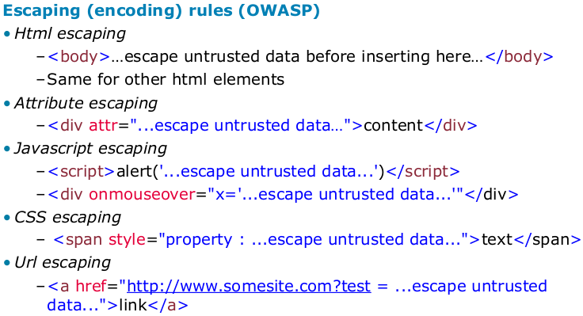
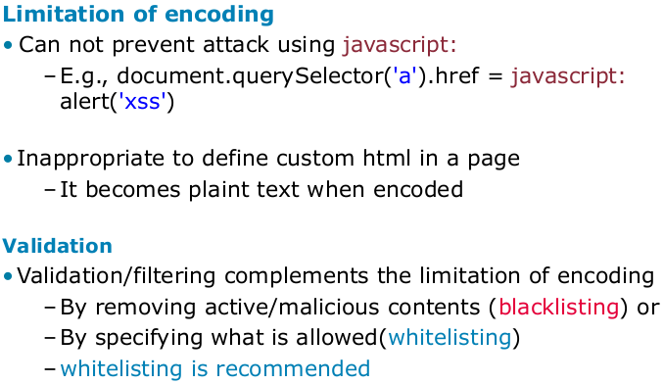
There are different ways to escape inputs, depending on where you will use it.

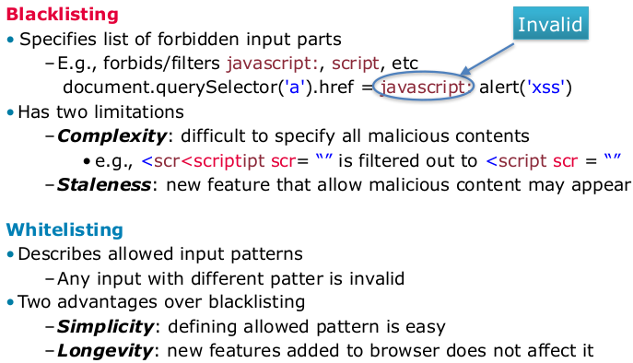
Limitation: When you url encode < > and html tags then you cannot include custom HTML tags in this case, like forums / mySpace. Adding images to your custom website e.g.

Usually white listing is better.

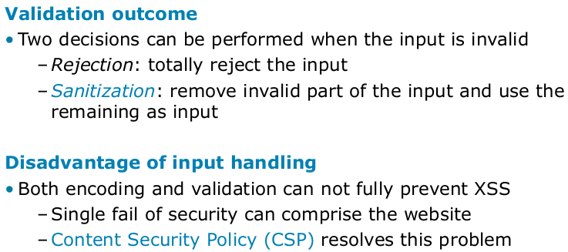
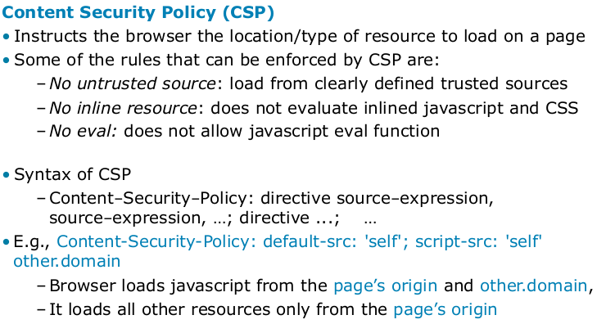

Sanitization is difficult to get right, rejection is easier

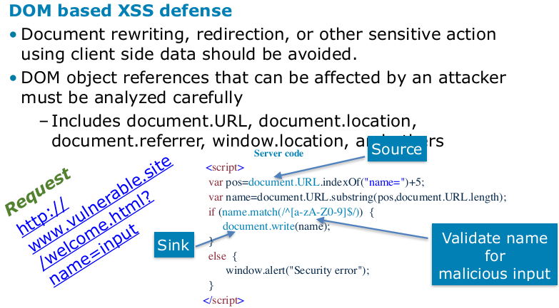
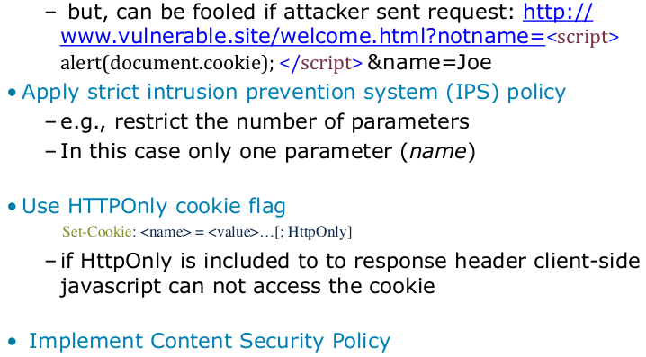
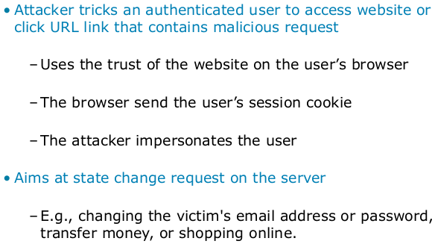
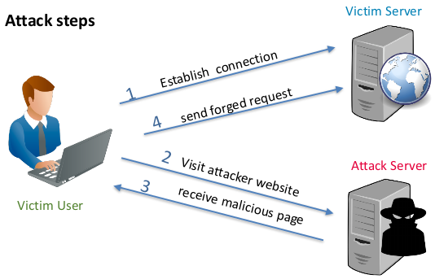


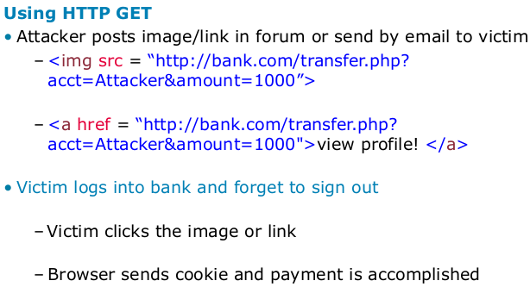
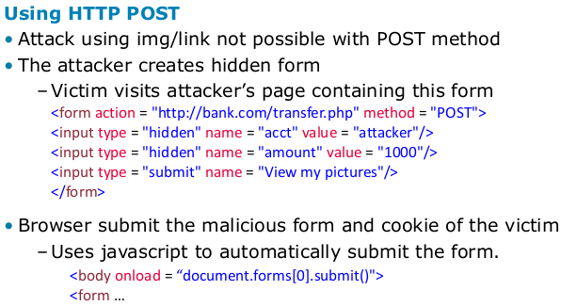

Basically tricks a user who is already authenticated (to some website) into doing some actions on that website that will benefit the attacker in a way. Generally there will be a malicious link that the user clicks.
When you are authenticated/logged in etc, then your browser will store a cookie (token?) of that website, helping you automatically authenticate so you don’t have to enter your password every time in a new page. Your requests each will contain that session cookie, it will be sent to the server so the server knows its still you. (Those cookies have different expiration dates: Facebook’s is forever, Sparkasse is 12 mins and so on.)
→ This means anybody that can send a Request including your session cookie, can do the exact same things as you do. You have to be logged in meaning the session cookie that you were using needs to be still valid(not expired) in order for it to work. The attacker does not steal your cookie, does not see the cookie at all.
The attacker just assumes/hopes that you are currently logged in to facebook/bank/etc. and when you click the malicious link your browser sends your cookie directly to fb/bank and does that action that the attacker wants. (changing email address to the attackers, transfering money to the attacker, deleting you account etc)
Different ways of doing it:
- Using GET: an image or link contains a get request to the site which you are assumed to logged in.
- Using POST: You need to visit attackers website. The Html document will contain a pre-filled invisible form and when the page is loaded, your browser will automatically send that form without you even knowing about it.

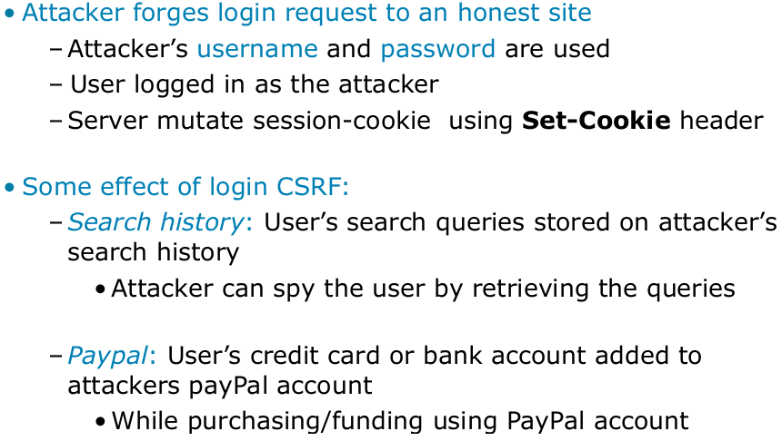
Login CSRF example: attacker can prepare a form on his website, fill it with his own google id and password, set the method to post, action to google.com.login and when you load that page, you will log yourself to the attackers account. From now on the attackers can see every action you are doing on google services.

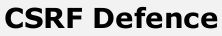
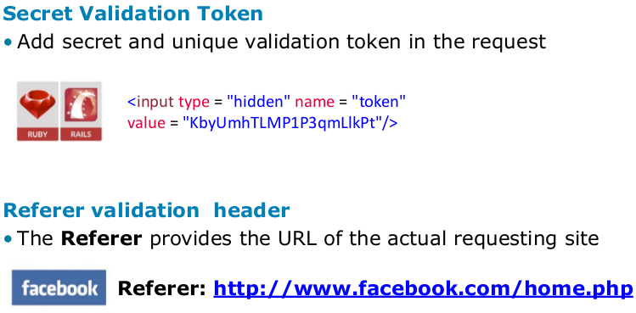
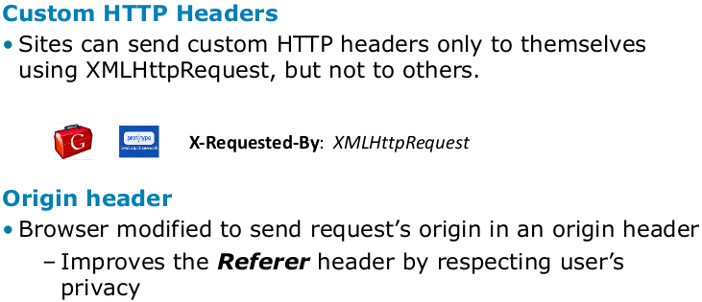

A lot of frameworks use Secret Validation Token. Whenever you try to start a request, the server sends you a page with a secret token. In order to make that request you have to copy that data and send it back to the server, meaning you need to send back the same token that they provided. (Can be bypassed)
Referer validation: Where this request is actually coming from? The browser adds that information as an additional header when making a request to somewere. (not a good solution)
Custom headers: You can have your own HTTP headers. You can only send some custom headers only to your own website. This way you can make sure that the request is coming from your own page and not by another page.
Origin header:

Cross-Site Scripting is not necessary for CSRF to work. However, any cross-site scripting vulnerability can be used to defeat token, Double-Submit cookie, referer and origin based CSRF defenses. This is because an XSS payload can simply read any page on the site using a XMLHttpRequest and obtain the generated token from the response, and include that token with a forged request. This technique is exactly how the MySpace (Samy) worm defeated MySpace's anti-CSRF defenses in 2005, which enabled the worm to propagate. XSS cannot defeat challenge-response defenses such as Captcha, re-authentication or one-time passwords. It is imperative that no XSS vulnerabilities are present to ensure that CSRF defenses can't be circumvented. Please see the OWASP XSS Prevention Cheat Sheet for detailed guidance on how to prevent XSS flaws.

What is a "Cookie"?
A cookie is a small piece of text stored on a user's computer by their browser. Common uses for cookies are authentication, storing of site preferences, shopping cart items, and server session identification.
Each time the users' web browser interacts with a web server it will pass the cookie information to the web server. Only the cookies stored by the browser that relate to the domain in the requested URL will be sent to the server. This means that cookies that relate to www.example.com will not be sent to www.exampledomain.com.
In essence, a cookie is a great way of linking one page to the next for a user's interaction with a web site or web application.
What is a "Session"?
A session can be defined as a server-side storage of information that is desired to persist throughout the user's interaction with the web site or web application.
Instead of storing large and constantly changing information via cookies in the user's browser, only a unique identifier is stored on the client side (called a "session id"). This session id is passed to the web server every time the browser makes an HTTP request (ie a page link or AJAX request). The web application pairs this session id with it's internal database and retrieves the stored variables for use by the requested page.
Users can disable cookies in some browsers, if this is the case then another way needs to be implemented.


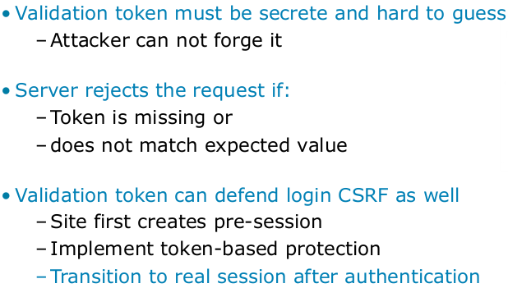
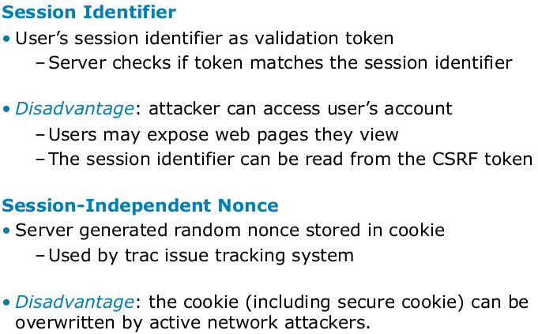
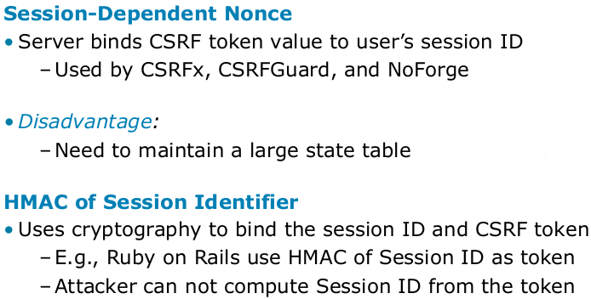

If you set your tokens from 1 to a billion, when you see 2 request after eachother then you can probably guess what the next number will be.
Nonce: just a random number


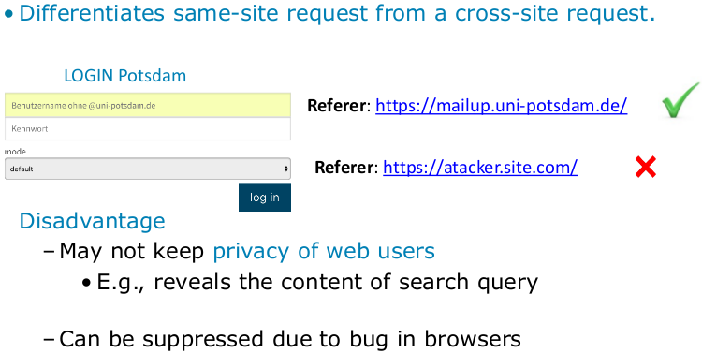
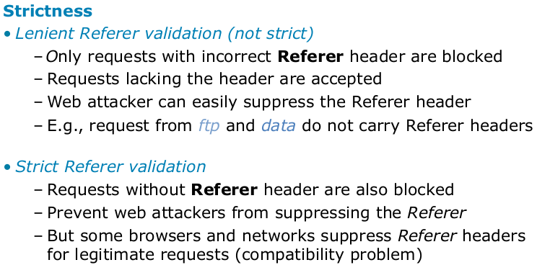


Some browsers may not send the referer and users could also disable it due to privacy violation issues(?)
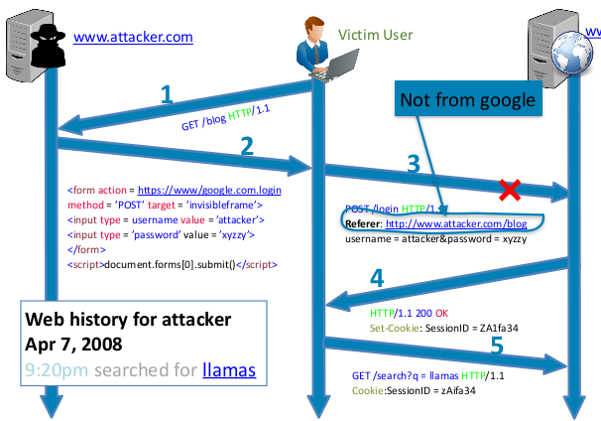


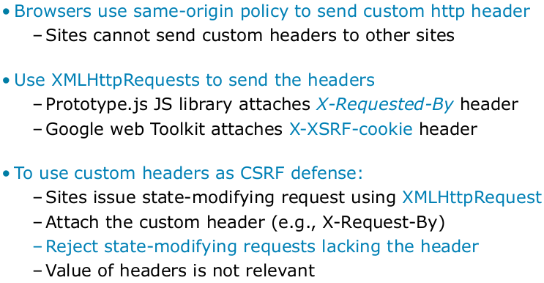
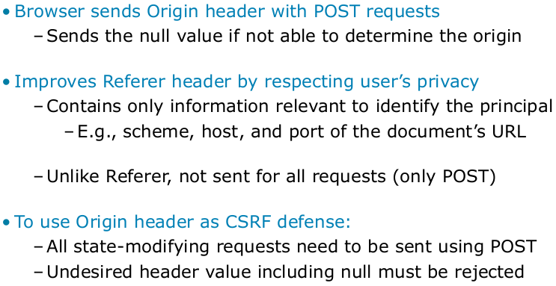
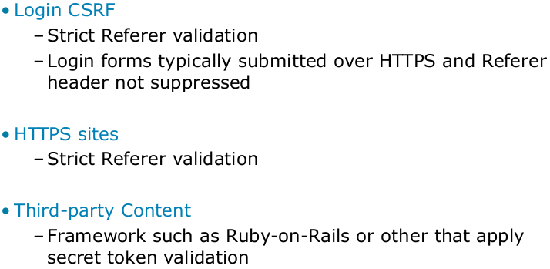

→ Origin: Only needs the scheme: https.google.com. Only POST
→ Referer: Needs the whole Url with all there parameters.
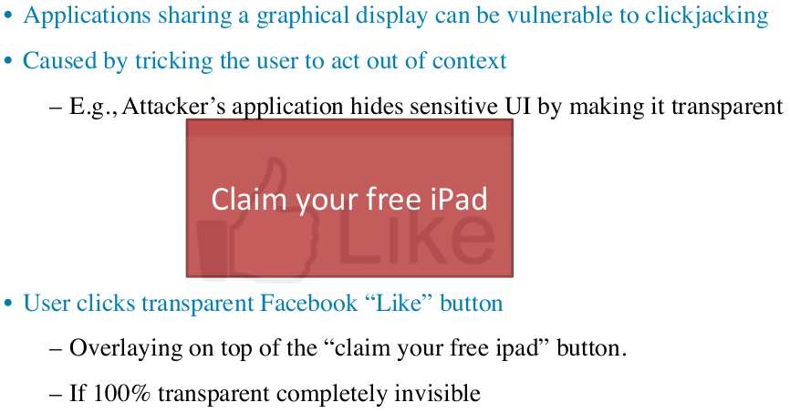
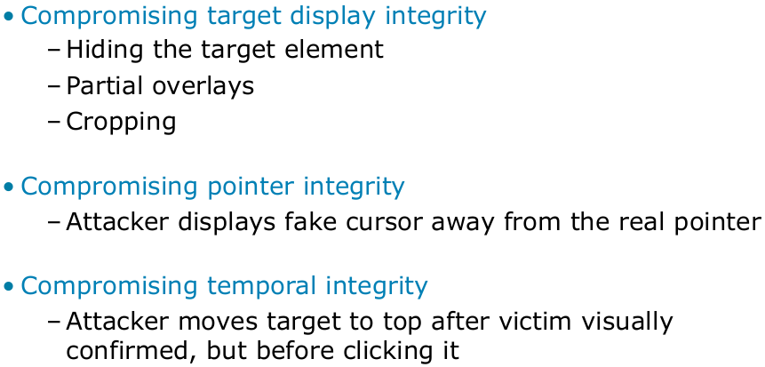


Browser checks whats the top most element at the clicked point. If there is the hidden like button on the very top but invisible, then the user clicked that like button. Someone it is impossible to make it invisible, then people make it oppeague almost invisible.

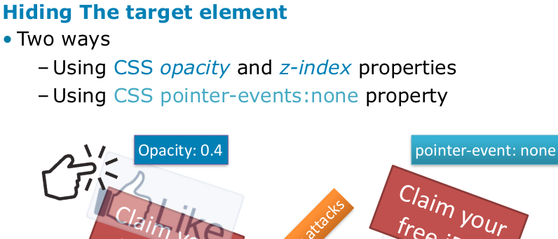
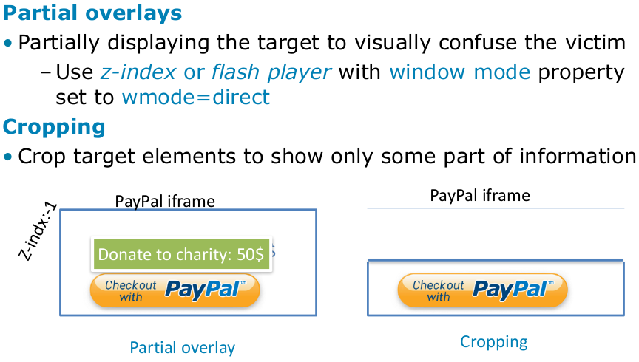

X, y and z is the 3 dimention: meaning what is on top.
Changing opacity: make it almost invisible.
Change css Z-index: make it on top.
Pointer-event:none: when clicked dont take this element but take one below it.

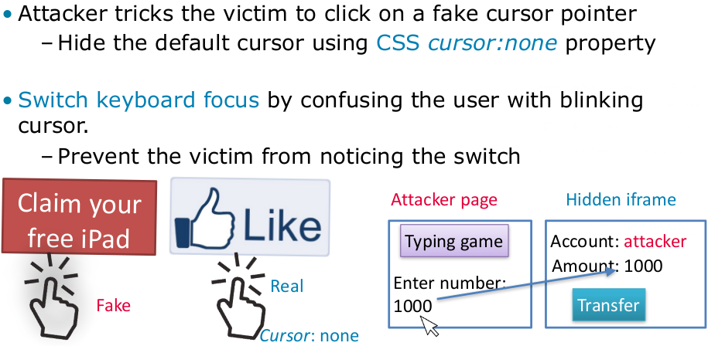
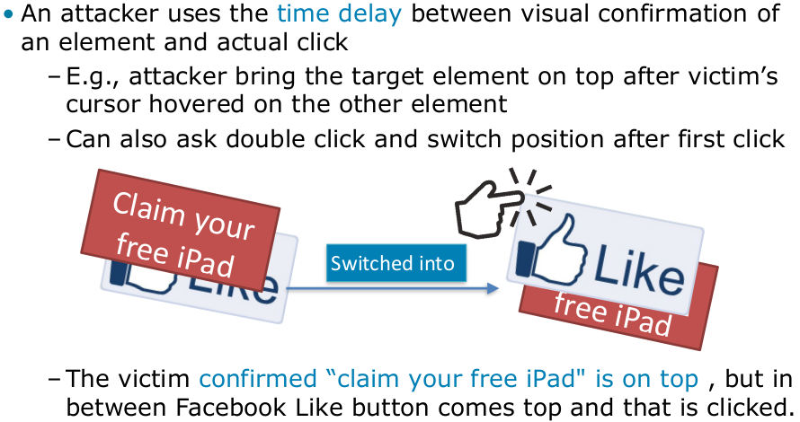

Paitnt a fake cursor so person thinks he clicks smth but in reality clicks smth else
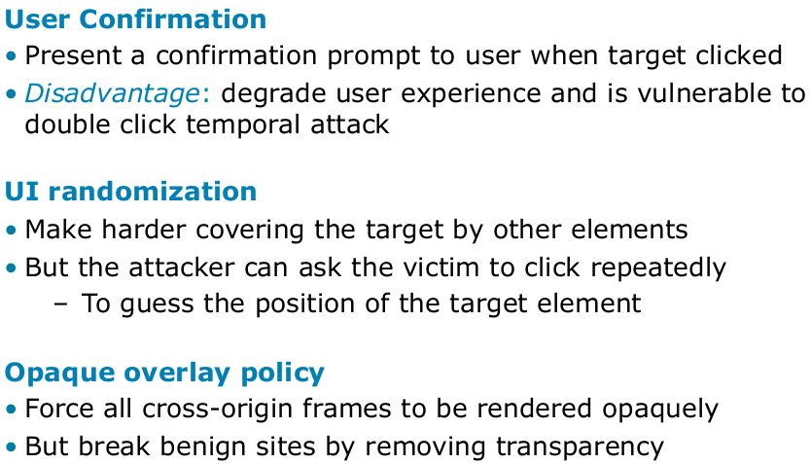
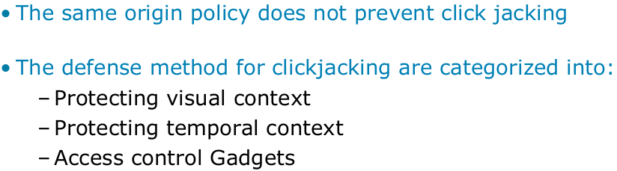

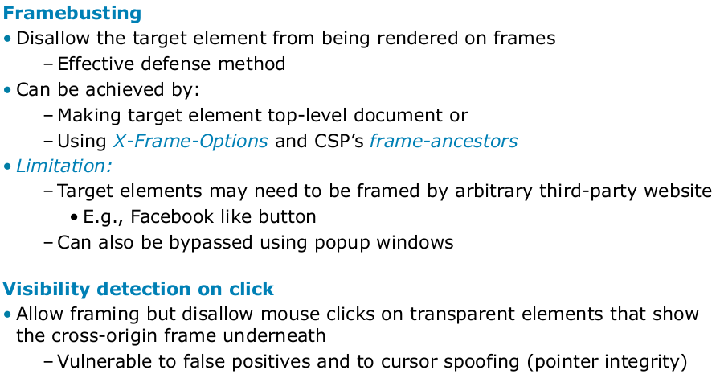
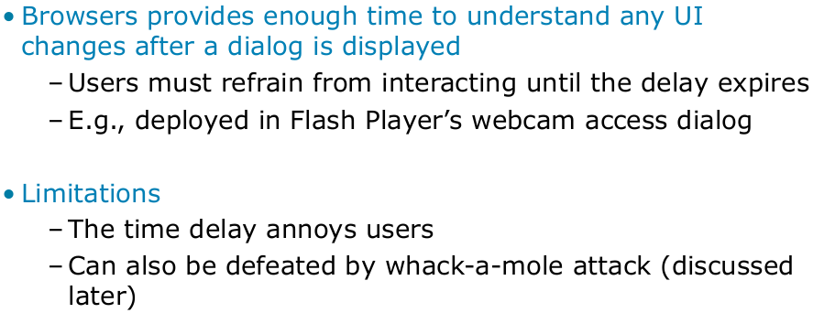



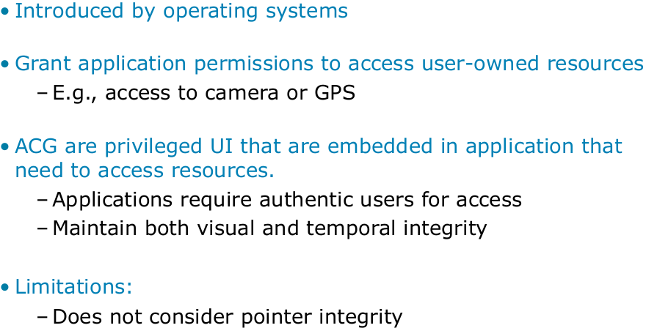

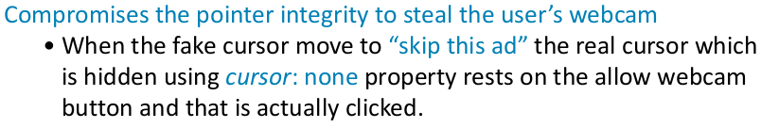
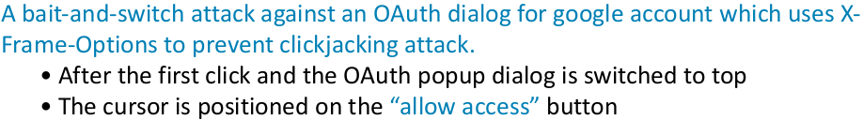

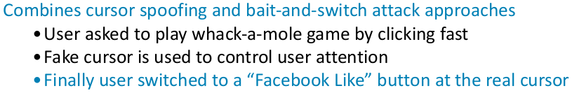
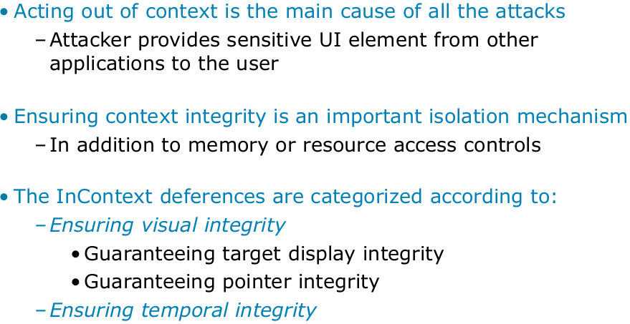
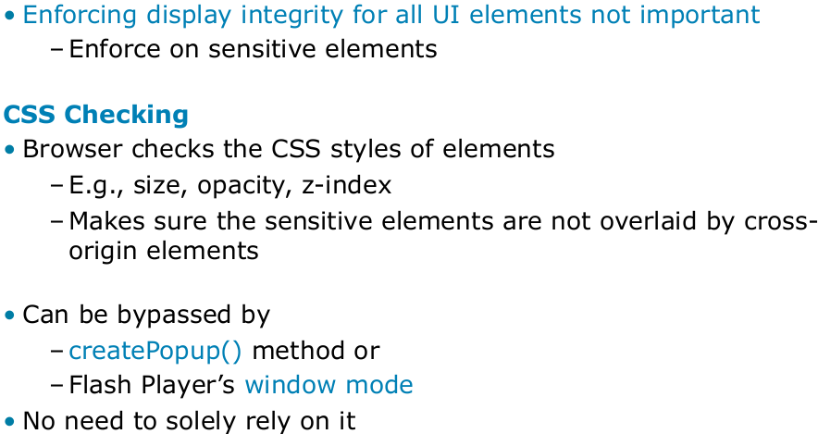
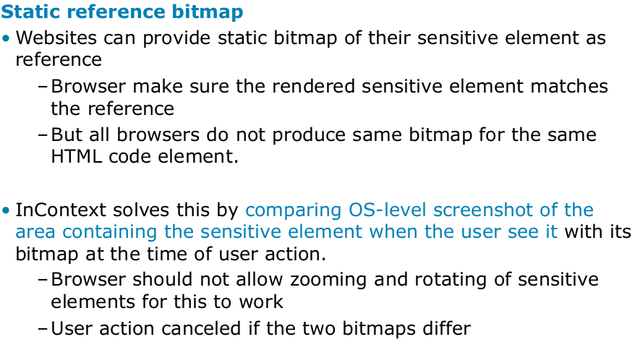

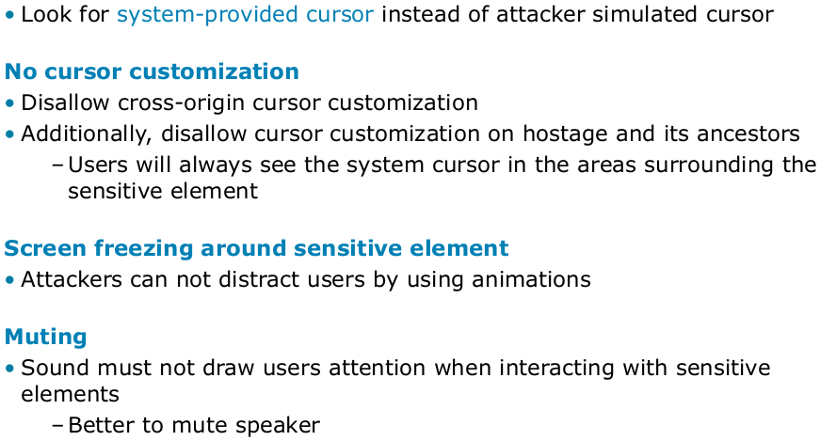
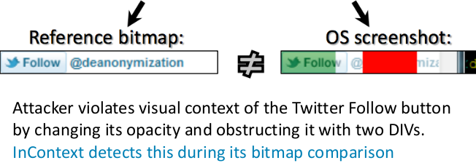
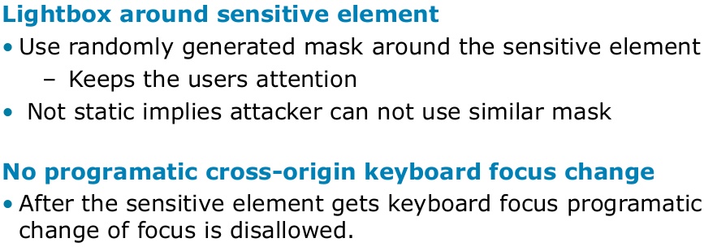

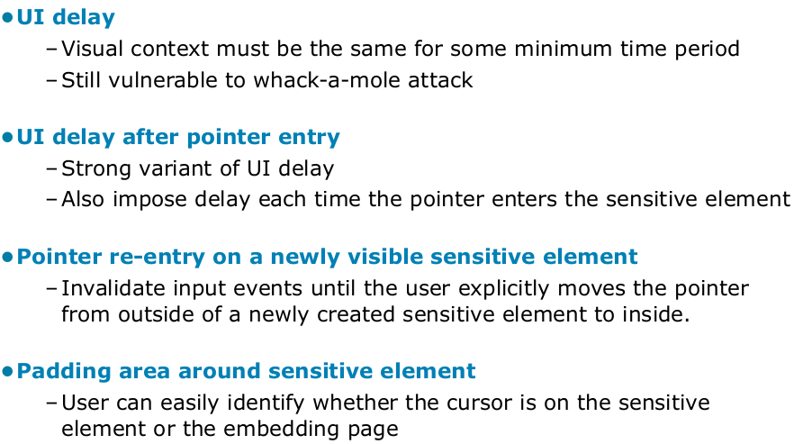
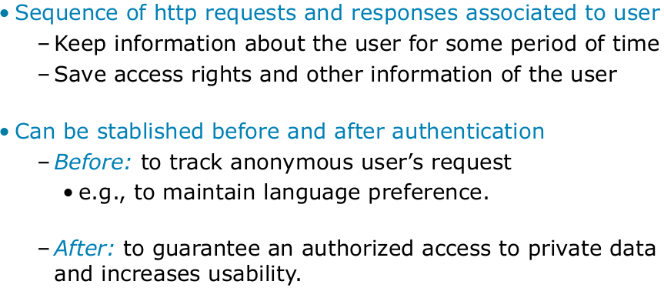

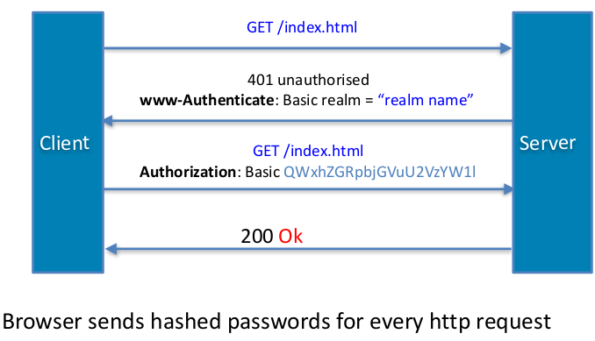

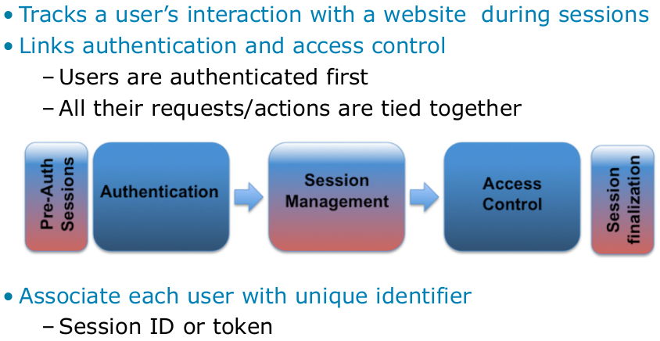

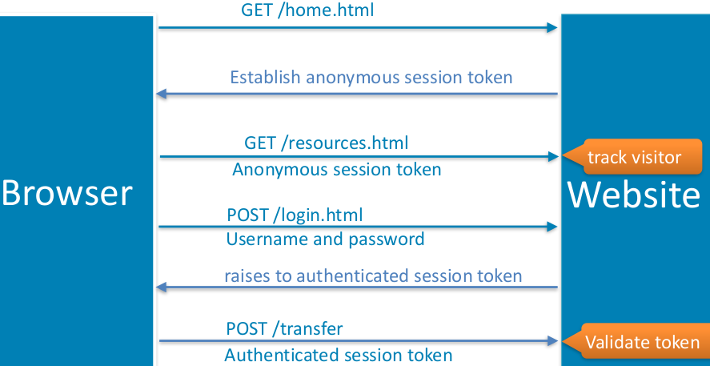
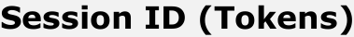

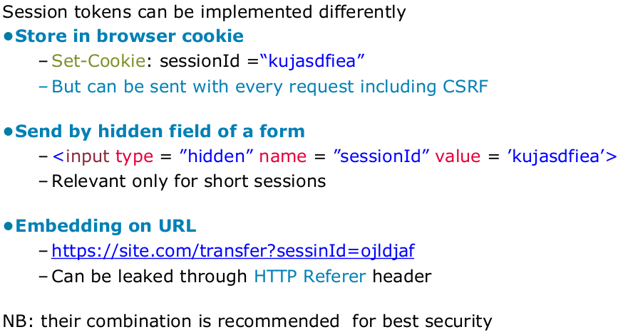

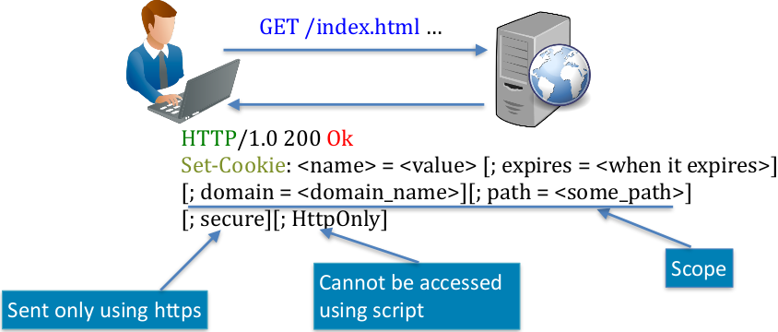

When you visit another website from google, lets say while you logged in in google, then the session id might be included in the referer header that is sent to the website.


