Android Development

Requirements:
- JDK
- Android SDK (JDK might be bundled with it)
- Android Studio IDE (or an other IDE)

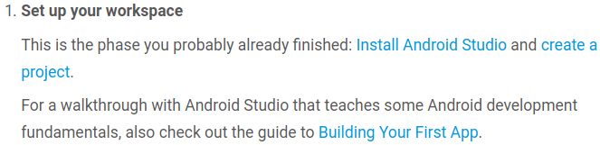
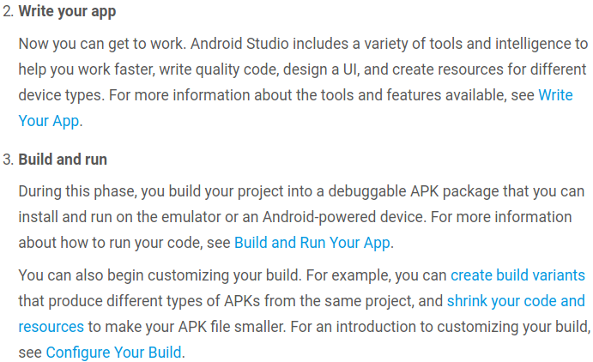
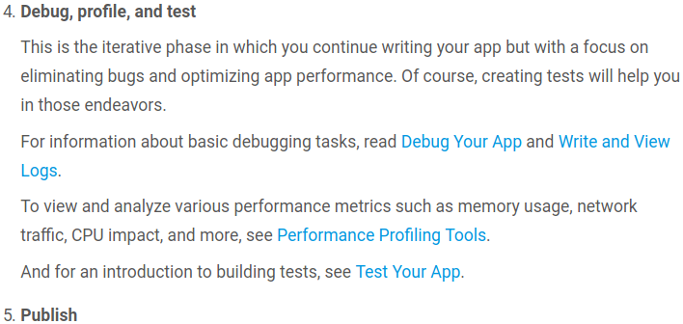
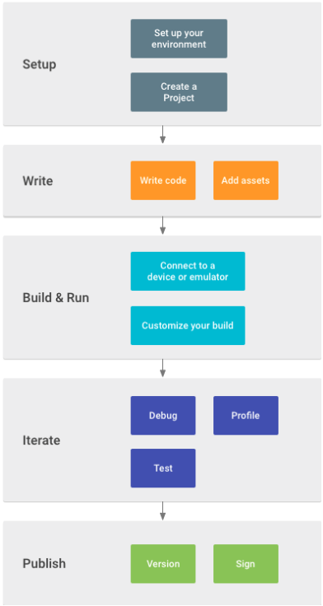

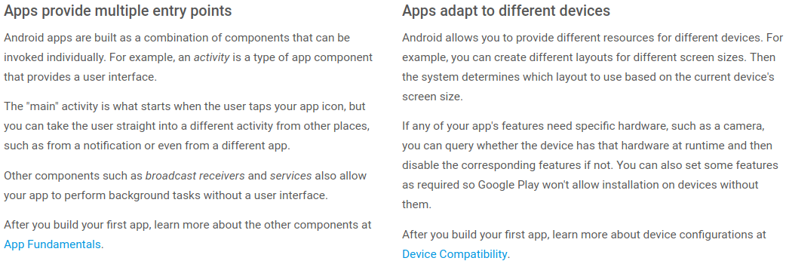

Create a new Project called ‘myFirstApp’, keep all the default values (Empty Activity). First, be sure the Project window is open (select View > Tool Windows > Project) and the Android view is selected from the drop-down list at the top of that window. You can then see the following files:

- This is the main activity (the entry point for your app). When you build and run the app, the system launches an instance of this Activity and loads its layout.

- This XML file defines the layout for the activity's UI. It contains a TextView element with the text "Hello world!".
- The manifest file describes the fundamental characteristics of the app and defines each of its components.
- You'll see two files with this name: one for the project and one for the "app" module. Each module has its own build.gradle file, but this project currently has just one module. You'll mostly work with the module's build.gradle file to configure how the Gradle tools compile and build your app. For more information about this file, see Configure Your Build.


- Connect your device to your development machine with a USB cable. If you're developing on Windows, you might need to install the appropriate USB driver for your device.
- Enable USB debugging in the Developer options as follows. First, you must enable the developer options (in the Phone):
- Open the Settings app > (Only on Android 8.0 or higher) Select System > Scroll to the bottom and select About phone > Scroll to the bottom and tap Build number 7 times > Return to the previous screen to find Developer options near the bottom > Open Developer options, and then scroll down to find and enable USB debugging.
Run the app on your device as follows:
- In Android Studio, click the app module in the Project window and then select Run > Run (or click Run in the toolbar).
- In the Select Deployment Target window, select your device, and click OK.
Android Studio installs the app on your connected device and starts it. You should now see "Hello World!" displayed in the app running on your device.
Run > Create New Virtual Device > Select a Hardware (Phone) > Select API version > OK

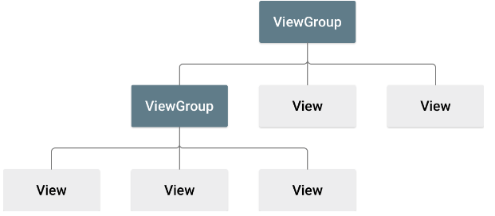
In this lesson, you'll use the Android Studio Layout Editor to create a layout that includes a text box and a button. In the next lesson, you'll make the app respond to the button tap by sending the content of the text box to another activity.
The user interface for an Android app is built using a hierarchy of layouts (ViewGroup objects) and widgets (View objects). Layouts are invisible containers that control how its child views are positioned on the screen. Widgets are UI components such as buttons and text boxes.
Android provides an XML vocabulary for ViewGroup and View classes, so most of your UI is defined in XML files. However, instead of teaching you to write some XML, this lesson shows you how to create a layout using Android Studio's Layout Editor, which makes it easy to build a layout by drag-and-dropping views.
The Component Tree window on the bottom-left side shows the layout's hierarchy of views. In this case, the root view is a ConstraintLayout, containing just one TextView object.
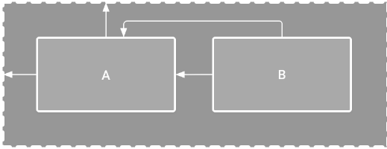
ConstraintLayout is a layout that defines the position for each view based on constraints to sibling views and the parent layout. In this way, you can create both simple and complex layouts with a flat view hierarchy. That is, it avoids the need for nested layouts (a layout inside a layout, as shown in figure 2), which can increase the time required to draw the UI.
For example, you can declare the following layout: View A appears 16dp from the top of the parent layout. View A appears 16dp from the left of the parent layout. View B appears 16dp to the right of view A. View B is aligned to the top of view A.
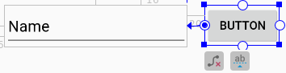
You can create a horizontal alignment using the top or bottom edges, but the button includes padding around its image, so the visual alignment is wrong if you align these views that way.
To constrain the views in a horizontal alignment, you need to create a constraint between the text baselines. So click the button, and then click Edit Baseline , which appears in the design editor directly below the selected view. The baseline anchor appears inside the button. Click-and-hold on this anchor and then drag it to the baseline anchor that appears in the text box.


To preview the UI, click Select Design Surface in the toolbar and select Design. Notice that the text input is pre-filled with "Name" and the button is labeled "Button." So now you'll change these strings.
- Open the Project window and then open app > res > values > strings.xml. This is a string resources file where you should specify all your UI strings. Doing so allows you to manage all UI strings in a single location, which makes it easier to find, update, and localize (compared to hard-coding strings in your layout or app code).
- Click Open editor at the top (right) of the editor window. This opens the Translations Editor, which provides a simple interface for adding and editing your default strings, and helps keep all your translated strings organized.
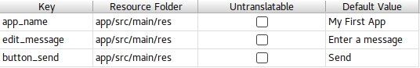
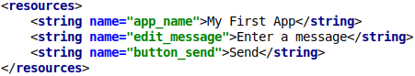
If we hard-code our sting in our code we will get this error
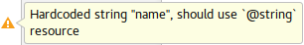
We can set the String names in 2 different ways. Select a view, if the Attributes window isn't already visible on the right, click Attributes on the right sidebar. Locate the text property. Now we can write either directly the path of our desired string like this: @string/button_send
Or we can click and then selecting the wanted string there. It will show all the default strings and also strings that we defined.
- The hint property is used to show some string when a view is empty. Like “Enter a Message”
To create a layout that's responsive to different screen sizes, you'll now make the text box stretch to fill all remaining horizontal space (after accounting for the button and margins).
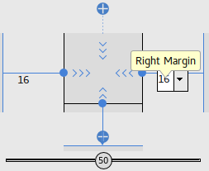
- Select both views (click one, hold Shift, and click the other), and then right-click either view and select Chain > Create Horizontal Chain. A chain is a bidirectional constraint between two or more views that allows you to lay out the chained views in unison.
- Select the button and open the Attributes window. Using the view inspector at the top of the Attributes window, set the right margin to 16.
- Now click the text box to view its attributes. Click the width indicator (>>> <<<) twice so that it is set to Match Constraints.
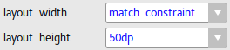
This can be also changed by the attributes tab (shown right)
"Match constraints" means that the width expands to meet the definition of the horizontal constraints and margins. Therefore, the text box stretches to fill the horizontal space (after accounting for the button and all margins).
The other options are: wrap_content or giving it a fix dp value (for example 200dp).
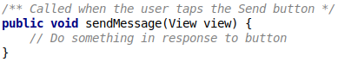
We will add a method to our MainActivity class which will be called when user taps the send button.
After we created our method we have to go to the activity_main.xml file to call this method from the button: Click to select the button in the Layout Editor. In the Attributes window, locate the onClick property and select sendMessage [MainActivity] from the drop-down list (or type it yourself).
Now when the button is tapped, the system calls the sendMessage() method. Take note of the details in this method that are required in order for the system to recognize it as compatible with the android:onClick attribute. Specifically, the method has the following characteristics:
- Public access
- A void or, in Kotlin, an implicit unit return value
- A View as the only parameter (it is the View object that was clicked)

An Intent is an object that provides runtime binding between separate components, such as two activities. The Intent represents an app’s "intent to do something." You can use intents for a wide variety of tasks, but in this lesson, your intent starts another activity. In MainActivity, add the EXTRA_MESSAGE constant and the sendMessage() code, as shown here
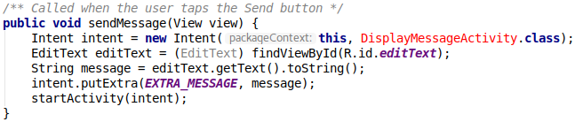
Here's what's going on in sendMessage():
The Intent constructor takes two parameters:
- A Context as its first parameter (this is used because the Activity class is a subclass of Context)
- The Class of the app component to which the system should deliver the Intent (in this case, the activity that should be started).
The putExtra() method adds the EditText's value to the intent. An Intent can carry data types as key-value pairs called extras. Your key is a public constant EXTRA_MESSAGE because the next activity uses the key to retrieve the text value. It's a good practice to define keys for intent extras using your app's package name as a prefix. This ensures the keys are unique, in case your app interacts with other apps.
The startActivity() method starts an instance of the DisplayMessageActivity specified by the Intent.

In the Project window, right-click the app folder and select New > Activity > Empty Activity. Click OK after selected a name etc.
Android Studio automatically does three things:
- Creates the DisplayMessageActivity file.
- Creates the corresponding activity_display_message.xml layout file.
- Adds the required <activity> element in AndroidManifest.xml.
If you run the app and tap the button on the first activity, the second activity starts but is empty. This is because the second activity uses the empty layout provided by the template.
Now we will add a TextView to our second activity’s layout (XML file). It’s ID will be “TextView”.
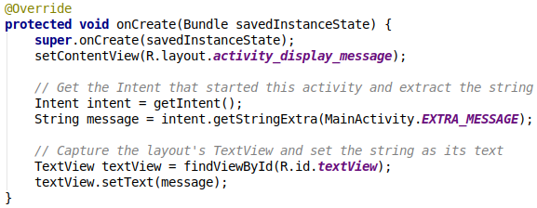
Now you will modify the second activity to display the message that was passed by the first activity. In DisplayMessageActivity, add the following code to the onCreate() method:

Each screen in your app that is not the main entry point (all screens that are not the "home" screen) should provide navigation so the user can return to the logical parent screen in the app hierarchy by tapping the Up button in the app bar.
All you need to do is declare which activity is the logical parent in the AndroidManifest.xml file. So open the file at app > manifests > AndroidManifest.xml, locate the <activity> tag for DisplayMessageActivity and replace it with the following:
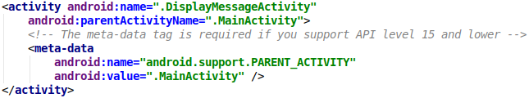

Adding only android:parentActivityName=”.MainActivity” as an attribute is enough if we wont support API level 15 or lower
Android apps can be written using Kotlin, Java, and C++ languages. The Android SDK tools compile your code along with any data and resource files into an APK, an Android package, which is an archive file with an .apk suffix. One APK file contains all the contents of an Android app and is the file that Android-powered devices use to install the app.
Each Android app lives in its own security sandbox, protected by the following Android security features:
- The Android operating system is a multi-user Linux system in which each app is a different user.
- By default, the system assigns each app a unique Linux user ID (the ID is used only by the system and is unknown to the app). The system sets permissions for all the files in an app so that only the user ID assigned to that app can access them.
- Each process has its own virtual machine (VM), so an app's code runs in isolation from other apps.
- By default, every app runs in its own Linux process. The Android system starts the process when any of the app's components need to be executed, and then shuts down the process when it's no longer needed or when the system must recover memory for other apps.
The Android system implements the principle of least privilege. That is, each app, by default, has access only to the components that it requires to do its work and no more. This creates a very secure environment in which an app cannot access parts of the system for which it is not given permission. However, there are ways for an app to share data with other apps and for an app to access system services:
- It's possible to arrange for two apps to share the same Linux user ID, in which case they are able to access each other's files. To conserve system resources, apps with the same user ID can also arrange to run in the same Linux process and share the same VM. The apps must also be signed with the same certificate.
- An app can request permission to access device data such as the user's contacts, SMS messages, the mountable storage (SD card), camera, and Bluetooth. The user has to explicitly grant these permissions. For more information, see Working with System Permissions.


App components are the essential building blocks of an Android app. Each component is an entry point through which the system or a user can enter your app. Some components depend on others.
There are four different types of app components:
- Activities.
- Services.
- Broadcast receivers.
- Content providers.
Each type serves a distinct purpose and has a distinct lifecycle that defines how the component is created and destroyed. The following sections describe the four types of app components.

An activity is the entry point for interacting with the user. It represents a single screen with a user interface. For example, an email app might have one activity that shows a list of new emails, another activity to compose an email, and another activity for reading emails. Although the activities work together to form a cohesive user experience in the email app, each one is independent of the others. As such, a different app can start any one of these activities if the email app allows it. For example, a camera app can start the activity in the email app that composes new mail to allow the user to share a picture.
An activity facilitates (making it easier) the following key interactions between system and app:
- Keeping track of what the user currently cares about (what is on screen) to ensure that the system keeps running the process that is hosting the activity.
- Knowing that previously used processes contain things the user may return to (stopped activities), and thus more highly prioritize keeping those processes around.
- Helping the app handle having its process killed so the user can return to activities with their previous state restored.
- Providing a way for apps to implement user flows between each other, and for the system to coordinate these flows. (The most classic example here being share.)
You implement an activity as a subclass of the Activity class. For more information about the Activity class, see the Activities developer guide.
A service is a general-purpose entry point for keeping an app running in the background for all kinds of reasons. It is a component that runs in the background to perform long-running operations or to perform work for remote processes. A service does not provide a user interface. For example, a service might play music in the background while the user is in a different app, or it might fetch data over the network without blocking user interaction with an activity. Another component, such as an activity, can start the service and let it run or bind to it in order to interact with it. There are actually two very distinct semantics services tell the system about how to manage an app: Started services tell the system to keep them running until their work is completed. This could be to sync some data in the background or play music even after the user leaves the app. Syncing data in the background or playing music also represent two different types of started services that modify how the system handles them:
- Music playback is something the user is directly aware of, so the app tells the system this by saying it wants to be foreground with a notification to tell the user about it; in this case the system knows that it should try really hard to keep that service's process running, because the user will be unhappy if it goes away.
- A regular background service is not something the user is directly aware as running, so the system has more freedom in managing its process. It may allow it to be killed (and then restarting the service sometime later) if it needs RAM for things that are of more immediate concern to the user.
Bound services run because some other app (or the system) has said that it wants to make use of the service. This is basically the service providing an API to another process. The system thus knows there is a dependency between these processes, so if process A is bound to a service in process B, it knows that it needs to keep process B (and its service) running for A. Further, if process A is something the user cares about, then it also knows to treat process B as something the user also cares about. Because of their flexibility (for better or worse), services have turned out to be a really useful building block for all kinds of higher-level system concepts. Live wallpapers, notification listeners, screen savers, input methods, accessibility services, and many other core system features are all built as services that applications implement and the system binds to when they should be running.
A service is implemented as a subclass of Service. For more information about the Service class, see the Services developer guide.
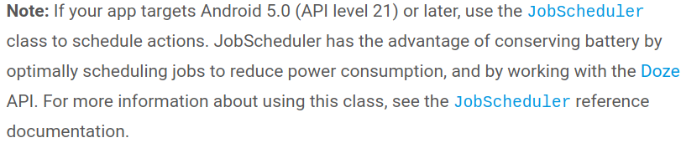
A broadcast receiver is a component that enables the system to deliver events to the app outside of a regular user flow, allowing the app to respond to system-wide broadcast announcements. Because broadcast receivers are another well-defined entry into the app, the system can deliver broadcasts even to apps that aren't currently running. So, for example, an app can schedule an alarm to post a notification to tell the user about an upcoming event... and by delivering that alarm to a BroadcastReceiver of the app, there is no need for the app to remain running until the alarm goes off. Many broadcasts originate from the system—for example, a broadcast announcing that the screen has turned off, the battery is low, or a picture was captured. Apps can also initiate broadcasts—for example, to let other apps know that some data has been downloaded to the device and is available for them to use. Although broadcast receivers don't display a user interface, they may create a status bar notification to alert the user when a broadcast event occurs. More commonly, though, a broadcast receiver is just a gateway to other components and is intended to do a very minimal amount of work. For instance, it might schedule a JobService to perform some work based on the event with JobScheduler
A broadcast receiver is implemented as a subclass of BroadcastReceiver and each broadcast is delivered as an Intent object. For more information, see the BroadcastReceiver class.
A content provider manages a shared set of app data that you can store in the file system, in a SQLite database, on the web, or on any other persistent storage location that your app can access. Through the content provider, other apps can query or modify the data if the content provider allows it. For example, the Android system provides a content provider that manages the user's contact information. As such, any app with the proper permissions can query the content provider, such as ContactsContract.Data, to read and write information about a particular person. It is tempting to think of a content provider as an abstraction on a database, because there is a lot of API and support built in to them for that common case. However, they have a different core purpose from a system-design perspective. To the system, a content provider is an entry point into an app for publishing named data items, identified by a URI scheme. Thus an app can decide how it wants to map the data it contains to a URI namespace, handing out those URIs to other entities which can in turn use them to access the data. There are a few particular things this allows the system to do in managing an app:
- Assigning a URI doesn't require that the app remain running, so URIs can persist after their owning apps have exited. The system only needs to make sure that an owning app is still running when it has to retrieve the app's data from the corresponding URI.
- These URIs also provide an important fine-grained security model. For example, an app can place the URI for an image it has on the clipboard, but leave its content provider locked up so that other apps cannot freely access it. When a second app attempts to access that URI on the clipboard,the system can allow that app to access the data via a temporary URI permission grant so that it is allowed to access the data only behind that URI, but nothing else in the second app.
Content providers are also useful for reading and writing data that is private to your app and not shared. For example, the Note Pad sample app uses a content provider to save notes.
A content provider is implemented as a subclass of ContentProvider and must implement a standard set of APIs that enable other apps to perform transactions. For more information, see the Content Providers developer guide.
A unique aspect of the Android system design is that any app can start another app’s component. For example, if you want the user to capture a photo with the device camera, there's probably another app that does that and your app can use it instead of developing an activity to capture a photo yourself. You don't need to incorporate or even link to the code from the camera app. Instead, you can simply start the activity in the camera app that captures a photo. When complete, the photo is even returned to your app so you can use it. To the user, it seems as if the camera is actually a part of your app.

When the system starts a component, it starts the process for that app if it's not already running and instantiates the classes needed for the component. For example, if your app starts the activity in the camera app that captures a photo, that activity runs in the process that belongs to the camera app, not in your app's process. Therefore, unlike apps on most other systems, Android apps don't have a single entry point (there's no main() function) → Android Apps have multiple different entry points.
Because the system runs each app in a separate process with file permissions that restrict access to other apps, your app cannot directly activate a component from another app. However, the Android system can. To activate a component in another app, deliver a message to the system that specifies your intent to start a particular component. The system then activates the component for you.


Three of the four component types—activities, services, and broadcast receivers—are activated by an asynchronous message called an intent. Intents bind individual components to each other at runtime. You can think of them as the messengers that request an action from other components, whether the component belongs to your app or another. Demek istenen: aynı app içinde de bu ‘postacı’ bu istekleri başka komponentlere gönderebilir, yada başka applere de gönderebilir. Mesela örnek olarak yazdığımız applikasyonda 2 tane Activity vardı. Bildiğimiz üzere her bir activity birer komponent. Bu activityler arasında bilgi alışverişi için bir Intent kullanmıştık. ‘Send’ buttonuna basıldığı zaman yazılan stringi intente yerleştirip o intenti diğer activitye göndermiştik.
An intent is created with an Intent object, which defines a message to activate either a specific component (explicit intent) or a specific type of component (implicit intent).
For activities and services, an intent defines the action to perform (for example, to view or send something) and may specify the URI of the data to act on, among other things that the component being started might need to know. For example, an intent might convey a request for an activity to show an image or to open a web page. In some cases, you can start an activity to receive a result, in which case the activity also returns the result in an Intent. For example, you can issue an intent to let the user pick a personal contact and have it returned to you. The return intent includes a URI pointing to the chosen contact.
For broadcast receivers, the intent simply defines the announcement being broadcast. For example, a broadcast to indicate the device battery is low includes only a known action string that indicates battery is low.
Unlike activities, services, and broadcast receivers, content providers are not activated by intents. Rather, they are activated when targeted by a request from a ContentResolver.
There are separate methods for activating each type of component:
- You can start an activity or give it something new to do by passing an Intent to startActivity() or startActivityForResult() (when you want the activity to return a result).
- With Android 5.0 (API level 21) and later, you can use the JobScheduler class to schedule actions. For earlier Android versions, you can start a service (or give new instructions to an ongoing service) by passing an Intent to startService(). You can bind to the service by passing an Intent to bindService().
- You can initiate a broadcast by passing an Intent to methods such as sendBroadcast(), sendOrderedBroadcast(), or sendStickyBroadcast().
- You can perform a query to a content provider by calling query() on a ContentResolver.


Before the Android system can start an app component, the system must know that the component exists by reading the app's manifest file, AndroidManifest.xml. Your app must declare all its components in this file, which must be at the root of the app project directory.
The manifest does a number of things in addition to declaring the app's components, such as the following:
- Identifies any user permissions the app requires, such as Internet access or read-access to the user's contacts.
- Declares the minimum API Level required by the app, based on which APIs the app uses.
- Declares hardware and software features used or required by the app, such as a camera, bluetooth services, or a multitouch screen.
- Declares API libraries the app needs to be linked against (other than the Android framework APIs), such as the Google Maps library.

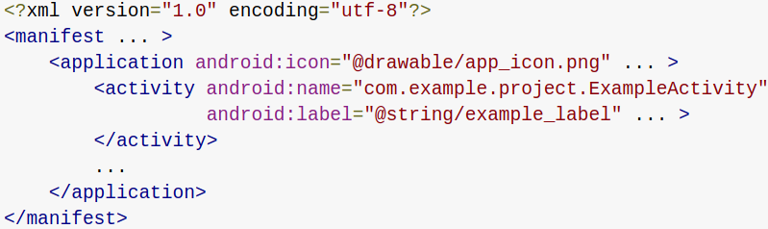

The primary task of the manifest is to inform the system about the app's components. For example, a manifest file can declare an activity as follows:

In the <application> element, the android:icon attribute points to resources for an icon that identifies the app. In the <activity> element, the android:name attribute specifies the fully qualified class name of the Activity subclass and the android:label attribute specifies a string to use as the user-visible label for the activity.
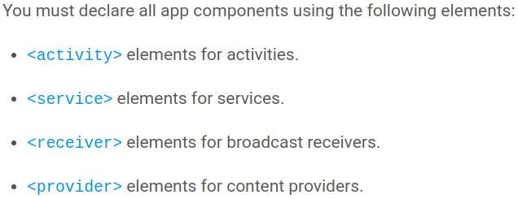
Activities, services, and content providers that you include in your source but do not declare in the manifest are not visible to the system and, consequently, can never run. However, broadcast receivers can be either declared in the manifest or created dynamically in code as BroadcastReceiver objects and registered with the system by calling registerReceiver().

There are a variety of devices powered by Android and not all of them provide the same features and capabilities. To prevent your app from being installed on devices that lack features needed by your app, it's important that you clearly define a profile for the types of devices your app supports by declaring device and software requirements in your manifest file. Most of these declarations are informational only and the system does not read them, but external services such as Google Play do read them in order to provide filtering for users when they search for apps from their device.
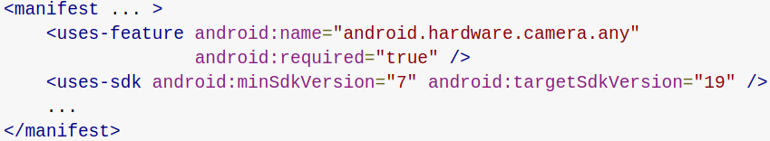
For example, if your app requires a camera and uses APIs introduced in Android 2.1 (API Level 7), you must declare these as requirements in your manifest file as shown in the following example:
With the declarations shown in the example, devices that do not have a camera or have an Android version lower than 2.1 cannot install your app from Google Play. However, you can declare that your app uses the camera, but does not require it. In that case, your app must set the required attribute to false and check at runtime whether the device has a camera and disable any camera features as appropriate.

An Android app is composed of more than just code—it requires resources that are separate from the source code, such as images, audio files, and anything relating to the visual presentation of the app. For example, you can define animations, menus, styles, colors, and the layout of activity user interfaces with XML files. Using app resources makes it easy to update various characteristics of your app without modifying code. Providing sets of alternative resources enables you to optimize your app for a variety of device configurations, such as different languages and screen sizes.
For every resource that you include in your Android project, the SDK build tools define a unique integer ID, which you can use to reference the resource from your app code or from other resources defined in XML. For example, if your app contains an image file named logo.png (saved in the res/drawable/ directory), the SDK tools generate a resource ID named R.drawable.logo. This ID maps to an app-specific integer, which you can use to reference the image and insert it in your user interface.
One of the most important aspects of providing resources separate from your source code is the ability to provide alternative resources for different device configurations. For example, by defining UI strings in XML, you can translate the strings into other languages and save those strings in separate files. Then Android applies the appropriate language strings to your UI based on a language qualifier that you append to the resource directory's name (such as res/values-fr/ for French string values) and the user's language setting.
Android supports many different qualifiers for your alternative resources. The qualifier is a short string that you include in the name of your resource directories in order to define the device configuration for which those resources should be used. For example, you should create different layouts for your activities, depending on the device's screen orientation and size. When the device screen is in portrait orientation (tall), you might want a layout with buttons to be vertical, but when the screen is in landscape orientation (wide), the buttons could be aligned horizontally. To change the layout depending on the orientation, you can define two different layouts and apply the appropriate qualifier to each layout's directory name. Then, the system automatically applies the appropriate layout depending on the current device orientation.


Unlike programming paradigms in which apps are launched with a main() method, the Android system initiates code in an Activity instance by invoking specific callback methods that correspond to specific stages of its lifecycle.
The mobile-app experience differs from its desktop counterpart in that a user's interaction with the app doesn't always begin in the same place. Instead, the user journey often begins non-deterministically. For instance, if you open an email app from your home screen, you might see a list of emails. By contrast, if you are using a social media app that then launches your email app, you might go directly to the email app's screen for composing an email.
The Activity class is designed to facilitate this paradigm. When one app invokes another, the calling app invokes an activity in the other app, rather than the app as an atomic whole. In this way, the activity serves as the entry point for an app's interaction with the user. You implement an activity as a subclass of the Activity class.
- An activity provides the window in which the app draws its UI. This window typically fills the screen, but may be smaller than the screen and float on top of other windows. Generally, one activity implements one screen in an app.
- Although activities work together to form a cohesive user experience in an app, each activity is only loosely bound to the other activities; there are usually minimal dependencies among the activities in an app. In fact, activities often start up activities belonging to other apps.


They provide the ability to launch an activity based not only on an explicit request, but also an implicit one. For example, an explicit request might tell the system to “Start the Send Email activity in the Gmail app". By contrast, an implicit request tells the system to “Start a Send Email screen in any activity that can do the job." When the system UI asks a user which app to use in performing a task, that’s an intent filter at work.
- Activities that you don't want to make available to other applications should have no intent filters, and you can start them yourself using explicit intents.
You can take advantage of this feature by declaring an <intent-filter> attribute in the <activity> element. The definition of this element includes an <action> element and, optionally, a <category> element and/or a <data> element. These elements combine to specify the type of intent to which your activity can respond. For example, the following code snippet shows how to configure an activity that sends text data, and receives requests from other activities to do so:
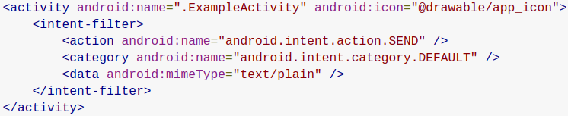
In this example, the <action> element specifies that this activity sends data. Declaring the <category> element as DEFAULT enables the activity to receive launch requests. The <data> element specifies the type of data that this activity can send.
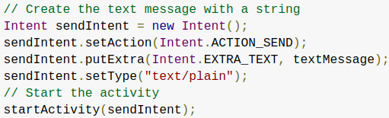
The following code snippet shows how to call the activity described above:



You can use the manifest's <activity> tag to control which apps can start a particular activity. A parent activity cannot launch a child activity unless both activities have the same permissions in their manifest. (This is for activities from different apps, not activities in the same app (?)) If you declare a <uses-permission> element for a particular activity, the calling activity must have a matching <uses-permission> element.
- It is preferable to design your application in a way that does not require any permissions if it’s possible.
If you must create a new permission, consider whether you can accomplish your task with a signature protection level. Signature permissions are transparent to the user and allow access only by applications signed by the same developer as the application performing the permission check.
- Bazı permissionlar app indirilmeden önce kabul ediliyor (emin değilim). Bazılarınıda run time kullanıcıya sorabiliyoruz. Mesela telefonun hafızasına erişim hakkı. Bunu <uses-permisson android:name=”android.permission.READ_EXTERNAL_STORAGE” /> tagi ile ve Activityler içinde birkaç fonksiyon ile yapabiliriz. Kullanıcıya sorulur: “Do you want this app to access external storage?” ve cevaba göre ayarlanır. Birçok permission var, mesela BLUETOOTH, INTERNET vs.


As a user navigates through, out of, and back to your app, the Activity instances in your app transition through different states in their lifecycle. The Activity class provides a number of callbacks that allow the activity to know that a state has changed: that the system is creating, stopping, or resuming an activity, or destroying the process in which the activity resides.
Doing the right work at the right time and handling transitions properly make your app more robust and performant. For example, good implementation of the lifecycle callbacks can help ensure that your app avoids:
- Crashing if the user receives a phone call or switches to another app while using your app.
- Consuming valuable system resources when the user is not actively using it.
- Losing the user's progress if they leave your app and return to it at a later time.
- Crashing or losing the user's progress when the screen rotates between landscape and portrait orientation.
To navigate transitions between stages of the activity lifecycle, the Activity class provides a core set of six callbacks: onCreate(), onStart(), onResume(), onPause(), onStop(), and onDestroy(). The system invokes each of these callbacks as an activity enters a new state.
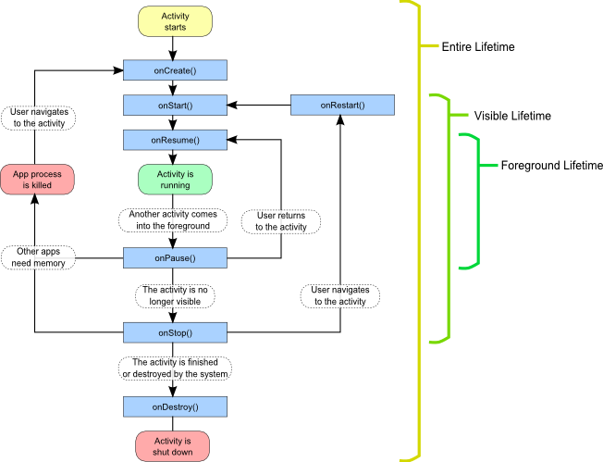
As the user begins to leave the activity, the system calls methods to dismantle the activity. In some cases, this dismantlement is only partial; the activity still resides in memory (such as when the user switches to another app), and can still come back to the foreground. If the user returns to that activity, the activity resumes from where the user left off. The system’s likelihood of killing a given process—along with the activities in it—depends on the state of the activity at the time. Activity state and ejection from memory provides more information on the relationship between state and vulnerability to ejection.
- Depending on the complexity of your activity, you probably don't need to implement all the lifecycle methods. However, it's important that you understand each one and implement those that ensure your app behaves the way users expect.

- You must implement this callback, which fires when the system first creates the activity.
- On activity creation, the activity enters the Created state.
- In the onCreate() method, you perform basic application startup logic that should happen only once for the entire life of the activity. (For example, your implementation of onCreate() might bind data to lists, initialize background threads, and instantiate some class-scope variables.)
- This method receives the parameter savedInstanceState, which is a Bundle object containing the activity's previously saved state. If the activity has never existed before, the value of the Bundle object is null. This state is not the same as the emulator state!
When the app starts, the saved Instance State is generally null (not sure?). Methods like onRestoreInstanceState(Bundle arg0) or onSaveInstanceState(Bundle arg0) can be used to save and restore the state.
Your activity does not reside in the Created state. After the onCreate() method finishes execution, the activity enters the Started state, and the system calls the onStart() and onResume() methods in quick succession.

The onStart() call makes the activity visible to the user, as the app prepares for the activity to enter the foreground and become interactive. For example, this method is where the app initializes the code that maintains the UI. It might also register a BroadcastReceiver that monitors changes that are reflected in the UI.
Once this callback finishes, the activity enters the Resumed state, and the system invokes the onResume() method.

When the activity enters the Resumed state, it comes to the foreground, and then the system invokes the onResume() callback. This is the state in which the app interacts with the user. The app stays in this state until something happens to take focus away from the app. Such an event might be, for instance, receiving a phone call, the user’s navigating to another activity, or the device screen’s turning off.
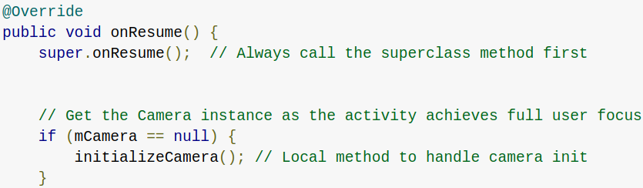


The system calls this method as the first indication that the user is leaving your activity (though it does not always mean the activity is being destroyed). Use the onPause() method to pause operations such animations and music playback that should not continue while the Activity is in the Paused state, and that you expect to resume shortly. There are several reasons why an activity may enter this state. For example:
- Some event interrupts app execution, as described in the onResume() section. This is the most common case.
- In Android 7.0 (API level 24) or higher, multiple apps run in multi-window mode. Because only one of the apps (windows) has focus at any time, the system pauses all of the other apps.
- A new, semi-transparent activity (such as a dialog) opens. As long as the activity is still partially visible but not in focus, it remains paused.
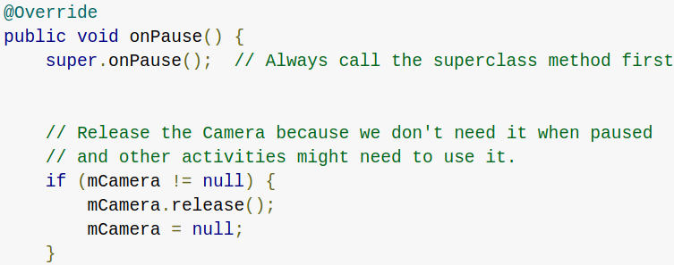
You can use the onPause() method to release system resources, such as broadcast receivers, handles to sensors (like GPS), or any resources that may affect battery life while your activity is paused and the user does not need them.
For example, if your application uses the Camera, the onPause() method is a good place to release it. The following example of onPause() is the counterpart to the onResume() example above, releasing the camera that the onResume() example initialized.

- onPause() execution is very brief, and does not necessarily afford enough time to perform save operations. For this reason, you should not use onPause() to save application or user data, make network calls, or execute database transactions; such work may not complete before the method completes. Instead, you should perform heavy-load shutdown operations during onStop().
Completion of the onPause() method does not mean that the activity leaves the Paused state. Rather, the activity remains in this state until either the activity resumes or becomes completely invisible to the user. If the activity resumes, the system once again invokes the onResume() callback. If the activity returns from the Paused state to the Resumed state, the system keeps the Activity instance resident in memory, recalling that instance when it the system invokes onResume(). In this scenario, you don’t need to re-initialize components that were created during any of the callback methods leading up to the Resumed state. If the activity becomes completely invisible, the system calls onStop().

When your activity is no longer visible to the user, it has entered the Stopped state, and the system invokes the onStop() callback. This may occur, for example, when a newly launched activity covers the entire screen. The system may also call onStop() when the activity has finished running, and is about to be terminated.
In the onStop() method, the app should release almost all resources that aren't needed while the user is not using it. For example:
- if you registered a BroadcastReceiver in onStart() to listen for changes that might affect your UI, you can unregister the broadcast receiver in onStop(), as the user can no longer see the UI.
It is also important that you use onStop() to release resources that might leak memory, because it is possible for the system to kill the process hosting your activity without calling the activity's final onDestroy() callback.
You should also use onStop() to perform relatively CPU-intensive shutdown operations. For example, if you can't find a more opportune time to save information to a database, you might do so during onStop().
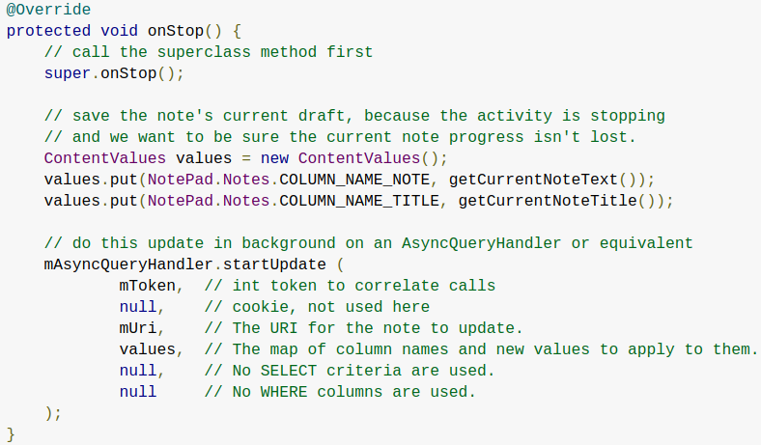
The following example shows an implementation of onStop() that saves the contents of a draft note to persistent storage:

When your activity enters the Stopped state, the Activity object is kept resident in memory: It maintains all state and member information, but is not attached to the window manager. When the activity resumes, the activity recalls this information. You don’t need to re-initialize components that were created during any of the callback methods leading up to the Resumed state. The system also keeps track of the current state for each View object in the layout, so if the user entered text into an EditText widget, that content is retained so you don't need to save and restore it.
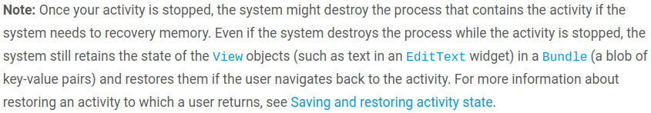


Called before the activity is destroyed. This is the final call that the activity receives. The system either invokes this callback because the activity is finishing due to someone's calling finish(), or because the system is temporarily destroying the process containing the activity to save space. You can distinguish between these two scenarios with the isFinishing() method. The system may also call this method when an orientation change occurs, and then immediately call onCreate() to recreate the process (and the components that it contains) in the new orientation.
The onDestroy() callback releases all resources that have not yet been released by earlier callbacks such as onStop().
Depending on whether your activity wants a result back from the new activity it’s about to start, you start the new activity using either the startActivity() or the startActivityForResult() method. In either case, you pass in an Intent object.
An Intent object can also carry small amounts of data to be used by the activity that is started. The Intent object specifies either:
- the exact activity you want to start or
- describes the type of action you want to perform (and the system selects the appropriate activity for you, which can even be from a different application).

Explicit Intent:

Implicit Intent: You can create an intent that describes an action you want to perform and the system launches the appropriate activity from another application. If there are multiple activities that can handle the intent, then the user can select which one to use. For example, if you want to allow the user to send an email message, you can create the following intent:
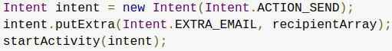

Sometimes you want to get a result back from an activity when it ends. For example, you may start an activity that lets the user pick a person in a list of contacts; when it ends, it returns the person that was selected. To do this, you call the startActivityForResult(Intent, int) method, where the integer parameter identifies the call. This identifier is meant to disambiguate between multiple calls to startActivityForResult(Intent, int) from the same activity. It's not global identifier and is not at risk of conflicting with other apps or activities.The result comes back through your onActivityResult(int, int, Intent) method.
When a child activity exits, it can call setResult(int) to return data to its parent. The child activity must always supply a result code, which can be the standard results RESULT_CANCELED, RESULT_OK, or any custom values starting at RESULT_FIRST_USER. In addition, the child activity can optionally return an Intent object containing any additional data it wants. The parent activity uses the onActivityResult(int, int, Intent) method, along with the integer identifier the parent activity originally supplied, to receive the information.
If a child activity fails for any reason, such as crashing, the parent activity receives a result with the code RESULT_CANCELED.

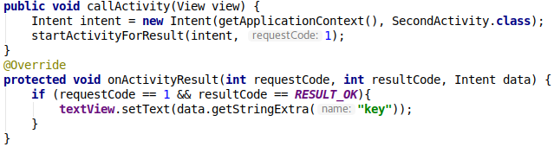

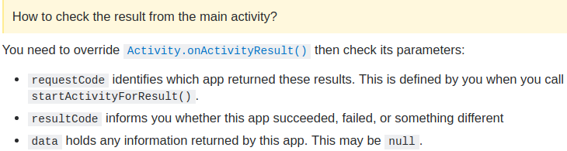
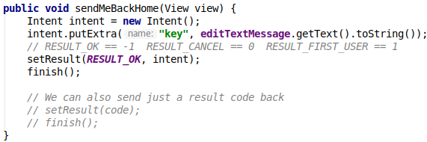

When one activity starts another, they both experience lifecycle transitions. The first activity stops operating and enters the Paused or Stopped state, while the other activity is created. In case these activities share data saved to disc or elsewhere, it's important to understand that the first activity is not completely stopped before the second one is created. Rather, the process of starting the second one overlaps with the process of stopping the first one.
The order of lifecycle callbacks is well defined, particularly when the two activities are in the same process (app) and one is starting the other. Here's the order of operations that occur when Activity A starts Activity B:
- Activity A's onPause() method executes.
- Activity B's onCreate(), onStart(), and onResume() methods execute in sequence. (Activity B now has user focus.)
- Then, if Activity A is no longer visible on screen, its onStop() method executes.
This predictable sequence of lifecycle callbacks allows you to manage the transition of information from one activity to another.

There are a few scenarios in which your activity is destroyed due to normal app behavior such as :
- when the user presses the Back button
- your activity signals its own destruction by calling the finish() method.
- The system may also destroy the process containing your activity to recover memory if the activity is in the Stopped state and hasn't been used in a long time or if the foreground activity requires more resources.

When your activity is destroyed because the user presses Back or the activity finishes itself, the system's concept of that Activity instance is gone forever because the behavior indicates the activity is no longer needed.
However, if the system destroys the activity due to system constraints (rather than normal app behavior), then although the actual Activity instance is gone, the system remembers that it existed such that if the user navigates back to it, the system creates a new instance of the activity using a set of saved data that describes the state of the activity when it was destroyed. The saved data that the system uses to restore the previous state is called the instance state and is a collection of key-value pairs stored in a Bundle object.
By default, the system uses the Bundle instance state to save information about each View object in your activity layout (such as the text value entered into an EditText widget). So, if your activity instance is destroyed and recreated, the state of the layout is restored to its previous state with no code required by you. However, your activity might have more state information that you'd like to restore, such as member variables that track the user's progress in the activity
A Bundle object isn't appropriate for preserving more than a trivial amount of data because it consumes system-process memory. To preserve more than a very small amount of data, you should take a combined approach to preserving data, using persistent local storage, the onSaveInstanceState() method, and the ViewModel class. For more information about preserving complex data structures, see Saving UI States.

For cases where a Bundle is appropriate, you may use the onSaveInstanceState() method. As your activity begins to stop, the system calls the onSaveInstanceState() method so your activity can save state information with a collection of key-value pairs. The default implementation of this method saves transient information about the state of the activity's view hierarchy, such as the text in an EditText widget or the scroll position of a ListView widget.
Your app should implement the onSaveInstanceState() callback after the onPause() method, and before onStop(). --- (Anlamadım ???)
Do not implement this callback in onPause().

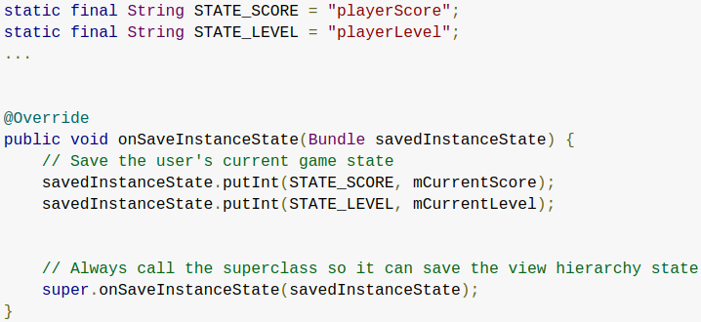
To save additional state information for your activity, you must override onSaveInstanceState() and add key-value pairs to the Bundle object that is saved in the event that your activity is destroyed unexpectedly. Like here →

Note: In order for the Android system to restore the state of the views in your activity, each view must have a unique ID, supplied by the android:id attribute.
To save persistent data, such as user preferences or data for a database, you should take appropriate opportunities when your activity is in the foreground. If no such opportunity arises, you should save such data during the onStop() method.
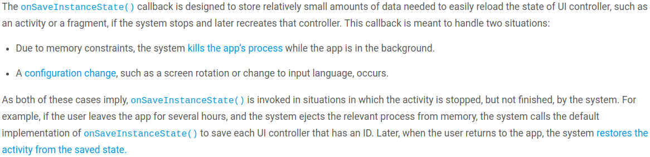

When your activity is recreated after it was previously destroyed, you can recover your saved state from the Bundle that the system passes to your activity. Both the onCreate() and onRestoreInstanceState() callback methods receive the same Bundle that contains the instance state information.
Because the onCreate() method is called whether the system is creating a new instance of your activity or recreating a previous one, you must check whether the state Bundle is null before you attempt to read it. If it is null, then the system is creating a new instance of the activity, instead of restoring a previous one that was destroyed.

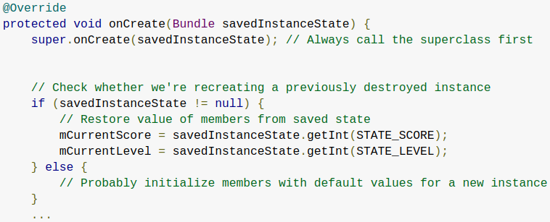
For example, the following code snippet shows how you can restore some state data in onCreate():

Instead of restoring the state during onCreate() you may choose to implement onRestoreInstanceState(), which the system calls after the onStart() method.
The system calls onRestoreInstanceState() only if there is a saved state to restore, so you do not need to check whether the Bundle is null:
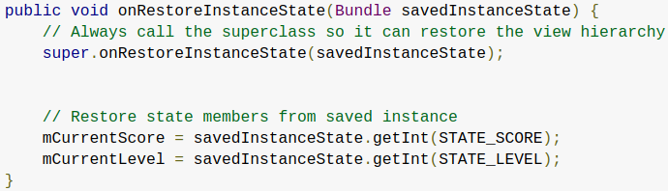



Different events, some user-triggered and some system-triggered, can cause an Activity to transition from one state to another. This document describes some common cases in which such transitions happen, and how to handle those transitions.
There are a number of events that can trigger a configuration change. Perhaps the most prominent example is a change between portrait and landscape orientations. Other cases that can cause configuration changes include changes to language or input device.
When a configuration change occurs, the activity is destroyed and recreated. To preserve simple transient-state data for the activity, you must override the onSaveInstanceState() method to save the data, and then use onCreate() OR onRestoreInstanceState() callbacks to recreate the instance state.

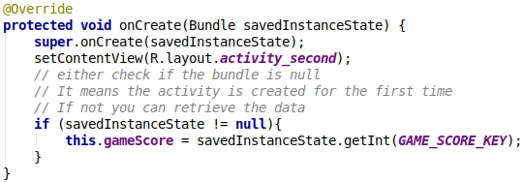
- So for example when we switch from portrait orientation to landscape orientation, the activity is destroyed and recreated. Basic things like the text inside a EditText widget is saved and recreated by default. BUT ! If we want to save other basic data, we have to use the onSaveInstanceState() method ! SEE NEXT PAGE
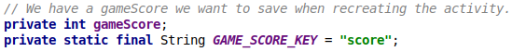
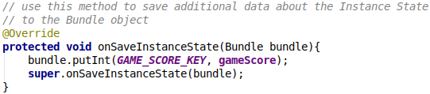
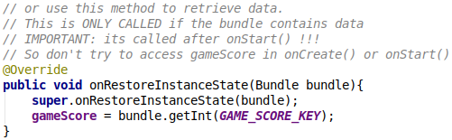
When an app enters multi-window mode, available in Android 7.0 (API level 24)and higher, the system notifies the currently running activity of a configuration change, thus going through the lifecycle transitions described above. This behavior also occurs if an app already in multi-window mode gets resized. Your activity can handle the configuration change itself, or it can allow the system to destroy the activity and recreate it with the new dimensions.

If a new activity or dialog appears in the foreground, taking focus and partially covering the activity in progress, the covered activity loses focus and enters the Paused state. Then, the system calls onResume() on it.
When the covered activity returns to the foreground and regains focus, it calls onResume().
If a new activity or dialog appears in the foreground, taking focus and completely covering the activity in progress, the covered activity loses focus and enters the Stopped state. The system then, in rapid succession, calls onPause() and onStop().
When the same instance of the covered activity comes back to the foreground, the system calls onRestart(), onStart(), and onResume() on the activity. If it is a new instance of the covered activity that comes to the background, the system does not call onRestart(), only calling onStart() and onResume().

If an activity is in the foreground, and the user taps the Back button, the activity transitions through the onPause(), onStop(), and onDestroy() callbacks. In addition to being destroyed, the activity is also removed from the back stack.
It is important to note that, by default, the onSaveInstanceState() callback does not fire in this case. This behavior is based on the assumption that the user tapped the Back button with no expectation of returning to the same instance of the activity.
However, you can override the onBackPressed() method to implement some custom behavior, for example a “confirm-quit" dialog. If you override the onBackPressed() method, we still highly recommend that you invoke super.onBackPressed() from your overridden method. Otherwise the Back button behavior may be jarring to the user.

This Button in your activity is calling onBackPressed() !

When we set a parent activity for an activity, we automatically get an arrow back at the top of our screen like here. This WONT call the onBackPressed() method !

