Save data using SQLite

Caution: Although these APIs are powerful, they are fairly low-level and require a great deal of time and effort to use:
- There is no compile-time verification of raw SQL queries. As your data graph changes, you need to update the affected SQL queries manually. This process can be time consuming and error prone.
- You need to use lots of boilerplate code to convert between SQL queries and data objects.
For these reasons, we highly recommended using the Room Persistence Library as an abstraction layer for accessing information in your app's SQLite databases.

The SQLiteOpenHelper class contains a useful set of APIs for managing your database.

Steps:
- Create a subclass of SQLiteOpenHelper that overrides the onCreate() and onUpgrade() callback methods. You may also want to implement the onDowngrade() or onOpen() methods, but they are not required.
- Set up constants in your class that defines that table names, column names, db version …
- To access your database, instantiate your subclass of SQLiteOpenHelper and then use the methods provided from that instance.
- Implement any methods you want.
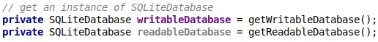

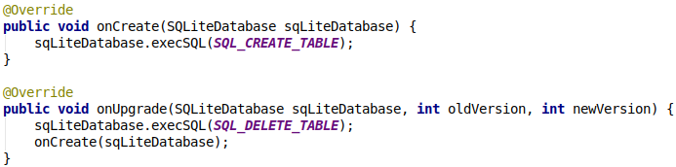
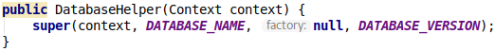

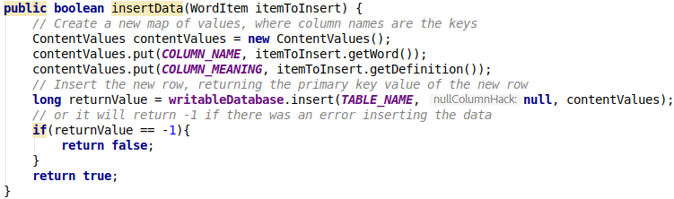
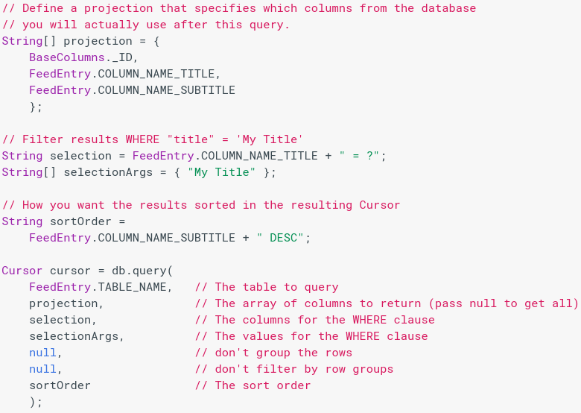

The third and fourth arguments (selection and selectionArgs) are combined to create a WHERE clause. Because the arguments are provided separately from the selection query, they are escaped before being combined. This makes your selection statements immune to SQL injection.
The other way is to get all the data from one table. Of course this will only be suitable for tables with small amounts of data in it. After getting everything as a Cursor object, we can fetch data from there.
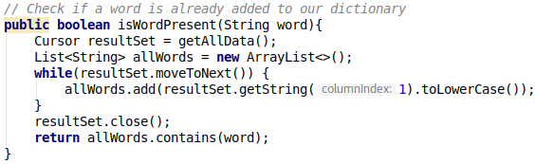

To look at a row in the cursor, use one of the Cursor move methods, which you must always call before you begin reading values. Since the cursor starts at position -1, calling moveToNext() places the "read position" on the first entry in the results and returns whether or not the cursor is already past the last entry in the result set. For each row, you can read a column's value by calling one of the Cursor get methods, such as getString() or getLong(). For each of the get methods, you must pass the index position of the column you desire, which you can get by calling getColumnIndex() or getColumnIndexOrThrow().
When finished iterating through results, call close() on the cursor to release its resources.

To delete rows from a table, you need to provide selection criteria that identify the rows to the delete() method. The mechanism works the same as the selection arguments to the query() method. It divides the selection specification into a selection clause and selection arguments. The clause defines the columns to look at, and also allows you to combine column tests. The arguments are values to test against that are bound into the clause. Because the result isn't handled the same as a regular SQL statement, it is immune to SQL injection.
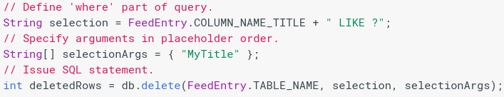

The return value for the delete() method indicates the number of rows that were deleted from the database.
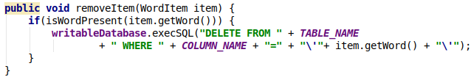

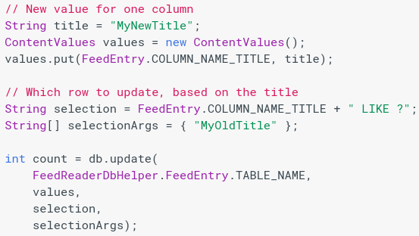
When you need to modify a subset of your database values, use the update() method.
Updating the table combines the ContentValues syntax of insert() with the WHERE syntax of delete().
The return value of the update() method is the number of rows affected in the database.

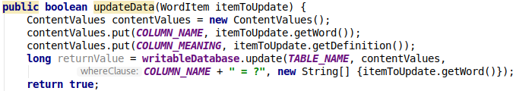
Since getWritableDatabase() and getReadableDatabase() are expensive to call when the database is closed, you should leave your database connection open for as long as you possibly need to access it. Typically, it is optimal to close the database in the onDestroy() of the calling Activity.
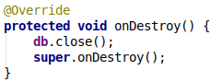
My Activity ‘WordListActivity’ instantiates a DatabaseHelper class once, uses just that instance and does all database operations with it. Also overriding onDestroy() to close the db connection.
Since I only call getWritableDatabase() in the DatabaseHelper class its good practise. It means I getWritableDatabase() is called just once with the start of the activity and we closed it when the Activity is destroyed.

The Android SDK includes a sqlite3 shell tool that allows you to browse table contents, run SQL commands, and perform other useful functions on SQLite databases. For more information, see how to how to issue shell commands.

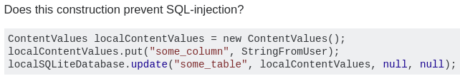

Developer Policy Center:

