ImageView: When we want to include a picture in our app, we should put it in the drawable folder. But since there are many different phones, we should create a drawable folder for each variation. For example drawable, drawable-hdpi, drawable-mdpi, drawable-xdpi, drawable-xxdpi etc…In Android Studio they will all be shown under one folder which is drawable.

SeekBar: we can track changes with myBar.setOnSeekBarChangeListener( innerClass). Every time the user moves the bar, a value ‘progress’ will be passed to the method which we can use.

RatingBar: same thing, myBar.setOnRatingBarChangeListener(inner class implementation). Same variable will be passed each time ‘float rating’. In the XML file we can add an attribute to declare the step size → android:stepSize=”1” , this way user can only chose between 1,2,3,4,5. The default is 0.5++
android:progressTint=… for the color.

Intent: we can pass data between activities by putting them inside the intent with
intent.putExtra(key, Value); → in the other class we can get the intent with the key (if its a string)
Intent myIntent = getIntent(); String name = intent.getStringExtra(key);

WebView: By default javaScript is disabled. Loading a URL: myBrowser.loadUrl(“http://www...”)
We can enable it by myBrowser.getSettings().setJavaScriptEnabled(true);
- By default when you click on a link in webView, your browser app will be opened. To open the link in your application(in WebView) myBrowser.setWebViewClient( WebViewClient arg0);
Create a subclass which extends WebViewClient and overrides ‘shouldOverrideUrlLoading(...)’ then pass it as a parameter.

AlertDialog: AlertDialog works with ‘Builder Pattern’. We should understand that first in order to understand how AlertDialog works.
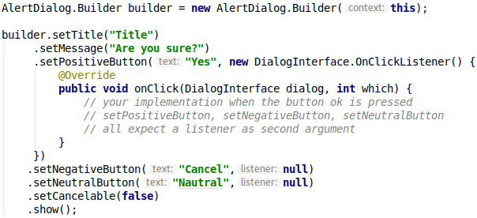
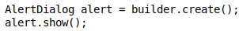
We can also create a AlertDialog out of the AlertDialog.Builder (in this case we wont say .show() on the builder):

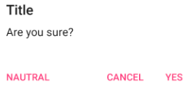

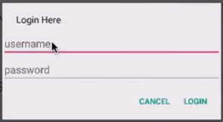
We can also create a view inside the alertDialog like this by using LayoutInflator.

Menu : How to create a menu in your activity :
- Right click on res directory > New > Android Resource Directory
- Right click on menu directory > New > Menu Resource File (XML file)
- Fill your menu xml file with items you want.
- In your activity class override 2 Methods: onCreateOptionsMenu(Menu menu) and onOptionsItemSelected(MenuItem item)

Every time we choose an item in the menu, it will call onOptionsItemSelected(MenuItem item) with the clicked item as the argument.
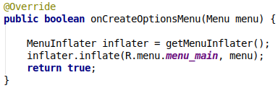
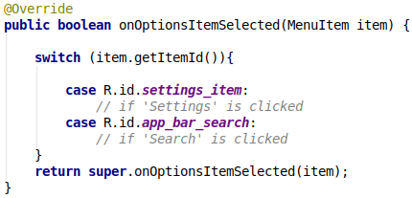

Closing software keyboard : When the user enters a text and clicks ‘OK’ or ‘Send’ etc. currently opened keyboard should close since the user will not be able to see half of the screen.
We can call this method in our button onClick method and it will close the keyboard
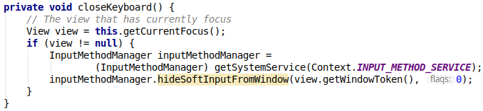
→ SHOW_FORCED causes some problems like when pressing preview button(hardware) the keyboard wont close or .hideSoftInputWindow also wont close the keyboard if it was opened with force.
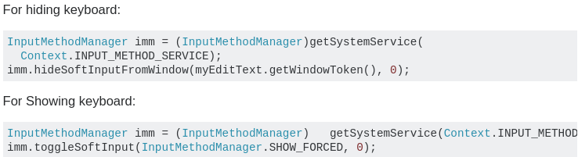

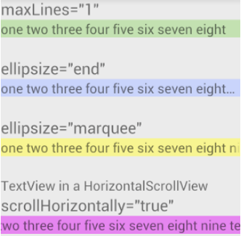
android:maxLines="1" : This just forces the text to one line. Any extra text is hidden.
ellipsize="end” : This cuts off the text that doesn't fit but lets users know that the text has been truncated by adding an ellipsis (the three dots).
ellipsize="start" (...aaabbbccc) ellipsize="middle" (aaa...ccc)
HorizontalScrollView with scrollHorizontally : This allows the user to manually scroll to see the whole line of text.

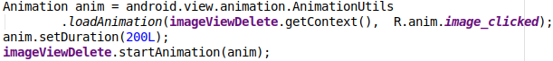
Adding an animation to an image:

using Android MediaPlayer:
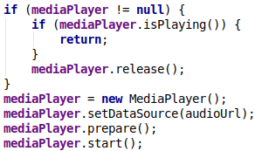
- We should call mediaPlayer.release(); whenever we are finished with an instance of MediaPlayer, this can be done in onPause(), in onStop() or also in a method right before we initialize a new instance to our field
- We can also check if the media player is currently running and continue our actions based on that
- Here we used a generated Wornik URL which was pointing to an mp3 file

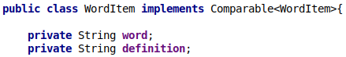
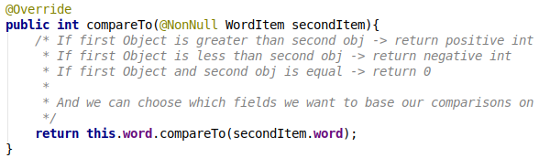

Restrict certain activities only to Landscape/portrait view:
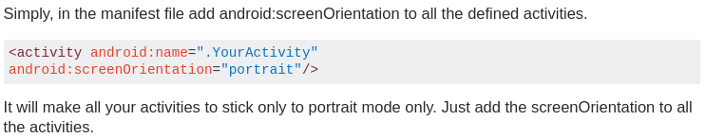
Change Image Button Color:
Android Studio now supports vector assets on 21+ and will generate pngs for lower versions at compile time. I have a vector asset (from the Material Icons) that I want to change the fill color.
- Don't edit the vector assets directly. If you using a vector drawable in an ImageButton, just choose your color in android:tint.
- android:tint must be after android:src.

Comparing Objects
Arrays.sort works for arrays which can be of primitive data type and also for array of objects (certain arguments should be there, like passing a comparator object as the second argument). Collections.sort() works for objects Collections like ArrayList, LinkedList, etc.
Implement the interface Comparable<>, set what should be compared in compareTo() method and calling Collections.sort(…) will use the overriden compareTo() method to compare WordItem objects.
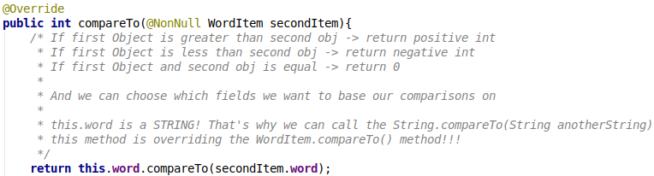

- If we want to change the compare criteria we can use the method that accepts a Comparator when you want to sort in something other than natural order.
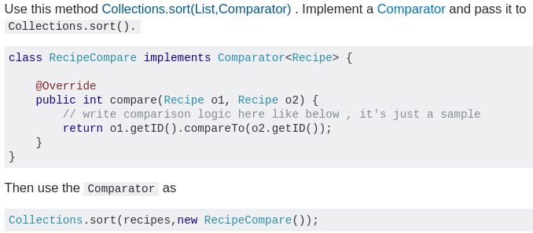

Android Material Design Button Styles
With the Support Library v7, all the styles are actually already defined and ready to use, for the standard buttons, all of these styles are available:
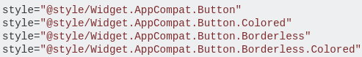

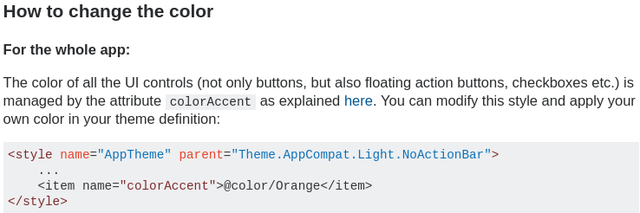
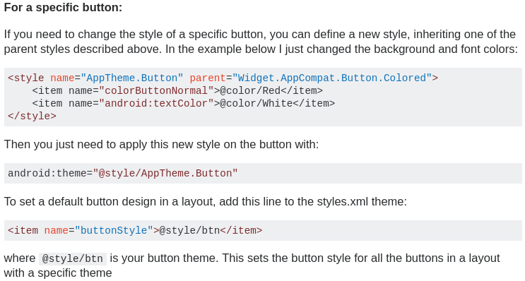
→ I inherited the Widget.AppCompat.Button.Colored style to the child AppTheme.Button and override some of the properties as I wanted.

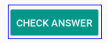
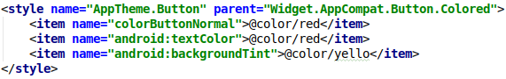

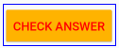

Content Description Warning imageview:
