RESTful

Web Services : Services that are exposed to the internet for programmatic access. They are online API’s that you can call from your code.
When we call an API while writing Java code , we basically add the JAR’s or the classes to our CLASSPATH . Everything executes in a single machine/enviroment.
In the case of web services we have different pieces of code that is contained in different machines and they call methods of eachother over the network.
- Example : We have seen different apps or maybe games that can post to our facebook page even though those apps were not developed by facebook and are completely independent apps. This is done by calling online API’s.
Companies like Facebook or Twitter publish web services that let other developers call them from their code. So other app developers actually can write code to consume/use these services, posting things to fb or twitter , read and access data that is on our accounts and so on.
Its similar to web pages. Twitter has www.twitter.com. When we access this site on our browser we get an HTML response that lets you read or write tweets. They have some HTML elements for the data , they also have elements for styling / CSS. This is because this web page is meant to be for human consumption. They want to make sure the data is formatted properly so its easier for humans to work with it.
But twitter has also this other url : api.twitter.com. Does the same things as the normal page but behaves differently. For instance , this site will give us a response which does not have HTML or CSS. It Contains data but it is returned in xml/Json format. There are spesific url’s for different operations.
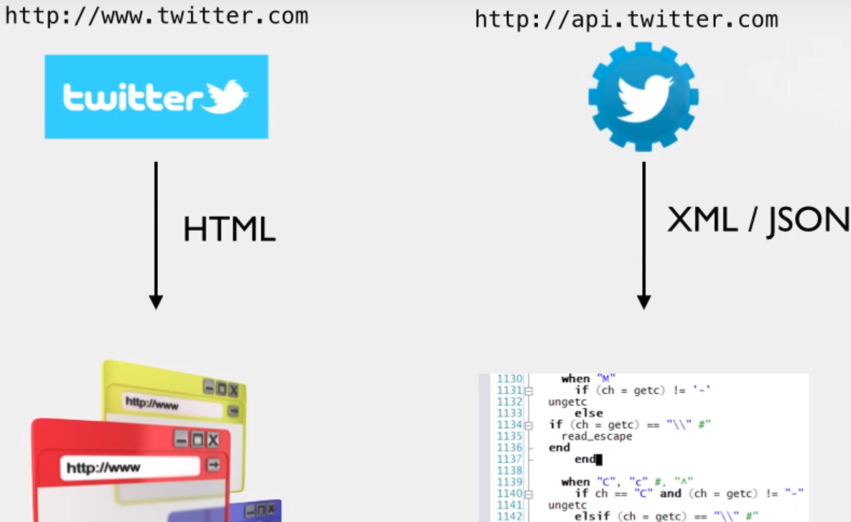
Since it deals just with bare bones data, its really easy for the developers to parse the data and convert it into their Objects in their code, their data structures. No need for HTML or CSS.

One way to build such API’s is using RESTful API’s

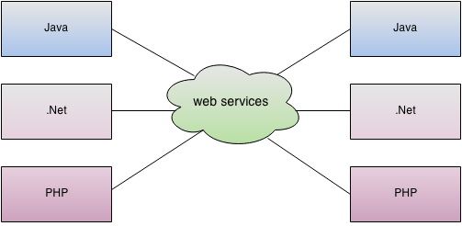
Web Service Types :
- REST Web Services
- SOAP Web Services

RESTful web services are a type of service, that are modern , light weight and they use a lot of concepts of HTTP.
- Different Applications written in different languages can use Web Services written in different language. So a C++ application can call and communicate with a Web Service written in Java
Yaptırmak istediğiniz işlemi çok küçük HTTP sorgularıyla fakat daha anlaşılabilir bir şekilde yapmak.
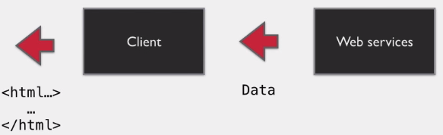
Some charasteristics of web services :
- The exchange of data happens over the web. Using HTTP. As we said before Web Services return just data to the Client , which is also a program. The client has some logic in it to process the data and doing other operation and then the client can format that data and present it in a nice way if the developer wishes to do so.
- Sometimes the protocols used between web services are standardized . SOAP Web Service uses a standard protocol which is SOAP (Simple Object Access Protocol). SOAP Web Services use the SOAP protocol. Protocol : Spesific format of messages and set of rules. The Format for SOAP is XML and there are spesific rules telling how that XML should be. The client and the server both need to talk SOAP only in order to communicate.
- Whats the protocol for REST ? → There is NONE. A REST client can send messages using XML or JSON or Text format or any other format as long as the client and the server understand eachother.
- Which HTTP Methods should we use , whats the standart ? → There is NONE. In case of REST , messages can be exchanged in any HTTP Method or all Methods. There are some guidelines when designing, what method to chose depending on what the operation is . But no concrete rule.
- Service definition : When programming in java and need to call a method of a library class, we need to know certain things about the library class and the method. The name of the class , method name , arguments, return type …
In the SOAP web service world the service definition is typically called by WSDL, its a document which defines what the web service does. It has all the details , what are the methods , the return types and so on. This document is available to all clients. This is the standard document.
So whats the standard document in REST ? → There is NONE. Most REST web services has little to no documentation (Its common). If they have a documentation its very likely to be in a format we can read from , a web page listing what the operations are . In fact the best designed REST web service wouldnt even need a documentation. There is something called WADL which is the equivalent of WSDL. But its not used so much.

All SOAP web services follow the “SOAP web service specification“. All the rules how SOAP services should look like. If a SOAP web service doesn’t follow even one of these rules its by definition not a SOAP web service. It is regulated by a comitee. A SOAP web service has strict rules defining each and every characteristics.
RESTful web services do not have a specification. Its a concep , its and idea. There is No committee to tell you whats right and whats wrong.
Representational State Transfer is actually not about web services , its an architecture style. REST consist of a coordinated set of criteria and constraints that you can use to guide you in your application architecture. Set of guidelines that work well together. Its a style of architecture.

You can use this style of architecture for any application. However if you apply the style when building a web service , you get RESTful Web Services.

The goal when building RESTful web services is to make is as RESTful as possible. Some Web services can be completely restfull and some not fully ...
- Main fact to think : Make it easy for the client/consumer

REST and HTTP

The concepts of REST are closely related to HTTP. Every time we load a web page , we make an HTTP request and we get HTML content in the response.
Roy Fielding , the one who come up with REST is also one of the authors of the HTTP specification. Specification mean rules . So what defines HTTP is clearly layed out on the specifications unlike REST.
Hyper Text Transfer Protocol. HTTP is a way to exchange and communicate information online. The stuff that we transfer is called Hypertext. Its a structured form of text. It has an interesting property. It contains logical links to other text, these links are called Hyperlinks. So Hypertext is text which contains links to other text.
A common and popular way to write Hypertext is in a language called Hyper Text Markup Language.

Resource Locations
Like web pages , REST API’s have URL’s and adresses too. Since these API’s are not meant to be read by humans the response contains usually just the core data.
- The good practice in RESTful api’s is to have Resource based adresses.
A weather websites url could be like this :
weatherapp.com/weatherLookup.do?zipcode=12345
this adress is not resource based , its more action based. It tells us there is something called weatherLookup.do that takes the zipcode as a parameter and then does something.
Resource based adresses indicate JUST the resource , independent from the server side implementation. A RESTful API for weather could have the adress :
weatherapp.com/zipcode/12345
Its almost like you wont make the server do anything , just looking up something that already is there. For a country it could be :
weatherapp.com/countries/brazil

HTTP Methods
There are some methods that are used to interact with URL’s.
A good RESTful API makes good use of all these methods and uses them in the right way . Each method does something spesific. Each method chosed for the API should depend on the action thats perform.

There can be a lot of different POST methods or GET methods .
For example :
- flickr.blogs.getList
- flickr.blogs.getServices
- flickr.blogs.postPhoto

Metadata
Every HTTP response have things like Status code , response headers , these are extra information that is send and its useful for both the client and the server.
- Why send status codes ? Again when a page is not found , the user will see a 404 Page not found error and some text with it , maybe a link to the home page . To make our program to understand if the request is successful or not it needs to get and read those status codes and to know what is happening.
- How can the server identify what kind of data is send ?
- How does the Client know what data format is returned from the server ?
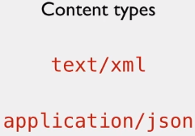
The answer is a header value called “Content Type”. A header value contains metadata about the message getting exchange, one of it is what format is the data being exchanged. A message send with the correct content type is easily processed . The program reads the header and sees that its XML content , so it can process/parse it in the correct way.
→ The same API could return multiple different content types. The format it chooses to send depends on the client and what format the client wants to get. This is called Content Negotiation. If the client wants XML then it will get XML format , or if he requests a JSON then it will get JSON.

RESTful Resource Based URIs

An important thing that makes a good RESTful API is how well its designed.
The app that we are building is called “Messenger” A social media application API.
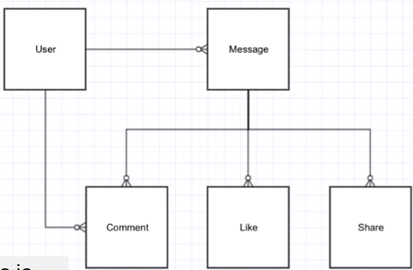
Users can :
- post messages as status updates
- write comments to other messages
- like other messages
- have user profile information

- What URIs would we design for this application ?

If this was a web application , the URL could be a lot of different things. URI to get a message with an ID 10 could look like this
When developing web applications, the URI’s we use doesnt really matter that much . Because we will provide a link to the user to go to that page , they don’t really have to remember the URI . They will just know the link to that page is in the home page, being able to navigate with links.
However with a Web Service , the users has to know of the URIs , because the users will be developers which have to write code to make these HTTP calls to our URI’s.
To have a common URI convention would be really helpful. So they wont be struggling to find which URI to use for what. → Here comes the Resource Based URIs into play
These are best practices , there is no right or wrong way to create these URIs . But if we are writing a REST API its better to follow these best practices.
In the early 90’s we had a lot of static pages . And every single page would have a unique URI. There was no ambiguity. This is exactly the concept behind Resource Based URI’s. Every thing / entity has a unique URI.
Imagine creating a static facebook page with 4 profiles . How would our pages be named ?
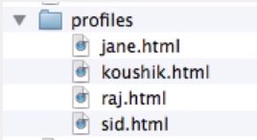
We would create a profile parent directory to put all of our profiles inside it.
To access a profile our URI would be : /profiles/jane.html
If we drop the .html extension we would get our RESTful URI : /profiles/jane

This is what we have to do when we want to create Resource Based URIs. Think about Resources and create unique URIs for them.
- How about posting a message ?

URIs contains Nouns and not verbs, Documents , Accounts , Persons , these are all Resources.
We dont have something like getMessages , postToAccount...
Typically the nouns will be the names of the resources itself. [Think about static web pages]
The Resource names are all Plural .”Messages” and not “Message”. It makes it clear that there are multiple messages under the messages directory.

The advantage of using Resource based URIs :
- it is not dependent on the Framework we use .There is no .do or .action , or ?ID=123 . Doesnt matter in what technology the Web Service is written, so why show it in the URI’s ?
- It makes it resistant to change. If you change your application design or the technology you use, the URIs will be still the same. Because its not dependent on the Framework

Some of the nouns in our Messanger Application :
Comments , Likes, Shares , each one can be a resource. What could be a good URI for comments ? Comment ID 20 → Maybe : /comments/20. This is correct but we have to think about Resource relations too.

Resource relations [One to Many]
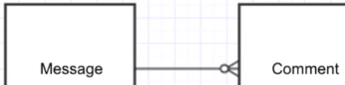
Some resources are dependent on other resources. For example “messages” and “comments”. Someone posts a message , someone else comments on that message. A message can have multiple comments.
Could the URI for comments be comments/{commentId} ?
Well it could but that treats both “messages” and “comments” as two independent resources and doesn’t acknowledge the relationship between those two.

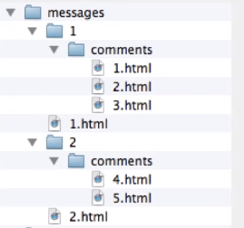
So to show that relationship we could create a sub-folder for each message. There are two messages . We create two sub-folders . The comments for message ID 1 we put in the first folder and the comments for message ID 2 we put in the second folder.
- What would be the URI for comment ID 2 ?

- So is this way to design resources better then comments/{commentId} ?
It depends . This URI makes it really clear that a comment belongs to a particular message. The relationship between resources are established.
On the other hand , to get a comment we need to know 2 things :
- Whats the comment ID ?
- Whats the message ID ?
Which approach you take depends on what you expect the client to know. If you expect the client to know just the comment ID then the first way is better and the second way might be a bit tricky. On the other hand if you know the client always knows the message ID when accessing a comment then its much better to use the second way :

This structure can be used with other resources too :
Messages can be liked , and each like has a unique ID
Messages can be shared , and each like has a share ID

- Typically when we have a one to many relationship, you choose to have the “one” side of the relationship be the root resource. The resource on the many side will be the one that follows it
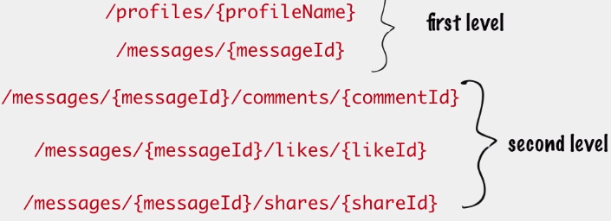
here we treat profiles and messages as first level entities comments , likes and shares as second level entities in relation to messages.

- Why “messages” are not related to “profiles” ? Cant we couple them together ?
When you think about it messages are posted from someone, so there is a one to many relationship between them.
→ Actually we could do it like this . But in this case we decided to have them separated. Because we felt that they aren’t so tightly coupled as say messages and likes were. We didn’t expect the client to know who the message author is when they are accessing a message. We want them to be able to have a message ID and access the message directly like that without having to know the author
→ “One to one” and “many to many” relationships will be covered later
Collection URIs
Two types of resource URIs :

- Instance Resource URIs
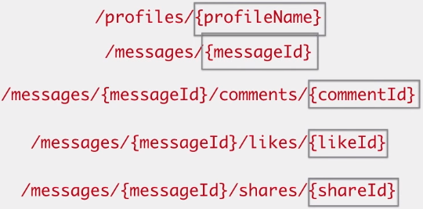
- Collection Resource URIs

A single instance of a message or comment etc. is accessible by an instance resource URI. They typically have a unique ID of the resource in the URI to identify what is the instance you are interested in

Collection URIs (a collection of Instance URIs) : For getting a collection (all messages) , just access /messages . Again this is similar to a static page. Accessing a directory gives you all the contents of the directory.

/messages Returns all messages ,/profiles returns all profiles ,
/messages/{messageID}/comments returns all the comments for a spesific message ID.
This shows us the advantage of nesting related resources. But there comes also a problem. What if we need all the comments for ant message ID ? Then this URI structure will be problematic because to access all the comments , we need to know each comments message ID.
If we had a /comment as a root resource then it would solve our problem perfecly.

- In some situations like this , there are both adv. And disadv. For any option we choose (Cant we provide both /messages/{messageID}/comments and /comment ?)

One of the goal should be to make it easy for the client to filter the results . One way to do this is providing query parameters. For filtering and pagination , it is a good scenario to use query parameters.

One standard practice is to provide pagination by having 2 query parameters.
Example : Starting point and the page size
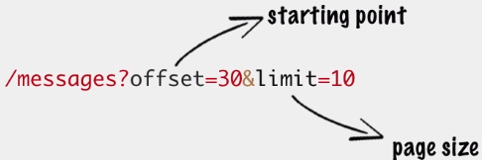
Starting from message 30 , return the next 10 messages. (given that the order will always be the same)

Retrieving messages based on date :
Giving the clients a feature , retrieve all messages posted a given year
This is something we can use with pagination

HTTP Methods
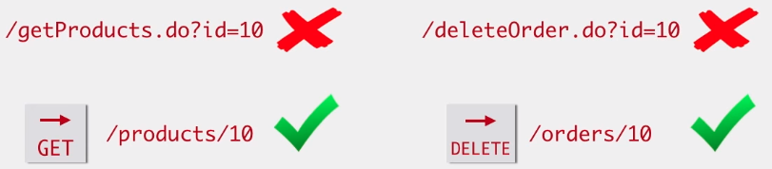
The URI tells you what entity or resource is being operated upon
The HTTP Method tells us what the operation is


Updating a message / changing a resource , POST can be used in this case but the standard practice is to use the PUT message

Ofcourse we want the resource to be updated so we need to send the new content in the body of the PUT request. The new message is going to replace the current message ID 20.


Deleting a message , no request body is required

Creating a new message , the message hasn’t been created yet, so there is no message ID. The ID is usually managed by the application , finding the next available ID and giving It to the message. So the client will have no idea what the ID will be.
Thats why requests for creating a new resource is always issued to the collection URI for that resource
For creating new resources the practice is to use the POST method. The POST body will contain the content of the new resource. Once the resource is created , the server need to tell the client what the ID is. The response of the server will be the resource ID of the newly created resource
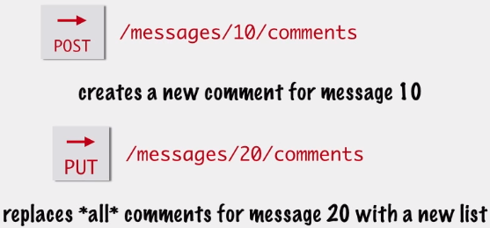
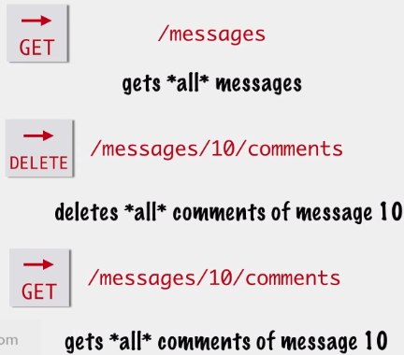

similarly a DELETE request on a collection URI is going to delete the whole list ( DELETE /messages)

** PUT and DELETE requests on a collection is not very common. We dont want the client to delete every message on the system.

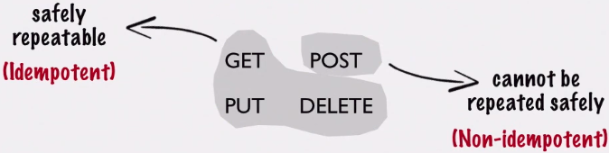
Idempotent / Non- Idempotent Methods

Idempotence : is the property of certain operations in mathematics and computer science that they can be applied multiple times without changing the result beyond the initial application.

The same GET request can be repeated multiple times → There will be no (side) effects on the server. You will get the same response each time without changing anything on the server.
The same DELETE request can be repeated multiple times → There will be no (side) effect on the server. Only the first delete request will have an effect on the server (deleting the requested resource), the rest of the requests wont effect anything because the resource is already deleted.
Same for the PUT request, if you send the same PUT request 3 times in a row , its the same as sending just 1 PUT request.

The POST request is different ! If we make a POST request, in our case we would create a new message. Lets say we forgot that we already clicked to send the request and we sent it again. What will happen now is , we will create 2 of the same message. If we send the same request 5 times in a row by accident then we will have 5 of the same messages posted . Cannot repeat requests safely without making any changes on the server.
- This is why, resource creation should always be via POST method. When you make a resource creation request you do create a new resource every time , even if you repeat the same request multiple times.
- Updating a resource can be done multiple times, safely via the PUT method.

These methods have standard meanings. The fact that its standard means, if you ignore these standards when implementing your API, you will either confuse your clients or you will cause their code to function improperly.
For example something common many APIs do is to cache some of their GET responses. When a client makes a GET request , the API also caches the response , so if the same client will make the same GET request in a short period of time, the API doesnt have to calculate the GET response again, instead just sending the cached request.
If you choose the right HTTP Methods , your client can build safeguards to make sure duplicate requests does not happen for non-idempotent methods. Example : Browser refresh button. Every browsers refresh button has a basic function : resubmit the last HTTP request made by the browser. So if you make a POST request and then refresh the browser , usually the browser warns you “You already send a request , are you sure ? “ . So this is a way that the browser protects the user.

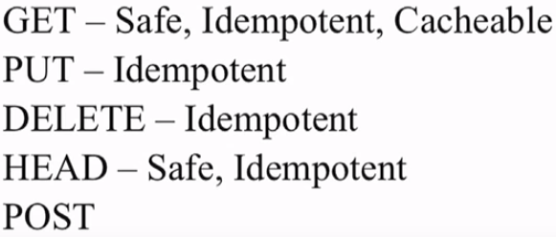
Idempotent means the request can be done multiple times
Safe there are no side effects performing that action

Post has non of these characteristics
HTTP Responses

Generally the client will be a piece of JavaScript code running in the Browser which makes these REST API calls. So sending a response back in JSON makes it easy for the JS client to convert it into a JS object. So for this project we will choose JSON as our response format.
- You dont need to settle for just one type of response format. We could write our APIs in a way so they can return multiple types of responses.

Our Message class could look like this, and when a request is sent to our server, we could send back our data as this JSON file or in an XML file.
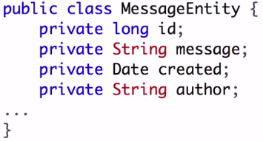
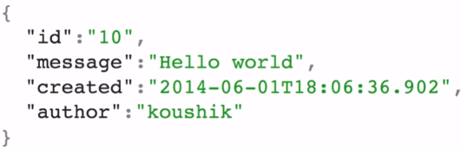
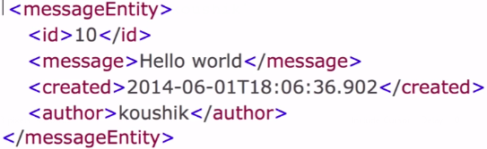

Obviously the responses are different but they still represent the same resource. The resource ID 10
These responses are different representations of the same resource. IMPORTANT to remember, when you make REST API calls you are sending or receiving representations of the resource.

How does the client know what format the response is in ? Of course the client can request a resource in a specific format but there is no guarantee that the server will deliver that format. Clients preferences could be ignored , if a client wants XML but the server only knows JSON.
The client knows which format it got as a response from the HTTP headers / Response headers. The “Content Type” value tells which format the resource is in. So the client can read from the response it gets, which format is sent.

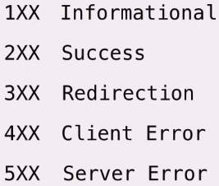
- Letting the client know what the status of the response is , done by “status codes”. The HTTP specification requires the very first line of the response to be a “status line”. Every HTTP response has to have this line. 200 OK , 201 Created (Successful resource creation), 204 No Content (Everything is OK but There is nothing to send back), 400 Bad Request, 401 Unauthorized, 403 Forbidden, 404 Non Found , 415 Unsupported Media Type...

These codes are for us to use , to send the right error codes when these events happens.
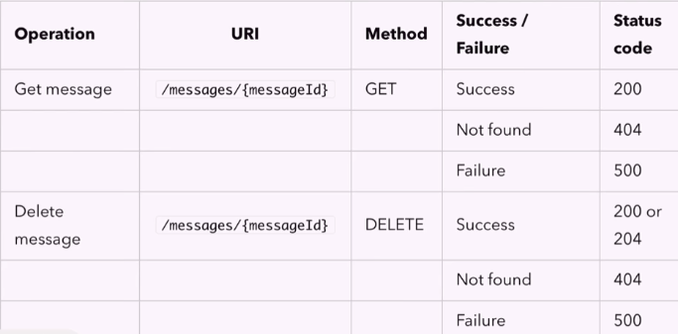
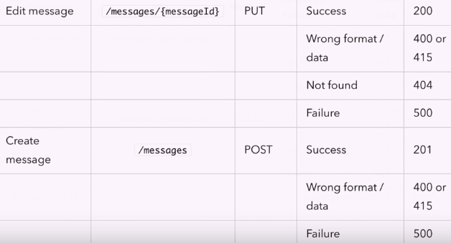

HATEOAS

Hypermedia as the Engine of Application State. As we already mentioned, there is no service definition , spesification for REST API’s, no formal document for these API’s. There are “help pages” that helps explaining what the REST URI’s are and what operations are supported on these.
→ We said previously also “Best API’s dont even need a documentation” .
When we visit a website , we dont need to look for a documantation for how to use that Website. We just remember the main URL of the site and then we can navigate with the hyperlinks to other pages we want.
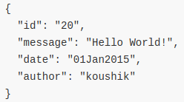
We can implement the same concept in the response for a REST API. Lets say we receive a GET request for a message ID.

We return that message ID in XML or JSON.

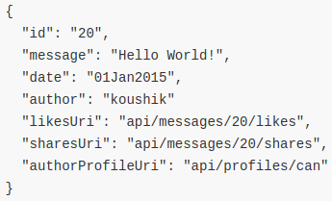
What if we could also send links to the comment, likes, shares resource URIs ?
It means the Web-service being really helpful to the client by providing all these additional links in the response. Same as hyperlinks in Websites : Doenst matter if the user wants to use them or not, but if they do , its there.
Every response will have some links to a service that the client might want to interact with.
- If we structure our API like this, the client programmer doesnt have to know and hard code these URI’s in order to interact with the resources. Let the hypertext/hypermedia (response) drive the clients interaction with the application state.
    - So we can say that the “Hypermedia As (is) The Engine Of Application State : HATEOAS
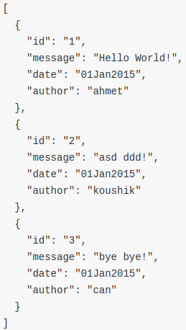
Another important thing :
When the client gets all the messages with /messages he will get a collection of message resources.(see right). Lets say the client wants to get the details just for a particular message or update it, the first message.
BUT they WILL NOT KNOW how to access that resource, what the Instance resource URI looks like, will it be /messages/ahmet , /messages/1, /messages/xxx or something else. So to use this they have to know before hand that the right way is /messages/messageID.
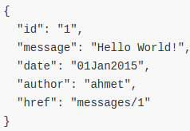
- Why not send the whole URI to the client ourselves ?
Its the same resource just with one more property, href : Contains the link to that message resource instance

If this were the kind of response we would send for every message in /messages, the client would have to do any URI constructions themselves.
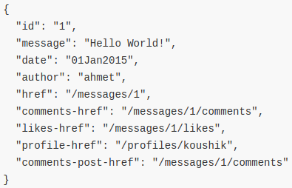
We can provide more links in our responses. A message resource could also have a link to get all the comments/likes/shares for that messages. Even links for posting comments for that message.
If we extend this it can get messy →
- Now the client doenst need to remember the URI’s, yes
- But now they have to remember all the property names for thes URI’s
(We basically have the same problem)
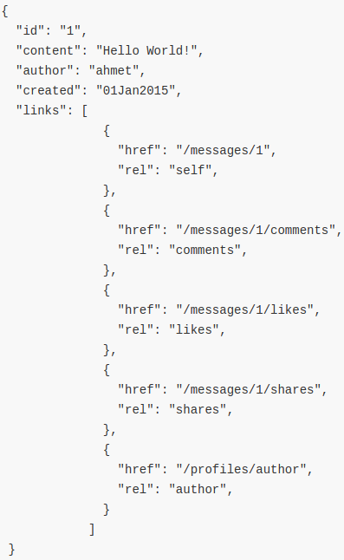
The “rel” attribute
The rel attribute specifies the relationship between the current document and the linked document.
Most common example :
<link href="css/bootstrap.min.css" rel="stylesheet">

The href provides the URI being linked and the rel attribute describes the relation of this link to the main document. (Here : “the link is the stylesheet of the main document”)
So we can use this rel attribute to add extra information in our REST response →
- Now the client doesnt have to remember the link property name, they just have to find the link for the right rel value for the resource that they want and they just look up the href for that link.

While the concept of having URI’s in the response to achieve HATEOAS is something well understood and mostly agreed upon by all. They way to do this could differ drastically depending on the implementation ! We just one one of the ways here to structure our links ! (There is no right or wrong) We can choose to tweak how we want to present the links in our JSON response, depending on our preferance and the clients ease of use.
Secondly, the rel attribute here is a part of the HTTP spesification. So there are only some standard values that are allowed for it. The rel values here like “comments” “likes” … are not actual standardized values but we will still use it.
The main idea : The API should be easy for the client to use and easy for us to maintain. We dont want to focus too much on getting things right , going by the book atleast Not at the cost of complicating the API too much.

The Richardson Maturity Model


Are we in a position to say that our API is fully RESTful ?
This isnt a “yes” or a “no” question. There is a spectrum of different terms , almost Restful , fully Restfull ….
So how do we know how RESTful an API is ?
There is one way to know it. With the Richardson Maturity Model. There are 3 Levels and every RESTful API belongs to one of these levels. The model also defines a Level 0 which is NOT a RESTful API.
Its not necessary that every API scores high in this Model. But its more for knowing where do we stand with our API and make it better if possible.

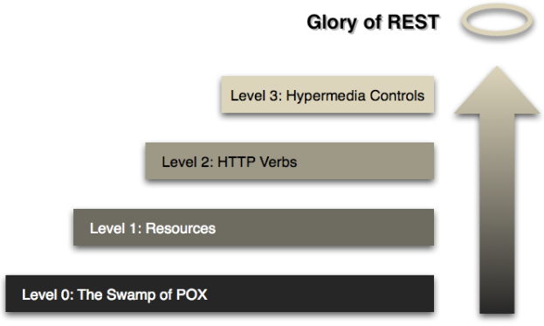
(Is Not REST) Level 0 : (Plain Old XML). Define everything that the operation need in XML. No HTTP concepts are used to communicate information.
Level 1 : When we introduce the Resource concept. We designed resource URI’s for messages , comments … If we did just this and nothing else , we stand at level 1.
Message requests going to one URI , comment requests going to another URI and so on.
The message would still contain the operation that needs to be done.

Level 2 : Introducing different HTTP methods for different operations. An API on level 2 uses standart HTTP methods like GET,POST … to do different operations on the resource URI’s.
The URI specifies the resource that is being operated upon and the HTTP method specifies what the operation is. Also the right use of idempotent and non idempotent Methods.

Level 3 : When we implement HATEOAS.

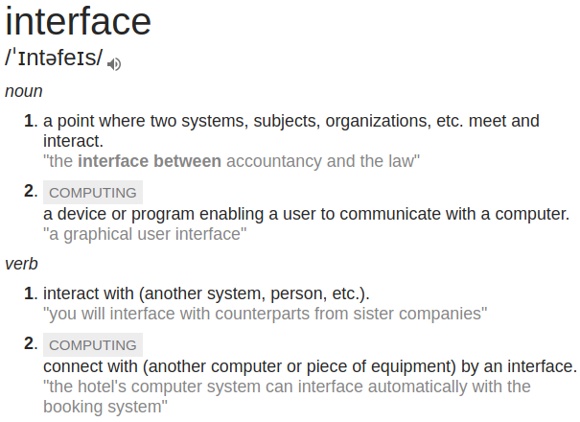

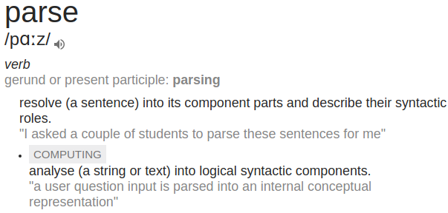

JAX-RS
JAX-RS: Java API for RESTful Web Services (JAX-RS) is a Java programming language API spec that provides support in creating web services according to the Representational State Transfer (REST) architectural pattern. JAX-RS uses annotations, introduced in Java SE 5, to simplify the development and deployment of web service clients and endpoints.
From version 1.1 on, JAX-RS is an official part of Java EE 6. A notable feature of being an official part of Java EE is that no configuration is necessary to start using JAX-RS. For non-Java EE 6 environments a small entry in the web.xml deployment descriptor is required.

- Different libraries like RESTeasy or Jersey implement the same API. So they have the same interface. Thats why they are really similar.
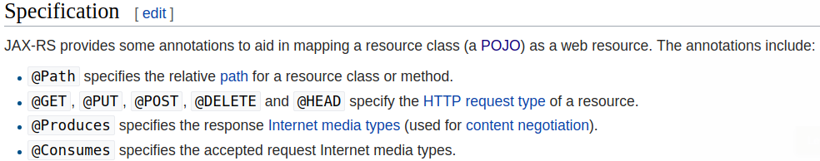
In addition, it provides further annotations to method parameters to pull information out of the request. All the @*Param annotations take a key of some form which is used to look up the value required.
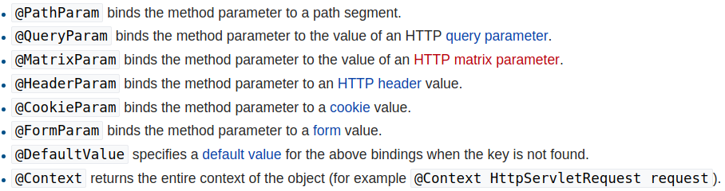
→ JAX-RS has all the interfaces and annotations, it doesnt have any functionality. We need classes to implement these interfaces and read these annotations. This is where libraries come in play. These libraries look at our code, see where we called the JAX-RS API’s and then they do the actual work. Our application interacts with JAX-RS interfaces and annotations.
Typically :
1. Write the application using JAX-RS interfaces and annotations
2. Deploy the application to TomCat along with JAX-RS API Classes and a library of our choice (JAX-RS API classes because we are using these classes and a library because it does the actual work)
- We dont have to include these 2 things. Every JAX-RS library comes with a copy of the API Classes. So we need to include only the library. So just deploy your app ,including the library, plug it into Tomcat and it should work
- Thats why we can replace one library with others (they are interchangeable)
- We choose Jersey because its a “Reference Implementation” for the JAX-RS specifiaction.

