Concurrency
The Java platform is designed from the ground up to support concurrent programming, with basic concurrency support in the Java programming language and the Java class libraries. Since version 5.0, the Java platform has also included high-level concurrency APIs. This lesson introduces the platform's basic concurrency support and summarizes some of the high-level APIs in the java.util.concurrent packages.
Processes and Threads
In concurrent programming, there are two basic units of execution: processes and threads. In the Java programming language, concurrent programming is mostly concerned with threads. However, processes are also important.
A computer system normally has many active processes and threads. This is true even in systems that only have a single execution core, and thus only have one thread actually executing at any given moment. Processing time for a single core is shared among processes and threads through an OS feature called time slicing.
It's becoming more and more common for computer systems to have multiple processors or processors with multiple execution cores. This greatly enhances a system's capacity for concurrent execution of processes and threads — but concurrency is possible even on simple systems, without multiple processors or execution cores.

Processes
A process has a self-contained execution environment. A process generally has a complete, private set of basic run-time resources; in particular, each process has its own memory space.
Processes are often seen as synonymous with programs or applications. However, what the user sees as a single application may in fact be a set of cooperating processes. To facilitate communication between processes, most operating systems support Inter Process Communication (IPC) resources, such as pipes and sockets. IPC is used not just for communication between processes on the same system, but processes on different systems.
Most implementations of the Java virtual machine run as a single process. A Java application can create additional processes using a ProcessBuilder object. Multiprocess applications are beyond the scope of this lesson.

Threads
Threads are sometimes called lightweight processes. Both processes and threads provide an execution environment, but creating a new thread requires fewer resources than creating a new process.
Threads exist within a process — every process has at least one. Threads share the process's resources, including memory and open files. This makes for efficient, but potentially problematic, communication.
Multithreaded execution is an essential feature of the Java platform. Every application has at least one thread — or several, if you count "system" threads that do things like memory management and signal handling. But from the application programmer's point of view, you start with just one thread, called the main thread. This thread has the ability to create additional threads, as we'll demonstrate in the next section.
Each thread is associated with an instance of the class Thread. There are two basic strategies for using Thread objects to create a concurrent application.
- To directly control thread creation and management, simply instantiate Thread each time the application needs to initiate an asynchronous task.
- To abstract thread management from the rest of your application, pass the application's tasks to an executor.
This section documents the use of Thread objects. Executors are discussed with other high-level concurrency objects.
Process
Each process provides the resources needed to execute a program. A process has a virtual address space, executable code, open handles to system objects, a security context, a unique process identifier, environment variables, a priority class, minimum and maximum working set sizes, and at least one thread of execution. Each process is started with a single thread, often called the primary thread, but can create additional threads from any of its threads.
Thread
A thread is an entity within a process that can be scheduled for execution. All threads of a process share its virtual address space and system resources. In addition, each thread maintains exception handlers, a scheduling priority, thread local storage, a unique thread identifier, and a set of structures the system will use to save the thread context until it is scheduled. The thread context includes the thread's set of machine registers, the kernel stack, a thread environment block, and a user stack in the address space of the thread's process. Threads can also have their own security context, which can be used for impersonating clients.

Sunucu mimarisinde port 80’e gelen requestlerleri hemen başka bir threade atıyor ve requestleri dinleyen thread bu sayede sürekli dinleyebiliyor.
Process kol, Thread, parmak. Threadler bir processin içinde çalışıyor.
Thread vs Process
- Process’ run in their own address space. Her processe kendisine özgü bir adres atanır. Kendi dünyasında, sanki tek process oymuş zanneder. Ona sanal bir şekilde ram’de adres aralığı veriliyor. Process zannerdiyor ki 1 numaralı adrese eriştim, ancak gerçekte 3000 numaralı adres.
- Threads shared memory. Bir processin içinde threadler üretildiği için, o processin address space’ini threadler paylarşıyor. Bir değişkenin değeri bir threadde değiştiriliyor ise, diğer bütün threadlerde de değişir. Ama process oluşturulurken o değişkenin bir kopyası yeni bir process için oluşturulur, yani artık iki ayrı değişken vardır ramde. Isimleri aynı olsa bile 2 farklı değişken.
- Process üretmek maliyetli. Thread maliyeti az. Multi-tasking işler için threadlerin kullanılması daha ekonomik.
- Scalability

MsDos uni process, uni thread
Modern OS, multi process, multi thread
Java, chromeOS: Uni process, multi thread
windows 3.1: Multi process, uni thread
- ilk önce donanımın multi core /multi processor olması lazım. Sonra işletim sisteminin multi processingi / threadingi desteklemesi lazım vs son olarak çalıştırılan programın da ona göre yazılmış olması lazım

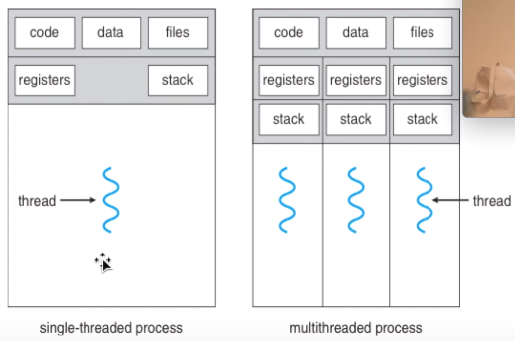

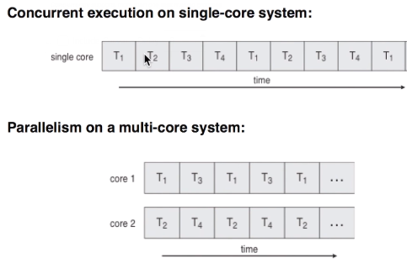

Java Thread meşhur kütüphane. Java threadlerinin güzel yanı: java 7-8’e kadar (?) process desteği yoktu. Birden fazla process java’da create edemiyorduk. Çünkü java’nın kendisi bir VM, sanal bir makine olarak zaten bir process. Java ortamında birden fazla işi yapabilmek istediğimizde threadlere muhtacız.
Java’nın her ortamda çalışabilme desteği var (WORA). Bunun için Java’nın tek bir işlem olarak kalması, o işlem üzerinde concurrency desteklemesine zorladı.
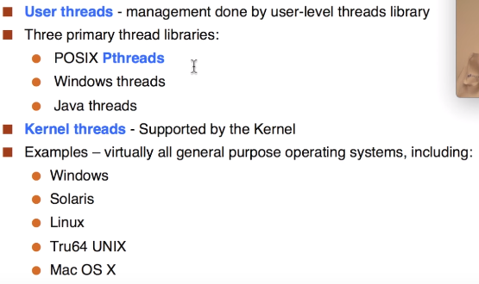
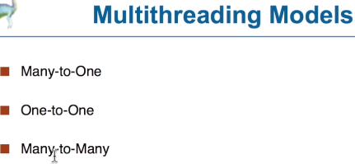
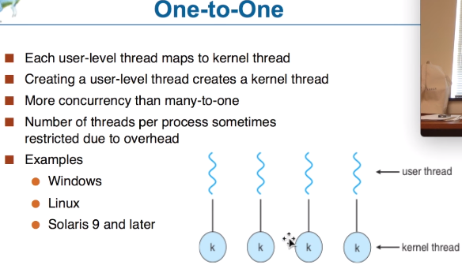
Artık java threadlerinin dışında java processleri de üretilebiliyor.

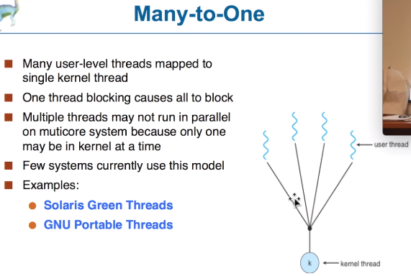

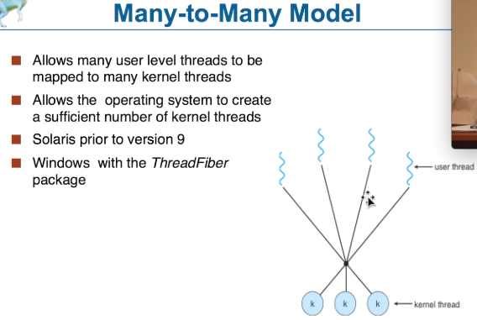
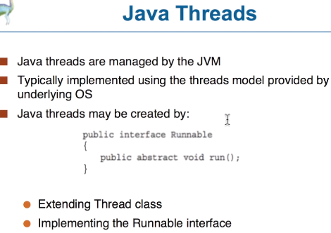
Threads, Cores, Hyper-threading, CPU, OS
Hyperthreading is not truly paralell: Hyperthreading causes two processes to share the same cpu, with fast context switching between the two processes. No additional computation resources are made available in this mode, so if both processes want access to the CPU then the two are going to contend for access, and on long term average probably each get a little under 1/2 of the work done that they would have gotten with dedicated CPUs.
Hyperthreading is just a clever way to schedule things. It kind of splits the cpu and can execute 2 threads on 1 cpu. Not the same as doubling your cores.
“With HTT, one physical core appears as two processors to the operating system, allowing concurrent scheduling of two processes per core. In addition, two or more processes can use the same resources: if resources for one process are not available, then another process can continue if its resources are available.”

You could have an infinite number of threads executed on the same processor via switching, i.e. executing one line of code from one thread and then switching to another, executing one line of code, and then switching back. The processor mimics "simultaneous execution" by switching back and forth really quickly.
However, most processors are limited on the number of true simultaneous threads they can execute to the number of cores they have, but even that is a bad estimate due to shared resources and hardware. In theory you could have up to 4 simultaneous threads running on a 4-core processor.

Software threads are threads of execution managed by the operating system.
Hardware threads are a feature of some processors that allow better utilization of the processor under some circumstances. They may be exposed to/by the operating system as appearing to be additional cores ("hyperthreading").
In Java, the threads you create maintain the software thread abstraction, where the JVM is the "operating system". Whether the JVM then maps Java threads to OS threads is the JVM's business (but it almost certainly does). And then the OS will be using hardware threads if they are available.

a "hardware thread" is a physical cpu or core. So, a 4 core cpu can support 4 hardware threads at once - the cpu really is doing 4 things at the same time. (not including hyperthreading in this example)
One hardware thread can run many software threads. In modern operating systems, this is often done by time-slicing - each thread gets a few milliseconds to execute before the OS schedules another thread to run on that cpu. Since the OS switches back and forth between the threads quickly, it appears as if one cpu is doing more than one thing at once, but in reality, a core is still running only one hardware thread, which switches between many software threads.
Modern JVMs map java threads directly to the native threads provided by the OS, so there is no inehrent overhead introduced by java threads vs native threads. As to hardware threads, the OS tries to map threads to cores, if there are sufficient cores. So, if you have a java program that starts 4 threads, and have more 4 or more cores, there's a good chance your 4 threads will run truly in parallel on 4 separate cores, if the cores are idle.
- Benim anladığım: Gerçekten paralel işlemleri yalnızca birden fazla çekirdek ile yapabiliriz. Hyperthreading 1 core’da 2 thread çalışyırabiliyor gibi gözüküyor ancak gerçek anlamda paralel değil, o da time-slicing / switching tarzı bir olay ve farklı teklonojiler kullanılıyor. Genelde 1 core 1 thread çalıştırıyor ve OS bu processleri time-slicing / scheduling ile parçalara bölüp cpu’ya gönderiyor ve OS’in oluşturduğu bütün threadler parça parça her biri işleniyor. Sanki hepsi aynı anda oluyormuş izlenimi veriyor.
- JVM’deki threadleri genelde OS’de threade dönüştürüp cpu’da çalıştırıyor..

Defining and Starting a Thread
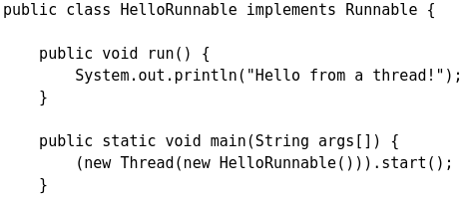
An application that creates an instance of Thread must provide the code that will run in that thread. There are two ways to do this:
- Provide a Runnable object. The Runnable interface defines a single method, run, meant to contain the code executed in the thread. The Runnable object is passed to the Thread constructor, as in the HelloRunnable example:

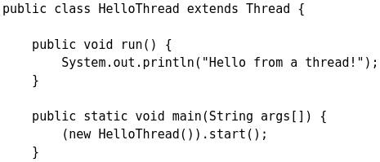
- Subclass Thread. The Thread class itself implements Runnable, though its run method does nothing. An application can subclass Thread, providing its own implementation of run, as in the HelloThread example:

Notice that both examples invoke Thread.start in order to start the new thread.
Which of these idioms should you use? The first idiom, which employs a Runnable object, is more general, because the Runnable object can subclass a class other than Thread. The second idiom is easier to use in simple applications, but is limited by the fact that your task class must be a descendant of Thread. This lesson focuses on the first approach, which separates the Runnable task from the Thread object that executes the task. Not only is this approach more flexible, but it is applicable to the high-level thread management APIs covered later.
The Thread class defines a number of methods useful for thread management. These include static methods, which provide information about, or affect the status of, the thread invoking the method. The other methods are invoked from other threads involved in managing the thread and Thread object.

Pausing Execution with Sleep
Thread.sleep causes the current thread to suspend execution for a specified period. This is an efficient means of making processor time available to the other threads of an application or other applications that might be running on a computer system. The sleep method can also be used for pacing, as shown in the example that follows, and waiting for another thread with duties that are understood to have time requirements, as with the SimpleThreads example in a later section.
Two overloaded versions of sleep are provided: one that specifies the sleep time to the millisecond and one that specifies the sleep time to the nanosecond. However, these sleep times are not guaranteed to be precise, because they are limited by the facilities provided by the underlying OS. Also, the sleep period can be terminated by interrupts, as we'll see in a later section. In any case, you cannot assume that invoking sleep will suspend the thread for precisely the time period specified.
InterruptedException is an exception that sleep throws when another thread interrupts the current thread while sleep is active.

Interrupts
An interrupt is an indication to a thread that it should stop what it is doing and do something else. It's up to the programmer to decide exactly how a thread responds to an interrupt, but it is very common for the thread to terminate. This is the usage emphasized in this lesson.
A thread sends an interrupt by invoking interrupt on the Thread object for the thread to be interrupted. For the interrupt mechanism to work correctly, the interrupted thread must support its own interruption.

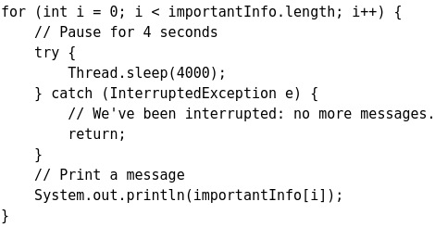
Supporting Interruption
How does a thread support its own interruption? This depends on what it's currently doing. If the thread is frequently invoking methods that throw InterruptedException, it simply returns from the run method after it catches that exception. For example, suppose the central message loop in the SleepMessages example were in the run method of a thread's Runnable object. Then it might be modified as follows to support interrupts:
Many methods that throw InterruptedException, such as sleep, are designed to cancel their current operation and return immediately when an interrupt is received.
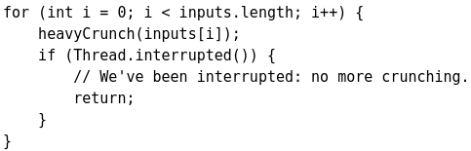
What if a thread goes a long time without invoking a method that throws InterruptedException? Then it must periodically invoke Thread.interrupted, which returns true if an interrupt has been received. For example:

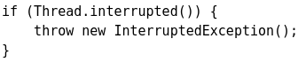
In this simple example, the code simply tests for the interrupt and exits the thread if one has been received. In more complex applications, it might make more sense to throw an InterruptedException. This allows interrupt handling code to be centralized in a catch clause
The Interrupt Status Flag
The interrupt mechanism is implemented using an internal flag known as the interrupt status. Invoking Thread.interrupt sets this flag. When a thread checks for an interrupt by invoking the static method Thread.interrupted, interrupt status is cleared. The non-static isInterrupted method, which is used by one thread to query the interrupt status of another, does not change the interrupt status flag.
By convention, any method that exits by throwing an InterruptedException clears interrupt status when it does so. However, it's always possible that interrupt status will immediately be set again, by another thread invoking interrupt.
Joins
The join method allows one thread to wait for the completion of another. If t is a Thread object whose thread is currently executing, t.join();
causes the current thread (in a simple example current thread will be the main thread) to pause execution until t's thread terminates. Overloads of join allow the programmer to specify a waiting period. However, as with sleep, join is dependent on the OS for timing, so you should not assume that join will wait exactly as long as you specify. Like sleep, join responds to an interrupt by exiting with an InterruptedException.

SimpleThread Açıklaması
Her java applikasyonumain thread le başlar. Bu örnekte main threadi sırayla bütün satırları execute ediyor. Altlara doğru yeni bir Thread oluşturuyor ve t.start(); dediği anda oluşturulan thread t ve main threadi beraber çalışmaya başlıyor! Main thread durmuyor! Yeni oluşturulan thread ise, run methodunun içindeki kodu 1 kere execute ediyor normalde, ancak loop olduğu için bu örnekte birkaç kere execute ediyor.
Main threadi sürekli t.isAllive() methodu ile t’nin hala execute edip etmediğine bakıyor. Ilk başta t.join(1000) methodu ile duruyor ve 1 saniye boyunca t’nin bitmesini bekliyor. t 1 saniyede bitmez ise main threadi devam ediyor ve if bloğuna geliyor. Eğer belirlenen süreyi geçmiş ise t.interrupd() ile threadi terminate’e davet ediyoruz ve t.join() ile tamamen bitene kadar main bekliyor (waits forever).
public final void join(long millis) throws InterruptedException
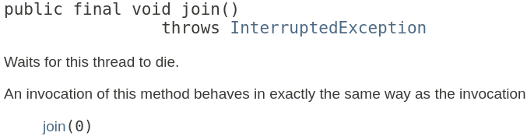
The SimpleThreads Example
The following example brings together some of the concepts of this section. SimpleThreads consists of two threads. The first is the main thread that every Java application has. The main thread creates a new thread from the Runnable object, MessageLoop, and waits for it to finish. If the MessageLoop thread takes too long to finish, the main thread interrupts it.
The MessageLoop thread prints out a series of messages. If interrupted before it has printed all its messages, the MessageLoop thread prints a message and exits.
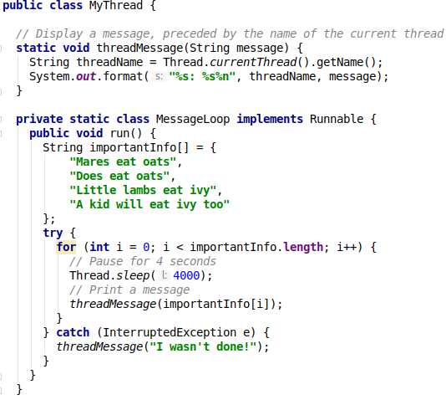
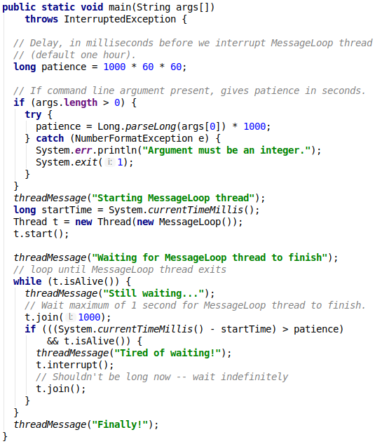

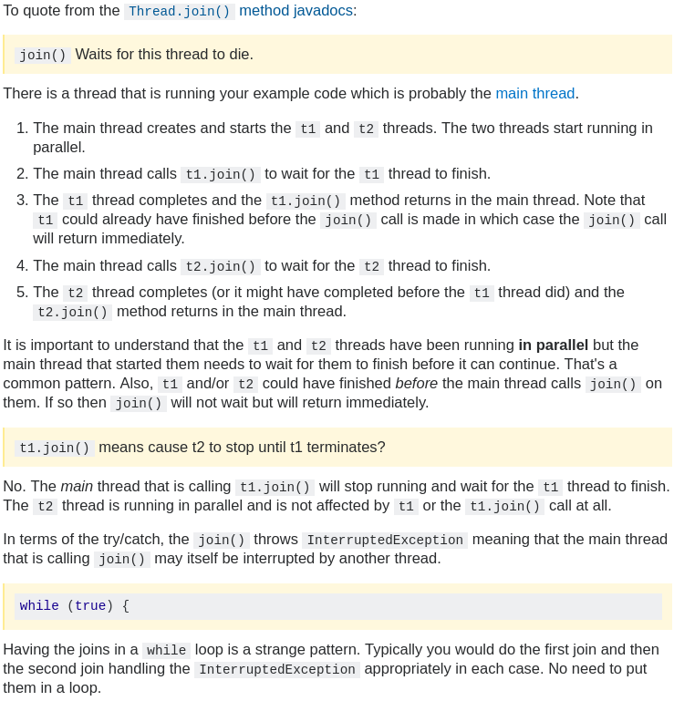
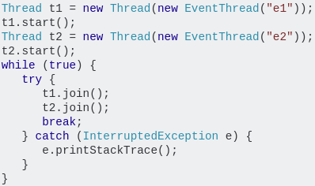
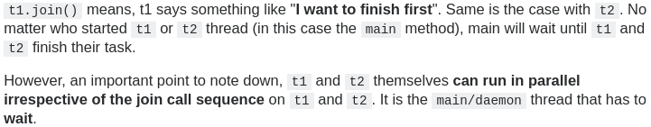


Synchronization
Threads communicate primarily by sharing access to fields and the objects reference fields refer to. This form of communication is extremely efficient, but makes two kinds of errors possible: thread interference and memory consistency errors. The tool needed to prevent these errors is synchronization.
However, synchronization can introduce thread contention, which occurs when two or more threads try to access the same resource simultaneously and cause the Java runtime to execute one or more threads more slowly, or even suspend their execution. Starvation and livelock are forms of thread contention.
This section covers the following topics:
- Thread Interference describes how errors are introduced when multiple threads access shared data.
- Memory Consistency Errors describes errors that result from inconsistent views of shared memory.
- Synchronized Methods describes a simple idiom that can effectively prevent thread interference and memory consistency errors.
- Implicit Locks and Synchronization describes a more general synchronization idiom, and describes how synchronization is based on implicit locks.
- Atomic Access talks about the general idea of operations that can't be interfered with by other threads.

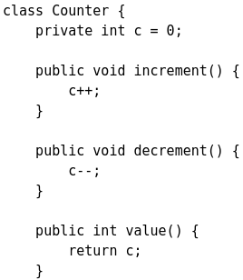
Thread Interference (Lost Update)
Counter is designed so that each invocation of increment will add 1 to c, and each invocation of decrement will subtract 1 from c. However, if a Counter object is referenced from multiple threads, interference between threads may prevent this from happening as expected.
Interference happens when two operations, running in different threads, but acting on the same data, interleave. This means that the two operations consist of multiple steps, and the sequences of steps overlap.
It might not seem possible for operations on instances of Counter to interleave, since both operations on c are single, simple statements. However, even simple statements can translate to multiple steps by the virtual machine. We won't examine the specific steps the virtual machine takes — it is enough to know that the single expression c++ can be decomposed into three steps:
- Retrieve the current value of c.
- Increment the retrieved value by 1.
- Store the incremented value back in c.
Suppose Thread A invokes increment at about the same time Thread B invokes decrement. If the initial value of c is 0, their interleaved actions might follow this sequence:
- Thread A: Retrieve c. Thread B: Retrieve c.
- Thread A: Increment retrieved value; result is 1.
- Thread B: Decrement retrieved value; result is -1.
- Thread A: Store result in c; c is now 1.
- Thread B: Store result in c; c is now -1.
- Thread A's result is lost, overwritten by Thread B.
This particular interleaving is only one possibility. Under different circumstances it might be Thread B's result that gets lost, or there could be no error at all. Because they are unpredictable, thread interference bugs can be difficult to detect and fix.
Memory Consistency Errors (inconsistent read)
Memory consistency errors occur when different threads have inconsistent views of what should be the same data. The causes of memory consistency errors are complex and beyond the scope of this tutorial. Fortunately, the programmer does not need a detailed understanding of these causes. All that is needed is a strategy for avoiding them.
The key to avoiding memory consistency errors is understanding the happens-before relationship. This relationship is simply a guarantee that memory writes by one specific statement are visible to another specific statement. Two actions can be ordered by a happens-before relationship. If one action happens-before another, then the first is visible to and ordered before the second. To see this, consider the following example. Suppose a simple int field is defined and initialized:
int counter = 0; The counter field is shared between two threads, A and B. Suppose thread A increments counter: counter++; Then, shortly afterwards, thread B prints out counter: System.out.println(counter);
If the two statements had been executed in the same thread, it would be safe to assume that the value printed out would be "1". But if the two statements are executed in separate threads, the value printed out might well be "0", because there's no guarantee that thread A's change to counter will be visible to thread B — unless the programmer has established a happens-before relationship between these two statements.
There are several actions that create happens-before relationships. One of them is synchronization, as we will see in the following sections.
We've already seen two actions that create happens-before relationships.
- When a statement invokes Thread.start, every statement that has a happens-before relationship with that statement also has a happens-before relationship with every statement executed by the new thread. The effects of the code that led up to the creation of the new thread are visible to the new thread.
- When a thread terminates and causes a Thread.join in another thread to return, then all the statements executed by the terminated thread have a happens-before relationship with all the statements following the successful join. The effects of the code in the thread are now visible to the thread that performed the join.
For a list of actions that create happens-before relationships, refer to the Summary page of the java.util.concurrent package.

- We can change the name of threads in different ways to manage them easier: thread.setName(“newName”);
- Threads have different priority values. It can be 1 <= p <= 10, default is 5. 10 is highest 0 is lowest. Changing the priority: t1.setPriority(10);
- Thread.getCurrentThread() returns the thread currently executing.
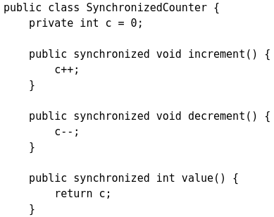
Synchronized Methods
The Java programming language provides two basic synchronization idioms: synchronized methods and synchronized statements. The more complex of the two, synchronized statements, are described in the next section. This section is about synchronized methods.
To make a method synchronized, simply add the synchronized keyword to its declaration.
If count is an instance of SynchronizedCounter, then making these methods synchronized has two effects:
- First, it is not possible for two invocations of synchronized methods on the same object to interleave. When one thread is executing a synchronized method for an object, all other threads that invoke synchronized methods for the same object will be blocked (suspend execution) until the first thread is done with the object.
- Second, when a synchronized method exits, it automatically establishes a happens-before relationship with any subsequent invocation (call) of a synchronized method for the same object. This guarantees that changes to the state of the object are visible to all threads.
Note that constructors cannot be synchronized — using the synchronized keyword with a constructor is a syntax error. Synchronizing constructors doesn't make sense, because only the thread that creates an object should have access to it while it is being constructed.
- Warning: When constructing an object that will be shared between threads, be very careful that a reference to the object does not "leak" prematurely. For example, suppose you want to maintain a List called instances containing every instance of class. You might be tempted to add the following line to your constructor: instances.add(this); But then other threads can use instances to access the object before construction of the object is complete.
Synchronized methods enable a simple strategy for preventing thread interference and memory consistency errors:
- if an object is visible to more than one thread, all reads or writes to that object's variables are done through synchronized methods. (An important exception: final fields, which cannot be modified after the object is constructed, can be safely read through non-synchronized methods, once the object is constructed) This strategy is effective, but can present problems with liveness, as we'll see later in this lesson.

Intrinsic Locks and Synchronization
Synchronization is built around an internal entity known as the intrinsic lock or monitor lock. (The API specification often refers to this entity simply as a "monitor.")
Intrinsic locks play a role in both aspects of synchronization:
- enforcing exclusive access to an object's state and
- establishing happens-before relationships that are essential to visibility.
Every object has an intrinsic lock associated with it. By convention, a thread that needs exclusive and consistent access to an object's fields has to acquire the object's intrinsic lock before accessing them, and then release the intrinsic lock when it's done with them. A thread is said to own the intrinsic lock between the time it has acquired the lock and released the lock. As long as a thread owns an intrinsic lock, no other thread can acquire the same lock. The other thread will block when it attempts to acquire the lock.
When a thread releases an intrinsic lock, a happens-before relationship is established between that action and any subsequent acquisition of the same lock. (intrinsic = esas, iç, hakiki, özünde olan)

Locks In Synchronized Methods
When a thread invokes a synchronized method, it automatically acquires the intrinsic lock for that method's object and releases it when the method returns. The lock release occurs even if the return was caused by an uncaught exception.
You might wonder what happens when a static synchronized method is invoked, since a static method is associated with a class, not an object.
- In this case, the thread acquires the intrinsic lock for the Class object associated with the class. Thus access to class's static fields is controlled by a lock that's distinct from the lock for any instance of the class.
Different explonation: (not javadoc) In Java, an intrinsic lock is implied by each use of the synchronized keyword. In this case, the locking is performed by Java behind the scenes. (This is distinct from the programmer using or defining an explicit lock object themselves.)
Each use of the synchronized keyword is associated with one of the two types of intrinsic lock:
- an "instance lock", attached to a single object
- a "static lock", attached to a class
If a method is declared as synchronized, then it will acquire either the instance lock or the static lock when it is invoked, according to whether it is an instance method or a static method.
- The two types of lock have similar behaviour, but are completely independent of each other.
Acquiring the instance lock only blocks other threads from invoking a synchronized instance method; it does not block other threads from invoking an un-synchronized method, nor does it block them from invoking a static synchronized method.
Similarly, acquiring the static lock only blocks other threads from invoking a static synchronized method; it does not block other threads from invoking an un-synchronized method, nor does it block them from invoking a synchronized instance method.
Outside of a method header, synchronized(this) acquires the instance lock.
The static lock can be acquired outside of a method header in two ways:
- synchronized(Blah.class), using the class literal
- synchronized(this.getClass()), if an object is available

Synchronized Statements
Another way to create synchronized code is with synchronized statements. Unlike synchronized methods, synchronized statements must specify the object that provides the intrinsic lock:
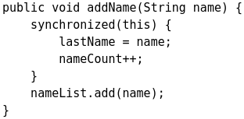
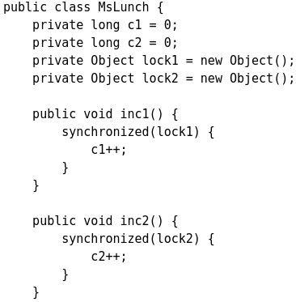
In this example, the addName method needs to synchronize changes to lastName and nameCount, but also needs to avoid synchronizing invocations of other objects' methods. (Invoking other objects' methods from synchronized code can create problems that are described in the section on Liveness.) Without synchronized statements, there would have to be a separate, unsynchronized method for the sole purpose of invoking nameList.add.
Synchronized statements are also useful for improving concurrency with fine-grained synchronization. Suppose, for example, class MsLunch has two instance fields, c1 and c2, that are never used together. All updates of these fields must be synchronized, but there's no reason to prevent an update of c1 from being interleaved with an update of c2 — and doing so reduces concurrency by creating unnecessary blocking. Instead of using synchronized methods or otherwise using the lock associated with this, we create two objects solely to provide locks.
- Use this idiom with extreme care. You must be absolutely sure that it really is safe to interleave access of the affected fields.

Reentrant Synchronization
Recall that a thread cannot acquire a lock owned by another thread. But a thread can acquire a lock that it already owns. Allowing a thread to acquire the same lock more than once enables reentrant synchronization. This describes a situation where synchronized code, directly or indirectly, invokes a method that also contains synchronized code, and both sets of code use the same lock. Without reentrant synchronization, synchronized code would have to take many additional precautions to avoid having a thread cause itself to block.
“What you might also find interesting is the term reentrancy, which allows the same thread to acquire the same lock again. Intrinsic locks are reentrant.”

Synchronize access to mutable fields (not javadoc)
In a multi-threaded environment, accessing mutable data (data that can change) must always be coordinated between readers and writers. The task of making sure that readers and writers don't interfere with each other in undesirable ways is called synchronization. Synchronization can be done with an explicit lock object, but a more common style is to use the intrinsic locks implied by the synchronized keyword.
For example, in a multi-threaded environment, all get and set methods for mutable fields should usually be synchronized methods. This includes primitive fields.
Most classes do not need to be designed for operation in a multi-threaded environment, and can ignore these considerations.
If an object does need to live in a multi-threaded environment, however, then a significant amount of care must be taken to ensure that it is correctly designed.
If an object is immutable, then it's automatically thread-safe. If it's mutable, then extra steps must be taken to ensure thread-safety: every use of every mutable field must be synchronized in some way (usually with using the synchronized keyword).
Here, mutable field simply means a field which might change in any way, after the initial construction of the object. (Objects are never shared between threads until after the object is fully created.) For example,
- an int field that changes its value some time after the constructor completes
- a Date field that changes state some time after the constructor completes, to represent a different date from the original
- any object field that is "pointed" to a new object, some time after the constructor completes
Remember that all local variables declared in the body of a method are never shared between threads, and so have no thread-safety considerations.
- It's a misconception that all mutable primitives except long and double do not need synchronized access.
Thread Safety (not javadoc)
“A piece of code is thread-safe if it functions correctly during simultaneous execution by multiple threads.”
“In particular, it must satisfy the need for multiple threads to access the same shared data, …”
“…and the need for a shared piece of data to be accessed by only one thread at any given time.”

Client side locking, if I understand what you mean, is something different. When you don't have a thread safe class, your clients need to take care about this. They need to hold locks so they can make sure that there are not any race conditions.
Extrinsic locking is, instead of using the built in mechanism of synchronized block which gives you implicit locks to specifically use explicit locks. It is kind of more sophisticate way of locking. There are many advantages (for example you can set priorities).
Atomic Access
In programming, an atomic action is one that effectively happens all at once. An atomic action cannot stop in the middle: it either happens completely, or it doesn't happen at all. No side effects of an atomic action are visible until the action is complete.
We have already seen that an increment expression, such as c++, does not describe an atomic action. Even very simple expressions can define complex actions that can decompose into other actions. However, there are actions you can specify that are atomic:
- Reads and writes are atomic for reference variables and for most primitive variables (all types except long and double). Important: Writing does not mean incrementing!!! It means assigning something to that variable. Incrementing a variable is not atomic, primitives are not thread-safe, read ve write atomic demek başka (internette böyle yazıyor)
- Reads and writes are atomic for all variables declared volatile (including long and double variables).
Using simple atomic variable access is more efficient than accessing these variables through synchronized code, but requires more care by the programmer to avoid memory consistency errors. Whether the extra effort is worthwhile depends on the size and complexity of the application.
Some of the classes in the java.util.concurrent package provide atomic methods that do not rely on synchronization. We'll discuss them in the section on High Level Concurrency Objects.

What does “atomic” mean in programming?
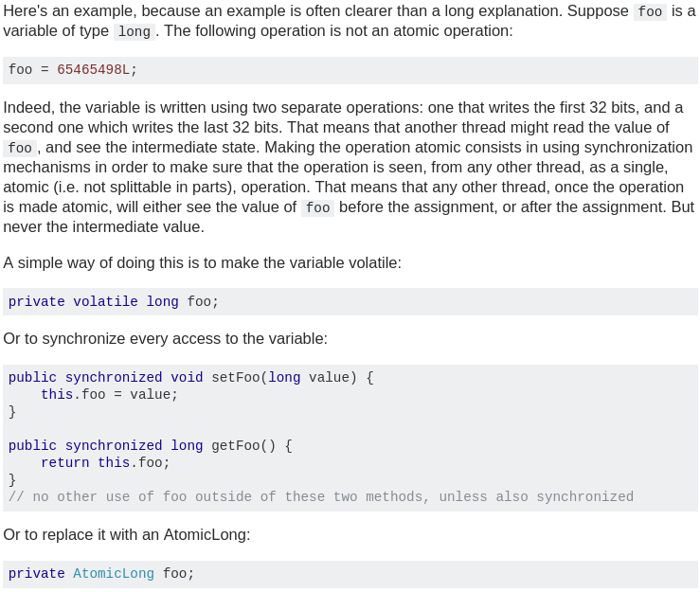
Liveness
A concurrent application's ability to execute in a timely manner is known as its liveness. This section describes the most common kind of liveness problem, deadlock, and goes on to briefly describe two other liveness problems, starvation and livelock.

Deadlock
Deadlock describes a situation where two or more threads are blocked forever, waiting for each other. Here's an example.
Alphonse and Gaston are friends, and great believers in courtesy. A strict rule of courtesy is that when you bow to a friend, you must remain bowed until your friend has a chance to return the bow. Unfortunately, this rule does not account for the possibility that two friends might bow to each other at the same time. This example application, Deadlock, models this possibility:
When Deadlock runs, it's extremely likely that both threads will block when they attempt to invoke bowBack. Neither block will ever end, because each thread is waiting for the other to exit bow.
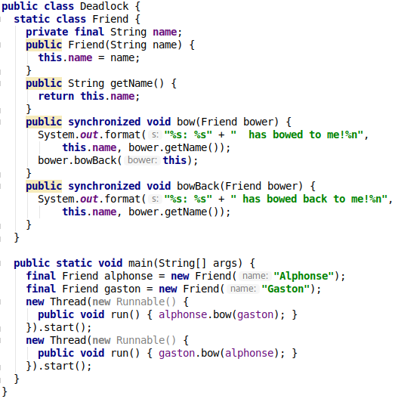
Thread 1: alphonse objesinin lockunu alıyor, aynı anda Thread 2: gaston objesinin lockunu alıyor.
Thread 1 şimdi gaston objesindeki bir synchronized methodu çağırmak istiyor. Ancak kitil alınmış durumda, o nedenle bekliyor. Aynı şekilde Thread 2 de bekliyor.

Starvation and Livelock
Starvation and livelock are much less common a problem than deadlock, but are still problems that every designer of concurrent software is likely to encounter.
Starvation: Starvation describes a situation where a thread is unable to gain regular access to shared resources and is unable to make progress. This happens when shared resources are made unavailable for long periods by "greedy" threads. For example, suppose an object provides a synchronized method that often takes a long time to return. If one thread invokes this method frequently, other threads that also need frequent synchronized access to the same object will often be blocked.
Livelock: A thread often acts in response to the action of another thread. If the other thread's action is also a response to the action of another thread, then livelock may result. As with deadlock, livelocked threads are unable to make further progress. However, the threads are not blocked — they are simply too busy responding to each other to resume work. This is comparable to two people attempting to pass each other in a corridor: Alphonse moves to his left to let Gaston pass, while Gaston moves to his right to let Alphonse pass. Seeing that they are still blocking each other, Alphone moves to his right, while Gaston moves to his left. They're still blocking each other, so…

Guarded Blocks
Threads often have to coordinate their actions. The most common coordination idiom is the guarded block. Such a block begins by polling a condition that must be true before the block can proceed. There are a number of steps to follow in order to do this correctly.
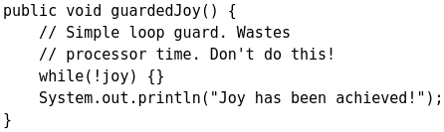
Suppose, for example guardedJoy is a method that must not proceed until a shared variable joy has been set by another thread. Such a method could, in theory, simply loop until the condition is satisfied, but that loop is wasteful, since it executes continuously while waiting.
A more efficient guard invokes Object.wait to suspend the current thread. The invocation of wait does not return until another thread has issued a notification that some special event may have occurred — though not necessarily the event this thread is waiting for:
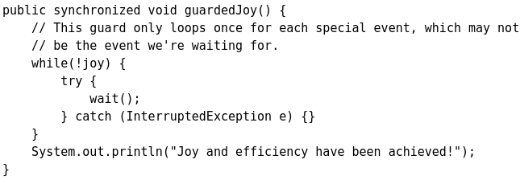
Note: Always invoke wait inside a loop that tests for the condition being waited for. Don't assume that the interrupt was for the particular condition you were waiting for, or that the condition is still true.

Açıklama: thread 1 wait()’i gördüğü zaman bekliyor. Başka bir thread herhangi bir olay olunca notify vaya notify all methodları ile haber gönderirse, Thread1 bunu görüp kaldığı yerden loopa devam ediyor. Taa ki ortak değişken başka bir thread tarafından set edilinceye kadar.

public final void wait() throws InterruptedException
Causes the current thread to wait until another thread invokes the notify() method or the notifyAll() method for this object. In other words, this method behaves exactly as if it simply performs the call wait(0).
The current thread must own this object's monitor. The thread releases ownership of this monitor and waits until another thread notifies threads waiting on this object's monitor to wake up either through a call to the notify method or the notifyAll method. The thread then waits until it can re-obtain ownership of the monitor and resumes execution.
This method should only be called by a thread that is the owner of this object's monitor. See the notify method for a description of the ways in which a thread can become the owner of a monitor.

Like many methods that suspend execution, wait can throw InterruptedException. In this example, we can just ignore that exception — we only care about the value of joy.
Why is this version of guardedJoy synchronized? Suppose d is the object we're using to invoke wait. When a thread invokes d.wait, it must own the intrinsic lock for d — otherwise an error is thrown. Invoking wait inside a synchronized method is a simple way to acquire the intrinsic lock.
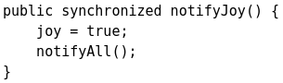
When wait is invoked, the thread releases the lock and suspends execution. At some future time, another thread will acquire the same lock and invoke Object.notifyAll, informing all threads waiting on that lock that something important has happened:
Some time after the second thread has released the lock, the first thread reacquires the lock and resumes by returning from the invocation of wait.
Note: There is a second notification method, notify, which wakes up a single thread. Because notify doesn't allow you to specify the thread that is woken up, it is useful only in massively parallel applications — that is, programs with a large number of threads, all doing similar chores. In such an application, you don't care which thread gets woken up.
Let's use guarded blocks to create a Producer-Consumer application. This kind of application shares data between two threads: the producer, that creates the data, and the consumer, that does something with it. The two threads communicate using a shared object. Coordination is essential: the consumer thread must not attempt to retrieve the data before the producer thread has delivered it, and the producer thread must not attempt to deliver new data if the consumer hasn't retrieved the old data.
In this example, the data is a series of text messages, which are shared through an object of type Drop:
The producer thread, defined in Producer, sends a series of familiar messages. The string "DONE" indicates that all messages have been sent. To simulate the unpredictable nature of real-world applications, the producer thread pauses for random intervals between messages.
The consumer thread, defined in Consumer, simply retrieves the messages and prints them out, until it retrieves the "DONE" string. This thread also pauses for random intervals
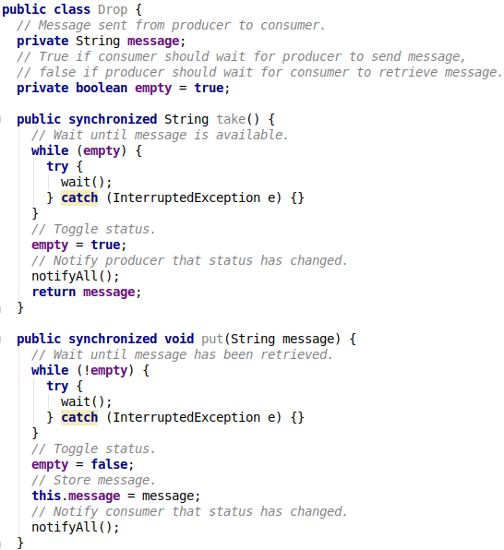
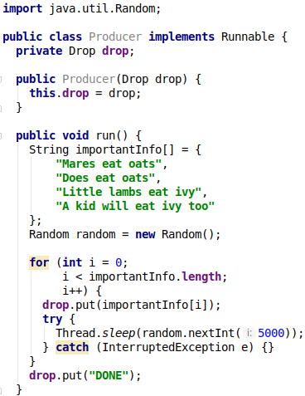
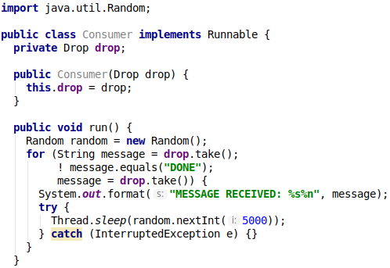
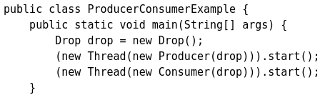
Immutable Objects
An object is considered immutable if its state cannot change after it is constructed. Maximum reliance on immutable objects is widely accepted as a sound strategy for creating simple, reliable code.
Immutable objects are particularly useful in concurrent applications. Since they cannot change state, they cannot be corrupted by thread interference or observed in an inconsistent state.
Programmers are often reluctant to employ immutable objects, because they worry about the cost of creating a new object as opposed to updating an object in place. The impact of object creation is often overestimated, and can be offset by some of the efficiencies associated with immutable objects. These include decreased overhead due to garbage collection, and the elimination of code needed to protect mutable objects from corruption.
The following subsections take a class whose instances are mutable and derives a class with immutable instances from it. In so doing, they give general rules for this kind of conversion and demonstrate some of the advantages of immutable objects.

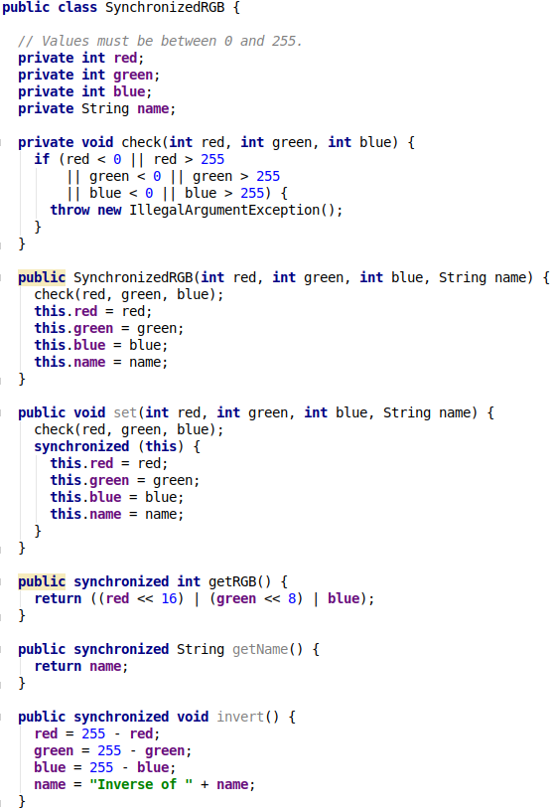
SynchronizedRGB must be used carefully to avoid being seen in an inconsistent state. Suppose, for example, a thread executes the following code:
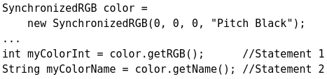

If another thread invokes color.set after Statement 1 but before Statement 2, the value of myColorInt won't match the value of myColorName. To avoid this outcome, the two statements must be bound together:
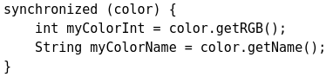

This kind of inconsistency is only possible for mutable objects — it will not be an issue for the immutable version of SynchronizedRGB.

A Strategy for Defining Immutable Objects
The following rules define a simple strategy for creating immutable objects. Not all classes documented as "immutable" follow these rules. This does not necessarily mean the creators of these classes were sloppy — they may have good reason for believing that instances of their classes never change after construction. However, such strategies require sophisticated analysis and are not for beginners.
- Don't provide "setter" methods — methods that modify fields or objects referred to by fields.
- Make all fields final and private.
- Don't allow subclasses to override methods. The simplest way to do this is to declare the class as final. A more sophisticated approach is to make the constructor private and construct instances in factory methods.
- If the instance fields include references to mutable objects, don't allow those objects to be changed:
  - Don't provide methods that modify the mutable objects.
  - Don't share references to the mutable objects. Never store references to external, mutable objects passed to the constructor; if necessary, create copies, and store references to the copies. Similarly, create copies of your internal mutable objects when necessary to avoid returning the originals in your methods.

Applying this strategy to SynchronizedRGB results in the following steps:
- There are two setter methods in this class. The first one, set, arbitrarily transforms the object, and has no place in an immutable version of the class. The second one, invert, can be adapted by having it create a new object instead of modifying the existing one.
- All fields are already private; they are further qualified as final.
- The class itself is declared final.
- Only one field refers to an object, and that object is itself immutable. Therefore, no safeguards against changing the state of "contained" mutable objects are necessary.
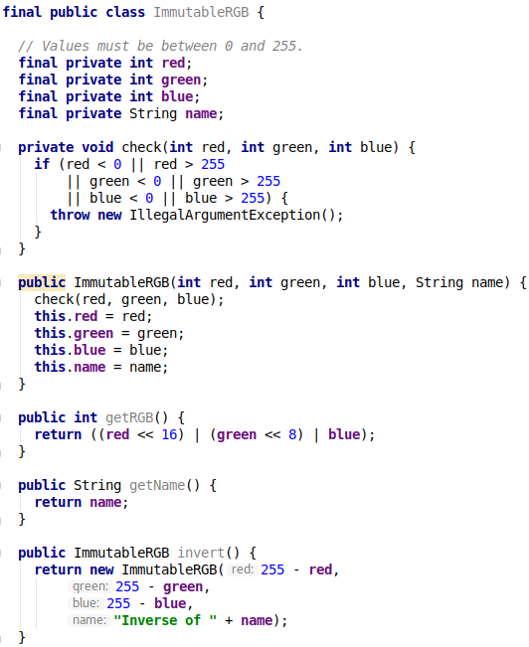

High Level Concurrency Objects
So far, this lesson has focused on the low-level APIs that have been part of the Java platform from the very beginning. These APIs are adequate for very basic tasks, but higher-level building blocks are needed for more advanced tasks. This is especially true for massively concurrent applications that fully exploit today's multiprocessor and multi-core systems.
In this section we'll look at some of the high-level concurrency features introduced with version 5.0 of the Java platform. Most of these features are implemented in the new java.util.concurrent packages. There are also new concurrent data structures in the Java Collections Framework.
- Lock objects support locking idioms that simplify many concurrent applications.
- Executors define a high-level API for launching and managing threads. Executor implementations provided by java.util.concurrent provide thread pool management suitable for large-scale applications.
- Concurrent collections make it easier to manage large collections of data, and can greatly reduce the need for synchronization.
- Atomic variables have features that minimize synchronization and help avoid memory consistency errors.
- ThreadLocalRandom (in JDK 7) provides efficient generation of pseudorandom numbers from multiple threads.

Lock Objects
Synchronized code relies on a simple kind of reentrant lock. This kind of lock is easy to use, but has many limitations. More sophisticated locking idioms are supported by the java.util.concurrent.locks package. We won't examine this package in detail, but instead will focus on its most basic interface, Lock.
Lock objects work very much like the implicit locks used by synchronized code. As with implicit locks, only one thread can own a Lock object at a time. Lock objects also support a wait/notify mechanism, through their associated Condition objects.
The biggest advantage of Lock objects over implicit locks is their ability to back out of an attempt to acquire a lock. The tryLock method backs out if the lock is not available immediately or before a timeout expires (if specified). The lockInterruptibly method backs out if another thread sends an interrupt before the lock is acquired.
Let's use Lock objects to solve the deadlock problem we saw in Liveness. Alphonse and Gaston have trained themselves to notice when a friend is about to bow. We model this improvement by requiring that our Friend objects must acquire locks for both participants before proceeding with the bow. Here is the source code for the improved model, Safelock. To demonstrate the versatility of this idiom, we assume that Alphonse and Gaston are so infatuated with their newfound ability to bow safely that they can't stop bowing to each other:

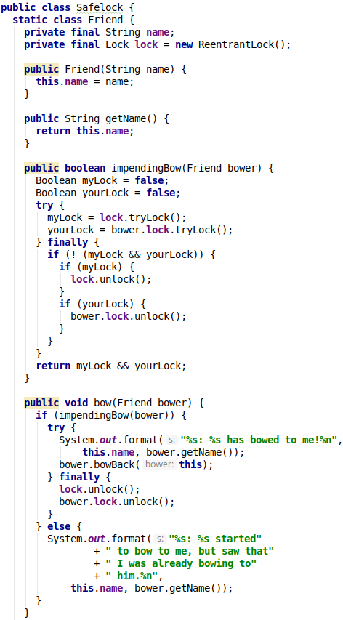
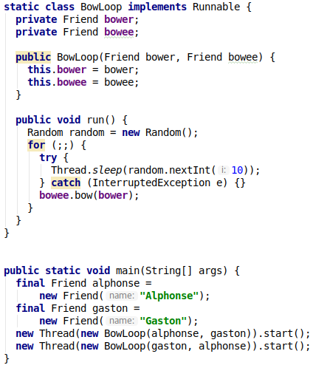

Executors
In all of the previous examples, there's a close connection between the task being done by a new thread, as defined by its Runnable object, and the thread itself, as defined by a Thread object. This works well for small applications, but in large-scale applications, it makes sense to separate thread management and creation from the rest of the application. Objects that encapsulate these functions are known as executors. The following subsections describe executors in detail.
- Executor Interfaces define the three executor object types.
- Thread Pools are the most common kind of executor implementation.
- Fork/Join is a framework (new in JDK 7) for taking advantage of multiple processors.

Executor Interfaces
The java.util.concurrent package defines three executor interfaces:
- Executor, a simple interface that supports launching new tasks.
- ExecutorService, a subinterface of Executor, which adds features that help manage the lifecycle, both of the individual tasks and of the executor itself.
- ScheduledExecutorService, a subinterface of ExecutorService, supports future and/or periodic execution of tasks.
Typically, variables that refer to executor objects are declared as one of these three interface types, not with an executor class type.

The Executor Interface
The Executor interface provides a single method, execute, designed to be a drop-in replacement for a common thread-creation idiom. If r is a Runnable object, and e is an Executor object you can replace
(new Thread(r)).start(); with e.execute(r);
However, the definition of execute is less specific. The low-level idiom creates a new thread and launches it immediately. Depending on the Executor implementation, execute may do the same thing, but is more likely to use an existing worker thread to run r, or to place r in a queue to wait for a worker thread to become available. (We'll describe worker threads in the section on Thread Pools.)
The executor implementations in java.util.concurrent are designed to make full use of the more advanced ExecutorService and ScheduledExecutorService interfaces, although they also work with the base Executor interface.
The ExecutorService Interface
The ExecutorService interface supplements execute with a similar, but more versatile submit method. Like execute, submit accepts Runnable objects, but also accepts Callable objects, which allow the task to return a value. The submit method returns a Future object, which is used to retrieve the Callable return value and to manage the status of both Callable and Runnable tasks.
ExecutorService also provides methods for submitting large collections of Callable objects. Finally, ExecutorService provides a number of methods for managing the shutdown of the executor. To support immediate shutdown, tasks should handle interrupts correctly.
The ScheduledExecutorService Interface
The ScheduledExecutorService interface supplements the methods of its parent ExecutorService with schedule, which executes a Runnable or Callable task after a specified delay. In addition, the interface defines scheduleAtFixedRate and scheduleWithFixedDelay, which executes specified tasks repeatedly, at defined intervals.

Thread Pools
Most of the executor implementations in java.util.concurrent use thread pools, which consist of worker threads. This kind of thread exists separately from the Runnable and Callable tasks it executes and is often used to execute multiple tasks.
Using worker threads minimizes the overhead due to thread creation. Thread objects use a significant amount of memory, and in a large-scale application, allocating and deallocating many thread objects creates a significant memory management overhead.
One common type of thread pool is the fixed thread pool. This type of pool always has a specified number of threads running; if a thread is somehow terminated while it is still in use, it is automatically replaced with a new thread. Tasks are submitted to the pool via an internal queue, which holds extra tasks whenever there are more active tasks than threads.
An important advantage of the fixed thread pool is that applications using it degrade gracefully. To understand this, consider a web server application where each HTTP request is handled by a separate thread. If the application simply creates a new thread for every new HTTP request, and the system receives more requests than it can handle immediately, the application will suddenly stop responding to all requests when the overhead of all those threads exceed the capacity of the system. With a limit on the number of the threads that can be created, the application will not be servicing HTTP requests as quickly as they come in, but it will be servicing them as quickly as the system can sustain.
A simple way to create an executor that uses a fixed thread pool is to invoke the newFixedThreadPool factory method in java.util.concurrent.Executors This class also provides the following factory methods:
- The newCachedThreadPool method creates an executor with an expandable thread pool. This executor is suitable for applications that launch many short-lived tasks.
- The newSingleThreadExecutor method creates an executor that executes a single task at a time.
- Several factory methods are ScheduledExecutorService versions of the above executors.
If none of the executors provided by the above factory methods meet your needs, constructing instances of java.util.concurrent.ThreadPoolExecutor or java.util.concurrent.ScheduledThreadPoolExecutor will give you additional options.

Fork/Join
The fork/join framework is an implementation of the ExecutorService interface that helps you take advantage of multiple processors. It is designed for work that can be broken into smaller pieces recursively. The goal is to use all the available processing power to enhance the performance of your application.
As with any ExecutorService implementation, the fork/join framework distributes tasks to worker threads in a thread pool. The fork/join framework is distinct because it uses a work-stealing algorithm. Worker threads that run out of things to do can steal tasks from other threads that are still busy.
The center of the fork/join framework is the ForkJoinPool class, an extension of the AbstractExecutorService class. ForkJoinPool implements the core work-stealing algorithm and can execute ForkJoinTask processes.
Basic Use: The first step for using the fork/join framework is to write code that performs a segment of the work. Your code should look similar to the following pseudocode:
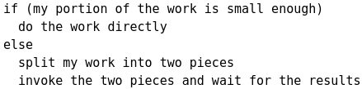

Wrap this code in a ForkJoinTask subclass, typically using one of its more specialized types, either RecursiveTask (which can return a result) or RecursiveAction.
After your ForkJoinTask subclass is ready, create the object that represents all the work to be done and pass it to the invoke() method of a ForkJoinPool instance.
Blurring for Clarity (fork/join)
To help you understand how the fork/join framework works, consider the following example. Suppose that you want to blur an image. The original source image is represented by an array of integers, where each integer contains the color values for a single pixel. The blurred destination image is also represented by an integer array with the same size as the source.
Performing the blur is accomplished by working through the source array one pixel at a time. Each pixel is averaged with its surrounding pixels (the red, green, and blue components are averaged), and the result is placed in the destination array. Since an image is a large array, this process can take a long time. You can take advantage of concurrent processing on multiprocessor systems by implementing the algorithm using the fork/join framework. Here is one possible implementation:

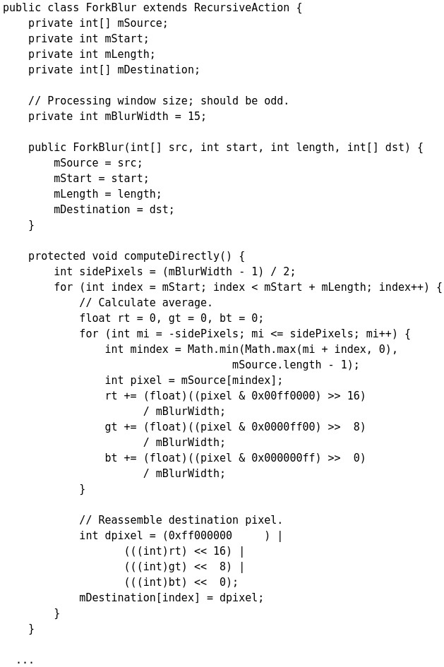
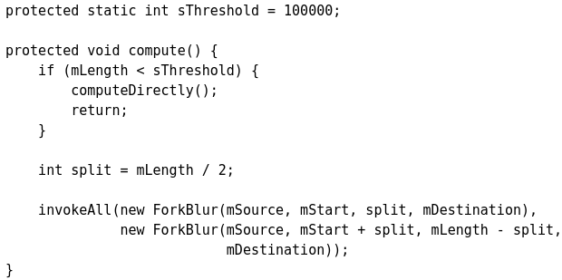
Now you implement the abstract compute() method, which either performs the blur directly or splits it into two smaller tasks. A simple array length threshold helps determine whether the work is performed or split.

If the previous methods are in a subclass of the RecursiveAction class, then setting up the task to run in a ForkJoinPool is straightforward, and involves the following steps:
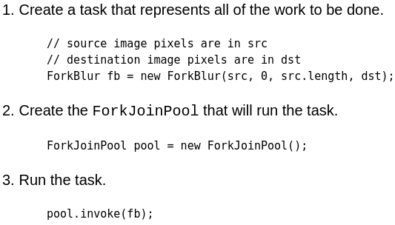

For the full source code, including some extra code that creates the destination image file, see the ForkBlur example.
Standard Implementations (fork/join)
Besides using the fork/join framework to implement custom algorithms for tasks to be performed concurrently on a multiprocessor system (such as the ForkBlur.java example in the previous section), there are some generally useful features in Java SE which are already implemented using the fork/join framework. One such implementation, introduced in Java SE 8, is used by the java.util.Arrays class for its parallelSort() methods. These methods are similar to sort(), but leverage concurrency via the fork/join framework. Parallel sorting of large arrays is faster than sequential sorting when run on multiprocessor systems. However, how exactly the fork/join framework is leveraged by these methods is outside the scope of the Java Tutorials. For this information, see the Java API documentation.
Another implementation of the fork/join framework is used by methods in the java.util.streams package, which is part of Project Lambda scheduled for the Java SE 8 release. For more information, see the Lambda Expressions section.

Concurrent Collections
The java.util.concurrent package includes a number of additions to the Java Collections Framework. These are most easily categorized by the collection interfaces provided:
- BlockingQueue defines a first-in-first-out data structure that blocks or times out when you attempt to add to a full queue, or retrieve from an empty queue.
- ConcurrentMap is a subinterface of java.util.Map that defines useful atomic operations. These operations remove or replace a key-value pair only if the key is present, or add a key-value pair only if the key is absent. Making these operations atomic helps avoid synchronization. The standard general-purpose implementation of ConcurrentMap is ConcurrentHashMap, which is a concurrent analog of HashMap.
- ConcurrentNavigableMap is a subinterface of ConcurrentMap that supports approximate matches. The standard general-purpose implementation of ConcurrentNavigableMap is ConcurrentSkipListMap, which is a concurrent analog of TreeMap.
All of these collections help avoid Memory Consistency Errors by defining a happens-before relationship between an operation that adds an object to the collection with subsequent operations that access or remove that object.

Atomic Variables
The java.util.concurrent.atomic package defines classes that support atomic operations on single variables. All classes have get and set methods that work like reads and writes on volatile variables. That is, a set has a happens-before relationship with any subsequent get on the same variable. The atomic compareAndSet method also has these memory consistency features, as do the simple atomic arithmetic methods that apply to integer atomic variables.
To see how this package might be used, let's return to the Counter class we originally used to demonstrate thread interference:
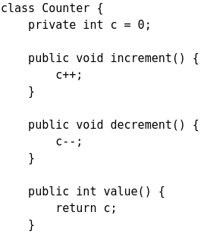
One way to make Counter safe from thread interference is to make its methods synchronized, as in SynchronizedCounter:
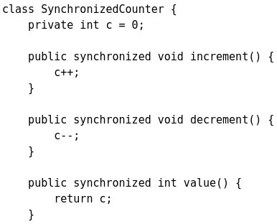

For this simple class, synchronization is an acceptable solution. But for a more complicated class, we might want to avoid the liveness impact of unnecessary synchronization. Replacing the int field with an AtomicInteger allows us to prevent thread interference without resorting to synchronization, as in AtomicCounter:
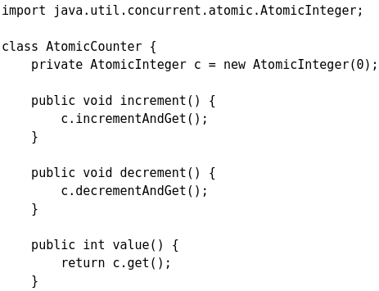

If you look at the methods AtomicInteger has, you'll notice that they tend to correspond to common operations on ints. For instance:
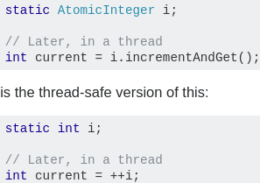
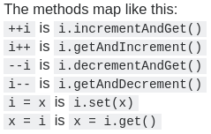

The primary use of AtomicInteger is when you are in a multithreaded context and you need to perform thread safe operations on an integer without using synchronized. The assignation and retrieval on the primitive type int are already atomic but AtomicInteger comes with many operations which are not atomic on int.
- The access is atomic (see chapter Atomic Access) but when we increment (i++;) or decrement an int field, it is NOT an atomic operation!!!

Concurrent Random Numbers
In JDK 7, java.util.concurrent includes a convenience class, ThreadLocalRandom, for applications that expect to use random numbers from multiple threads or ForkJoinTasks.
For concurrent access, using ThreadLocalRandom instead of Math.random() results in less contention and, ultimately, better performance.
All you need to do is call ThreadLocalRandom.current(), then call one of its methods to retrieve a random number. Here is one example:
int r = ThreadLocalRandom.current() .nextInt(4, 77);

