JDBC API

The JDBC API is a Java API that can access any kind of tabular data, especially data stored in a Relational Database.
JDBC helps you to write Java applications that manage these three programming activities:

- Connect to a data source, like a database
- Send queries and update statements to the database
- Retrieve and process the results received from the database in answer to your query

Connection con = DriverManager.getConnection( "jdbc:myDriver:myDatabase", username, password);

Statement stmt = con.createStatement( );

ResultSet rs = stmt.executeQuery("SELECT a, b, c FROM Table1");

JDBC includes four components:

The JDBC API — The JDBC™ API provides programmatic access to relational data from the Java™ programming language. Using the JDBC API, applications can execute SQL statements, retrieve results, and propagate changes back to an underlying data source. The JDBC API can also interact with multiple data sources in a distributed, heterogeneous environment.
The JDBC API is part of the Java platform, which includes the Java™ Standard Edition (Java™ SE ) and the Java™ Enterprise Edition (Java™ EE). The JDBC 4.0 API is divided into two packages: java.sql and javax.sql. Both packages are included in the Java SE and Java EE platforms.

JDBC Driver Manager — The JDBC DriverManager class defines objects which can connect Java applications to a JDBC driver. DriverManager has traditionally been the backbone of the JDBC architecture. It is quite small and simple.
The Standard Extension packages javax.naming and javax.sql let you use a DataSource object registered with a Java Naming and Directory Interface™ (JNDI) naming service to establish a connection with a data source. You can use either connecting mechanism, but using a DataSource object is recommended whenever possible.

JDBC Test Suite — The JDBC driver test suite helps you to determine that JDBC drivers will run your program. These tests are not comprehensive or exhaustive, but they do exercise many of the important features in the JDBC API

JDBC-ODBC Bridge — The Java Software bridge provides JDBC access via ODBC drivers. Note that you need to load ODBC binary code onto each client machine that uses this driver. As a result, the ODBC driver is most appropriate on a corporate network where client installations are not a major problem, or for application server code written in Java in a three-tier architecture.

- This Trail uses the first two of these these four JDBC components to connect to a database and then build a java program that uses SQL commands to communicate with a test Relational Database. The last two components are used in specialized environments to test web applications, or to communicate with ODBC-aware DBMSs.
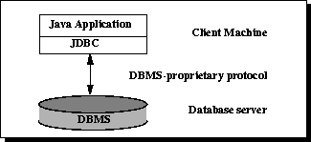
JDBC Architecture

The JDBC API supports both two-tier and three-tier processing models for database access.
In the two-tier model, a Java applet or application talks directly to the data source. This requires a JDBC driver that can communicate with the particular data source being accessed. A user's commands are delivered to the database or other data source, and the results of those statements are sent back to the user. The data source may be located on another machine to which the user is connected via a network. This is referred to as a client/server configuration, with the user's machine as the client, and the machine housing the data source as the server. The network can be an intranet, which, for example, connects employees within a corporation, or it can be the Internet.
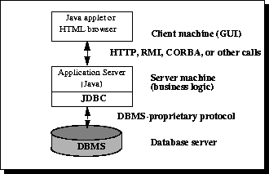
In the three-tier model, commands are sent to a "middle tier" of services, which then sends the commands to the data source. The data source processes the commands and sends the results back to the middle tier, which then sends them to the user. MIS directors find the three-tier model very attractive because the middle tier makes it possible to maintain control over access and the kinds of updates that can be made to corporate data. Another advantage is that it simplifies the deployment of applications. Finally, in many cases, the three-tier architecture can provide performance advantages.
With enterprises increasingly using the Java programming language for writing server code, the JDBC API is being used more and more in the middle tier of a three-tier architecture. Some of the features that make JDBC a server technology are its support for connection pooling, distributed transactions, and disconnected rowsets. The JDBC API is also what allows access to a data source from a Java middle tier.

Result Sets and Cursors
The rows that satisfy the conditions of a query are called the result set. The number of rows returned in a result set can be zero, one, or many. A user can access the data in a result set one row at a time, and a cursor provides the means to do that. A cursor can be thought of as a pointer into a file that contains the rows of the result set, and that pointer has the ability to keep track of which row is currently being accessed. A cursor allows a user to process each row of a result set from top to bottom and consequently may be used for iterative processing. Most DBMSs create a cursor automatically when a result set is generated.
Earlier JDBC API versions added new capabilities for a result set's cursor, allowing it to move both forward and backward and also allowing it to move to a specified row or to a row whose position is relative to another row.

Transactions
When one user is accessing data in a database, another user may be accessing the same data at the same time. For this reason, DBMSs use transactions to maintain data in a consistent state (data consistency) while allowing more than one user to access a database at the same time (data concurrency).

A transaction is a set of one or more SQL statements that make up a logical unit of work. A transaction ends with either a commit or a rollback, depending on whether there are any problems with data consistency or data concurrency. The commit statement makes permanent the changes resulting from the SQL statements in the transaction, and the rollback statement undoes all changes resulting from the SQL statements in the transaction.
A lock is a mechanism that prohibits two transactions from manipulating the same data at the same time. For example, a table lock prevents a table from being dropped if there is an uncommitted transaction on that table. In some DBMSs, a table lock also locks all of the rows in a table. A row lock prevents two transactions from modifying the same row, or it prevents one transaction from selecting a row while another transaction is still modifying it.

Stored Procedures
A stored procedure is a group of SQL statements that can be called by name. In other words, it is executable code, a mini-program, that performs a particular task that can be invoked the same way one can call a function or method. Traditionally, stored procedures have been written in a DBMS-specific programming language. The latest generation of database products allows stored procedures to be written using the Java programming language and the JDBC API. Stored procedures written in the Java programming language are bytecode portable between DBMSs. Once a stored procedure is written, it can be used and reused because a DBMS that supports stored procedures will, as its name implies, store it in the database.
The following code is an example of how to create a very simple stored procedure using the Java programming language. Note that the stored procedure is just a static Java method that contains normal JDBC code.

Processing SQL Statements with JDBC

In general, to process any SQL statement with JDBC, you follow these steps:
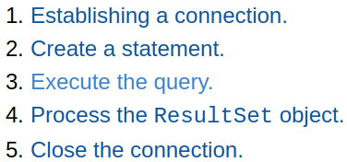

Establishing a Connection
First, you need to establish a connection with the data source you want to use. A data source can be a DBMS, a legacy file system, or some other source of data with a corresponding JDBC driver. Typically, a JDBC application connects to a target data source using one of two classes:
- DriverManager: This fully implemented class connects an application to a data source, which is specified by a database URL. (it is easier to use)
- DataSource: This interface is preferred over DriverManager because it allows details about the underlying data source to be transparent to your application. A DataSource object's properties are set so that it represents a particular data source.
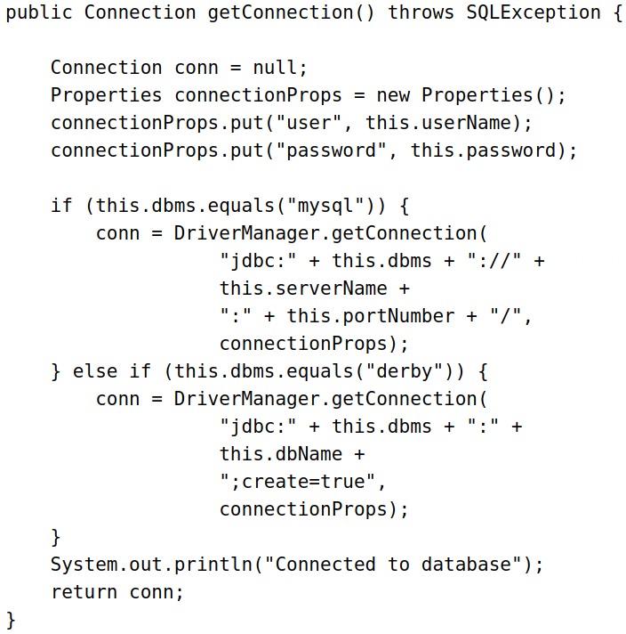

The method DriverManager.getConnection establishes a database connection. This method requires a database URL, which varies depending on your DBMS. The following are some examples of database URLs:
- MySQL: jdbc:mysql://localhost:3306/, where localhost is the name of the server hosting your database, and 3306 is the port number
- Java DB: jdbc:derby:testdb;create=true, where testdb is the name of the database to connect to, and create=true instructs the DBMS to create the database.

Note: Typically, in the database URL, you also specify the name of an existing database to which you want to connect. For example, the URL jdbc:mysql://localhost:3306/mysql represents the database URL for the MySQL database named mysql. The samples in this tutorial use a URL that does not specify a specific database because the samples create a new database.
In previous versions of JDBC, to obtain a connection, you first had to initialize your JDBC driver by calling the method Class.forName. This methods required an object of type java.sql.Driver. Each JDBC driver contains one or more classes that implements the interface java.sql.Driver. The drivers for Java DB are org.apache.derby.jdbc.EmbeddedDriver and org.apache.derby.jdbc.ClientDriver, and the one for MySQL Connector/J is com.mysql.jdbc.Driver. See the documentation of your DBMS driver to obtain the name of the class that implements the interface java.sql.Driver.
- Any JDBC 4.0 drivers that are found in your class path are automatically loaded. (However, you must manually load any drivers prior to JDBC 4.0 with the method Class.forName.)

MySQL Connector/J
Database URL The following is the database connection URL syntax for MySQL Connector/J:
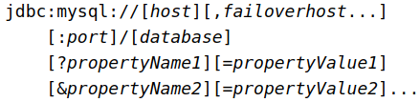

- host:port is the host name and port number of the computer hosting your database. If not specified, the default values of host and port are 127.0.0.1 and 3306, respectively.
- database is the name of the database to connect to. If not specified, a connection is made with no default database.
- failover is the name of a standby database (MySQL Connector/J supports failover).
- propertyName=propertyValue represents an optional, ampersand-separated list of properties. These attributes enable you to instruct MySQL Connector/J to perform various tasks.

Creating Statements
A Statement is an interface that represents a SQL statement. You execute Statement objects, and they generate ResultSet objects, which is a table of data representing a database result set. You need a Connection object to create a Statement object.
There are three different kinds of statements:
- Statement: Used to implement simple SQL statements with no parameters.
- PreparedStatement: (Extends Statement.) Used for precompiling SQL statements that might contain input parameters.
- CallableStatement: (Extends PreparedStatement.) Used to execute stored procedures that may contain both input and output parameters.

Executing Queries
To execute a query, call an execute method from Statement such as the following:
- execute: Returns true if the first object that the query returns is a ResultSet object. Use this method if the query could return one or more ResultSet objects. Retrieve the ResultSet objects returned from the query by repeatedly calling Statement.getResultSet.
- executeQuery: Returns one ResultSet object.
- executeUpdate: Returns an integer representing the number of rows affected by the SQL statement. Use this method if you are using INSERT, DELETE, or UPDATE SQL statements.

Processing ResultSet
Objects You access the data in a ResultSet object through a cursor. Note that this cursor is not a database cursor. This cursor is a pointer that points to one row of data in the ResultSet object. Initially, the cursor is positioned before the first row. You call various methods defined in the ResultSet object to move the cursor.
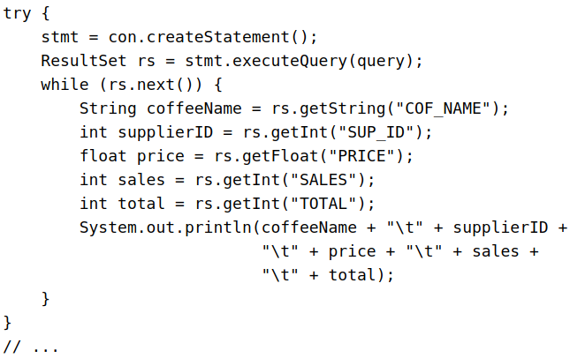
For example, CoffeesTables.viewTable repeatedly calls the method ResultSet.next to move the cursor forward by one row. Every time it calls next, the method outputs the data in the row where the cursor is currently positioned:

There are other methods available to move the cursor:
next: Moves the cursor forward one row. Returns true if the cursor is now positioned on a row and false if the cursor is positioned after the last row.
previous: Moves the cursor backward one row. Returns true if the cursor is now positioned on a row and false if the cursor is positioned before the first row.
first: Moves the cursor to the first row in the ResultSet object. Returns true if the cursor is now positioned on the first row and false if the ResultSet object does not contain any rows.
last:: Moves the cursor to the last row in the ResultSet object. Returns true if the cursor is now positioned on the last row and false if the ResultSet object does not contain any rows.
beforeFirst: Positions the cursor at the start of the ResultSet object, before the first row. If the ResultSet object does not contain any rows, this method has no effect.
afterLast: Positions the cursor at the end of the ResultSet object, after the last row. If the ResultSet object does not contain any rows, this method has no effect.

// this returns false if the cursor is not before the first record
// or if there are no rows in the ResultSet.
if (!rs.isBeforeFirst() ) {
textOutput.setText("Wrong ID password combination");
System.out.println("No data");
return;
}
Note that the default sensitivity of a ResultSet is TYPE_FORWARD_ONLY, which means that it cannot be scrolled; you cannot call any of these methods that move the cursor, except next, if your ResultSet cannot be scrolled. The method CoffeesTable.modifyPrices, described in the following section, demonstrates how you can move the cursor of a ResultSet.
- You cannot update a default ResultSet object, and you can only move its cursor forward. However, you can create ResultSet objects that can be scrolled (the cursor can move backwards or move to an absolute position) and updated.

